**KIM-PP 推拉作業檢核表**

**臨場健康守護犬  
www.ohsdog.com**

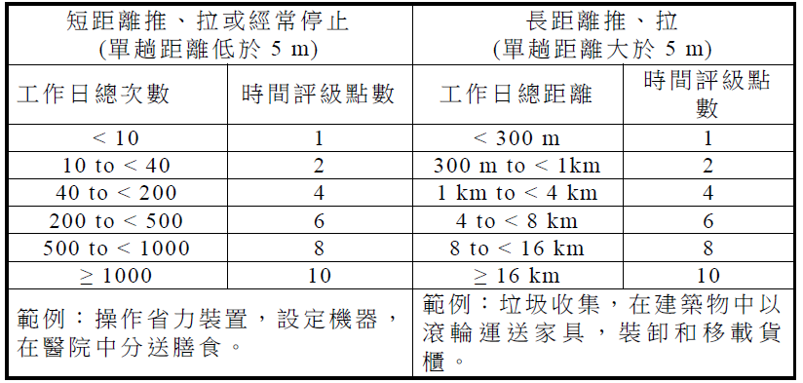

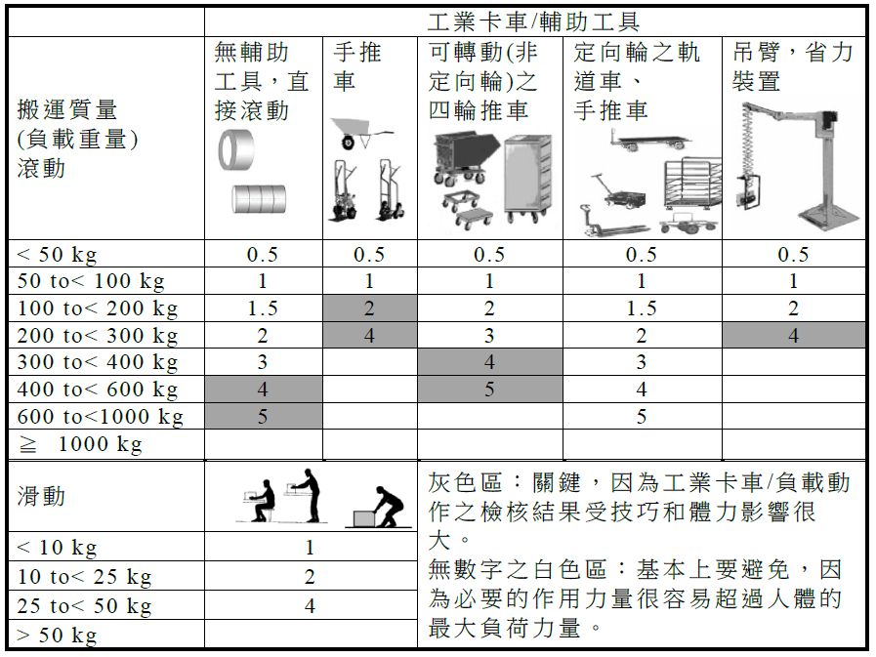

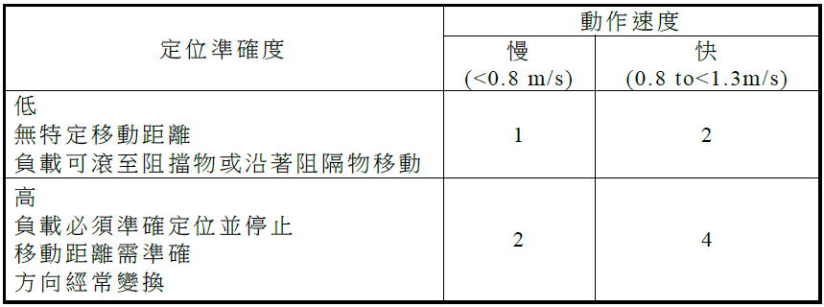

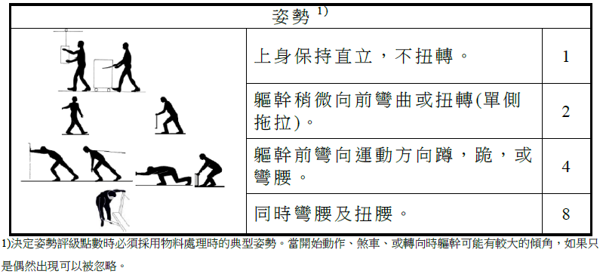

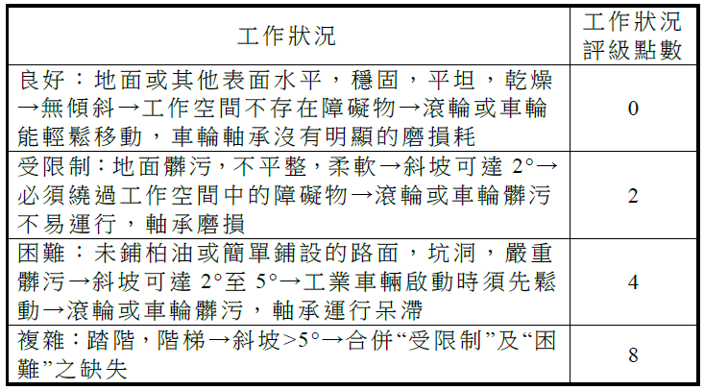

|  |  |  |  |
| --- | --- | --- | --- |
| **姓名** |  | **評估日期** |  |
| **部門單位** |  | **員工編號** |  |
| **性別** | **□男 □女** | **年齡** |  |

**________ ×( ________ + __________ + ________ + ________ )= _______**

**時間評級×(搬運質量+定位準確度+姿勢評級+工作狀況)=風險值**

