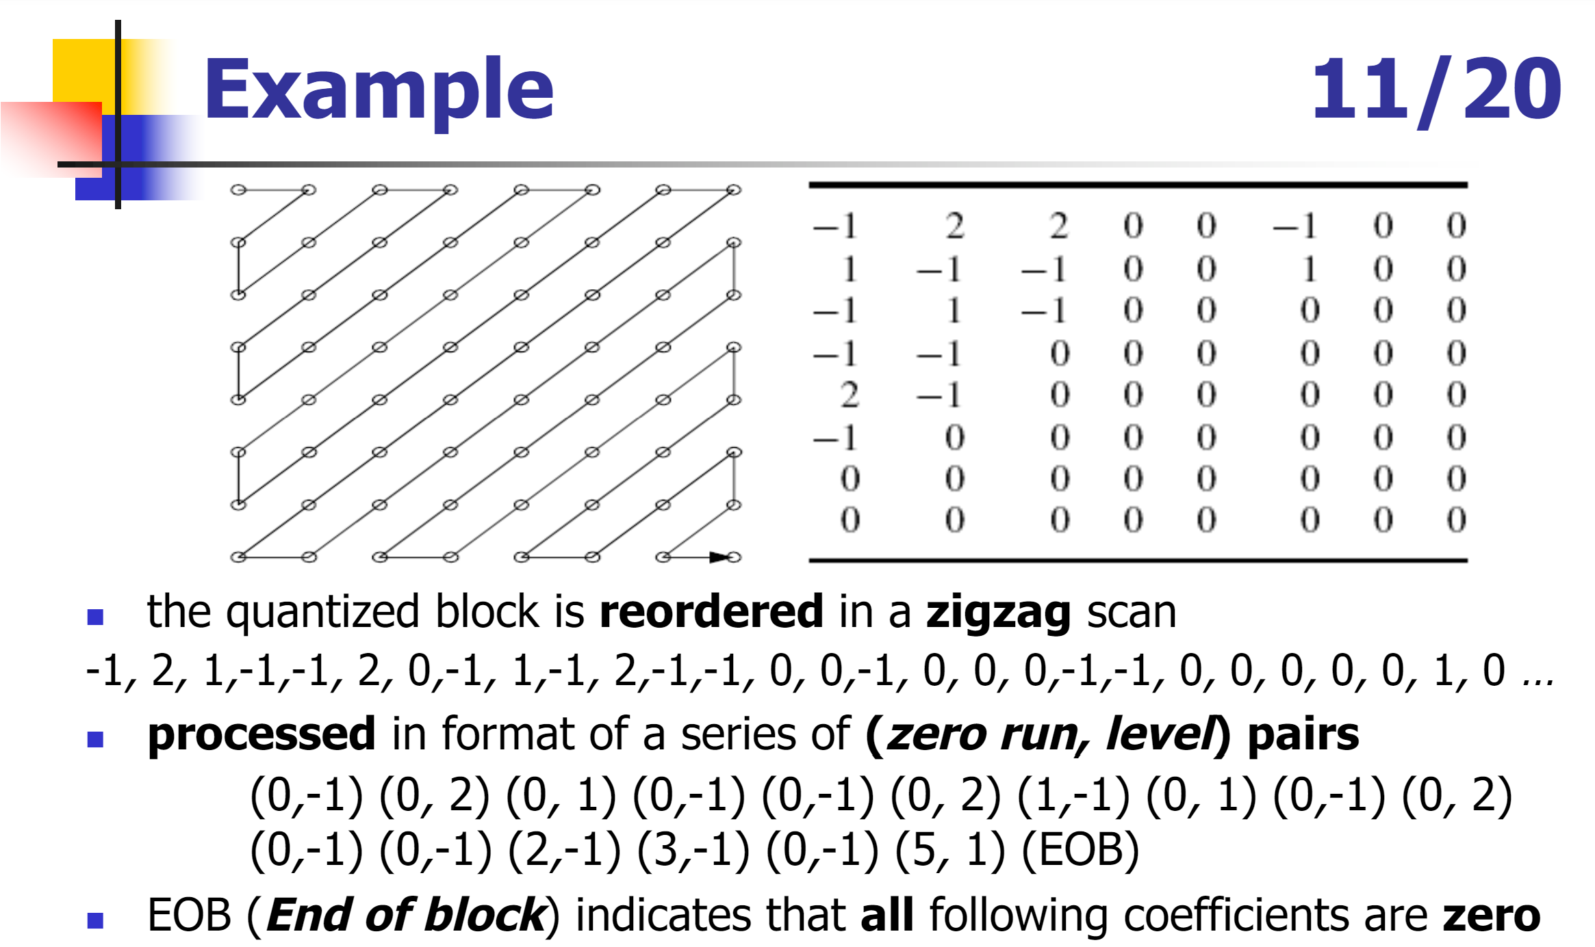

Block: 8x8, QP: 32
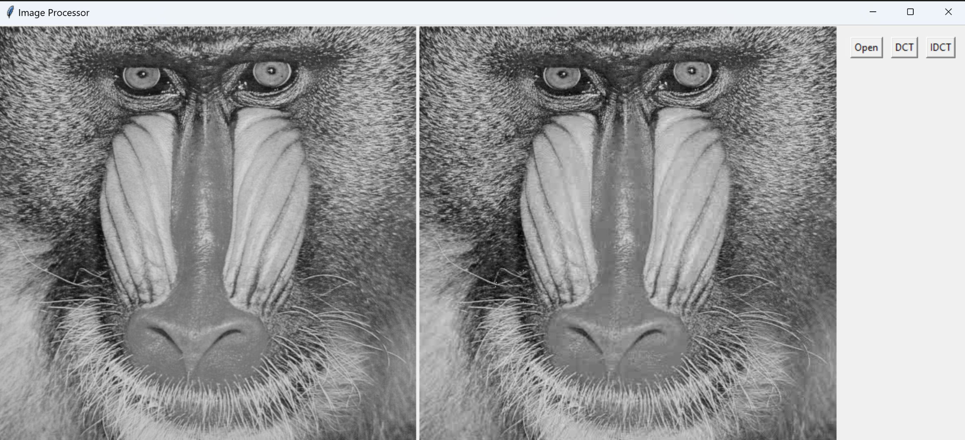

Block size: 32x32, QP: 32
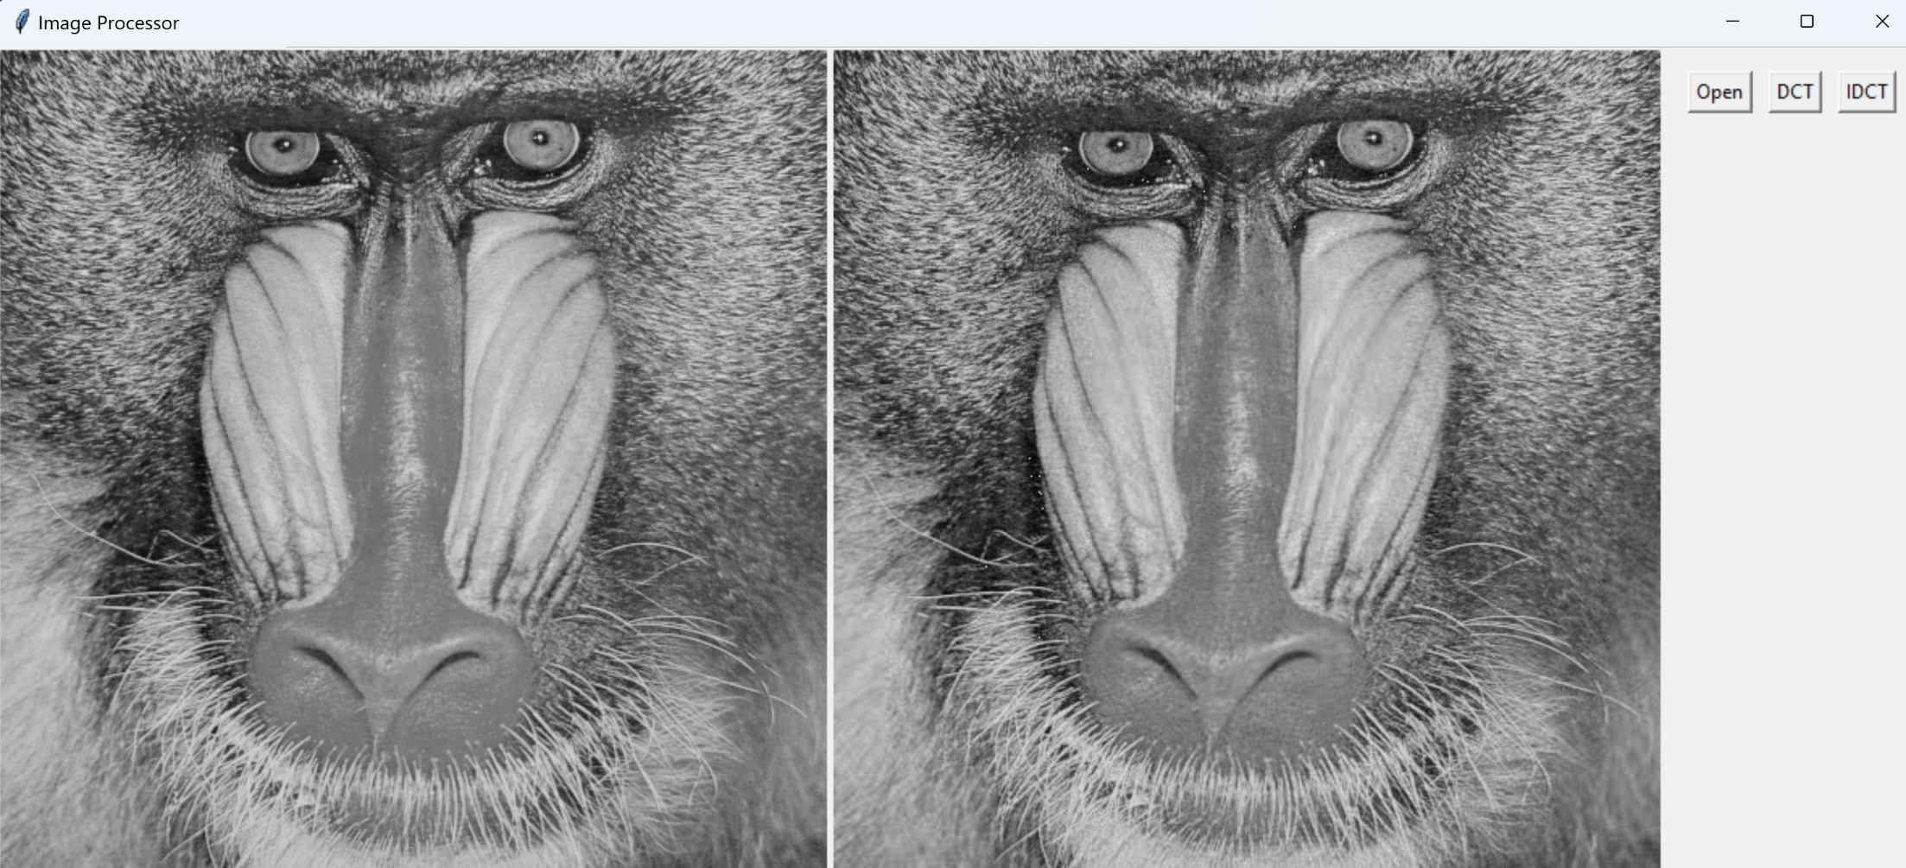

Block size: 64x64, QP: 32
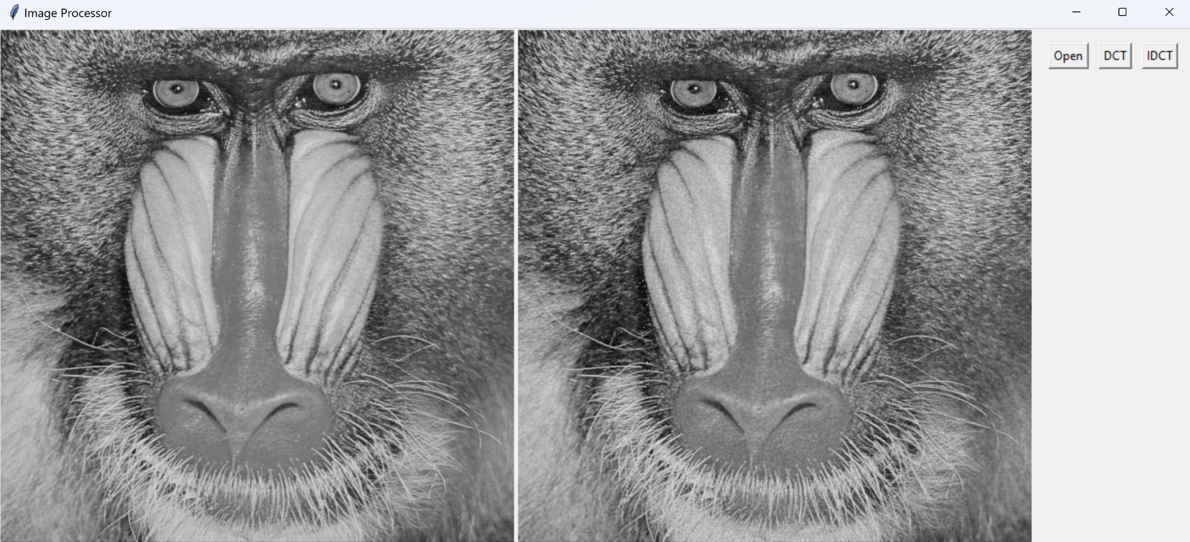

Huffman compression efficiency:
Image 8x8 block: 512 bits
RLE block: 64 x 8 bit = 512 bits, plus 64 x 16 bits (at least) = 1024 => total: 1536 bits
Huffman bits: 187 bits
111000011000011101001011110011110111000111101110111011101111001111000011101111011100011000110111101001000011101110100110011110001001011110110010101001011110111011001000100101100010111101
- 8.21 times reduction of storage space per block

