https://analytics.google.com/

Login with admin@vietnamracing.com.vn

Click Set up for free

Enter admin@vietnamracing.com.vn

Property name: admin@vietnamracing.com.vn

Website URL : http://vietnamracing.com.vn

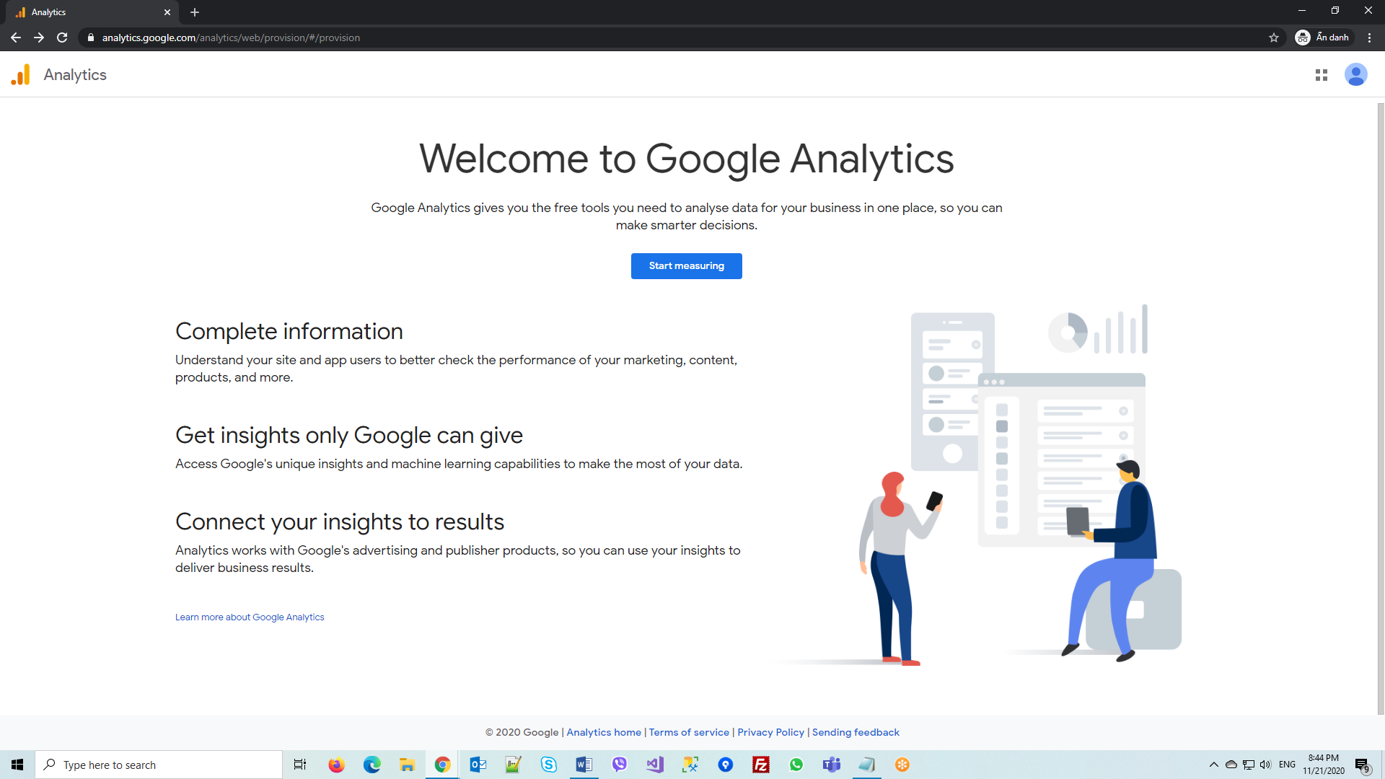

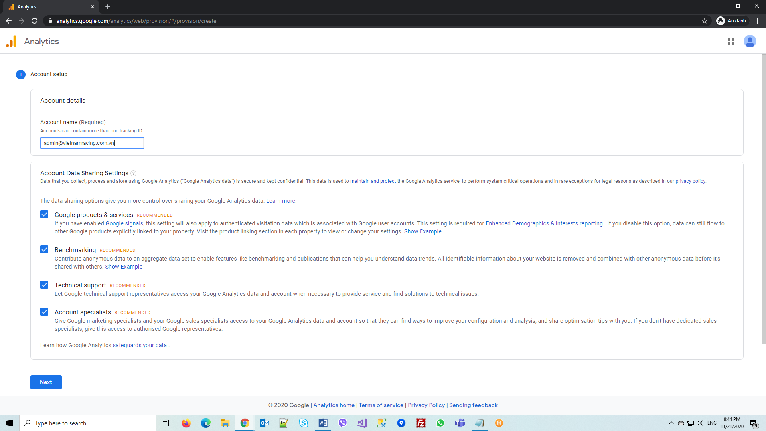

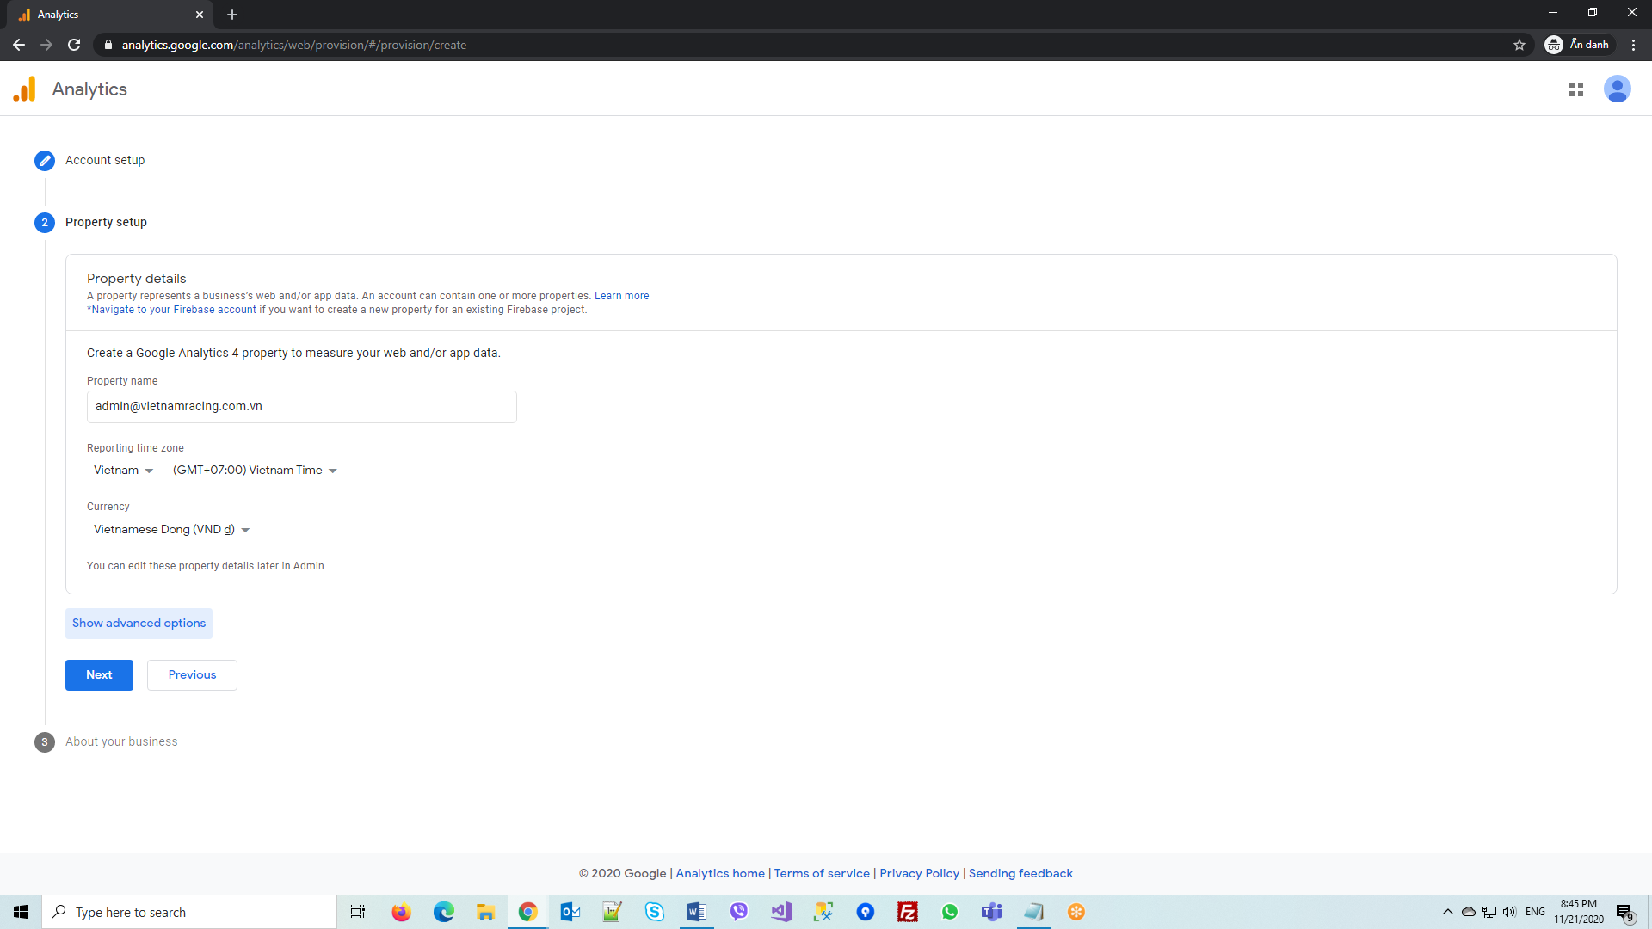

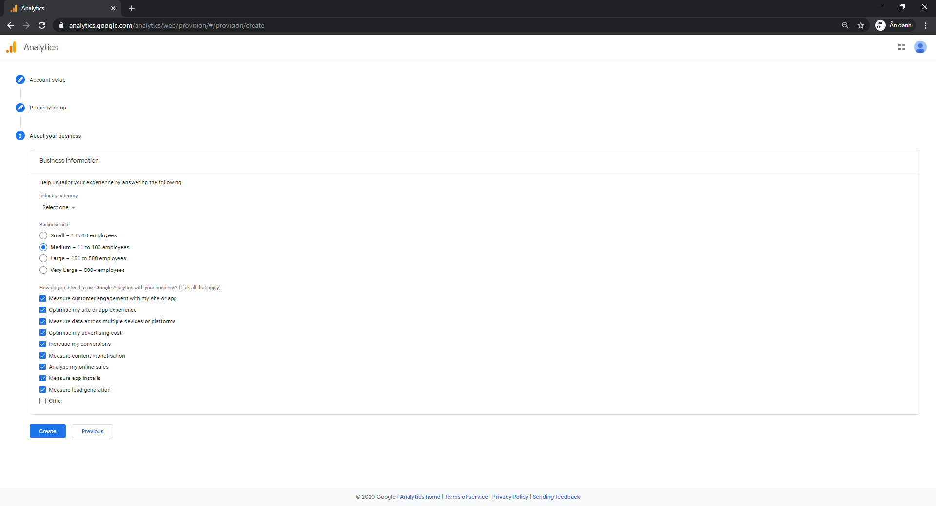

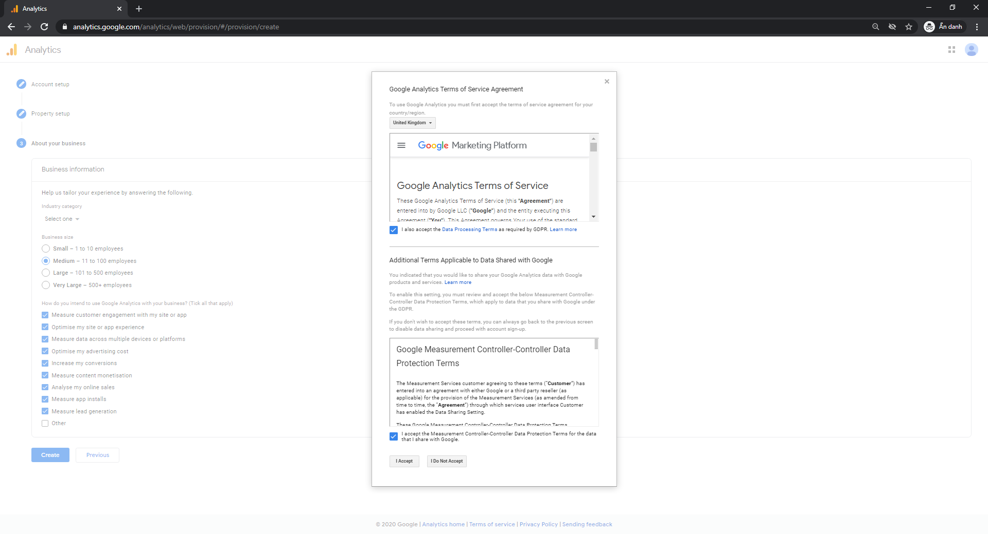

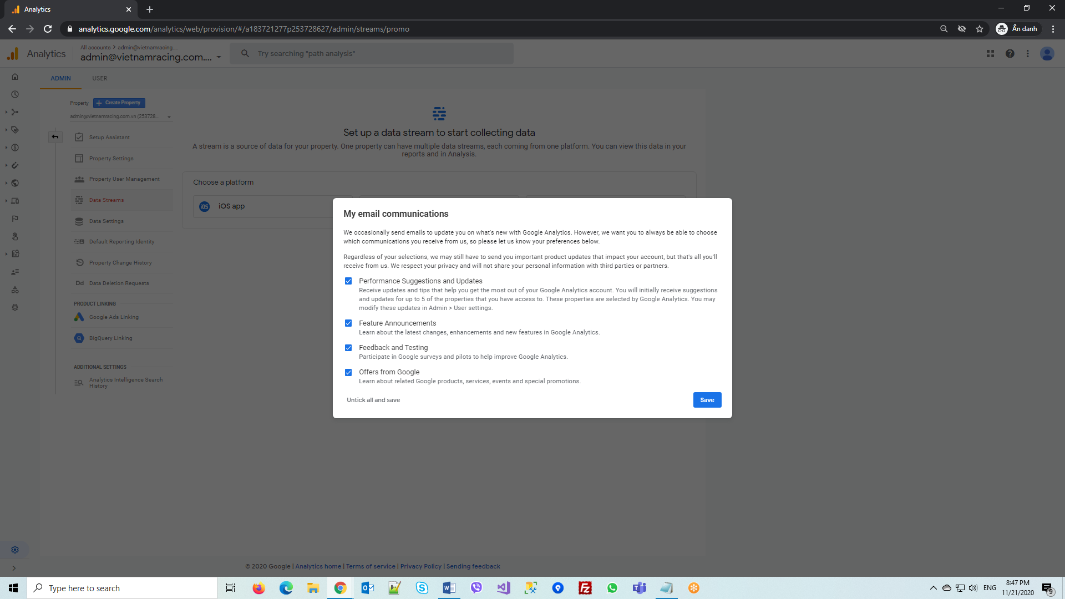

Click Home

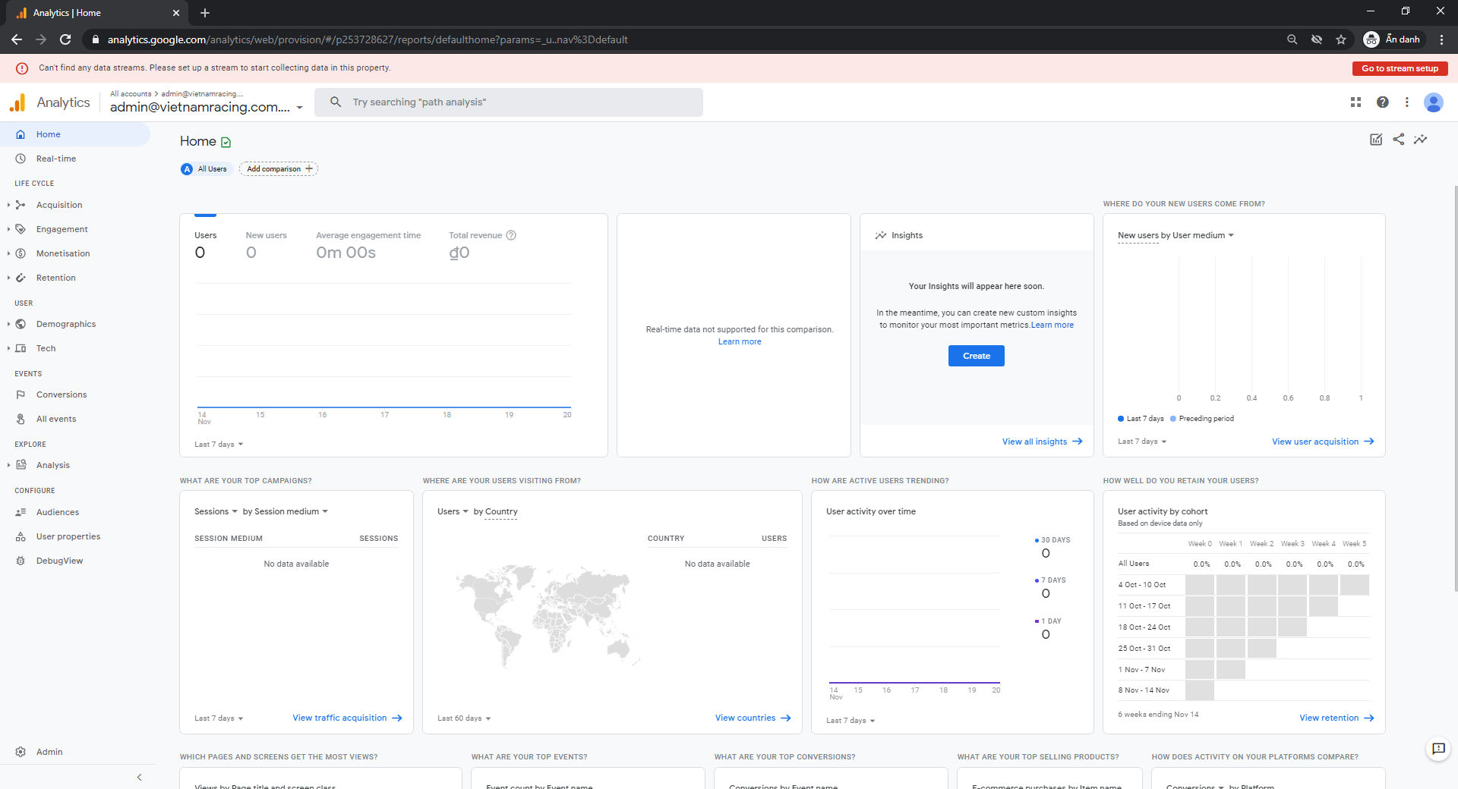

Click Admin at bottom left corner

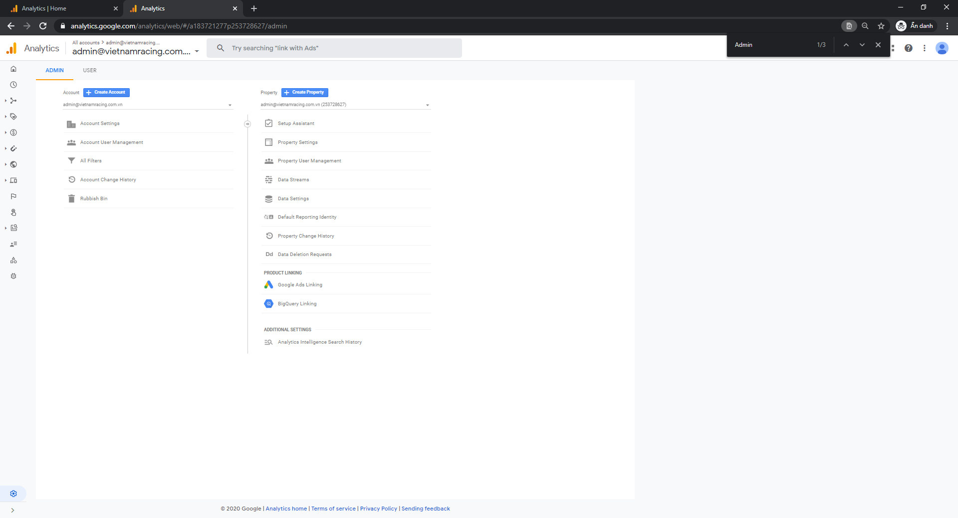

Select an account from the menu in the ACCOUNT column.

Select a property from the menu in the PROPERTY column.

Click Property Settings to copy Property ID

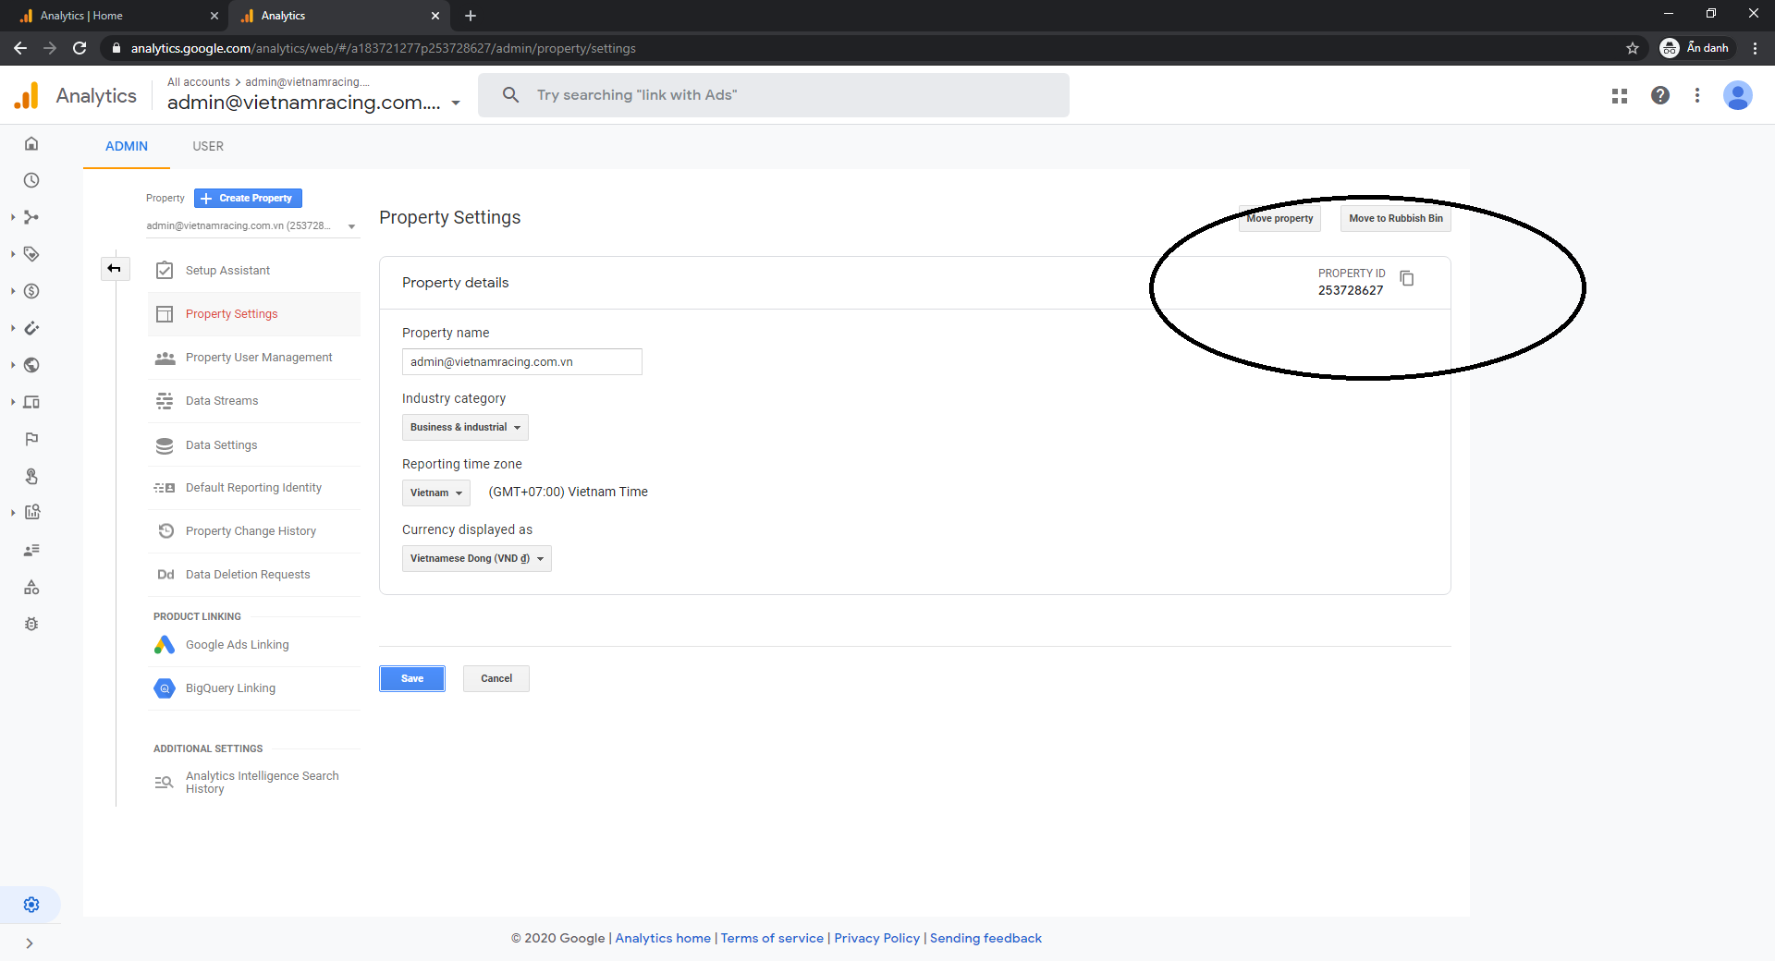

Click Account Settings to get Account ID:

https://analytics.google.com/analytics/web/#/a183721277p253728627/admin/account/settings

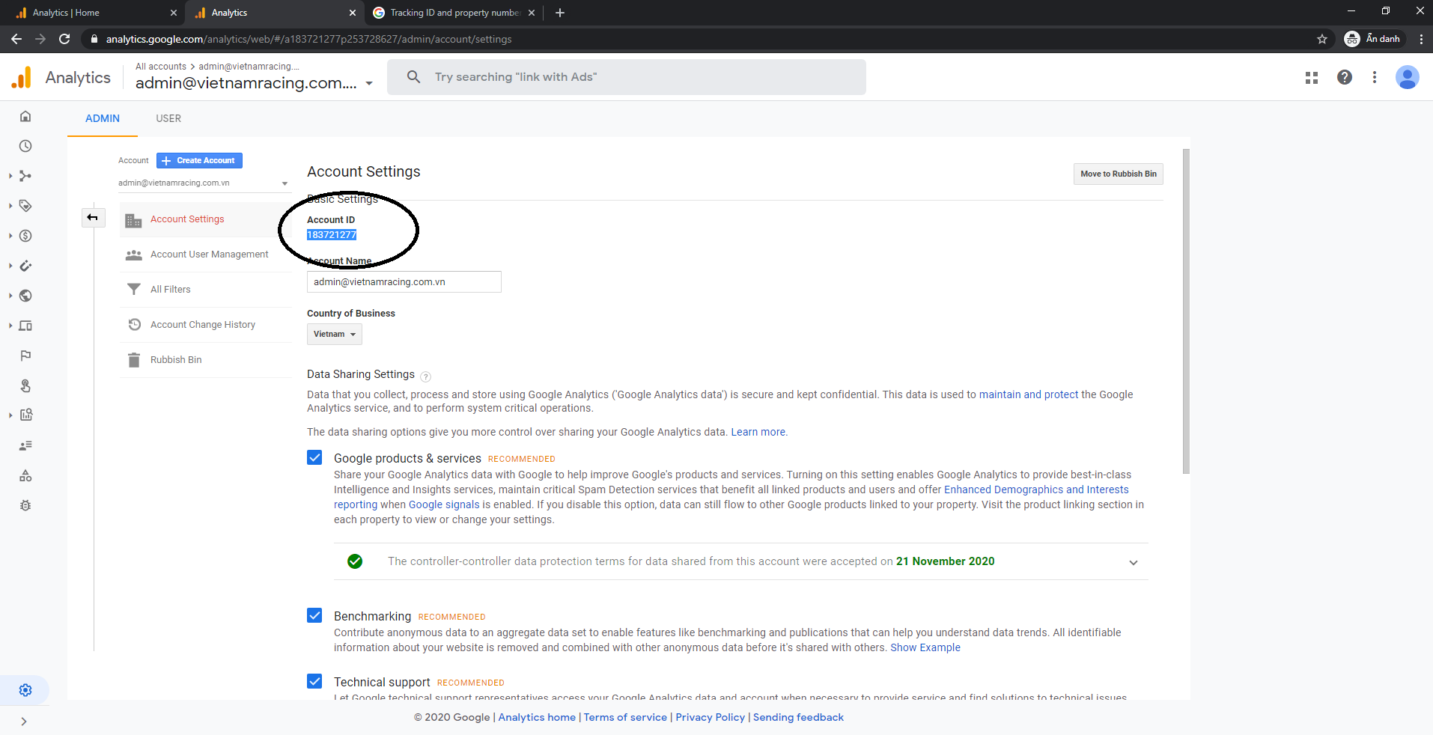

Tracking ID and property number

The *tracking ID* is a string like UA-000000-2. It must be included in your tracking code to tell Analytics which account and property to send data to.

The tracking ID is automatically included in the JavaScript snippet for websites, but also needs to be included in other tracking technologies like the SDKs and the Measurement Protocol for Analytics to work.

The first set of numbers (-000000, in the example above) refers to your account number, and the second set of numbers (-2) refers to the specific *property number* associated with the account.

Traking ID: UA-183721277-253728627

Create a new property:

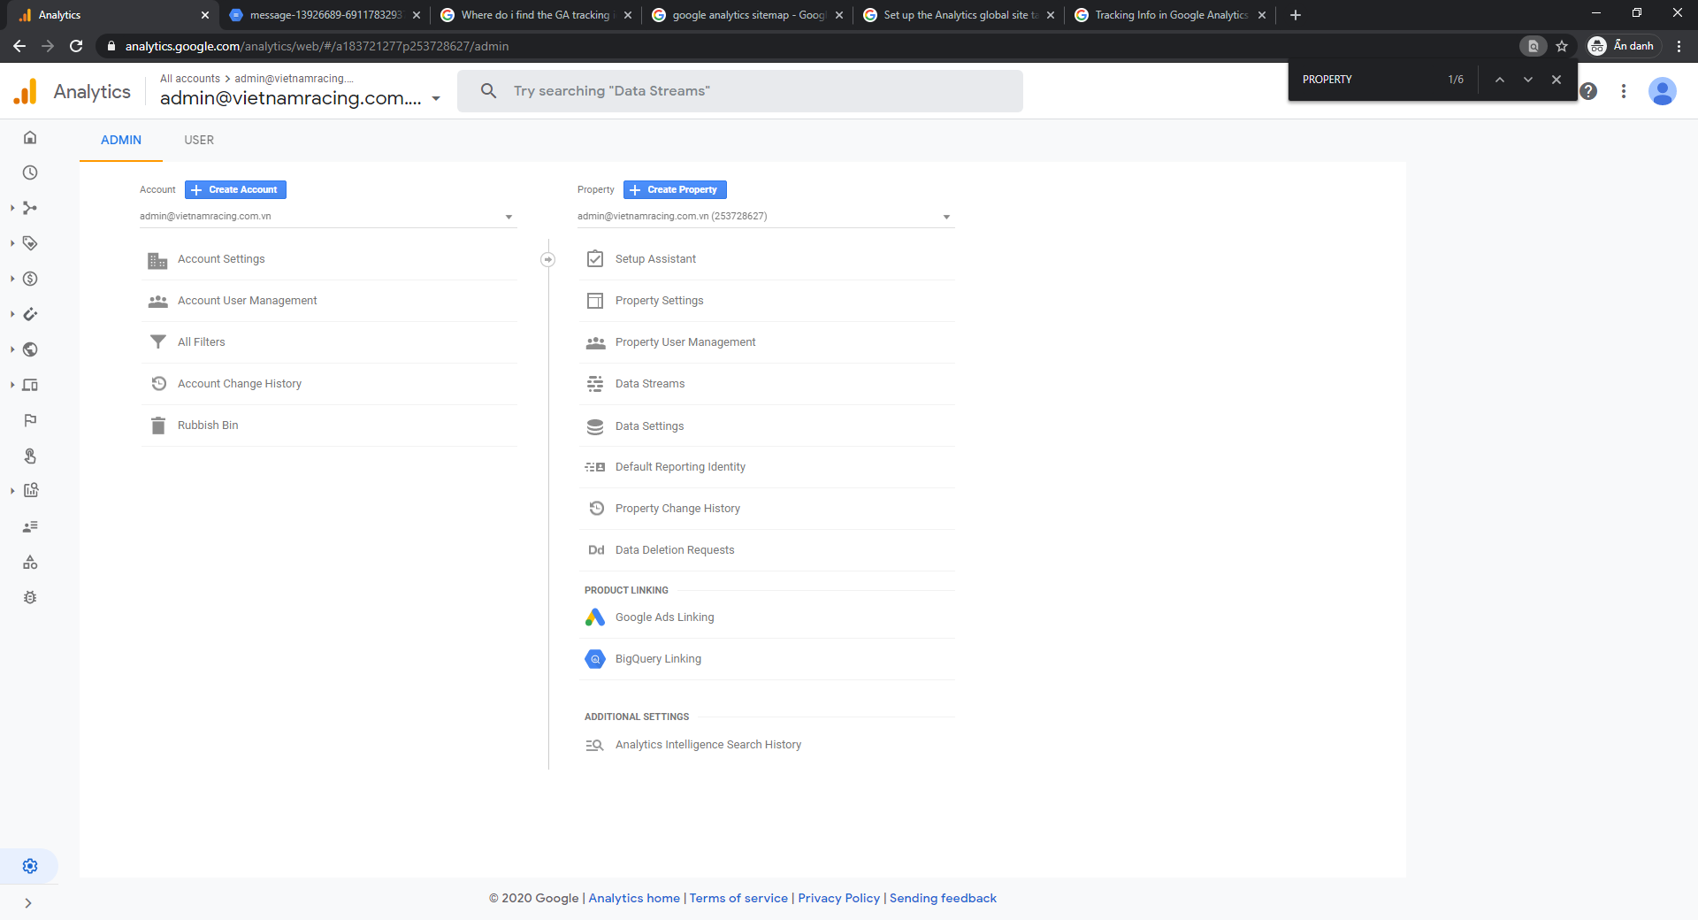

Click “Create property 🡪 Show advanced options 🡪 Check Create a Universal Analytics property”

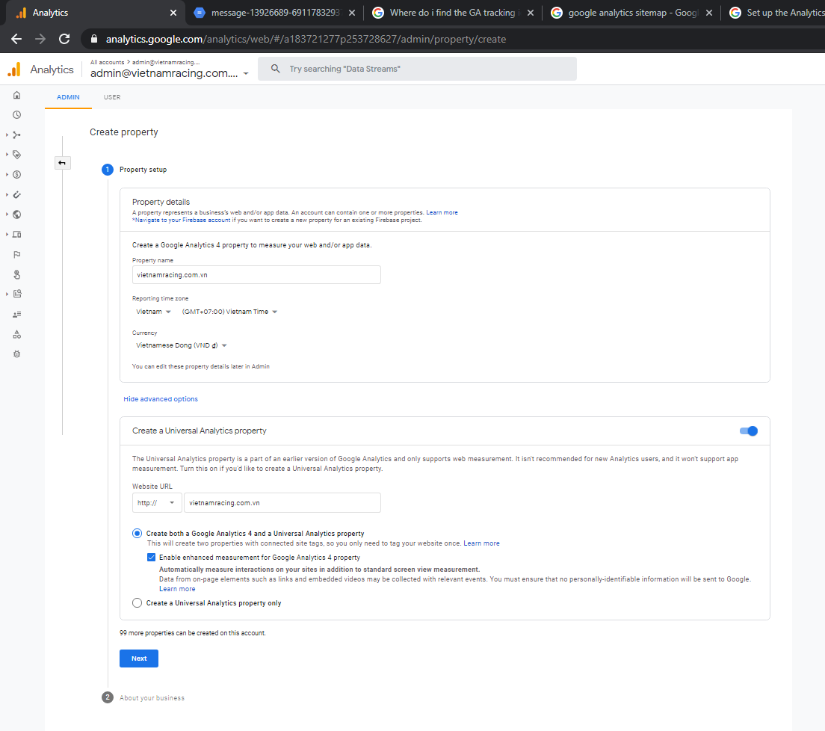

Check all and click Create

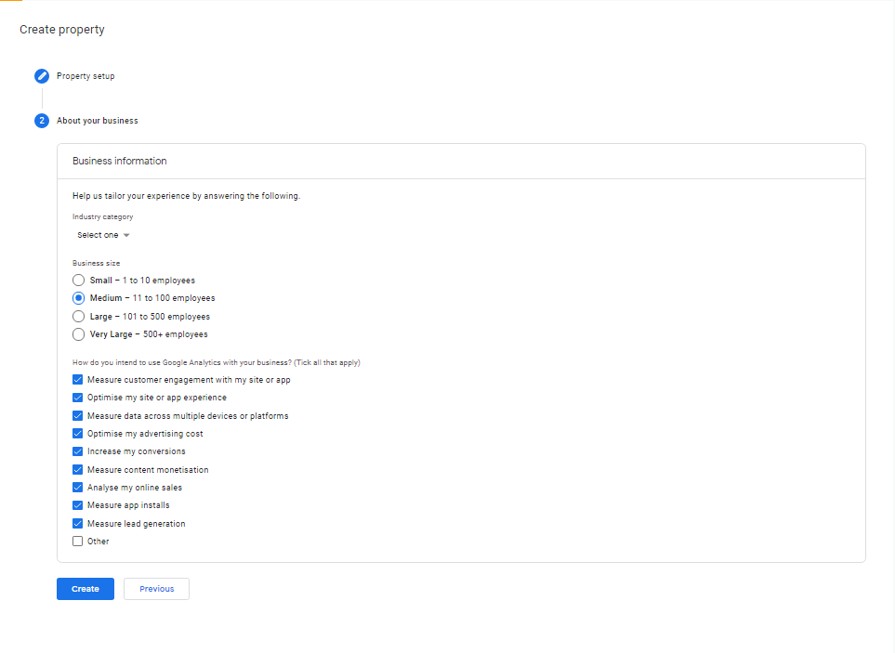

Copy Golbal Site Tag (gtag.js)

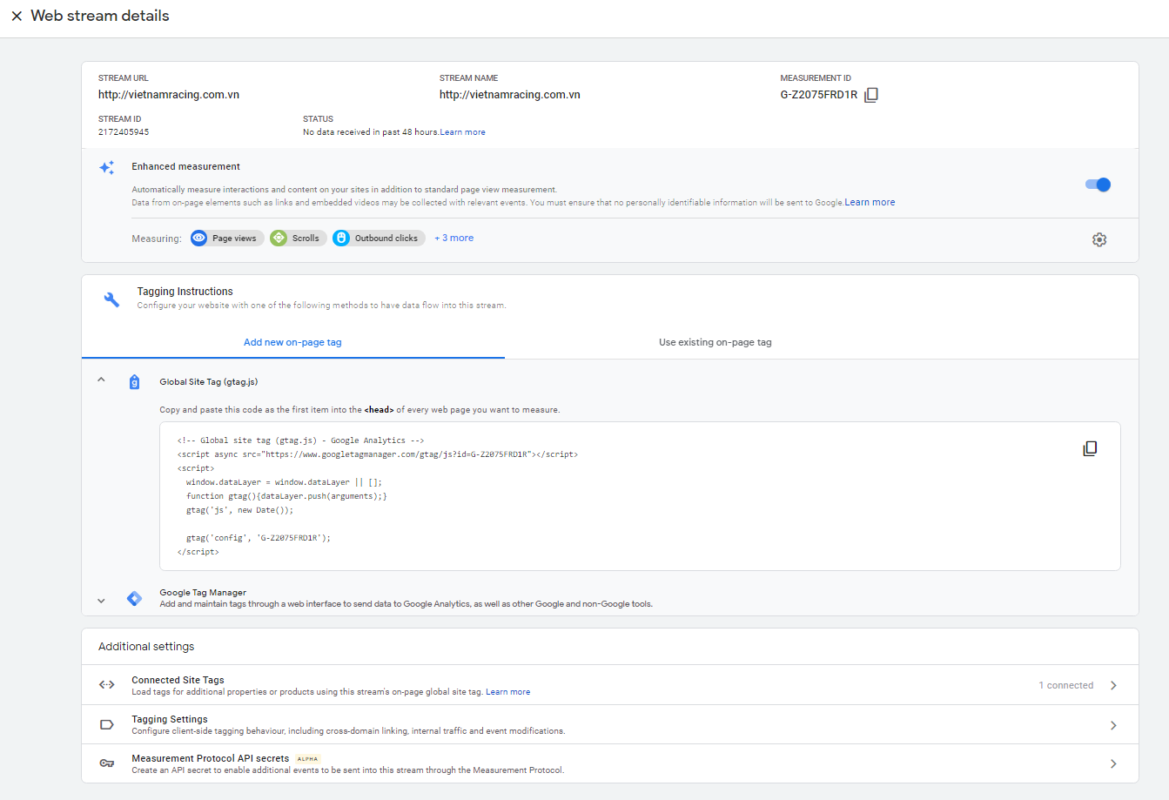

Click home and select property to view analytics data

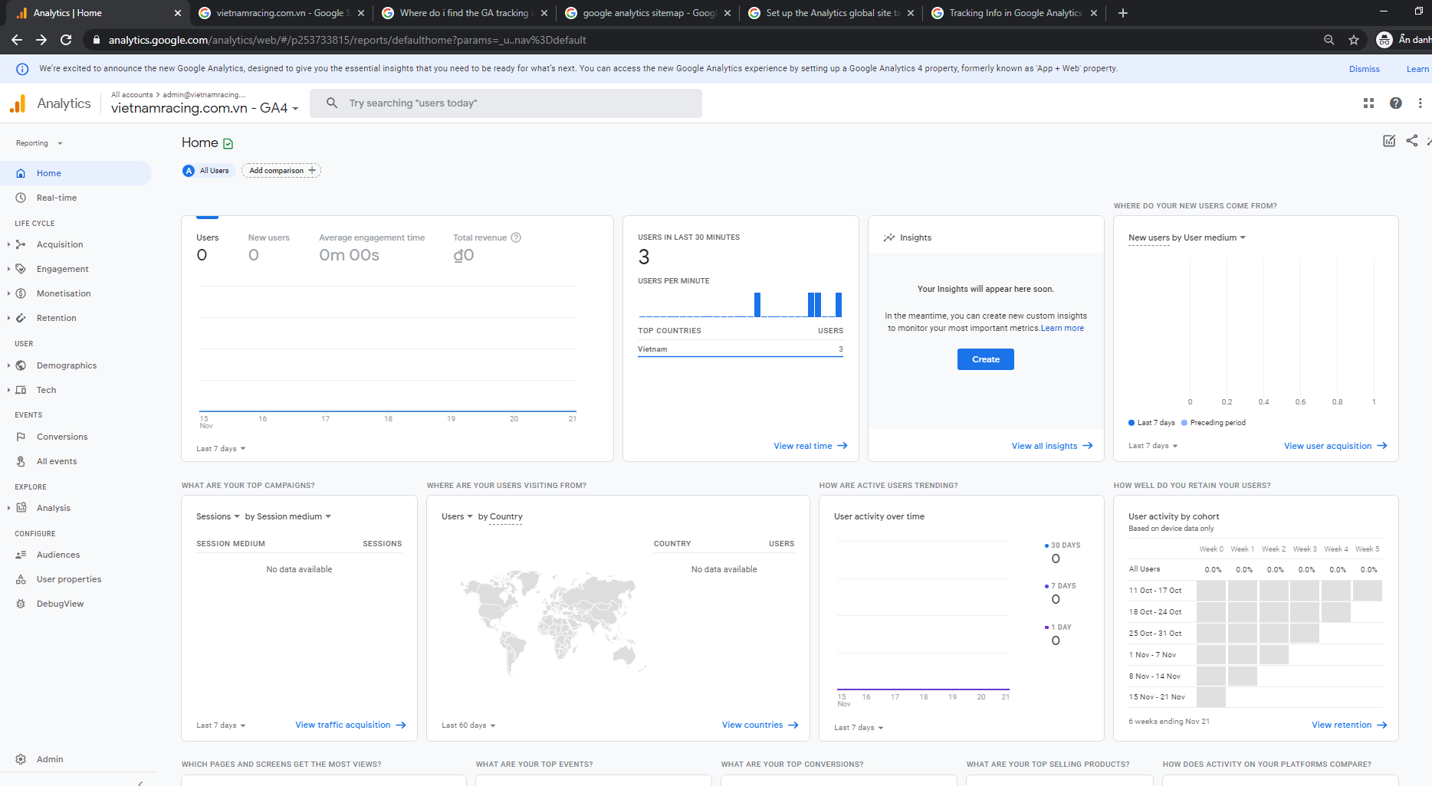

Click View real time

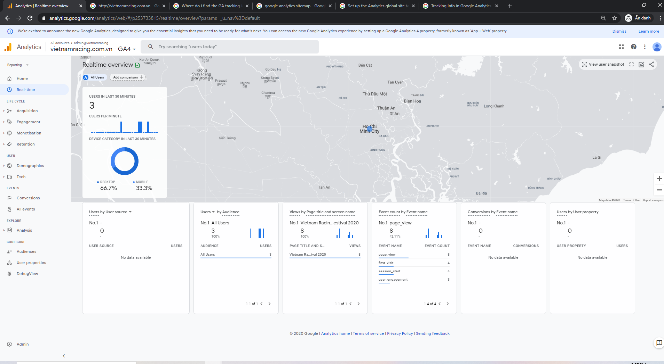

Data after one date:

