**26.04.2022 Kosovo PTACC Orientation**

**Program Overview**

Instructors give lectures and do code reviews (1 on 1 with ANY instructor, not always our own).

Our instructor is one of the following names: Robert Ponce, Andrew Lederman, Corey McKeel (for the Web Fundamentials phase only).

TAs (Teacher Assistants): answer our questions during office hours (or on Discord)

Student support manager: support system throughout program (Deja Donaldson for us)



Fellow cohort-mates: Discord

**Bootcamp Progression**

**Throughout each phase of the program, you must complete at least 80% of discussions and 90% of core assignments.**

Web Fundamentals (4 WEEKS): HTML, CSS, JS with one of the 3 instructors above

**BELT EXAM:** 24 hours to complete. At least Yellow Belt needed to continue onto the next phase. Exam can be taken from end of week 2 if you feel confident. Retakes are encouraged, although a maximum of 3 attempts is allowed to pass.

Python Stack (8 WEEKS): new instructor

**BELT EXAM:** At least Orange Belt needed to continue onto the next phase.

Projects and Algos (2 WEEKS EACH = 4 WEEKS TOTAL): at least **two projects** (1 every 2 weeks) needed for graduation of the entire program, all while we also have to complete our weekly assignments and discussions. We will have to present one solo project idea to our instructor and then start working on it while we also get reviews from our instructor. After the first project is finished, we will work on another project with fellow cohort-mates. We can put these two projects on Github as part of our portfolios. This phase of learning Algorithms will be especially helpful as preparation for job interviews.

Web Fundamentals schedule example:

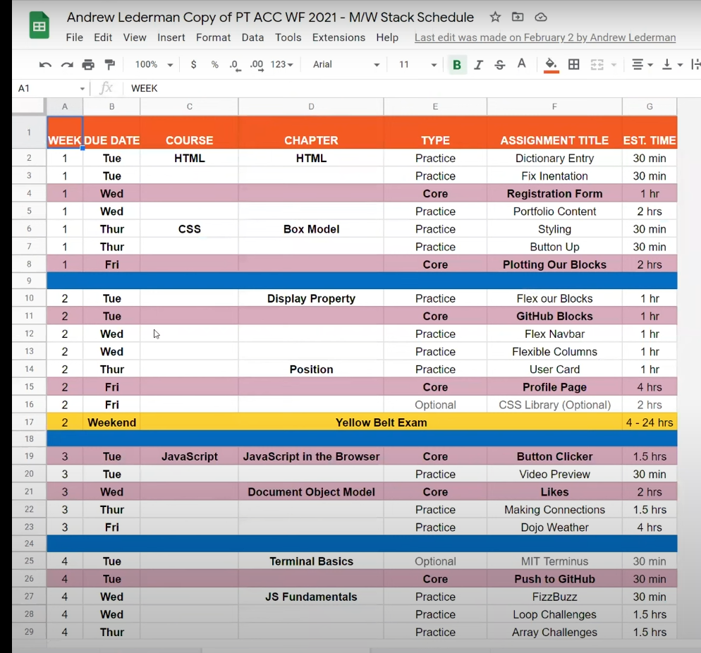

And a daily example:

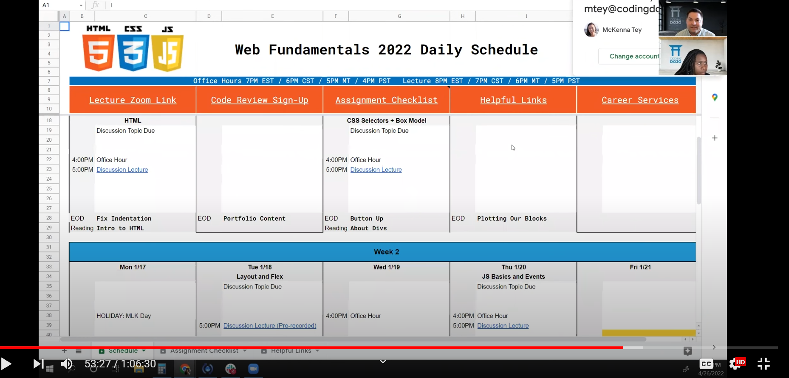

**Lectures and homework:**

Office Hours:

TUESDAY 1AM and THURSDAY 1AM | at ZOOM link of lecture | 1h max | Sometimes recorded

We can discuss assignments, optional stuff etc. w/ other students, instructors, cohorts etc.

Except for office hours, we can always just ask our instructors and TAs questions on Discord.

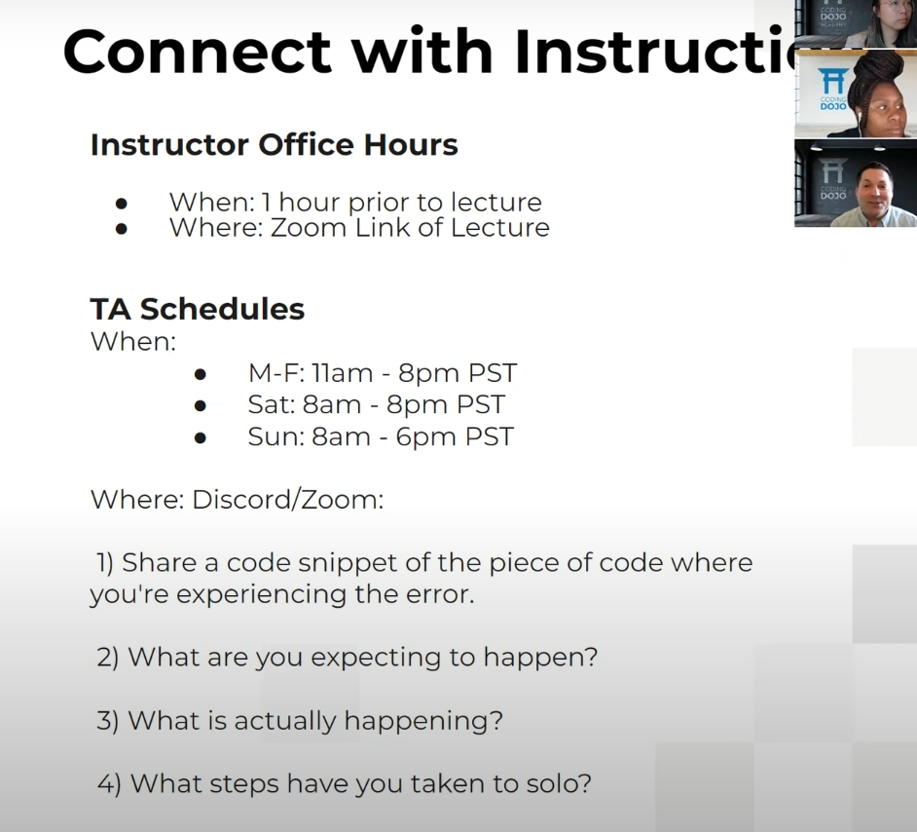

Lectures:

THURSDAY **2AM** and THURSDAY 2AM | at ZOOM link of lecture | 1h to 1h30min | Always recorded

We will also be provided with a calendar (excel spreadsheet) with all lecture links and some office hours.

Additionally, all lectures will be on a YOUTUBE playlist (unlisted).

Previous lectures will also be available, in case you want to work ahead.

Assignments and discussions:

Assignments and discussions are posted every Monday (PT) and are on Sundays (PT).

Discussions usually contian 2 questions per week, while assignments can range from 6 to 7 or so.

Assignments are divided in three groups: core, optional, practice.

CORE ASSIGNMENTS are mandatory for graduation. 90% of the core assignments must be finished within the dead- line every week. If we’re not sure how many assignments are needed to complete the 90% quota, we must ask the student support.

Everything is located in the WEB FUNDAMENTALS (2022) PART-TIME ONLINE section of [learn.codingdojo.com](https://learn.codingdojo.com/dashboard):

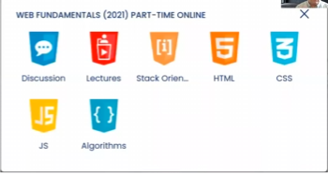

Discussions will look like this:

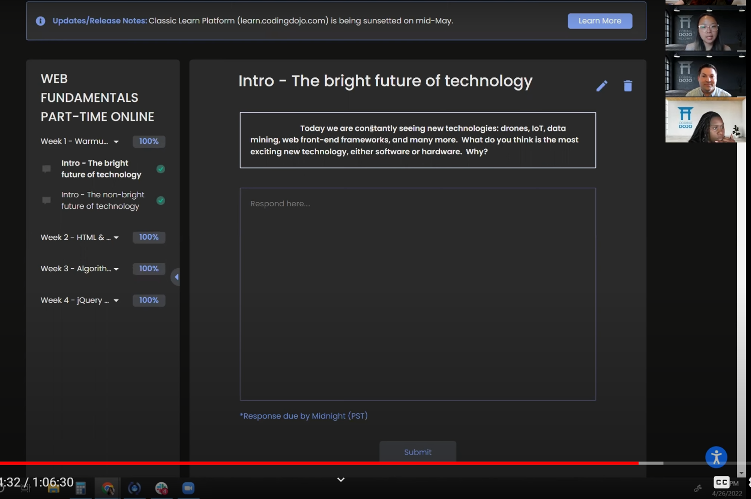

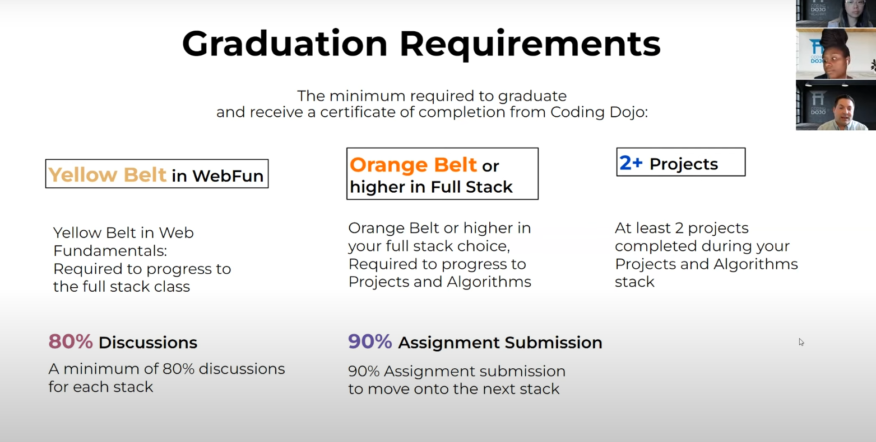

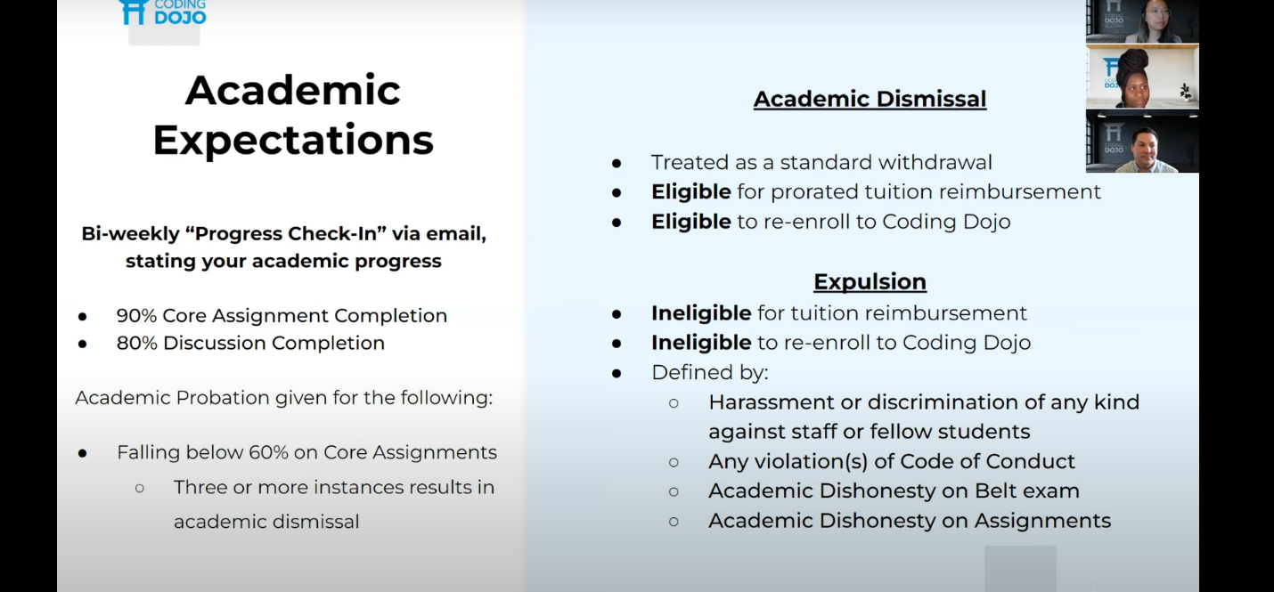

**ACADEMIC DISHONESTY** is considered copying and pasting code from the solution videos, from Github, from the internet etc.

We must make a schedule for ourselves during the bootcamp so we finish everything on time. Example:

