Jessica Trinh

May 19th, 2020

IT FDN 100 A

Assignment 06

<https://github.com/trinh-j/IntroToProg-Python-Mod06>

## Building a Program with Functions and Classes

## Introduction ------------------------------------------------------------------------------

In this assignment, we will be building on a starter script provided by Professor Randal Root. From it, we will “fill in the blanks” to write a program that allows the user to choose from a menu of options that will allow them to input, save, display, and/or reload data. While this assignment is set up as an exercise for students to learn how to work with another developer’s code, it also challenges students to apply newly acquired knowledge of python classes and functions from Module 06. Classes and functions can be intimidating, but hopefully we will gain a better understanding as we go through the assignment

## Basics --------------------------------------------------------------------------------------

A **function** is an object that groups variables and statements. A function is initialized by *def* for “define”, followed by a function name of your choosing. Here is an example of a simple function, *minus*, that takes in two parameters, number1 and number2, with default assignments of 0, and returns the difference of the two numbers.

**def** minus(number1=0, number2=0):  
 **return** number1 - number2

In order for this function to work, we have to call out to it. Below, we have two input functions defined after the *minus* function was created (above); this allows the end-user to provide an input that would be used as arguments in the function callout at the very bottom.

number1 = float(input(“Enter your first number: ” )  
number2 = float(input(“Enter your second number: ” )

minus(number1, number2)

Say, what if the user just wants to specify the values upon function callout? Then the arguments they provide would be considered *positional* arguments. Below, since 3 is in place of parameter “number1” and 4 in place of “number2”, the output would be -1 since the function defines their operation in its body as “number1 – number2.”

minus(3,4)

A remedy for having more control over the arguments is to simply assign their parameter names. The output of the following example is (positive) 1.

minus(number2 = 3, number1 = 4)

A **class** is an object that groups together functions. A class is initialized with *class* and the class name is often in snake-casing. In programming, classes are useful because they can be reused in different parts of the program once defined and can even be imported into another program if saved. The body of a class contains functions; but here, the functions are called “class methods.”

Below is an example class *math* with class methods *minus* and *plus*.

**class** math:  
 **def** plus(number1=0, number2=0):  
 **return** number1 + number2

@staticmethod

**def** minus(number1=0, number2=0):  
 **return** number1 - number2

Like functions, classes have to be called out to be used. There are two ways of doing this;

1. make a copy of the class, reassign it to a variable, and call out the function;
2. use a decorator (@staticmethod from second class method in *math* class)—calls out directly to the method

math.minus(3,4)

## Writing the Script -----------------------------------------------------------------------

Since we are given a starter script, there is not much to do with regards to creating the script header and defining variables in the data section. The most we would have to do with the script header is update the change log as necessary.

Here comes the hard part. The sections that we are to build on are Processing, Presentation, and Main Body of Script. Here is an overview of each section we are building on:

**Processing** section holds all the code that is needed to execute data-entry/appending, data-removal, reading, and writing data; all functions associated with processing is grouped into a *Processor* class.

The **Presentation** section is all the code that displays data to the end-user, and generally requires feedback from the user. All functions associated with user input/output is grouped into the *IO* class

**Main Body of Script** is the last section in which everything is pieced together. The body of the while loop in this section is mostly composed of class-method callouts.

*Disclaimer:* Though the following demonstration may seem linear, as I am presenting from the beginning to end of my script, the process of building this program was far from it; I had to build one method, check and troubleshoot it in the main body, fix another secondary class-method, go to the main body to troubleshoot again, etc.

# Processing

(See Figure 1 for all references made to the script in this section)

As mentioned earlier, this section is one class composed of four functions or class-methods—*read_data_from_file, add_data_to_list, remove_data_from_list,* and *write_data_to_file*. Each of these class-methods is responsible for processing the data. More specifically, the first class-method reads data from a text file and reformats each row to a dictionary, which is then appended to an empty list. The second class-method reformats the user-input into a dictionary then appends it to the existing (previously empty) list. The third removes a task by iterating through the list until the user’s input (in lowercase) matches a task in the list (in lowercase), and removes the matched row. And finally, the last class-method opens, writes data to the text file, and then closes the file, should the end-user want to save any data entered through the program.

On the same line of class initiation, each class requires parameters, for which an associated argument is needed upon callout to make the class-method work. Also, above each class method is a decorator @staticmethod. This will make the function within the class more accessible by allowing the program to directly call it out when it is used later in the script.

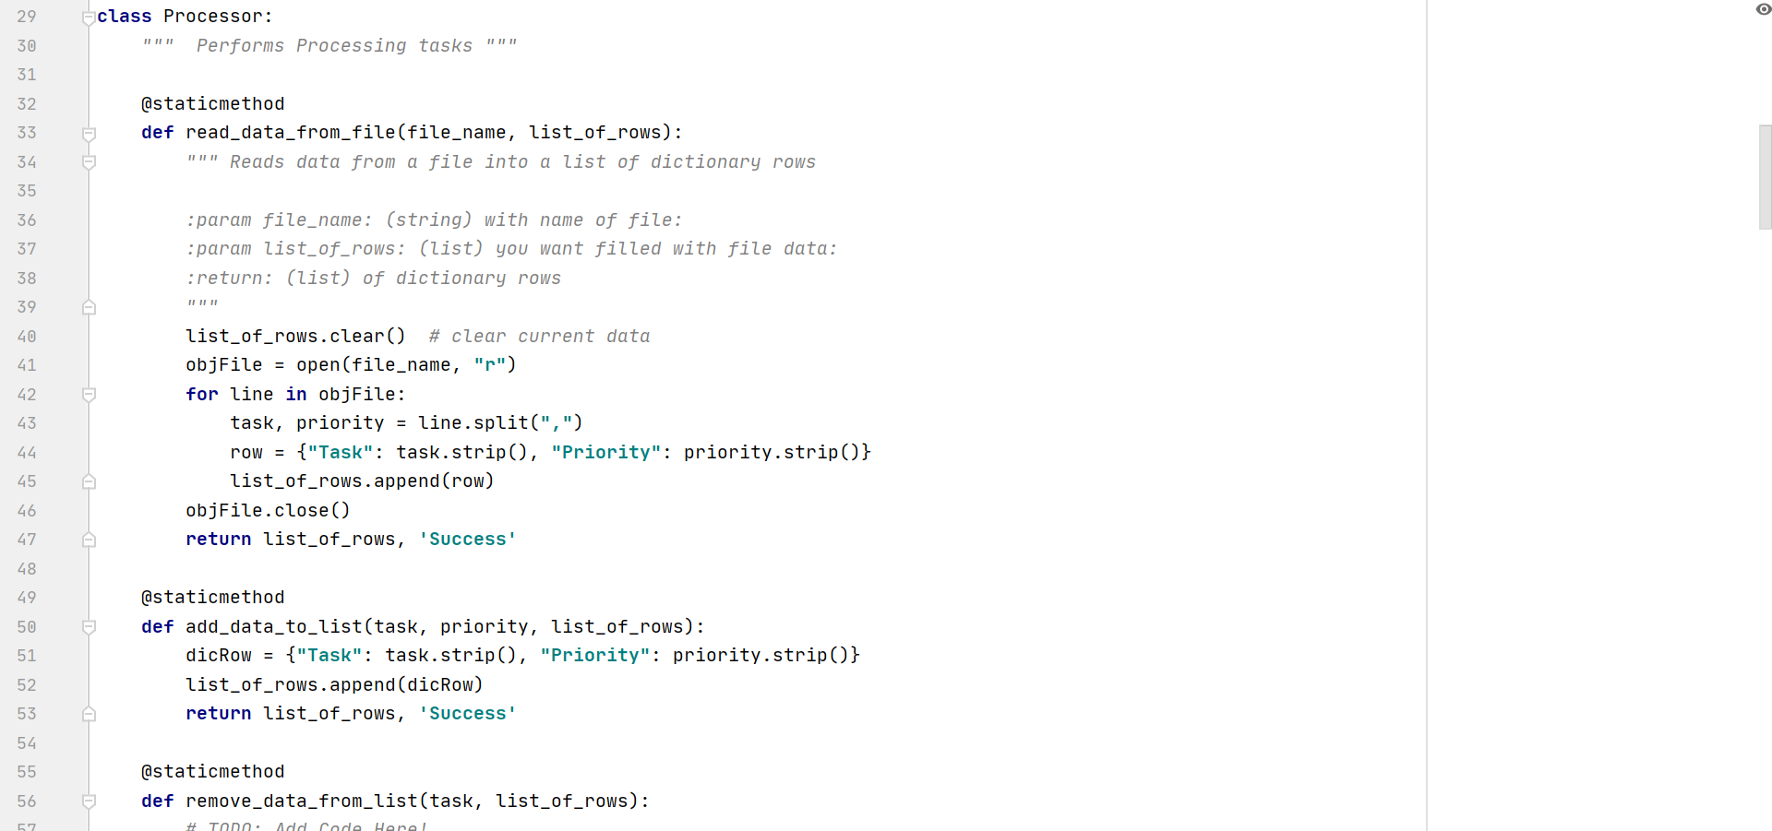 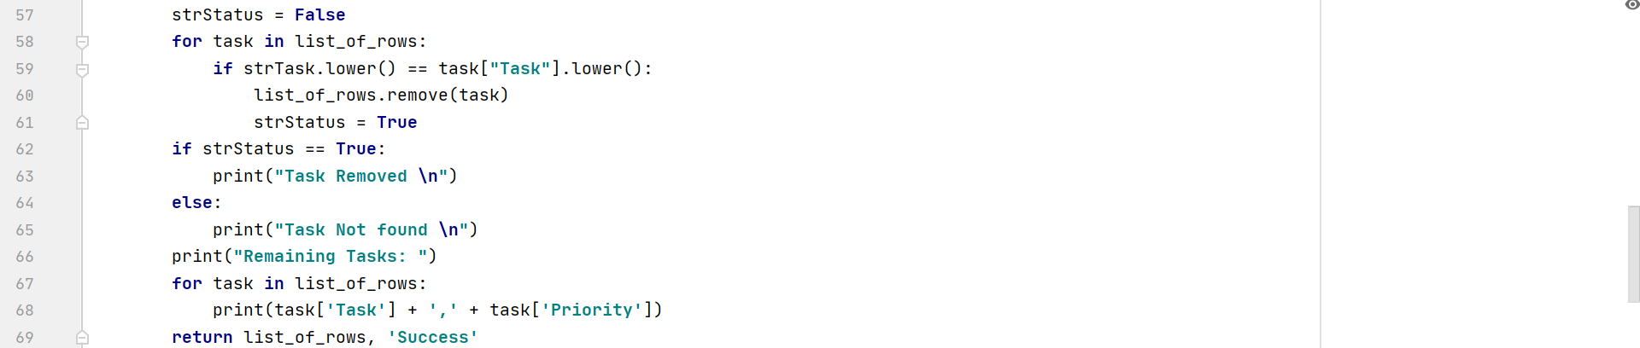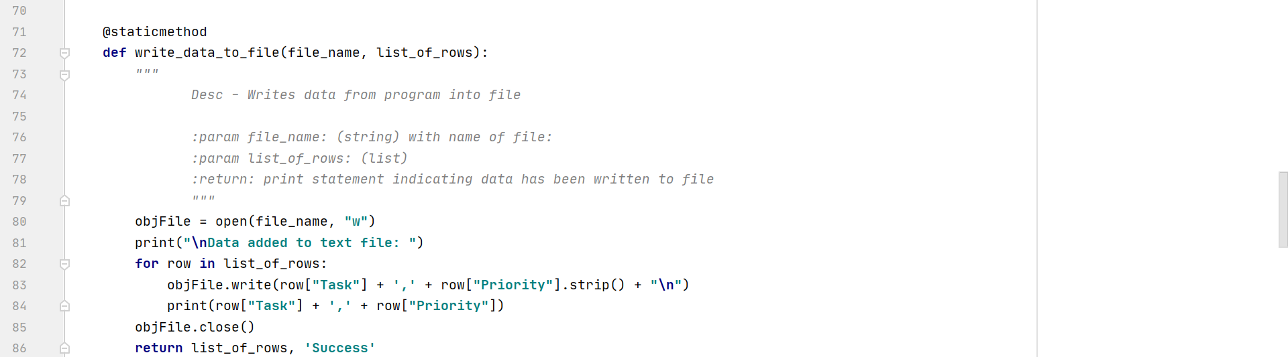

**Figure 1. Processing Section of Assignment06.py script.**

# Presentation

(See Figure 2 for all references made to the script in this section, unless noted otherwise.)

This section is also entirely made up of one class, *IO* (for Input Output), which is made of 7 functions. Similar to class *Processor* in the Processing section (Figure 1), each class-method has a decorator above it to make class-method callout easier later in the script. In this section, we see all functions associated with displaying data to the user. For example, in lines 92-105 (Figure 2), we see the Menu of Options being defined as a function, *print_menu­­­_Tasks()*. Since this function is just a simple print function, it needs no parameters/arguments. However, as we have seen before with the functions in the processing section, the parameters vary with each function, and is defined by the developer. In this starter script, Professor root pre-defined the parameter and function names.

Something not seen until this section is the use of the *global* function (lines 150 -151, Figure 2). Initially, strTask and strPriority were defined as an empty string in the Data section of the script. However, when using it within a class-method, I was not able to access the associated end-user inputs. After reprocessing strTask and strPriority as global variables within my class method, I was able to access/return the values and use them in another class-method.

Working with each class-method can be daunting, especially if there is a class-method that relies on another class method. Again, there was a lot of back-and-forth coding/troubleshooting that was required for me to get the program to work as it does now.

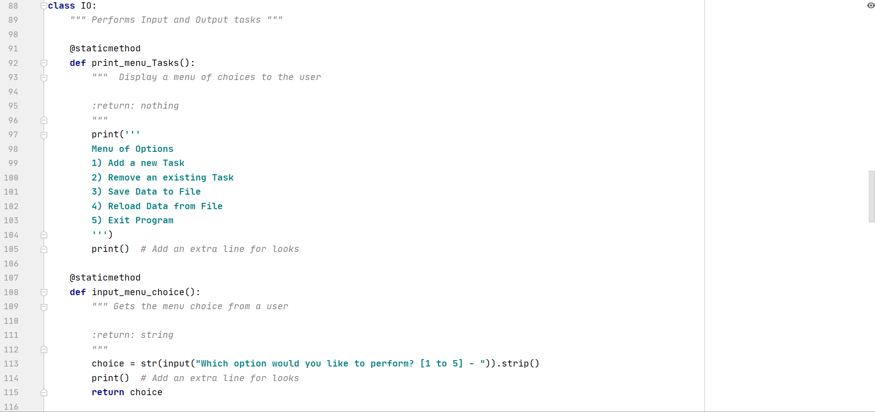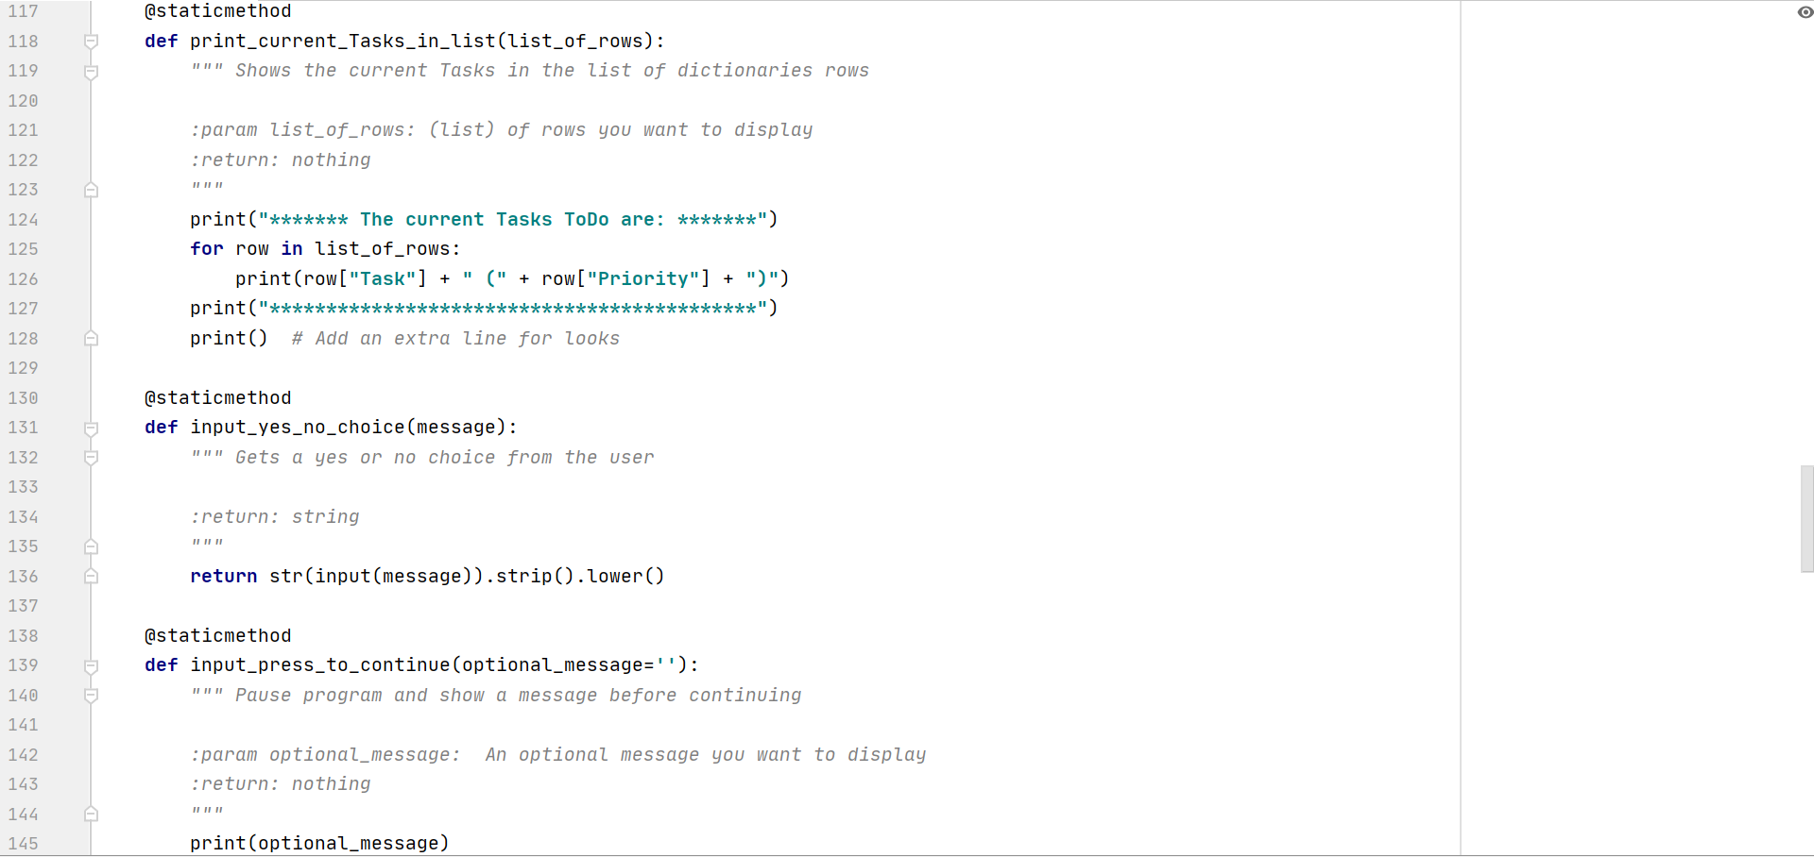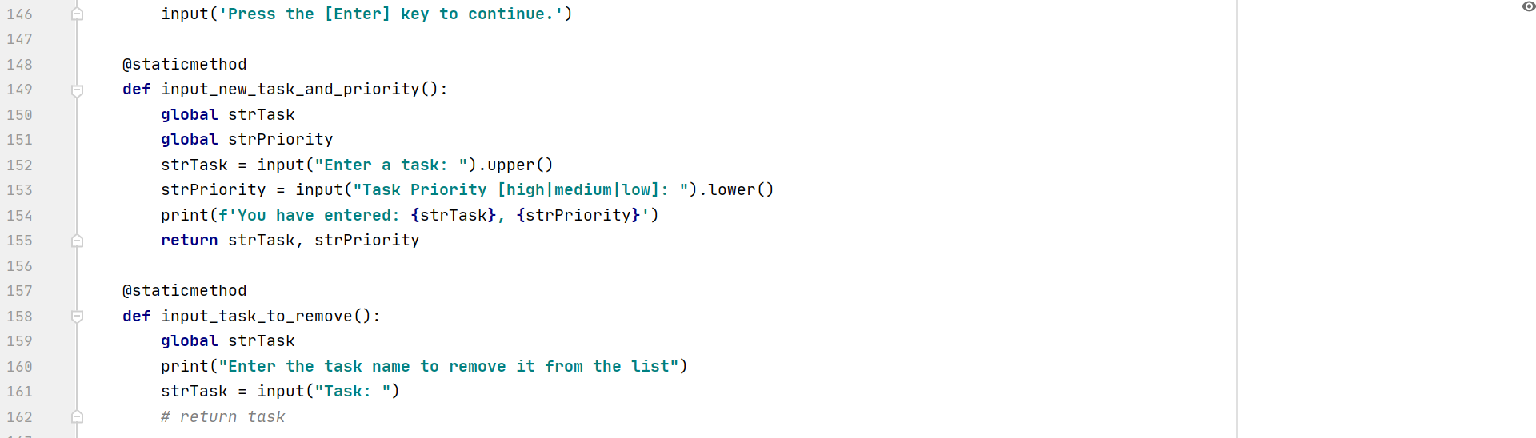

**Figure 2. Presentation Section of Assignment06.py script. Class IO with 7 input-output-associated class-methods in the body.**

# Main Body of Script

(See Figure 3 for all references made to the script in this section, unless noted otherwise.)

Finally, the Main Body. In this section, we piece together a program using mostly class-methods previously defined in the Processing (Figure 1) and the Presentation (Figure 2) sections of the script. Since we “prefaced” each class-method with a decorator, we can call out to it in the form *class.class-method(arguments).*

The main body (Figure 3) uses a while-loop to filter through different menu options based on end-user input.

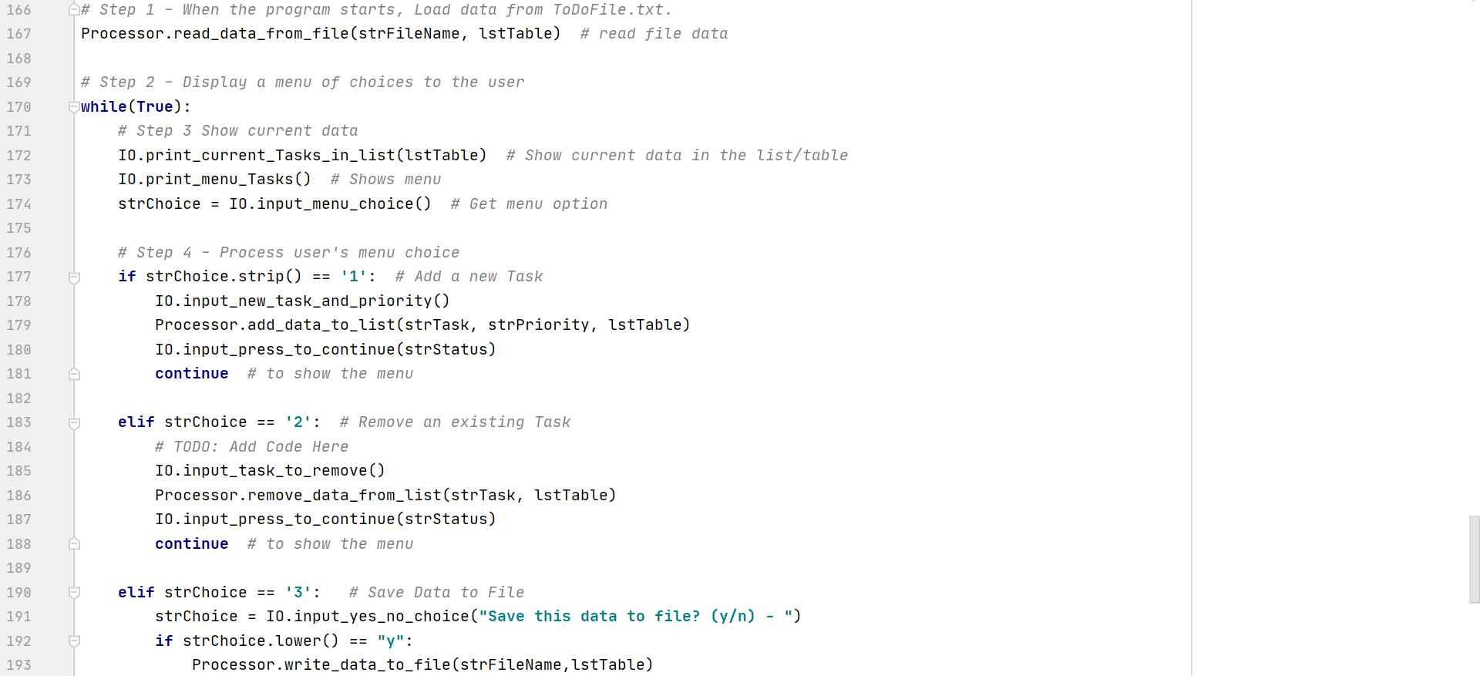 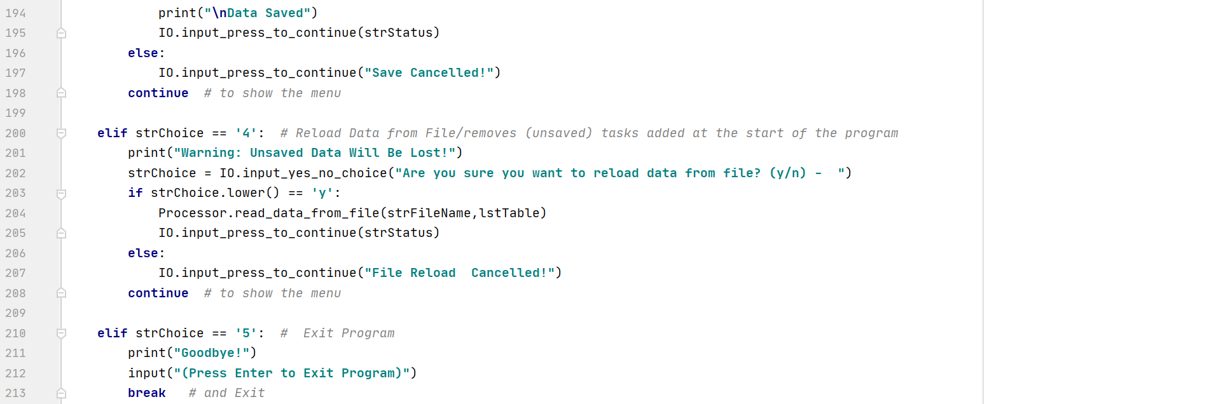

**Figure 3. Main Body of Script Section of Assignment06.py. The body of each if-elif section using class-method callouts.**

# Output

Working with the script in the PyCharm IDE, I knew that my program worked. To double check program functionality, I access my script through the command line, which immediately displayed the current tasks in the text file, and a menu of options that the end-user is prompted to choose from (Figure 4).

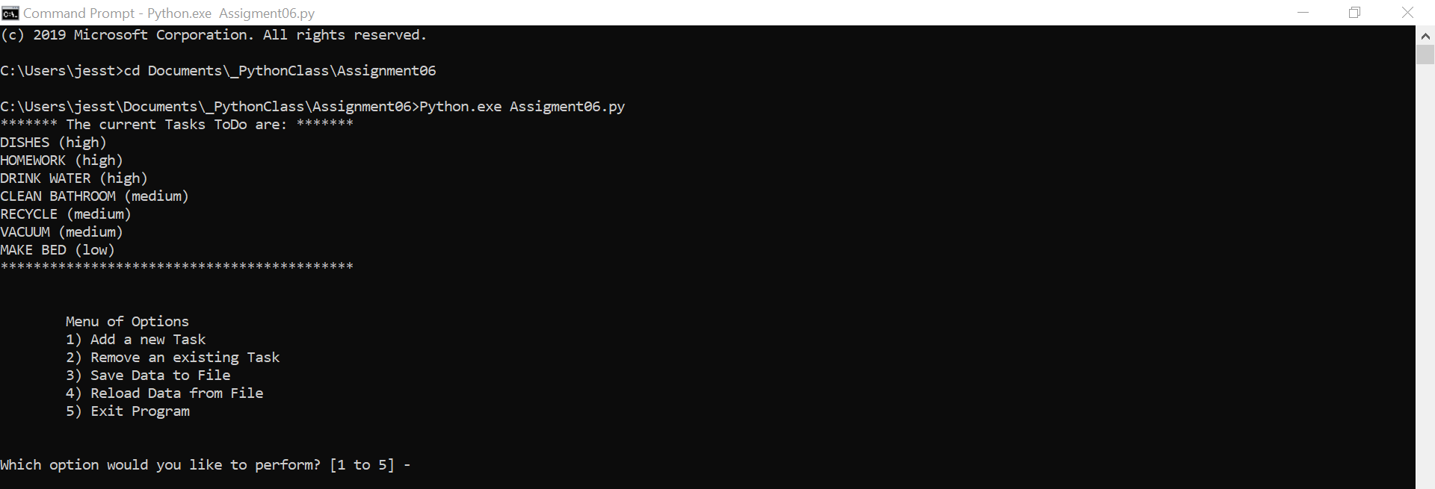

**Figure 4. Program started from the command line.**

After choosing each option, the most updated data is displayed to the user (Figure 5). (unfortunately, the formatting of these images aren’t aligned but the following 5 images belong to a single figure-Figure 5).

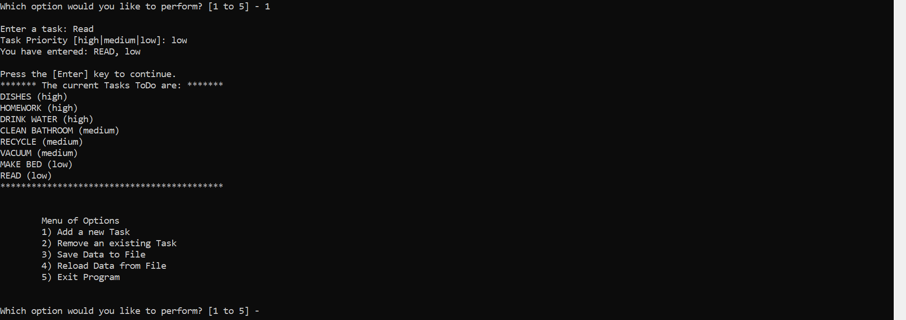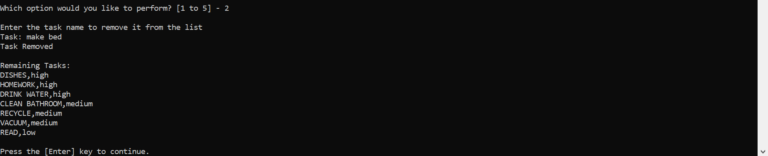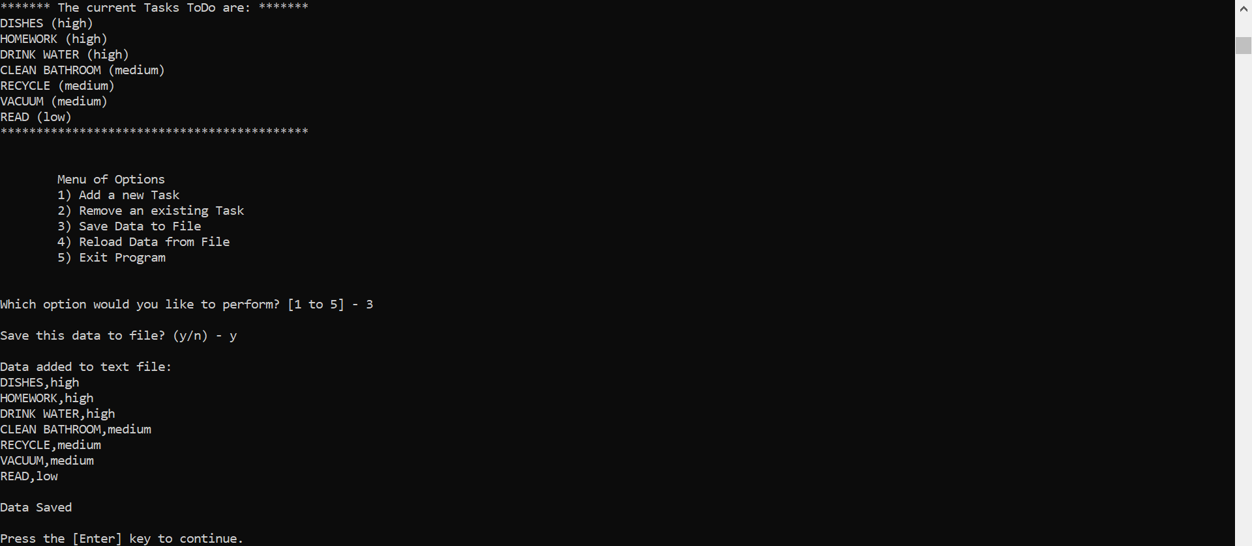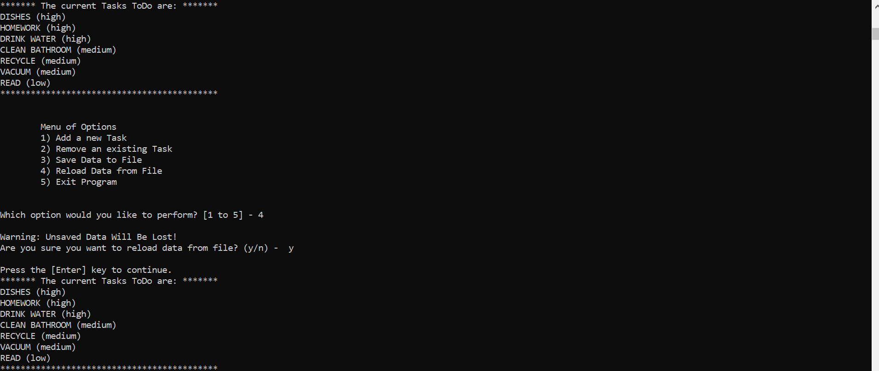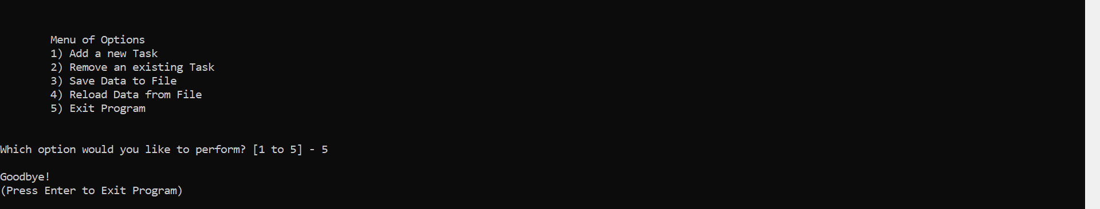

**Figure 5. Program in command line with all outputs for each menu option.**

To make sure our data is saved to the text file, we can navigate to the appropriate directory using the file explorer. Here (Figure 6), you can see that the file explorer contains the text file, and in the preview section to the right, the list has contains the updated list resulting from the execution in the command line above (Figure 5).

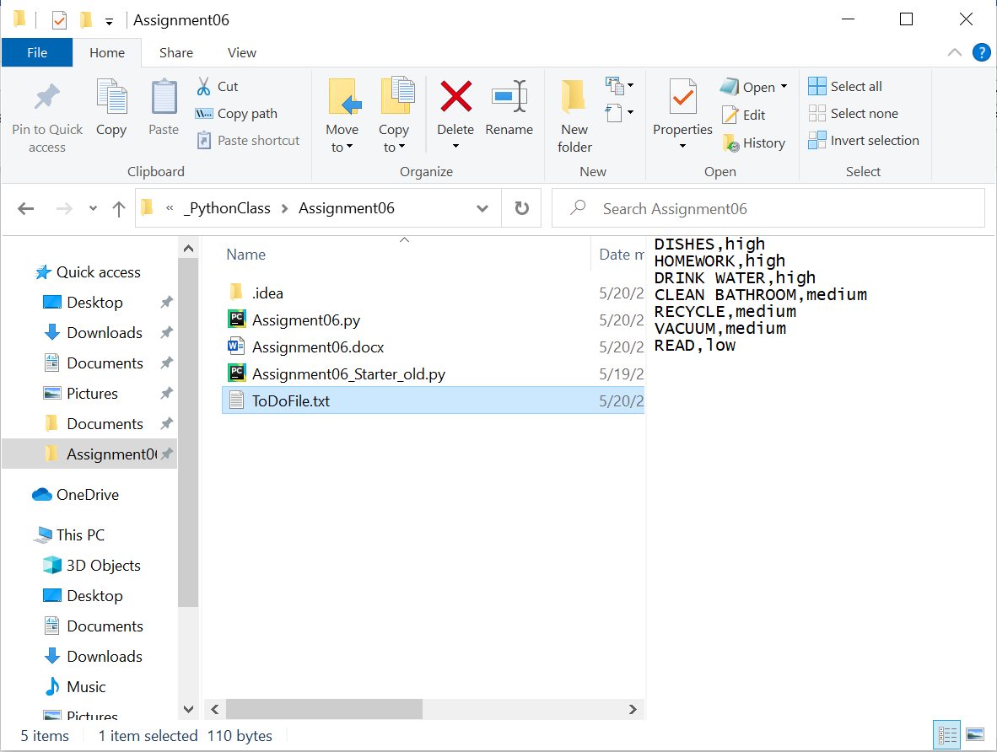

**Figure 6. Use File Explorer to navigate to project directory; ToDoFile.txt found with updated list in preview panel.**

If you don’t have a preview panel, you can set it up by going to the View tab, and selecting “Preview Pane.” Otherwise you can open the text file to see any changes made.

# Summary/Discussion

In this assignment, we learned how to use classes and functions to organize a program. This was definitely a tough assignment, as I spent quite a while just reading through the script to try to figure it out. Still, after understanding what the program was trying to do and starting to add some code, I quickly found myself scrolling back and forth to understand the order of code being processed, and mitigating frequently arising issues by commenting out specific lines of code. For data removal, in the previous assignment, I had trouble displaying the correct statement to the user; if data was removed, “Task not found” would sometimes be printed instead of “Task removed.” For this assignment, I reviewed the answer key to Assignment05 and found that to do what I want it to do—print “removed” for data removal and “not found” if data isn’t in the list—I had to use a Boolean statement with my if-conditional statement. I incorporated this into my latest code. A concept I’ve yet to fully understand is the reassignment of a local variable as a global variable. Though this project was challenging, I enjoyed solving it.