[](https://www.ntu.edu.sg/)

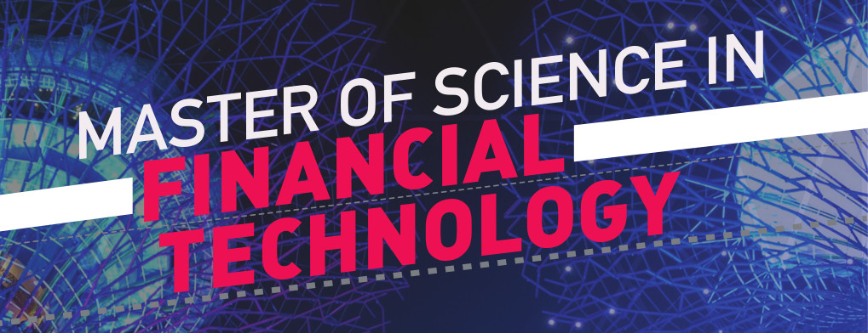

**Financial Technology (FinTech)** refers to a cluster of emerging innovations that have the potential to revolutionize the nature of the finance industry, enhancing the productivity of financial firms by employing data science and cyber technologies. Global investment in FinTech has been so active in recent years that the Monetary Authority of Singapore has launched an in​itiative, the FinTech and Innovation Group, and pledged to spend S$225 million over the next five years to develop the FinTech sector in Singapore.

Nanyang Technological University, Singapore (NTU Singapore) offers a Master of Science in FinTech (MSc in FinTech) hosted by the School of Physical and Mathematical Sciences. The curriculum is built upon data science, artificial intelligence, and information technology to provide students with the FinTech skills necessary for navigating the changing landscape of the finance industry. Strong emphasis is placed on the in-depth mastery of disruptive technologies in finance, including financial automation (e.g. robo-advisors) and financial cryptography (e.g. blockchain technology).

[Click here for the MSc in FinTech programme brochure!](https://ebook.ntu.edu.sg/20191025-msc-in-financial-technology-brochure.html" \t "_blank)

* [Programme & Curriculum Structure](https://spms.ntu.edu.sg/MathematicalSciences/MSc-Degrees/Pages/MSc-in-Fintech.aspx#programme)
  + [Compulsory Courses](https://spms.ntu.edu.sg/MathematicalSciences/MSc-Degrees/Pages/MSc-in-Fintech.aspx#compulsory-courses)
  + [Elective Courses](https://spms.ntu.edu.sg/MathematicalSciences/MSc-Degrees/Pages/MSc-in-Fintech.aspx#electives)
* [Academic Timeline](https://spms.ntu.edu.sg/MathematicalSciences/MSc-Degrees/Pages/MSc-in-Fintech.aspx#timeline)
* [General Admission Criteria](https://spms.ntu.edu.sg/MathematicalSciences/MSc-Degrees/Pages/MSc-in-Fintech.aspx#admission)
* [Programme Fees](https://spms.ntu.edu.sg/MathematicalSciences/MSc-Degrees/Pages/MSc-in-Fintech.aspx#fees)
* [Contact Us](https://spms.ntu.edu.sg/MathematicalSciences/MSc-Degrees/Pages/MSc-in-Fintech.aspx#contact)

**Programme & Curriculum Structure**

The MSc in FinTech Programme is an intensive **1-year full-time or 2-year part-time** programme by coursework taught in 3 trimesters per year. The curriculum consists of two tracks: *Artificial Intelligence* and *Operations and Compliance*. ​​The courses in the MSc in FinTech programme are delivered in intensive periods of 7 weeks. In other words, each trimester is split into two halves. All courses are conducted at **NTU (main campus)** in the evenings of weekdays or Saturdays.

The programme consists a total of **33 Academic Units (AUs)**, with 21 AUs of compulsory modules, 6 AUs from the chosen track's electives, and 6 AUs from other electives:

|  |  |
| --- | --- |
| Compulsory courses | 21 AUs |
| Prescribed Electives of the chosen track | 6 AUs |
| Unrestricted Electives | 6 AUs |
| **Total graduation requirements** | **33 AUs** |

The requirements for graduation are as follow:

1. ​​Successful completion of all requirements as prescribed by the programme of study; and
2. A minimum CGPA of 2.50 is attained at the completion of the programme of study.​

**Compulsory Courses**

MH8801 Introduction to ​FinTech (1.5AU)

MH8802 FinTech Ecosystem and Innovations (1.5AU)

MH8803 Principles of Finance and Risk Management (1.5AU)

MH8131 Probability and Statistics (1.5AU)

MH6151 Data Mining (3AU)

MH8804 Quantitative Methods in Finance (1.5AU)

MH8805 Algorithmic Trading and Robo-Advisors (1.5AU)

MH6808 Blockchain Systems and Applications (3AU)

MH6809 Practicum (6AU)

**Artificial Intelligence Prescribed Elective Courses**

MH8101 Operations Research I (1.5AU)

MH8811 Python Programming (1.5AU)

MH6812 Advanced Natural Language Processing with Deep Learning (3 AU)

**Operations and Compliance Prescribed Elective Courses**

MH8822 Regulatory Technology (1.5AU)

MH8821 Anti-Financial Crime and Compliance (1.5AU)

MH8331 Financial and Risk Analytics I (1.5AU)

MH8332 Financial and Risk Analytics II (1.5AU)

**Unrestricted Elective Courses**

MH8102 Operations Research II (1.5AU)

MH8141 Time Series Analysis (1.5AU)

MH8341 Data Management and Business Intelligence (1.5AU)

MH6301 Information Retrieval and Analysis (3AU)

MH8831 Applied Cryptography

Note: Prescribed Elective courses of one track could be Unrestricted Elective courses of another track. On average, full-time students take **4-5** classes a week and part-time students take **2-3** classes a week.

**Academic Timeline**

|  |  |  |
| --- | --- | --- |
| Trimester 1 (Indicative) | 1st Half | 20 July 2020 to 6 September 2020 (7 weeks) |
| 2nd Half | 7 September 2020 to 25 October 2020 (7 weeks)  *Recess: 26 October 2020 to 1 November 2020 (1 week)* |
| Trimester 2 (Indicative) | 1st Half | 2 November 2020 to 20 December 2020 (7 weeks)  *Recess: 21 December 2020 to 3 January 2021 (2 weeks)* |
| 2nd Half | 4 January 2021 to 21 February 2021 (7 weeks)  *Recess: 22 February 2021 to 28 February 2021 (1 week)* |
| Trimester 3 (Indicative) | 1st Half | 1 March 2021 to 18 April 2021 (7 weeks) |
| 2nd Half | 19 April 2021 to 30 May 2021 (6 weeks)  *Recess: 31 May 2021 to 19 July 2021 (7 weeks)* |

**General Admission Criteria**

1. **A good Bachelor's Degree** in a relevant programme, e.g. quantitative majors, business, etc.
2. **A good TOEFL score** (iBT = 92 or more, PBT = 580 or more, CBT = 235 or more) or **IELTS score** (6.5 or more) for graduates of universities in which English is not the medium of instruction.
3. A good GRE or GMAT score is preferred (Graduates from autonomous universities in Singapore are exempted).
4. A minimum of two years of relevant working experience is preferred.

Applicants can send their GMAT and GRE score to us with the following program code:

| **Program** | **Program Code** |
| --- | --- |
| School of Physical and Mathematical Sciences, Part Time (GMAT) | V24-97-23 |
| School of Physical and Mathematical Sciences, Full Time (GMAT)​ | V24-97-63 |
| School of Physical and Mathematical Sciences (GRE) | 4434 |

**H​ow to Apply**

| **Admission Stage** | **Action** | **Date / Deadline** |
| --- | --- | --- |
| **Application** | Please​ check out [How to apply](http://admissions.ntu.edu.sg/graduate/coursework/HowDoIApply/Pages/ApplyOnline.aspx) for electronic application; [Direct link to the online a​pplication​](https://wis.ntu.edu.sg/webexe/owa/coal_main.notice) | 1 Nov 2019 to 31 Jan 2020 |
| **Offer and Acceptance** | Offer (Accept and pay the deposit in two weeks) | March 2020 |
| ​ | ​Online Appeal (via email to [MScFinTech@ntu.edu.sg​](mailto:MScFinTech@ntu.edu.sg)) | ​Apr 2020 |
| **After Acceptance** | Matriculation | Jul 2020 |
| ​ | ​Welcome Ceremony | ​TBC |
|  | Course Commencement | 20 July 2020 |

**Medical Check-up**

Enrolling students must go to the Medical Centre to do the medical check-up and obtain a receipt certifying that they are medically fit for studies. The medical examination clearance certification must be presented prior to matriculation.

**Programme Fees**

**AY2019/2020**

|  |  |
| --- | --- |
| **Singapore Citizens** | S$35,000 |
| **Singapore Permanent Residents** | S$45,000 |
| **International Students** | S$55,000 |

All fees are inclusive of GST.

**Payment Schedule (full-time students)**

|  |  |  |  |  |
| --- | --- | --- | --- | --- |
|  | **Deposit Upon Acceptance of Offer** | **Trimester 1** | **Trimester 2** | **Trimester 3** |
| **Singapore Citizens** | S$5,000 | S$6,667 | S$11,667 | S$11,666 |
| **Singapore Permanent Residents** | S$5,000 | S$10,000 | S$15,000 | S$15,000 |
| **International Students** | S$5,000 | S$13,333 | S$18,333 | S$18,334 |

S$5,000 is **non-refundable** upon acceptance of offer, and will offset the first installment.

The MSFT programme is totally self-financed through fees collected. Service obligation option would not be extended to international students.

Note:

* Successful international applicants must show proof of having sufficient funds for the normal duration of the MSc in FinTech programme, after accepting the admission offer. Currently, the calculation of the required amount is based on S$18,000 per year for living expenses, in addition to the tuition and miscellaneous student fees.
* Fees must be paid in full before the start of the Trimester.
* Part-time students pay their fees over 6 trimesters.

**Financial Assistance**

The **Financial Specialist Scholarship (FSS)** is offered by the Institute of Banking & Finance.

Prospective Singaporean students applying for the MSc in FinTech are eligible for the Financial Specialist Scholarship (FSS), offered by the Institute of Banking & Finance. Note that the deadline for the FSS application is mid-May for company-track applicants and end of February for individual-track applicants.

