**MARKETING TAB V1**

**BLOCK PUBLICITE SUR LES PORTAILS**

**AT HOME**

Is publish a property for promote it on this website : <https://www.athome.lu/>

**WORT IMMO**

Is publish a property for promote it on this website : <https://www.wortimmo.lu/>

**IMMO.LU**

Is publish a property for promote it on this website : <https://www.immo.lu>

**IMMOTOP.LU**

Is publish a property for promote it on this website : <https://www.immotop.lu>

**LUXBAZAR**

Is publish a property for promote it on this website : <http://www.luxbazar.lu/>

**EDITUS HOME**

Is publish a property for promote it on this website : <https://home.editus.lu/fr>

**BLOCK PUBLICITE SUR LES MAGAZINES**

**EDITUS HOME**

Is publish a property for promote inside print magazine this website : <https://home.editus.lu/fr>

**Luxembourg WORT**

Is publish a property for promote inside print magazine

**Distribution de flyers / brochure**

Is street marketing, distribute flyers promote this property in the street

**BLOCK RESEAUX SOCIAUX**

Is promote property on social media : facebook, linkedin, instagram..

**BLOCK PUBLICITE AGENCE**

Fichier client de l’agence : is emarketing through the customers database agency

Vitrine Agence : is promote property in office’ agency

Autre publicité : is other marketing distribution for promote this property

This tab provide Agency A possibility to « marketing collaborate » with a selected Agency B or all agencies existing in system.

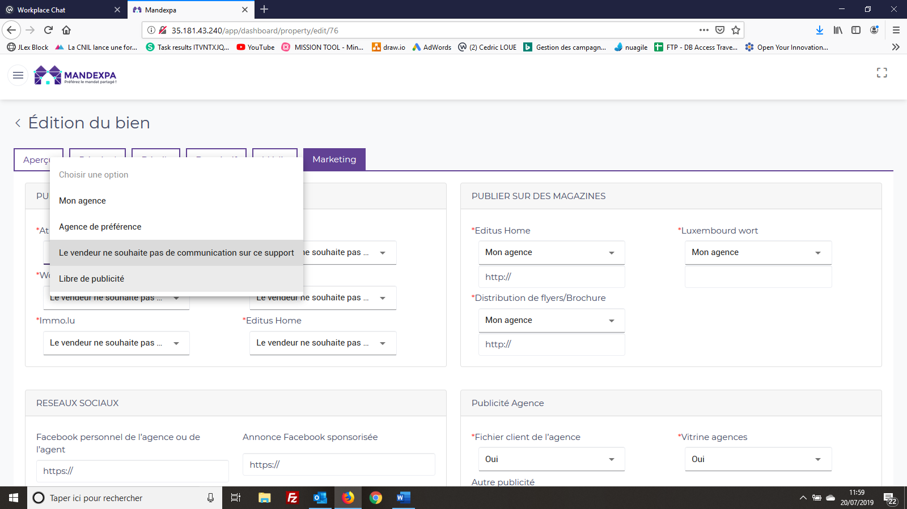

**Mon Agence** : mean only Agency A will promote this property on this media. With select « Mon agence » is display a new field « http ». In this one, Agency A will input external url where is promote the property for this media

**Agence de préférence** : mean Agency A will select 1 Agency B who will promote this property on this media. With select « **Agence de préférence** » is display a new field « http ». In this one, Agency B will input external url where is promote the property for this media.

**Le vendeur ne souhaite pas de communication sur ce support** : mean « owner property » don’t want promote property on this media.

**Libre de publicité** : mean « all agencies existing in system «  can promote property on this media.

**MARKETING TAB V2**

Logic still the same, but have additional features :

1. Owner property will have a user account to login the system. After login, can only see the 1st tab the property. In this 1st can see what « marketing collaborate » Agency A has define for him, can see the external url input for the different media.
2. In case « Agence de préférence » , Agency B will « edit » & input himself the external url. Can do this from list properties, detail property (1st tab)
3. In case « Libre de publicité » : the first time an agency (B, C) add the external url to media, the function is closed for the other agencies.