Comnhalam.com

Version 1.0

Revision History

|  |  |  |  |
| --- | --- | --- | --- |
| **Date** | **Version** | **Description** | **Author** |
| November 7, 2018 | 1.0 | Initial use-case specification for all users | Trần Hải Phong |
|  |  |  |  |
|  |  |  |  |
|  |  |  |  |

Table of Contents

1. Use-case Model 4

2. Use-case Specifications 4

2.1 Use-case: Register an account 4

2.2 Use-case: Change account password 4

2.3 Use-case: Edit profile 5

2.4 Use-case: View a product 5

2.5 Use-case: View info 6

# Use-case Model

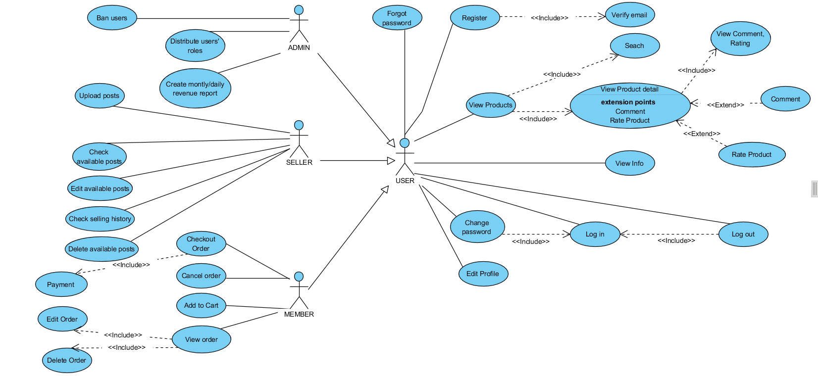

# Use-case Specifications

## Use-case: Register an account

|  |  |
| --- | --- |
| Use case Name | Register an account |
| Brief description | This use case describes how the user can register an account |
| Actors | User |
| Basic Flow | 1. At the logging page, user clicks on ‘Register’ button 2. System goes to registration page 3. User provides all of necessary information to register their account 4. System receive the information and create a new account. |
| Alternative Flows |  |
| Pre-conditions | Administrator goes to homepage at [www.comnhalam.com](http://www.comnhalam.com) |
| Post-conditions | The user successfully registers a new account. |

## Use-case: Change account password

|  |  |
| --- | --- |
| Use case Name | Change account password |
| Brief description | This use case describes how the user can change password of their account. |
| Actors | User |
| Basic Flow | 1. At the homepage, the user clicks on ‘My account’ button 2. System goes to profile page 3. User clicks on ‘Change password’ button at profile page. 4. System goes to change password page 5. User enters old password and new password 6. User clicks on ‘Save’ button to save the change. |
| Alternative Flows |  |
| Pre-conditions | Administrator goes to homepage at [www.comnhalam.com](http://www.comnhalam.com) and logs into their account. |
| Post-conditions | The user successfully changes the password of their account. |

## Use-case: Edit profile

|  |  |
| --- | --- |
| Use case Name | Edit profile |
| Brief description | This use case describes how the user can edit their profile. |
| Actors | User |
| Basic Flow | 1. At the homepage, the user clicks on ‘My account’ button 2. System goes to profile page 3. System just enable ‘Edit’ button for the information that have a permit that the user could change. 4. User clicks on ‘Edit’ button of the information that they want to change. |
| Alternative Flows |  |
| Pre-conditions | Administrator goes to homepage at [www.comnhalam.com](http://www.comnhalam.com) and logs into their account. |
| Post-conditions | The user successfully changes some necessary information |

## Use-case: View a product

|  |  |
| --- | --- |
| Use case Name | View a product |
| Brief description | This use case describes how the user can view the detail of a product |
| Actors | User |
| Basic Flow | 1. At the homepage, user clicks on the name of a product 2. System goes to product detail page to show all information of the product was clicked. |
| Alternative Flows | **Alternative flow 1: See detail of a product after searching**   1. At the homepage, user enters keywords (name, tag) on ‘search’ field 2. User clicks on ‘Search’ button to start searching the product 3. Continue #2 of basic flow.   **Alternative flow 2: See detail of a product when checking currently order**   1. At the viewing order page, user clicks on the name of a product 2. Continue #2 of basic flow. |
| Pre-conditions | Administrator goes to homepage at [www.comnhalam.com](http://www.comnhalam.com) and logs into their account. |
| Post-conditions | The user successfully see detail of a product |

## Use-case: View info (profile of user)

|  |  |
| --- | --- |
| Use case Name | View info |
| Brief description | This use case describes how the user can see the profile of other users. |
| Actors | User |
| Basic Flow | 1. At the homepage, the user enters keywords (email) on the ‘Search’ field 2. Users clicks on ‘Search’ button to start searching a product 3. System displays the user found 4. User clicks on the name of user that they want to see profile 5. System goes to profile page of the user that was clicked (Just see some public information) |
| Alternative Flows |  |
| Pre-conditions | Administrator goes to homepage at [www.comnhalam.com](http://www.comnhalam.com) and logs into their account. |
| Post-conditions | The user successfully see profile of others. |