1. **Small talk**
   1. **Link :** <http://www.eslfast.com/robot/topics/smalltalk/smalltalk01.htm>

* **Pretty** **{** **pret‧ty** [+ adjective/adverb] *spoken* **}**



In this case is mean [ **very** ]:

* *Dinner at Luigi's sounds pretty good to me.*
* **Campus { cam‧pus** [uncountable and countable] **}**

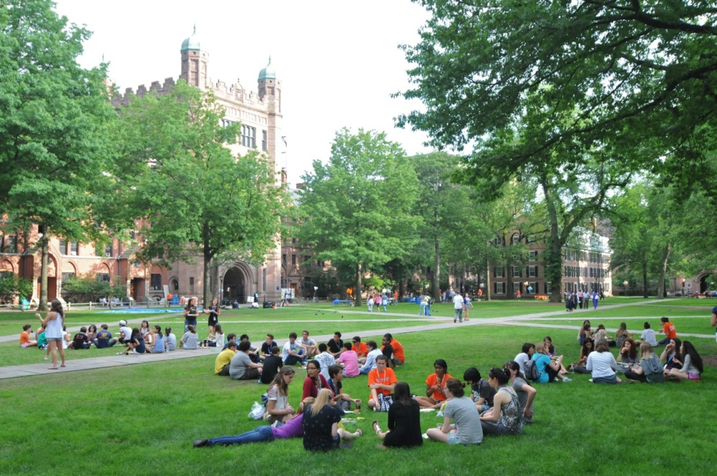

It means **[** the land and **buildings of a university or college**, **including the buildings where students live ]**

* *a beautiful campus in New England*
* **have been ??????**
  1. **Số lần nghe & thời gian nghe**
* **Lần 1 – 1h30 [** *15/7/2016* **]**

1. Aaa
   1. sss