***CZECH TECHNICAL UNIVERSITY IN PRAGUE***

***FACULTY OF ELECTRICAL ENGINEERING***



**MASTER THESIS**

**Cooperation of Home Automatization Systems with Sensors in IoT network**

**Author:**

**Phuc Trinh Gia**

**Supervisor:**

**Ing. Zbyněk Kocur, Ph.D**

**Reviewer:**

**PRAGUE**

**2019**

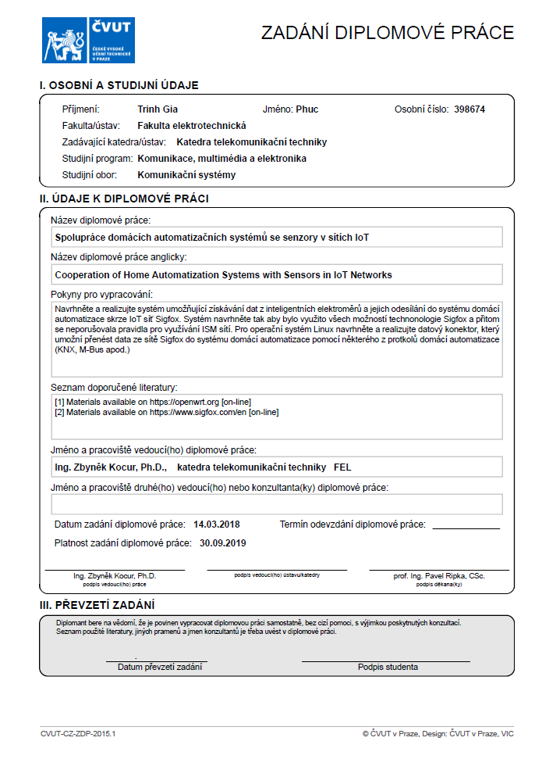

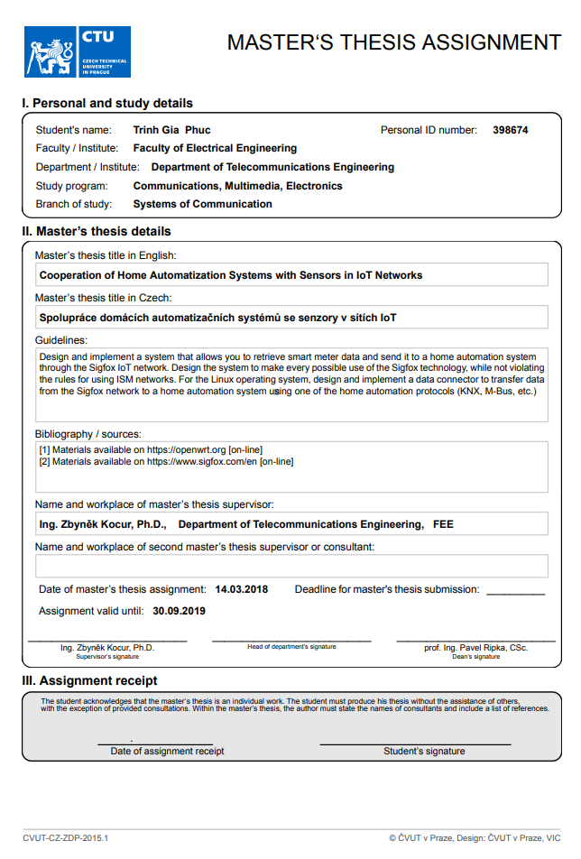

**Abstract**

Nowadays, Internet of Things (IoT) are developing rapidly and vastly and goes along with its development are the technologies behind which create the eco-system based on Internet back-bone to collect and process the data from sensors (or ‘things’) to end user which need to be implemented according to their applications.

As the IoT is a target to many fields of application and its tension is to update the existing infrastructures in order the upgraded system can be connected to the back-bone internet with minimal efforts included cost and installation.

The goal of the thesis is to design and implement a system that retrieves the data from smart power meter and send collected data through IoT network using common current technology such as Lora or Sigfox to a custom back-end server. On the other hand, the custom back-end server will be implemented in such a way that it can prepare the collected data and prepare reception data for home automation systems, in which running on a standardized protocol for home automation such as KNX.

**Acknowledgment**

I wish to express my sincere thanks to my supervisor Ing. Zbyněk Kocur, Ph.D., for providing me with all the necessary facilities for the research as well as for his sharing expertise, experiences and valuable advices.

I am also grateful to ….., for his review, comments, and evaluation for my thesis which gives plenty of experiences for my works.

I take this opportunity to express gratitude to all teachers of the Electrical engineering faculty for their teaching and support.

I also thank my family for the encouragement, support, and attention which they intended for me through this venture.

**Declaration**

“I hereby declare:

- that I have written this writing thesis without any help from others and without the use of documents and aids other than those stated in the Bibliography.

- that I have mentioned all the sources used and that I have cited them correctly according to established academic citation rules.”

**Phuc Trinh Gia**

**………………………………………….**

**Prague, 2019**

Contents

Introduction 1

1.1 Purpose and structure of the thesis 1

1.2 Hardware and materials overview 2

1.3 Software and material overview 4

Analysis and Motivation 6

2.1 Analysis of smart meter and current usages in home automation 6

2.2 Analysis of IoT network and technology 7

2.3 Analysis of existing technologies in home automatization 10

2.4 Problems in existing infrastructures of home automation 12

2.5 Motivation for solving existing problems 16

2.6 Proposal for designing and implementaion 21

Power meter and LoRa network 23

3.1 Introduction Lora 23

3.2 Network structure analysis 25

3.3 Impelentatin of Application layer 28

3.4 Implementation of Transport layer 30

3.5 Implementation of Network layer 33

3.6 Implementation of Physical layer 34

KNX protocol 38

4.1 Introduction to KNX 38

4.2 Using KNX for developing application on embedded server 40

4.3 Demo Webpages and demonstration of server 44

Conclusion 47

Bibliography 48

**List of Figures**

**Chapter 1**

# Introduction

## Purpose and structure of the thesis

The purpose of the thesis is to analyze the current situations of power monitoring in households in the Czech Republic with power meter as well as the using of home automation system to regulate the power consumption for users/customers or utilities. Base on the analysis, advantages and disadvantages of the current systems will be considered and evaluated for figuring out current problems, thus, the proposed solution will follow on for solving the problems. The aim of the proposed solution is to focus on the application of IoT technologies for transferring the data from power meter to end customer, specified in this thesis as a home automation network (HAN). The proposed solution deals with the breaking data into several data streams with several data protocols used across the data transfer procedure. The solution is not only dealing with how to transfer the data from the power meter to the Internet but also resolving the data from the internet to the HAN.

**Chapter 1 – Introduction.** This chapter is an introduction of whole server with its functions and brief review of its construction and it also includes all materials which are used to create the server.

**Chapter 2 – TCP/IP.** This chapter is my studying about TCP/IP protocol from its model and structure to its individual layers with detailed explanations, not only their roles of each layer in the system but also how these layers can be applied on a network.

**Chapter 3 – LwIP stack**. Regardless the TCP/IP in general, this chapter explains in detail the implementations of layers of TCP/IP on embedded server using the LwIP. It also deals with problems during implementation process such as point-to-point model(or client-server model), Socket programming and others.

**Chapter 4 – FreeRTOS.** This chapter is about FreeRTOS (free Real Time Operating System). The chapter covers the aspect of implementation of FreeRTOS on embedded server together with LwIP stack and application for controlling the extension board.

**Chapter 5 – Conclusion.** Final chapter contains the summary of whole process in order to develop the embedded system.

## Hardware and software overview

In order to retrieving data from the power meter the extra system on chip based board (exchange board) is used for this purpose and connect with the meter via standard optical port (IEC 62056) by optical-serial converter. On the other side, the board connects with Lora module through serial port. The list of elements and their descriptions are listed below. Figure 1 below shows the construction of connection among “power meter”- “exchange board” - ‘’LoRa module’’:

Figure 1. Hardware overview

List of elements used to construct the hardware part:

* Digital power meter Landis-Gyr E350 with optical port used for measuring power consumption and other electrical quantities such as electric-current, voltage, frequency, power factors,etc.
* Olinuxino – RT5350F is used as exchange board for collecting data from power meter and sending data to LoRa module for on air transmission.
* Lora module with RN2483 chip is used for sending data over the air to Lora Gateway.

Descriptions:

* Digital power meter Landis-Gyr E350 provides the measurement of power consumption and other electrical quantities in household grids and it support data read-out of data through many communication ports such as Ethernet,RS485, Optical port.

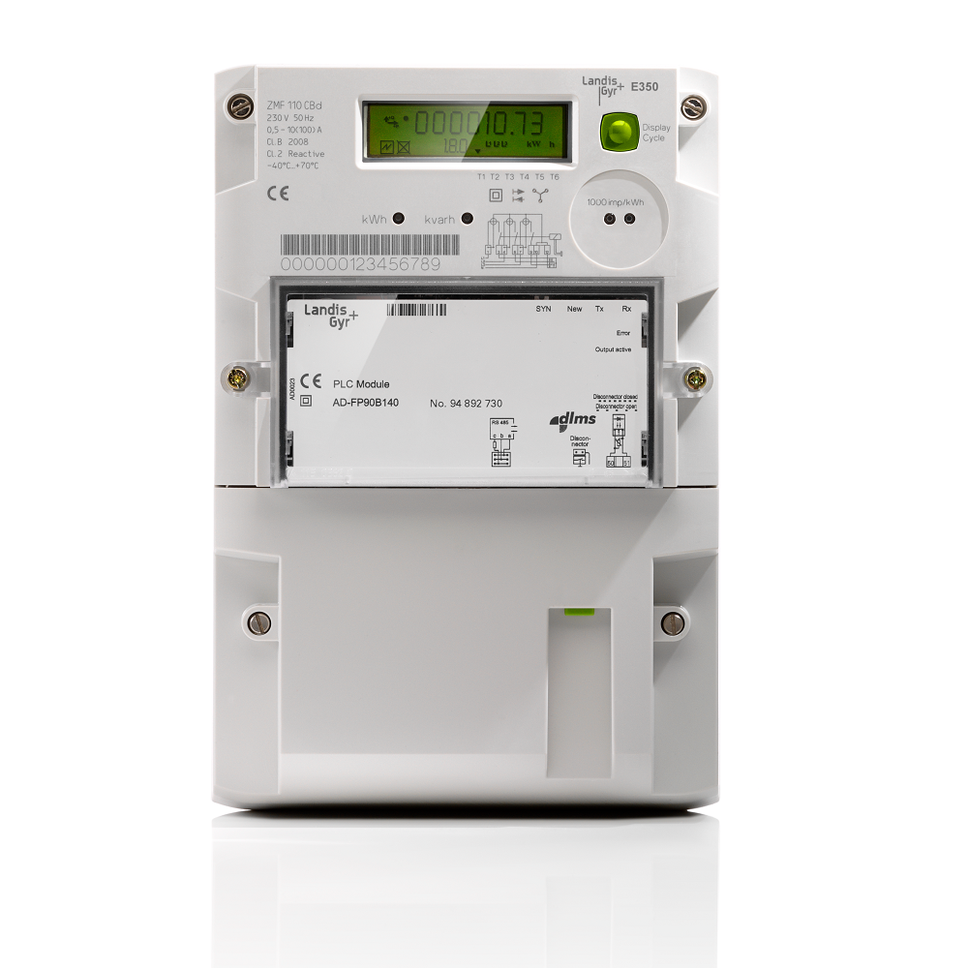

Figure 2. Power Meter

* Olinuxino – RT5350F is system on chip based board which is used in this project as an exchange board for retrieving data from power meter and then send them to Lora module for over air transmission. The board using RT5350F system on chip (SoC) which has enough power to run small embedded Linux operating system on it and performing scheduled communication for power meter read-out and Lora transmission. The board supports two serial ports (UART) for communication with power meter and LoRa module.

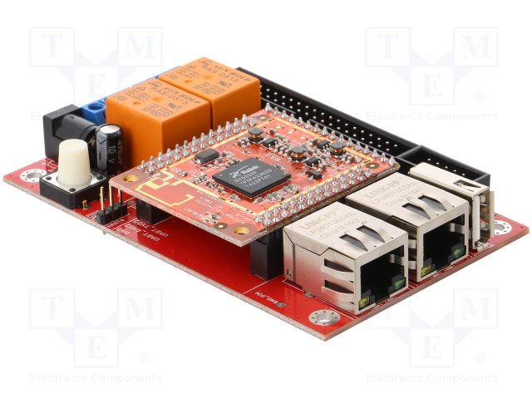

Figure 3. Olinuxino – RT5350F exchange board

* Lora module RN2483 provides dual band 433/868Mhz based on Lora Technology, the module is acquired with UART serial communication for interfacing with exchange board.

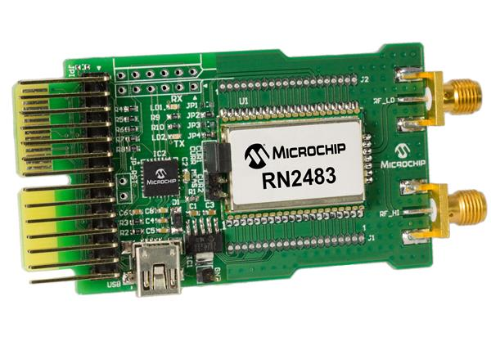

**Chapter 2**

# Analysis and Motivation

## Overview of smart power meter

The smart power meter is the next generation of an analog power meter, it functions is inherited from analog one that measures the consumption of electrical power (some other case even with water and gas consumptions). It is called ‘’smart’’ because it is not only simply measures the power consumption but also can collect data in intervals of an hour and transfers that information at least daily back to the utility for monitoring and billing. Smart power meter enables two-way communications between the central system and itself. Unlike home energy monitor, smart meters can gather data for remote reporting. Communication between smart power meter to the network can be done via fixed connections or via wireless. Before going more into the technical specification of power meters, there are some several important benefits that smart power meter brings to users (customers) and power companies. [14]

* + No more estimate bills: The accuracy of digitalized measurement in smart power meter helps to get rid of estimated bills when a meter reader is unable to access the property. Means that the company does not have to come to their customer location for collecting the data.
  + Detail usage of electricity: With an analog meter, most power bill shows to customers how much electricity they used for last month (or several months) – but not how they used them. A smart meter records customer’s electricity usage for every hour give access to their usage quickly and even shows them what is the device is using the most electricity power in there house.
  + User friendly: With a smart power meter, customers can monitor the power consumption and choose proper appliances with different behavior and make an effective decision.
  + Consulting: Power companies can consult their customers with proper tariffs with the different process at different times or days according to the customer’s needs.
  + Improve the environment: Use less energy means reducing pollutions to the environment.
* Safety enhanced: Smart power meter can detect failure problems that are happened in electrical network and can either automatically decided situations ( set an alarm/ controlling automatically switching system) or sending a report to users/companies.

In this section, a general architecture of a smart power meter is considered, it is not only concern about hardware specifications but also an emphasis on the aspect of communication protocols. The figure below demonstrates the typical hardware of a smart power meter

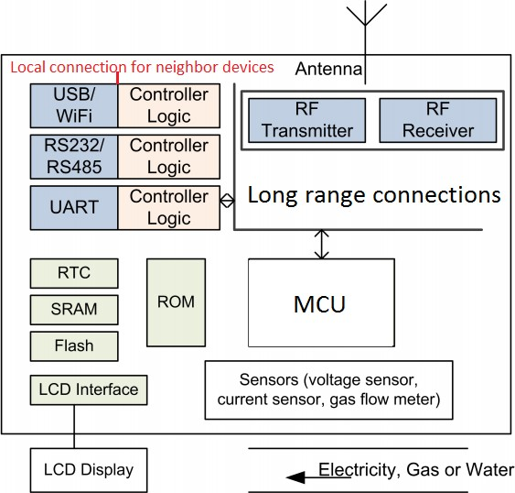

Figure 4. Hardware demonstration of smart power meter [4]

On hardware point of view for communications, smart meters are designed to have local communication for HAN and long ranged communication for Internet or IoT network. For local communication with HAN systems or terminals, typical standards are used such as USB/WIFI, Serial communications (USART, UART), two-wire communications. On the other hand, for long-range communication, radio frequency is implemented using such technology like LoRA, WiMAX, Sigfox etc.

On the aspect of communication protocols, there are many protocols are used for different purposes. For example, if the power meter is required to connect to the HANs system, it can use wire/wireless protocol such as Bluetooth, Zigbee, Z-wave, DSLM/COSEM, KNX, etc. On the other hand, if the power meter is needed to connect to neighbor devices (in long-range communication) or to utilities it can use DSLM/COSEM, internet gateways.

Currently in the Czech Republic, the most common installed version of power meter is the one with local communications such as Ethernet , RS485 or KNX, DLSM/COSEM,

## Home automation network

A home automation network is a network where electrical devices in a home are connected to a central system that automates those devices under user inputs. As the technologies have been changing, those electrical devices are added together with sensors for and connected to the Internet so users can monitoring, scheduling, controlling those devices according to their need remotely. The futures of those devices are going into next states where they are becoming smart, which mean these devices can communicate with each other and make their own decision base on the usage of users or by the conditions of the environment around them. The typical of HAN network is shown in the figure below.

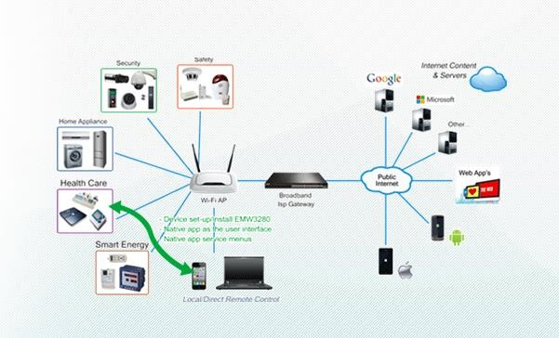

Figure 1. Topology of HAN network [1]

From the figure 1, the typical communications of HAN to users are through Internet gateway such as routers or through mobile networks such as 3G, 4G networks and toward the backbone network of Internet. The central processing unit of HAN network is designed to communicate with sensors and actuators inside a building or house through many communication protocols from wired to wireless methods such as Ethernet, Serial ports, Z-wave, Zigbee, Bluetooth, etc.

Base on its architecture, the HAN is constrained for a single home or a building thus causes several disadvantages on its functions:

* + - The data from HAN network is streaming data and required the gateway must be connected to a high-speed internet connection. Besides that, the connection to the Internet is totally depended on the Internet backbone network.
    - Extending the scale of the network is limited by the communication protocols. For example, the internal devices (sensors, actuators) are connected with central controller by wireless communication protocols (Zigbee, Z-wave, Bluetooth, Wifi, etc) with the maximum distance is 10- 300m (depended on protocols). Obviously, the network is extensible by adding nodes through networks, however, it creates more complexities and extra cost for installation as well as maintenance of the system.
    - The main objects (house, buildings) in the network can communicate with each other (depends on applications) with the Internet connections (if the distance excesses the maximum distance of above) or when they are in the range of wireless protocols. Once again, if we need to extend the communications among objects, wire communication protocols (Ethernet, Serials) are considered. However, the distances again is a problem because the distance for these protocols are also limited and the cost will be raised up.
    - On the aspect of utilization convenience, each HAN system is manufactured by different manufacturer thus it causes asynchronization for the system. For example, if users want to add extra internal devices (sensors or actuators) they need to select the devices with same protocols or some time from the same manufacturer. Furthermore, the application services are also provided differently by each manufacturer

## Internet of Things

Internet of thing (IoT) is a network where all devices in the network are interconnected and communicate to each other for collecting and sharing data. The term IoT is very large which covers many applications. However, the main purpose of IoT is leading to smarter solutions and providing big data for all the aspects of life. From the perspective of how IoT devices are interconnected and operate the Internet Architecture Board classified them into following class: [17]

* + - IoT Device-to-Device model: Two or more devices directly connected through a shared network.
    - IoT Device to cloud model: in this model IoT sensors or devices connected straight through cloud services.
    - IoT Device-to- gateway model: in this model sensors and other IoT devices are connected to a local application gateway, which is used to process the data gathered by IoT devices before sending them to the

Cloud. In this model, the application gateway is always considered as an intermediate server between IoT devices and clouds.

* + - IoT Back-End-Sharing-Data model: this model enables IoT devices to transfer data to a cloud service for analysis along with data from gathered from other IoT devices or sources.

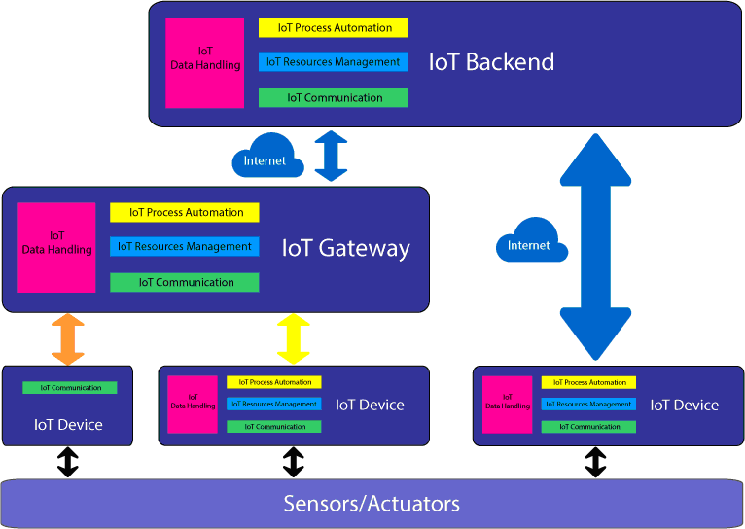

Figure 2. Topology of IoT network [2]

One of the most important element operates in IoT network is sensors, they are tiny embedded devices with limited power and computational ability and used for collecting data and monitoring the environment around them such as temperatures, humidity, pressure, heat, power, etc. Besides that, as the technology is growing up, they are intended for using wireless communications for reducing complexity and cost meanwhile increasing range efficiency. This idea generated a definition of Wireless Sensor Network (WSN) operating in IoT network. [11]

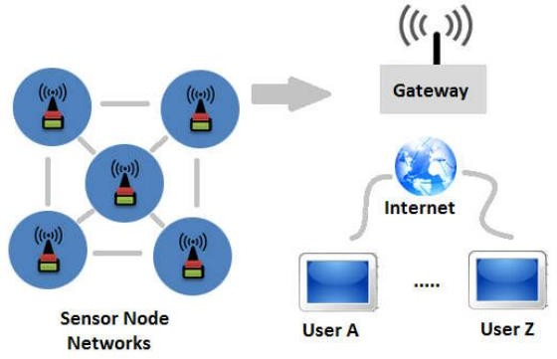

Figure 3. Topology of WSN in IoT network [3]

This idea is main characteristic using in this project because each power meter will be considered as an individual node. The detail will be explained in next sections.

The wireless sensors networks using IoT network has specific characteristics described as bellow:

* + - * The IoT network itself uses specific radio technologies providing ultralow power consumption which mean that the sensors can run with battery sized power supplies and lasts for years.
      * The radio technology which is designed for IoT network with long range communication with low data rate. In general, technologies such as LoRa,Sigfox, or NB-IoT provide the connection distance from sensors to gateways with range from 2-10Km depends on topography of terrain where the system is installed. On the other hand, the transfer data rate for these systems are also limited to 10 – 10000 bps and messages per day are around 140 -250 messages per day ( 5-10 messages per hour)

## Analysis the usages of power meter in Home Automation Network

In this section, the possibilities of connection of smart power meter to HAN and IoT are considered.

2.4.1. Study cases for HAN and IoT

### Case 1: Smart power meter is directly connected to HAN controller

There are several types of integrating smart power meter to HAN system, because HAN systems support multi connection flat-form (Wire/wireless) thus smart power meter can become a part of sensors/actuators in HAN system by communicating with the central controller of HAN. The demonstration of this design can be shown in figure below

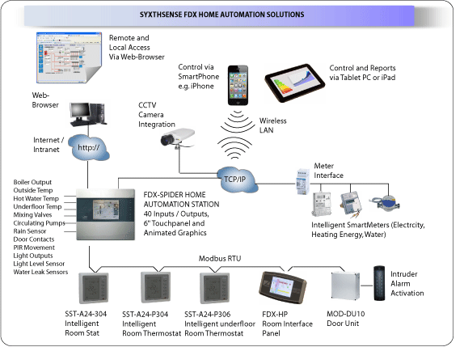

Figure 5. Smart power meter connected to central controller [5]

With this configuration, the data from the smart power meter is directly connected to the application server by Internet gateway. However, there are some several issues with this model:

* Data is mixed with stream data from other devices, require a special way of access to the application layer on the server as well as central controller of HAN.
* This method also limits the ability to create a connection to neighbor network area (NAN). There is no possibility for interfacing with IoT network.
* The power meter needs to be preprogrammed in order to communicate with the central controller. As mentioned before, each manufacture has different protocols thus the compatibility of the smart power meter is limited.
* The smart power meter is must be installed within communication range of HAN controller.

### Case 2: Smart power meter is connected to HAN but has itself data flow path for server/cloud services [15]

This method gives better options for the smart power meter to communicate with HAN as well as among themselves by wire or wireless media. The figure below demonstrates the case when smart power meters are connected.

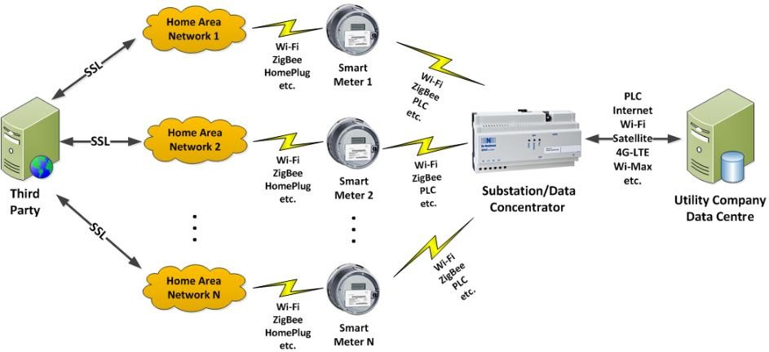

Figure 6. Smart power meter connected to Data concentrators [6]

In this configuration, smart power meters have themselves data paths and separate data plan from stream data of HAN system. The protocols and communication methods are variety for the user as well as utilities (companies). Data from all the nodes are transferred to the cloud (server) using data concentrator (data collector).

There is a possibility for smart meters can connect to each other in order to create a Neighbor area network (NAN) as the figure below. Yet, this network can be only created through data collectors. By this way, the range of the network is increased.

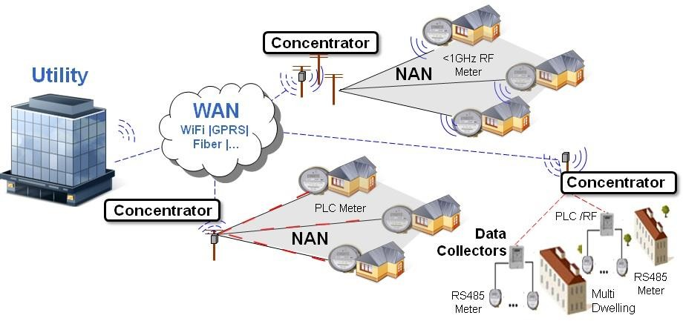

Figure 7. Demonstration of smart power meter configured as sensors networks [7]

Because the data from smart power meter are separated thus it is easier to handle for the application layer.

However, there are still several disadvantages to this method.

* It requests extra layer (data collection) for the network, furthermore, the connections from smart power meters to data collecters are not synchronized. It means each power meter can connect to the data collecter by different protocols.
* Customers (users) need an extra connection in oder to retrive the data for their need because the third party server and utility data center are not connected in some cases.

### Case 3: Smart power meter is connected to HAN by some industrial protocols using for buiding management.

This study case is inherited from previous study case (Case 2) but it specified by communication protocols for wire media connection.

Protocols such ask DLSM/COSEM, KNX, MODBUS, M-BUS (Meter -BUS), etc are frequenly using in building management (as well as in HAN systems) can be idealized by the figure below.

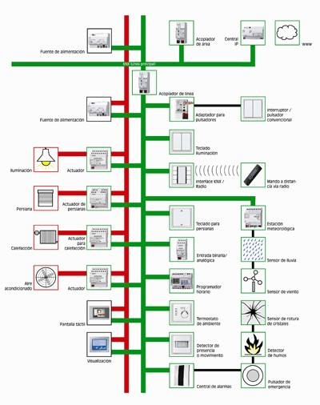

Figure 8. Bus-based connection in HAN network [8]

These protocols provide all functions which necessary for HAN network in order to create more complex networks in a large area as well as fully support multilayer for developing applications. From server side to end user sides and it can be shown in figure below (demonstration from DLSM/COSEM protocol)

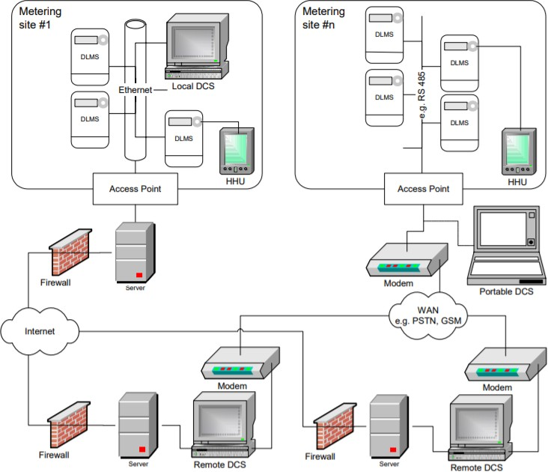

Figure 9. Connection of DLSM/COSEM for remote data acquisitions [9]

These protols are also standard and supported by many manufactures in HAN industry. Similarly as in previous study cases, these protocols also have some disadvantages that are can be considered as below:

* Created an extra bus for data exchange between devices causing extra cost for installation.
* These protocols are good for monitoring buiding and midle side areas but it can cause low effiency problem to the bigger network (NAN) because of high installation cost.
* Each protocol using a different way of working thus they request different way of implementation for HAN network as well as on the side of utilities. For example, in one buiding where the smart power installed running on DLSM/COSEM the collected data is encapsulated and sent in a different way and in other buiding where power meters running on M-BUS causing the different way of data reception. Therefore, it is hard for the utility to synchronized these data.

## Summary

From case studies, there are some disadvantages from exiting infrastructures and protocols of HAN systems that are significantly affected by the separation of using smart power meters such as:

* Data measured from smart power meters do not have itself data path. It must be sent either through HAN central controller or to data concentrators/collectors in case of the Bus-based system.
* The expanding and upgrading capabilities of existing infrastructures are not reliable because of differences in technologies (Wireless/Wired, bus-based).
* Installation of the smart power meter is constrained by distance/condition of existing infrastructures.

## Internet layer (Network layer)

## Physical layer

**Chapter 5**

# Conclusion

# Bibliography