Required software

Firefox web browser

https://www.mozilla.org/

AWS Proxy Server: 3.69.63.211 (port 3128)

Exceed Server IP Address: 10.111.1.224

To connect to the environment:

1. Disconnect from any VPN, this may block AWS

2. Setup your proxy in Firefox (DO NOT USE ANY OTHER BROWSERS)

     Firefox->Options->Network Settings (bottom of the page)

     User the Proxy Server IP address provided above.  The port is always 3128

     Check the box "Also use this proxy for FTP and HTTPS" (It may just be for HTTPS)

     This needs to be done only once (unless you change them)

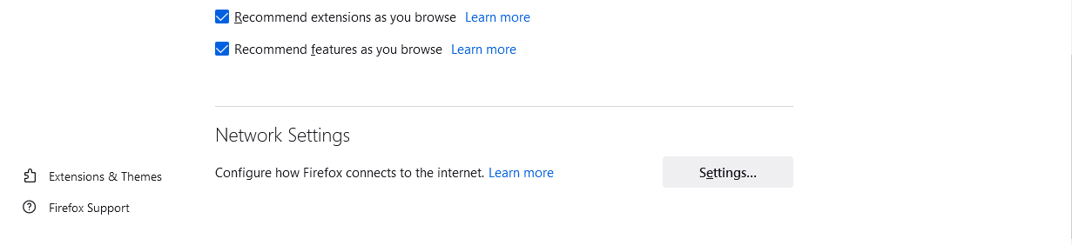

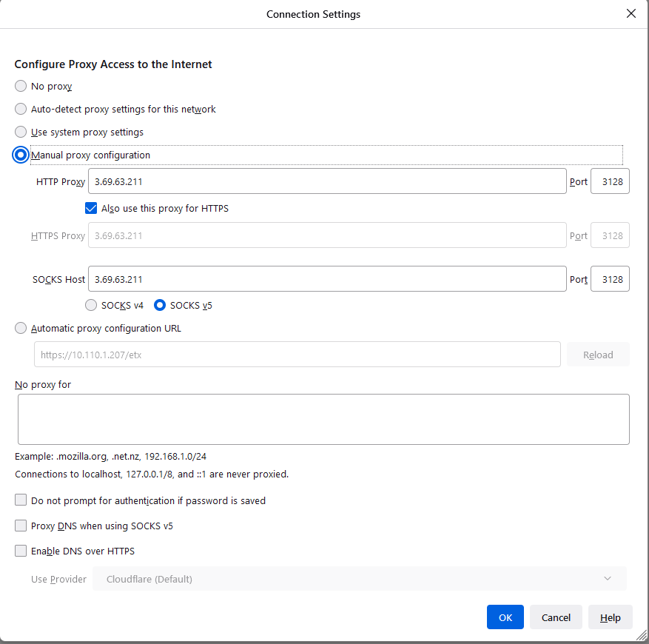

3. Use firefox and connect to:

     https://<Exceed Server ip address>/etx

     It will not work if you don't specify https

https://10.111.1.224/etx/

4. Login with the username and password

5. You should see:

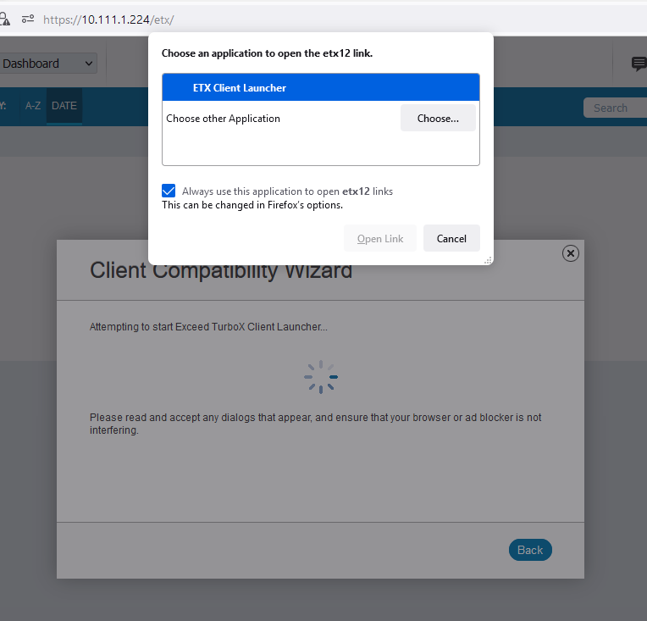

Select ETX Client Launcher and click Open Link

5. From the Dashboard select KDE to launch it

    KDE : Full Window Manager Environment (should match your screen resolution) in a window​

User home directory are in: /project/home/<username>