SOFTWARE REQUIREMENTS SPECIFICATION
JobTrack
Job Application Tracking System
Version 2.0
Prepared by: Pooja Tiwari, Business Analyst
Student ID: s396163
Derived from the JobTrack Business Requirements Document (BRD) v2.0
Date: 5 October 2026

Document Control

Version History
Version | Date | Author | Description
0.1 | 16 Aug 2026 | Pooja Tiwari (s396163) | Initial SRS derived from approved BRD v1.0
1.0 | TBC | Pooja Tiwari (s396163) | Reviewed by team and finalised for submission
2.0 | 05 Oct 2026 | Pooja Tiwari (s396163) | As-built update aligned with BRD v2.0 and the implemented system: requirements, interfaces, business rules, use cases, data model and diagrams updated; traceability to automated tests added. Pooja Tiwari's role updated to include Data Analyst and QA.

Summary of Changes in Version 2.0
Version 2.0 brings this SRS in line with the application delivered at the end of development. The main changes are:
- Requirements rewritten to describe the system as built (as-built baseline) instead of the planned MVP.
- Application date is now set automatically on creation and edited afterwards; a job listing link was added.
- Document tracking now uses real file uploads (PDF, DOC, DOCX) stored in AWS S3, with a reusable resume library and one cover letter per application.
- Interview contact details moved from the application to each interview round; interview type, location and meeting link added.
- Follow-ups are now separate items with a title, due date, notes and done/reopen; dedicated Interviews and Follow-ups pages added.
- Session handling defined: 15-minute access tokens, 180-day rotating refresh tokens, logout revokes the session.
- Permanent deletion of applications (FR-APP-07) and the outcome summary over a period (FR-DASH-06) are deferred; status history is stored but not yet shown in the UI.
- Business rules, data model, user stories and diagrams updated to match the implementation; implementation status and test traceability added.
- Section 4.3 now lists the REST API endpoints, and Section 10 adds a traceability matrix to automated test IDs and an implementation status table.

Distribution List
Name | Role
Trinh Hieu Tran | Developer and DBA
Pooja Tiwari (s396163) | Business Analyst, Report Analyst, Data Analyst (DA) and Quality Assurance (QA)
Prince Kumar Sah | Data Analyst And Tester
Unit Coordinator (Ahmedi Azra) | Assessor

Table of Contents
Document Control 2
Version History 2
Summary of Changes in Version 2.0 2
Distribution List 3
1. Introduction 6
1.1 Purpose 6
1.2 Scope 6
1.3 Intended Audience 6
1.4 Definitions, Acronyms and Abbreviations 6
1.5 References 7
1.6 Overview 7
2. Overall Description 8
2.1 Product Perspective 8
2.2 Product Functions (Summary) 8
2.3 User Classes and Characteristics 8
2.4 Operating Environment 9
2.5 Design and Implementation Constraints 9
2.6 Assumptions and Dependencies 9
3. System Features (Functional Requirements) 10
3.1 Authentication and Workspace (AUTH) 10
3.2 Application Tracker (APP) 10
3.3 Status Tracking (STA) 11
3.4 Document Tracking (DOC) 11
3.5 Interview and Follow-up Management (INT) 12
3.6 Dashboard Summaries (DASH) 12
4. External Interface Requirements 13
4.1 User Interfaces 13
4.2 Hardware Interfaces 13
4.3 Software Interfaces 13
4.4 Communications Interfaces 14
5. Non-Functional Requirements 14
6. Business Rules – Application Status Workflow 16
6.1 Allowed Statuses 16
6.2 Status Workflow Diagram 16
6.3 Allowed Transitions 16
6.4 Edge Cases and Validation Rules 17
7. Use Case Model 18
7.1 Use Case Descriptions 19
8. High-Level Data Model 22
9. User Stories and Acceptance Criteria 25
10. Requirements Traceability 27
10.1 Traceability Matrix 27
10.2 Implementation Status 27
11. Sign-off 28

1. Introduction

1.1 Purpose
This Software Requirements Specification (SRS) defines the functional and non-functional requirements for JobTrack, a local web application that gives job seekers a single private workspace to record, track and review their job applications. It translates the JobTrack Business Requirements Document (BRD v2.0) into a structured specification for design, development and test-case derivation, and for review by the unit coordinator. Version 2.0 is an as-built update: it describes the behaviour of the delivered system, and marks planned features that were not built as Deferred.

1.2 Scope
JobTrack allows an authenticated user to create, edit, search, filter, archive and restore job application records; move each application through an enforced status workflow; upload the resume and cover letter used and record job listing, portfolio and GitHub links; manage interview rounds and follow-ups; and review a dashboard plus dedicated Interviews and Follow-ups pages. The system is a locally executed web application (React frontend, ASP.NET Core Web API, PostgreSQL via Entity Framework Core) that stores document files in AWS S3, delivered for a university group project. Integration with job-board APIs, production hosting, native mobile apps, email/SMS notifications, password reset and permanent deletion of applications are out of scope for this release.

1.3 Intended Audience
- Frontend developer(s) implementing the React user interface
- Backend/database developer(s) implementing the ASP.NET Core API and PostgreSQL schema
- The Business Analyst maintaining requirements traceability
- The Tester/Data Analyst maintaining the automated test suite and test evidence
- The unit coordinator/assessor reviewing project deliverables

1.4 Definitions, Acronyms and Abbreviations
Term | Definition
SRS | Software Requirements Specification
BRD | Business Requirements Document
MVP | Minimum Viable Product
FR | Functional Requirement
NFR | Non-Functional Requirement
UI | User Interface
API | Application Programming Interface
CRUD | Create, Read, Update, Delete
ERD | Entity-Relationship Diagram
EF Core | Entity Framework Core (ORM used by the backend)
JWT | JSON Web Token — the short-lived access token sent with every API request
Refresh token | Long-lived token used to obtain a new access token without logging in again; replaced on every use
AWS S3 | Amazon Simple Storage Service, used to store uploaded resume and cover letter files
Pre-signed URL | Time-limited link issued by the API that lets the browser upload or read one S3 file directly
CORS | Cross-Origin Resource Sharing — browser rule restricting which web origins may call the API
UTC | Coordinated Universal Time; all timestamps are stored in UTC
Playwright | Test automation framework used for the API and end-to-end UI test suite

1.5 References
- JobTrack Business Requirements Document (BRD), Version 2.0, 5 October 2026
- JobTrack Project Brief, Trinh Hieu Tran
- JobTrack source code: Web Application/backend and Web Application/frontend, including README setup notes
- JobTrack sample job application dataset, created by Pooja Tiwari (Data Analyst)
- JobTrack automated test suite: Web Application/automation-tests (README and test reports), built and run by Pooja Tiwari (QA)
- JobTrack User Manual, written by Pooja Tiwari

1.6 Overview
Section 2 describes the overall product context, user classes and constraints. Section 3 specifies system features as functional requirements grouped by module. Section 4 defines external interfaces, including the REST API. Section 5 specifies non-functional requirements. Section 6 documents the status workflow business rules. Section 7 presents the use case model. Section 8 presents the data model. Section 9 lists user stories and acceptance criteria. Section 10 maps requirements to use cases, user stories and automated tests and records implementation status. Section 11 records sign-off.

2. Overall Description

2.1 Product Perspective
JobTrack is a new, self-contained system rather than a component of an existing product line. It is a three-tier web application: a React single-page frontend, an ASP.NET Core Web API backend, and a PostgreSQL database accessed through Entity Framework Core. Uploaded documents are stored in an AWS S3 bucket; the browser uploads and reads files directly from S3 using pre-signed URLs issued by the API, and the database stores only file metadata. The system runs locally from a single shared repository; there is no production deployment.

2.2 Product Functions (Summary)
- User registration, login and logout with per-user data isolation and automatic session renewal
- Create, view, inline-edit, search, filter, archive and restore job application records
- Enforced status workflow (Applied, Interview, Offer, Rejected, Withdrawn, Archived) with confirmation and history logging
- Upload of resume and cover letter files with a reusable resume library, plus job listing, portfolio and GitHub links
- Interview rounds with type, time, location, meeting link and contact details
- Follow-ups with due dates, notes, done/reopen and overdue detection
- Dashboard, Interviews page and Follow-ups page summarising active applications and upcoming or overdue work

2.3 User Classes and Characteristics
Persona | Goal | Key Pain Point | Primary Needs from JobTrack
Recent Graduate | Land a first graduate role | Applies to 20+ roles and loses track of which resume version was sent where | Fast entry, resume/cover letter version tracking, simple status view
Migrant Job Seeker | Secure stable local employment in a new industry | Needs clear notes on each employer's requirements and follow-up etiquette | Detailed notes, follow-up reminders, active vs closed overview
Career Changer | Transition into a new field with limited time | Needs to track applications efficiently in short bursts | Quick dashboard summary, overdue alerts, search/filter
Student (Part-time) | Find part-time or casual work around study | Applies casually; applications and interviews are easily forgotten | Lightweight entry, interview tracking, simple reminders

2.4 Operating Environment
- Frontend: React 18 with TypeScript, built with Vite and Tailwind CSS, served at http://localhost:5173 and used in a current desktop browser (Chrome, Edge or Firefox) at 1024px width or above
- Backend: ASP.NET Core Web API on .NET 10, served at http://localhost:5100 (Swagger UI available in development)
- Database: PostgreSQL 16 running in Docker, accessed via Entity Framework Core with migrations
- File storage: AWS S3 bucket (region ap-southeast-2 by default)
- Execution: local/development environment only, run from a single shared repository with README setup instructions

2.5 Design and Implementation Constraints
- Technology stack: React and TypeScript, ASP.NET Core (.NET 10), PostgreSQL, Entity Framework Core, AWS S3
- Status transitions and all validation rules must be enforced server-side (backend), not only in the UI, so data integrity holds regardless of client
- Files are uploaded from the browser directly to S3 using pre-signed URLs; the API never receives file contents
- Delivery is bound by the unit's weekly milestones and final presentation date
- Team members are part-time student developers with limited weekly hours; scope must remain within the agreed release

2.6 Assumptions and Dependencies
- Each user manages only their own applications; there is no recruiter, admin, or multi-tenant company view in this version
- Users enter application data manually; there is no automatic capture from email or job boards
- The system will be run locally by the development team and assessors; no hosting or domain is required for MVP
- The backend needs S3 settings to start; real S3 credentials are only required for uploading and previewing documents
- Timestamps are stored in UTC and displayed in the Australia/Sydney time zone

3. System Features (Functional Requirements)
Each requirement carries a unique identifier for traceability to the use case model (Section 7), the user stories (Section 9), and the project's test plan (Section 10). Priority uses the MoSCoW scale: Must, Should, Could.

3.1 Authentication and Workspace (AUTH)
ID | Requirement | Priority
FR-AUTH-01 | The system shall allow a new user to register with a unique email address and a password. Email uniqueness is case-insensitive. | Must
FR-AUTH-02 | The system shall allow a registered user to log in and log out securely. A session uses a short-lived access token (15 minutes) that is renewed automatically with a refresh token (valid 180 days, replaced on every renewal). Logging out revokes the refresh token. | Must
FR-AUTH-03 | The system shall ensure a logged-in user can only view, create or change their own records (applications, documents, interviews and follow-ups). A request for another user's record is answered as 'not found'. | Must
FR-AUTH-04 | The system shall validate email format and password strength at registration: 8 to 128 characters with at least one uppercase letter, one lowercase letter, one number and one special character. Validation is applied in both the user interface and the API. | Should
FR-AUTH-05 | The system shall redirect a user who is not logged in to the login page when they open any protected page. | Must

3.2 Application Tracker (APP)
ID | Requirement | Priority
FR-APP-01 | The system shall allow a user to create a job application with company name, role title and platform as mandatory fields, and an optional job listing link, portfolio link and GitHub link. The application date is set automatically to the current date and the status to Applied. | Must
FR-APP-02 | The system shall allow a user to view a paginated list (20 per page) of their active (non-archived) applications, ordered by application date with the newest first. | Must
FR-APP-03 | The system shall allow a user to edit the company name, role title, platform, application date and links of an existing application directly on its detail page (inline editing). Status and documents are changed through their own actions. | Must
FR-APP-04 | The system shall allow a user to archive an application that is in Offer, Rejected or Withdrawn status without deleting it, and to restore (unarchive) it to the status it held before archiving. | Must
FR-APP-05 | The system shall allow a user to search applications by company name or role title using a case-insensitive, partial match. | Must
FR-APP-06 | The system shall allow a user to filter applications by status (including Archived), platform (exact, case-insensitive match) and an inclusive application date range. Filters can be combined with each other and with search. | Should
FR-APP-07 | Deferred: the system shall allow a user to permanently delete an application, with a confirmation step. Not implemented in this release; archiving is used instead. | Could

3.3 Status Tracking (STA)
ID | Requirement | Priority
FR-STA-01 | The system shall support the following application statuses: Applied, Interview, Offer, Rejected, Withdrawn, Archived. | Must
FR-STA-02 | The system shall only allow status transitions defined in the status workflow. The rules are enforced by the API; the user interface only offers the actions that are valid for the current status. | Must
FR-STA-03 | The system shall record a timestamped status history entry (previous status, new status, time) every time an application's status changes, including restores. History is stored for audit; displaying it in the UI is deferred. | Must
FR-STA-04 | The system shall display the current status prominently on each application card and detail page as a coloured badge. | Must
FR-STA-05 | The system shall ask the user to confirm every status change and restore, explaining that the change cannot be rolled back through the normal workflow. | Should

3.4 Document Tracking (DOC)
ID | Requirement | Priority
FR-DOC-01 | The system shall allow a user to record the resume used for an application by uploading a file (PDF, DOC or DOCX) or selecting a resume they uploaded previously. | Must
FR-DOC-02 | The system shall allow a user to upload one cover letter file (PDF, DOC or DOCX) per application and replace it later. | Should
FR-DOC-03 | The system shall allow a user to record a job listing link, portfolio link and/or GitHub link for an application, and to change or clear them later. | Should
FR-DOC-04 | The system shall keep a reusable library of each user's resume versions, identified by a file name that is unique per user, so a resume can be attached to many applications without re-uploading. | Could
FR-DOC-05 | The system shall allow a user to preview the attached resume and cover letter from the application detail page. Files are stored in AWS S3 and accessed through time-limited (15-minute) links. | Should

3.5 Interview and Follow-up Management (INT)
ID | Requirement | Priority
FR-INT-01 | The system shall allow a user to record one or more interview rounds per application, each with a title, interview type, scheduled date and time, and optional location, meeting link and notes. Rounds can be edited and deleted. | Must
FR-INT-02 | The system shall allow a user to record contact details (name, email, phone) for each interview round. | Should
FR-INT-03 | The system shall allow a user to add follow-ups to an application, each with a title, a due date (today or later) and optional notes. Follow-ups can be edited, marked done, reopened and deleted. | Must
FR-INT-04 | The system shall flag a follow-up as overdue when its due date is earlier than today and it has not been marked done. | Must
FR-INT-05 | The system shall provide an Interviews page listing upcoming interviews across all applications for the next 7, 14 or 30 days. | Should
FR-INT-06 | The system shall provide a Follow-ups page listing all open follow-ups across applications, ordered by due date and grouped by urgency (overdue, due today, upcoming). | Should

3.6 Dashboard Summaries (DASH)
ID | Requirement | Priority
FR-DASH-01 | The system shall display the total count of active (non-archived) applications on the dashboard. | Must
FR-DASH-02 | The system shall display a list of upcoming interviews within the next 7 days. | Must
FR-DASH-03 | The system shall display a list of overdue follow-ups and allow the user to mark one done from the dashboard. | Must
FR-DASH-04 | The system shall display a count of active applications grouped by status. | Must
FR-DASH-05 | The system shall display a count of active applications grouped by platform (platform names grouped case-insensitively). | Should
FR-DASH-06 | Deferred: the system shall display a summary of outcomes (Offer / Rejected / Withdrawn) over a selected period. Not implemented; current totals for these statuses appear in the status counts. | Could

4. External Interface Requirements

4.1 User Interfaces
- A responsive web UI built in React, usable at desktop widths of 1024px and above without horizontal scrolling; the sidebar navigation collapses into a menu on small screens
- Key screens: Login / Register; Dashboard; Job Applications list (search, filters, pagination); Application Detail (inline editing, status actions, interview rounds, follow-ups, documents, links); Interviews (next 7, 14 or 30 days); Follow-ups (open items by urgency); Not Found. Archived applications are viewed through the Status filter rather than a separate screen
- Status changes, restores, deletions and logout use a confirmation dialog; feedback is given through inline field messages and short toast notifications
- Dates use one long format (e.g. 5 October 2026) and times are shown in the Australia/Sydney time zone

4.2 Hardware Interfaces
None. JobTrack is a standard web application with no direct hardware interface requirements.

4.3 Software Interfaces
- Frontend (React) communicates with the backend through a JSON REST API exposed by ASP.NET Core under /api, using a JWT bearer token in the Authorization header
- Backend communicates with PostgreSQL via Entity Framework Core (Npgsql provider)
- Backend issues pre-signed upload and download URLs for AWS S3 using the AWS SDK for .NET
- No external job-board or third-party API integrations in this release
- Validation errors are returned as HTTP 400, missing or invalid tokens as 401, records not owned by the user as 404 and conflicts (e.g. duplicate resume name) as 409, with a JSON body containing a readable message
The main API endpoints are listed below. Interactive documentation is available at /swagger when the backend runs in development mode.
Endpoint | Purpose
POST /api/auth/register, /login | Create an account or log in; both return an access token and a refresh token
POST /api/auth/refresh, /logout | Renew the token pair; revoke the refresh token on logout
GET, POST /api/job-applications | List applications (search, status, platform, fromDate, toDate, pageNumber, pageSize) or create one
GET, PUT /api/job-applications/{id} | Get one application with its documents, or update its fields
PATCH /api/job-applications/{id}/status | Change status (newStatus, skipToOffer)
POST /api/job-applications/{id}/unarchive | Restore an archived application to its previous status
GET, POST, PATCH, DELETE /api/job-applications/{id}/interviews | Manage interview rounds for an application
GET /api/interviews/upcoming?days= | Upcoming interviews across applications (1 to 30 days)
GET, POST, PATCH, DELETE /api/job-applications/{id}/follow-ups | Manage follow-ups; PATCH …/completion marks done or reopens
GET /api/follow-ups/pending | All open follow-ups across applications
POST /api/storage/upload-presigned-urls | Get time-limited S3 upload URLs for a resume or cover letter
GET, POST /api/resumes; PUT /api/job-applications/{id}/resume | List or save resume versions; attach a saved resume to an application
PUT /api/job-applications/{id}/cover-letter | Save or replace the application's cover letter
GET /api/dashboard/summary | Dashboard counts, upcoming interviews and overdue follow-ups

4.4 Communications Interfaces
HTTP between the React frontend and the ASP.NET Core API in the local development environment (HTTPS redirection is enabled outside development). The API only accepts browser requests from the configured frontend origin (CORS). Documents are transferred between the browser and AWS S3 over HTTPS using pre-signed URLs that expire after 15 minutes. No email or SMS interfaces are implemented (in-app flags only).

5. Non-Functional Requirements
ID | Requirement | Category
NFR-01 | The system shall run locally from the shared project repository. README files in backend/ and frontend/ describe setup: PostgreSQL in Docker, database migrations, .NET 10 SDK and Node.js. | Deployment
NFR-02 | Passwords shall be stored only as salted hashes (ASP.NET Core Identity password hasher, PBKDF2), never in plain text. Refresh tokens shall be stored only as SHA-256 hashes. | Security
NFR-03 | Core dashboard views shall load within 2 seconds using representative sample data (≤ 200 applications per user). | Performance
NFR-04 | The UI shall be usable on standard desktop browser widths (1024px and above) without horizontal scrolling, and shall collapse navigation into a menu on smaller screens. | Usability
NFR-05 | Dates shall be displayed in one consistent long format (e.g. 5 October 2026) and times in the Australia/Sydney time zone throughout the UI. | Usability
NFR-06 | Every business endpoint shall require a valid JWT access token, and the API shall only accept browser requests from the configured frontend origin (CORS). | Security
NFR-07 | All validation and business rules (required fields, length limits, status transitions, due dates, file types) shall be enforced on the server, and errors shall be returned in a consistent JSON format with a readable message. | Reliability
NFR-08 | Core requirements shall be covered by an automated test suite (Playwright API and end-to-end UI tests) that can be re-run against a local build. | Quality
NFR-09 | The backend shall be organised in layers (Api, Modules, Database, Core, Common) and the database schema shall be managed through Entity Framework Core migrations. | Maintainability

6. Business Rules – Application Status Workflow
The following rules govern how an application record moves between statuses. These rules must be enforced by the backend, not only the UI, so data integrity holds regardless of client.

6.1 Allowed Statuses
- Applied — default status when an application is first created.
- Interview — employer has responded and one or more interview rounds are scheduled or held.
- Offer — employer has extended a job offer.
- Rejected — employer has declined the application.
- Withdrawn — the user has withdrawn the application or declined an offer.
- Archived — the record is closed and hidden from active views and dashboard counts, but kept and can be restored.

6.2 Status Workflow Diagram
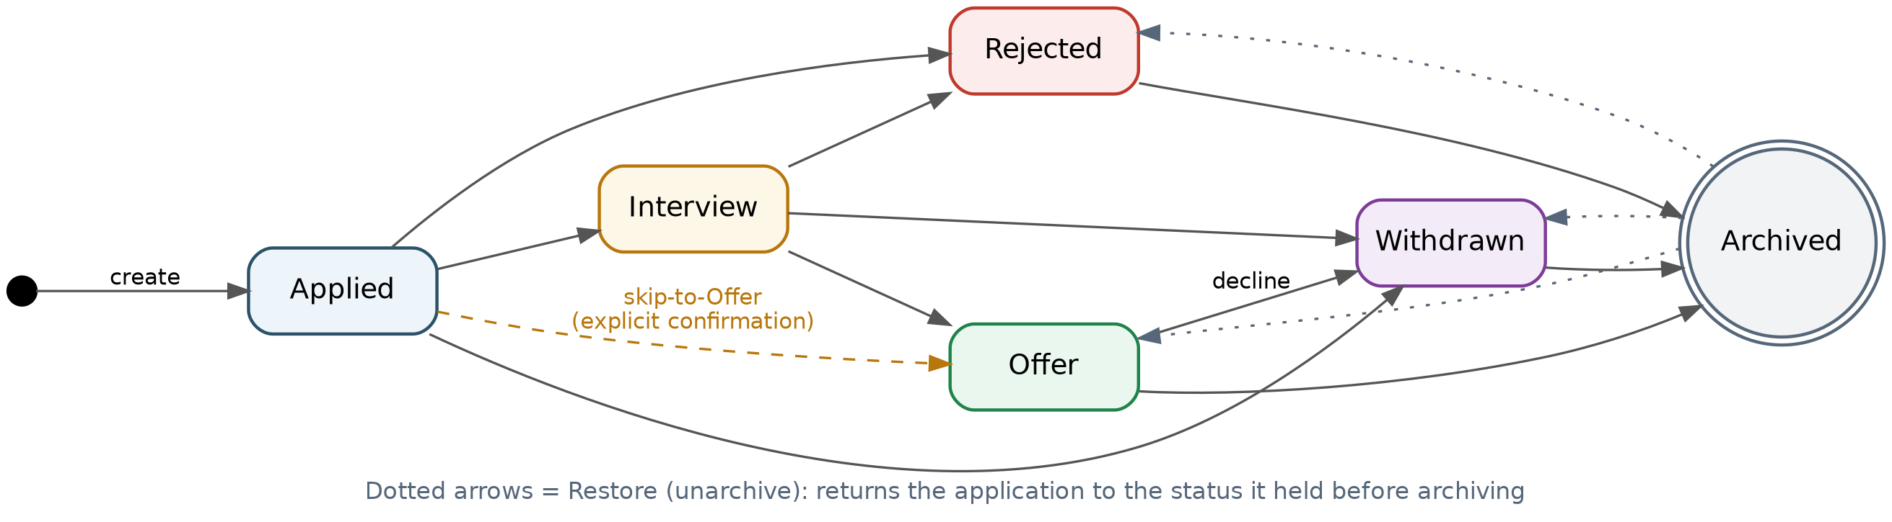
Figure 1. Application status workflow (state diagram), as implemented.

6.3 Allowed Transitions
From Status | Allowed To | Rule / Notes
Applied | Interview, Rejected, Withdrawn | Moving directly to Offer requires the explicit skip-to-Offer confirmation (see edge cases).
Interview | Offer, Rejected, Withdrawn | Multiple interview rounds are recorded as separate interview entries; the status stays Interview.
Offer | Withdrawn, Archived | Withdrawn is shown in the UI as 'Decline offer'.
Rejected | Archived | Rejected applications can only move to Archived.
Withdrawn | Archived | Withdrawn applications can only move to Archived.
Archived | (none via normal flow) | Only the 'Restore application' (unarchive) action applies; it returns the application to the status it held immediately before archiving.

6.4 Edge Cases and Validation Rules
- Direct Applied → Offer: permitted only when the user confirms 'Skip straight to offer?'. The skip-to-Offer override is rejected for any other transition.
- Selecting the status the application already has is rejected with a message.
- An archived application cannot change status except through Restore. Note: in this build, field edits (e.g. company name) are still accepted on archived applications; locking archived records against editing is deferred.
- Every status change, including a restore, is written to the status history with previous status, new status and timestamp; the user is identified through the application's owner.
- A follow-up due date cannot be in the past when the follow-up is created or edited. Overdue is calculated when data is read, using the current UTC date.
- Permanent deletion of applications is not available (FR-APP-07 deferred). Interview rounds and follow-ups can be permanently deleted after a confirmation dialog.
- Resume file names must be unique per user; uploading a resume with an existing name is rejected and the user is asked to rename it or select the existing version. Only PDF, DOC and DOCX files are accepted.
- Platform is free text; filtering and dashboard grouping treat platform names case-insensitively.
- Field limits: company name and role title 150 characters, platform 50, links 2,048 (must start with http:// or https://), interview and follow-up titles 150, notes 4,000.

7. Use Case Model
JobTrack has a single actor, the Job Seeker (the authenticated end user). The diagram shows the use cases available to this actor, with <<include>> relationships for mandatory sub-behaviour (e.g. every status change is confirmed and logged to history) and <<extend>> relationships for optional behaviour (e.g. recording links while editing an application).
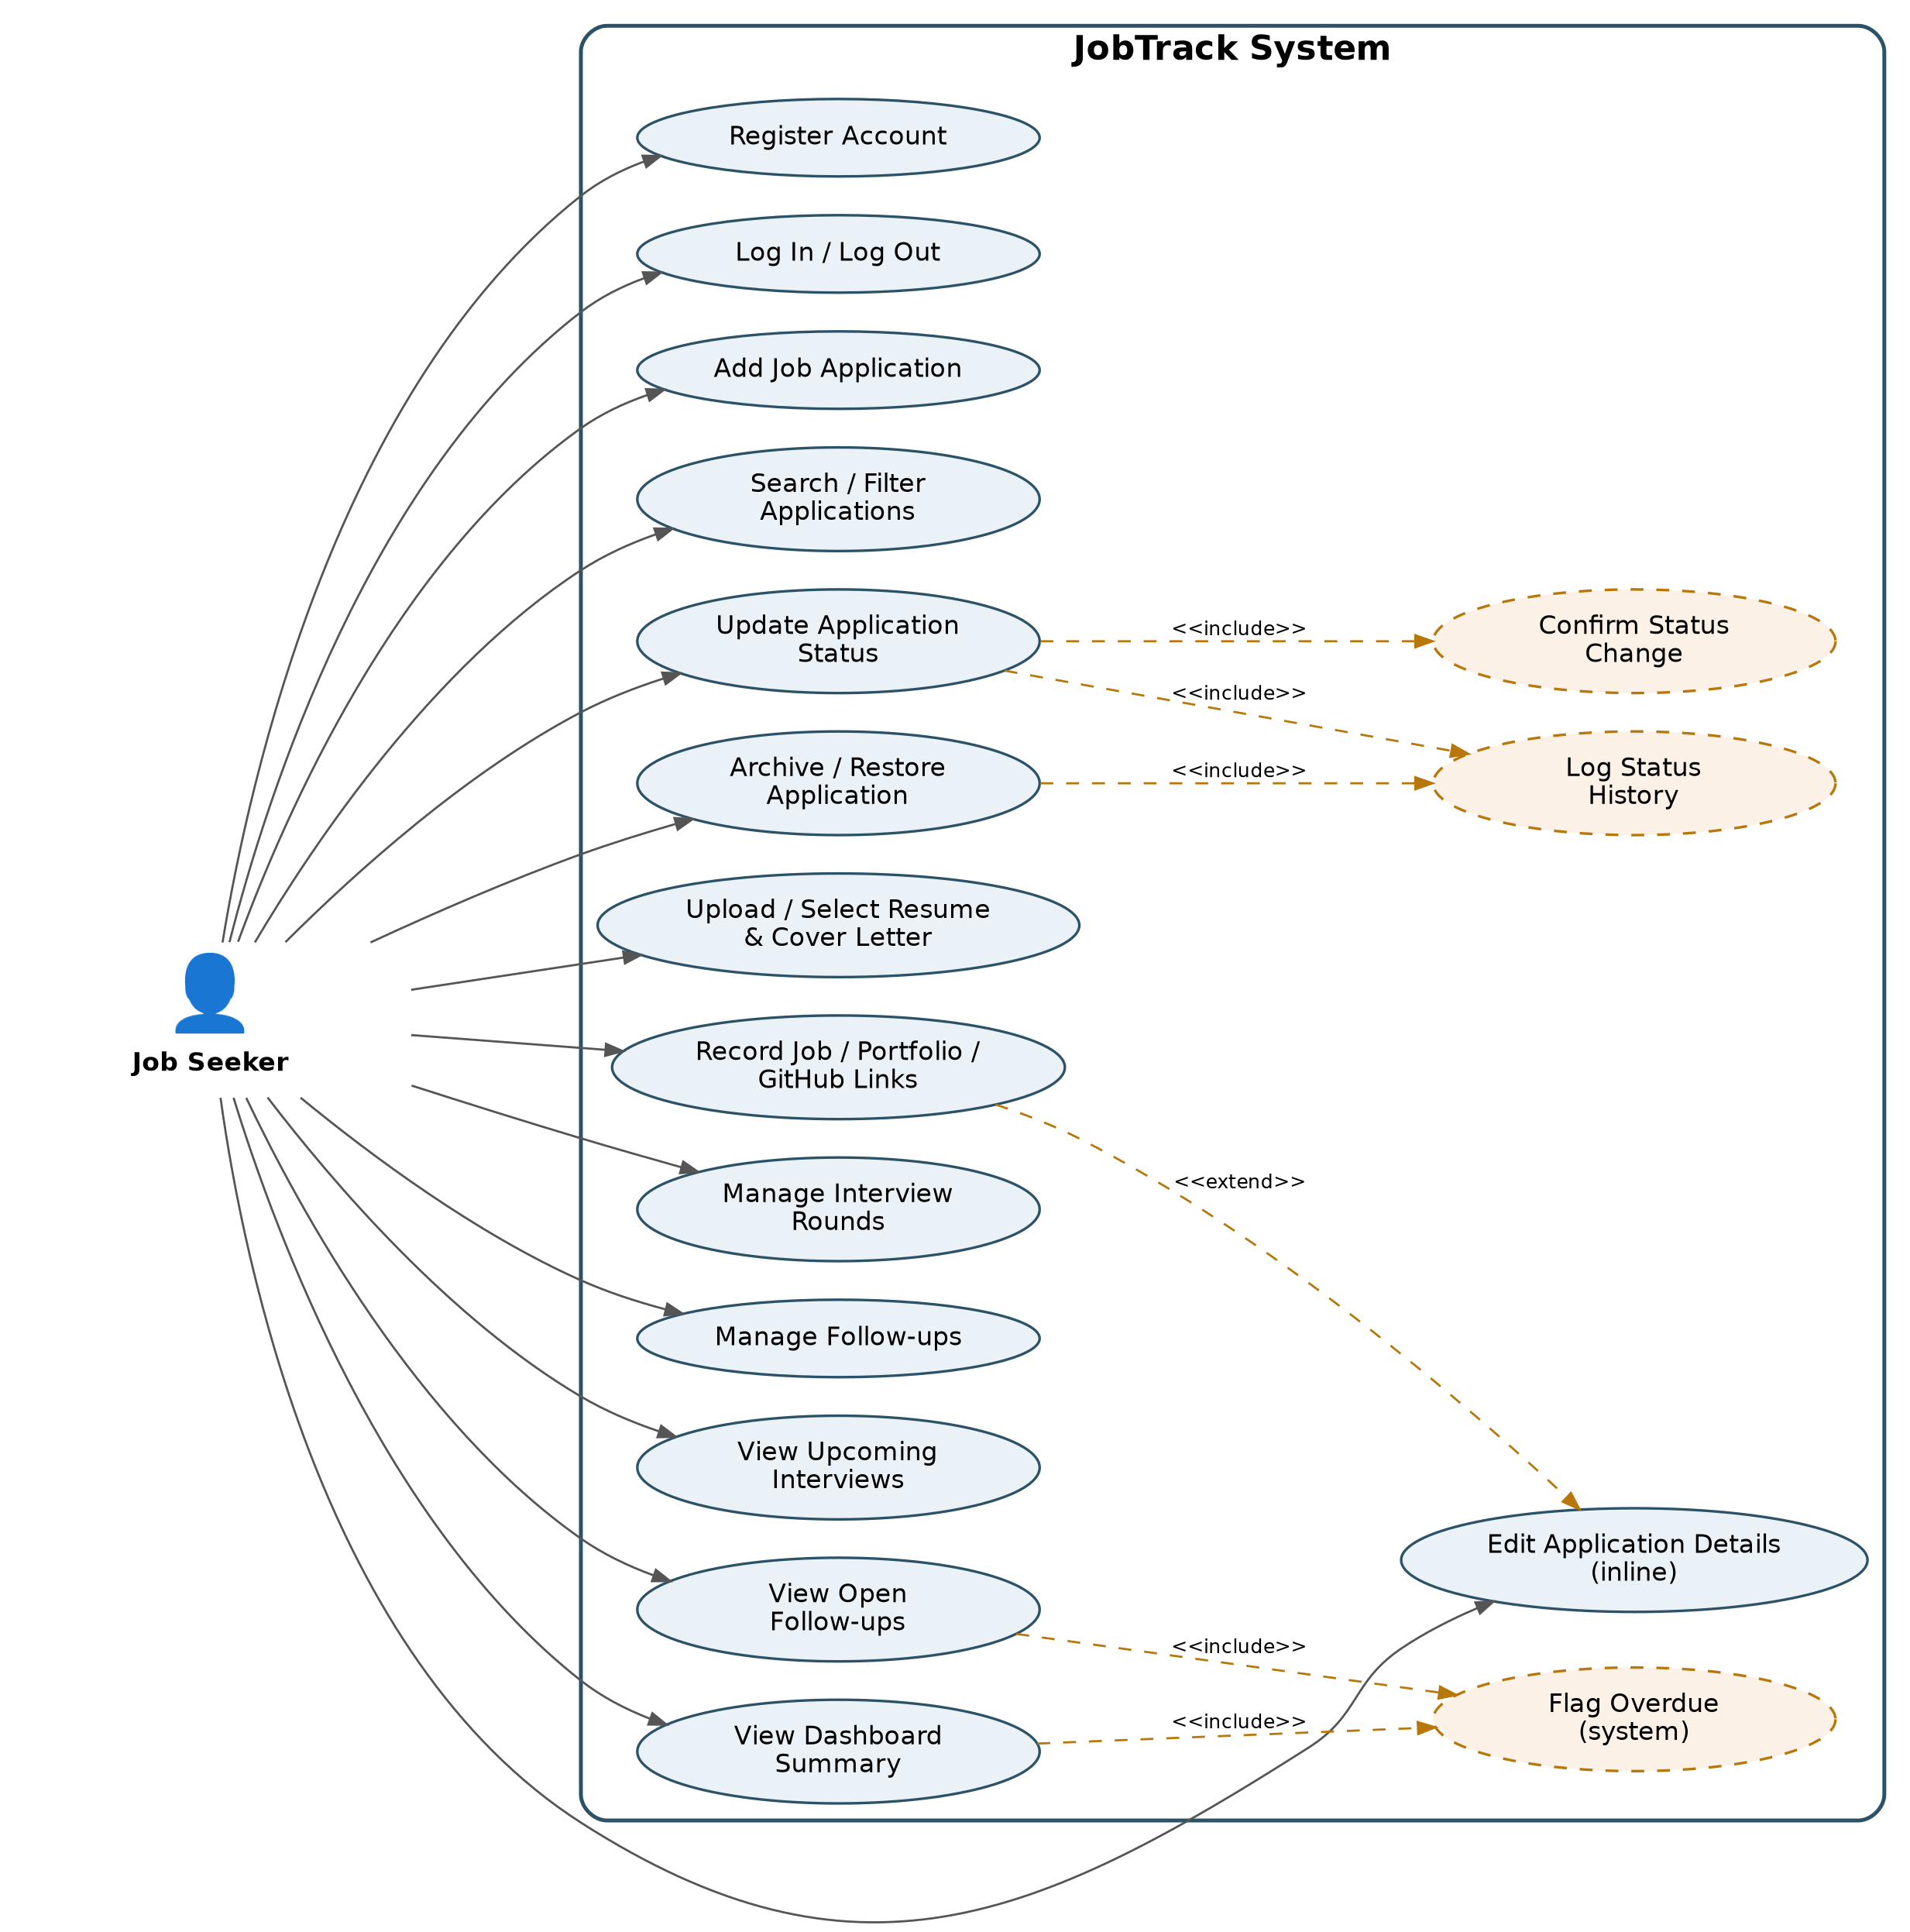
Figure 2. JobTrack use case diagram (as implemented).

7.1 Use Case Descriptions

UC-01 Add Job Application
Field | Description
Actor | Job Seeker
Precondition | User is logged in.
Main Flow | User selects 'Add opportunity' → enters company name, role title and platform (mandatory) and optionally job listing, portfolio and GitHub links → selects 'Create job application'. The form validates required fields and URL format before sending.
Postcondition | A new application is created with status 'Applied' and today's date, and appears in the user's application list. Documents, interviews and follow-ups are added afterwards on the detail page.
Related Requirements | FR-APP-01, FR-DOC-03

UC-02 Update Application Status
Field | Description
Actor | Job Seeker
Precondition | The application exists, belongs to the user and is not Archived.
Main Flow | User opens the application → selects one of the next-step actions shown for the current status (e.g. 'Move to interview', 'Record an offer', 'Mark as rejected', 'Withdraw application') → confirms the dialog → the API validates the transition against the workflow rules (Section 6).
Postcondition | The status is updated and a history entry is logged; an invalid transition is rejected with an explanation. Cancelling the dialog leaves the status unchanged.
Related Requirements | FR-STA-01/02/03/04/05

UC-03 Manage Interview Rounds & Follow-ups
Field | Description
Actor | Job Seeker
Precondition | The application exists and belongs to the user.
Main Flow | On the application detail page, user adds an interview round (title, type, date and time, optional location, meeting link, contact details, notes) and/or a follow-up (title, due date, notes). User can later edit or delete either, and mark follow-ups done or reopen them.
Postcondition | Interview rounds and follow-ups are saved and shown on the application, the Interviews and Follow-ups pages, and the dashboard where relevant.
Related Requirements | FR-INT-01/02/03/04/05/06

UC-04 View Dashboard Summary
Field | Description
Actor | Job Seeker
Precondition | User is logged in.
Main Flow | User opens the dashboard → system computes the active application count, counts by status and platform, interviews in the next 7 days and overdue follow-ups → displays the summary. User can mark an overdue follow-up done or open the related application.
Postcondition | Dashboard reflects the current state of the user's non-archived applications.
Related Requirements | FR-DASH-01/02/03/04/05

UC-05 Search / Filter Applications
Field | Description
Actor | Job Seeker
Precondition | User is logged in.
Main Flow | User types in the search box (company or role) and/or opens Filters and sets status, platform and date range → selects 'Apply filters' → system returns matching records one page at a time. 'Clear all' resets search and filters.
Postcondition | Only matching application records are displayed; a 'No opportunities match' message is shown when nothing matches.
Related Requirements | FR-APP-02/05/06

UC-06 Archive / Restore Application
Field | Description
Actor | Job Seeker
Precondition | The application belongs to the user and is in Offer, Rejected or Withdrawn status (to archive), or in Archived status (to restore).
Main Flow | User selects 'Archive application' and confirms → status becomes Archived. To restore, user filters the list by 'Archived', opens the application, selects 'Restore application' and confirms.
Postcondition | An archived application is hidden from the active list and dashboard counts but kept; a restored application returns to the status it held before archiving. Both changes are logged to history.
Related Requirements | FR-APP-04, FR-APP-06, Section 6.3

UC-07 Edit Application Details
Field | Description
Actor | Job Seeker
Precondition | The application exists and belongs to the user.
Main Flow | On the detail page, user selects the edit (pencil) icon next to company name, role title, platform, application date or a link → changes the value → saves (✓) or cancels (✗). Invalid values are reported inline and not saved.
Postcondition | The changed field is saved and shown immediately; other fields are unchanged.
Related Requirements | FR-APP-03, FR-DOC-03

UC-08 Manage Application Documents
Field | Description
Actor | Job Seeker
Precondition | The application exists and belongs to the user; S3 storage is configured.
Main Flow | In the Documents section, user either uploads a resume file (PDF, DOC, DOCX) or selects a saved resume from the list, and uploads (or replaces) a cover letter file. The browser uploads the file to S3 using a pre-signed URL and the API records it. User can preview either document.
Postcondition | The application shows the resume and cover letter used; a newly uploaded resume is added to the user's reusable library.
Related Requirements | FR-DOC-01/02/04/05

8. High-Level Data Model
The entity-relationship view below reflects the implemented Entity Framework Core model and PostgreSQL schema (table names shown).
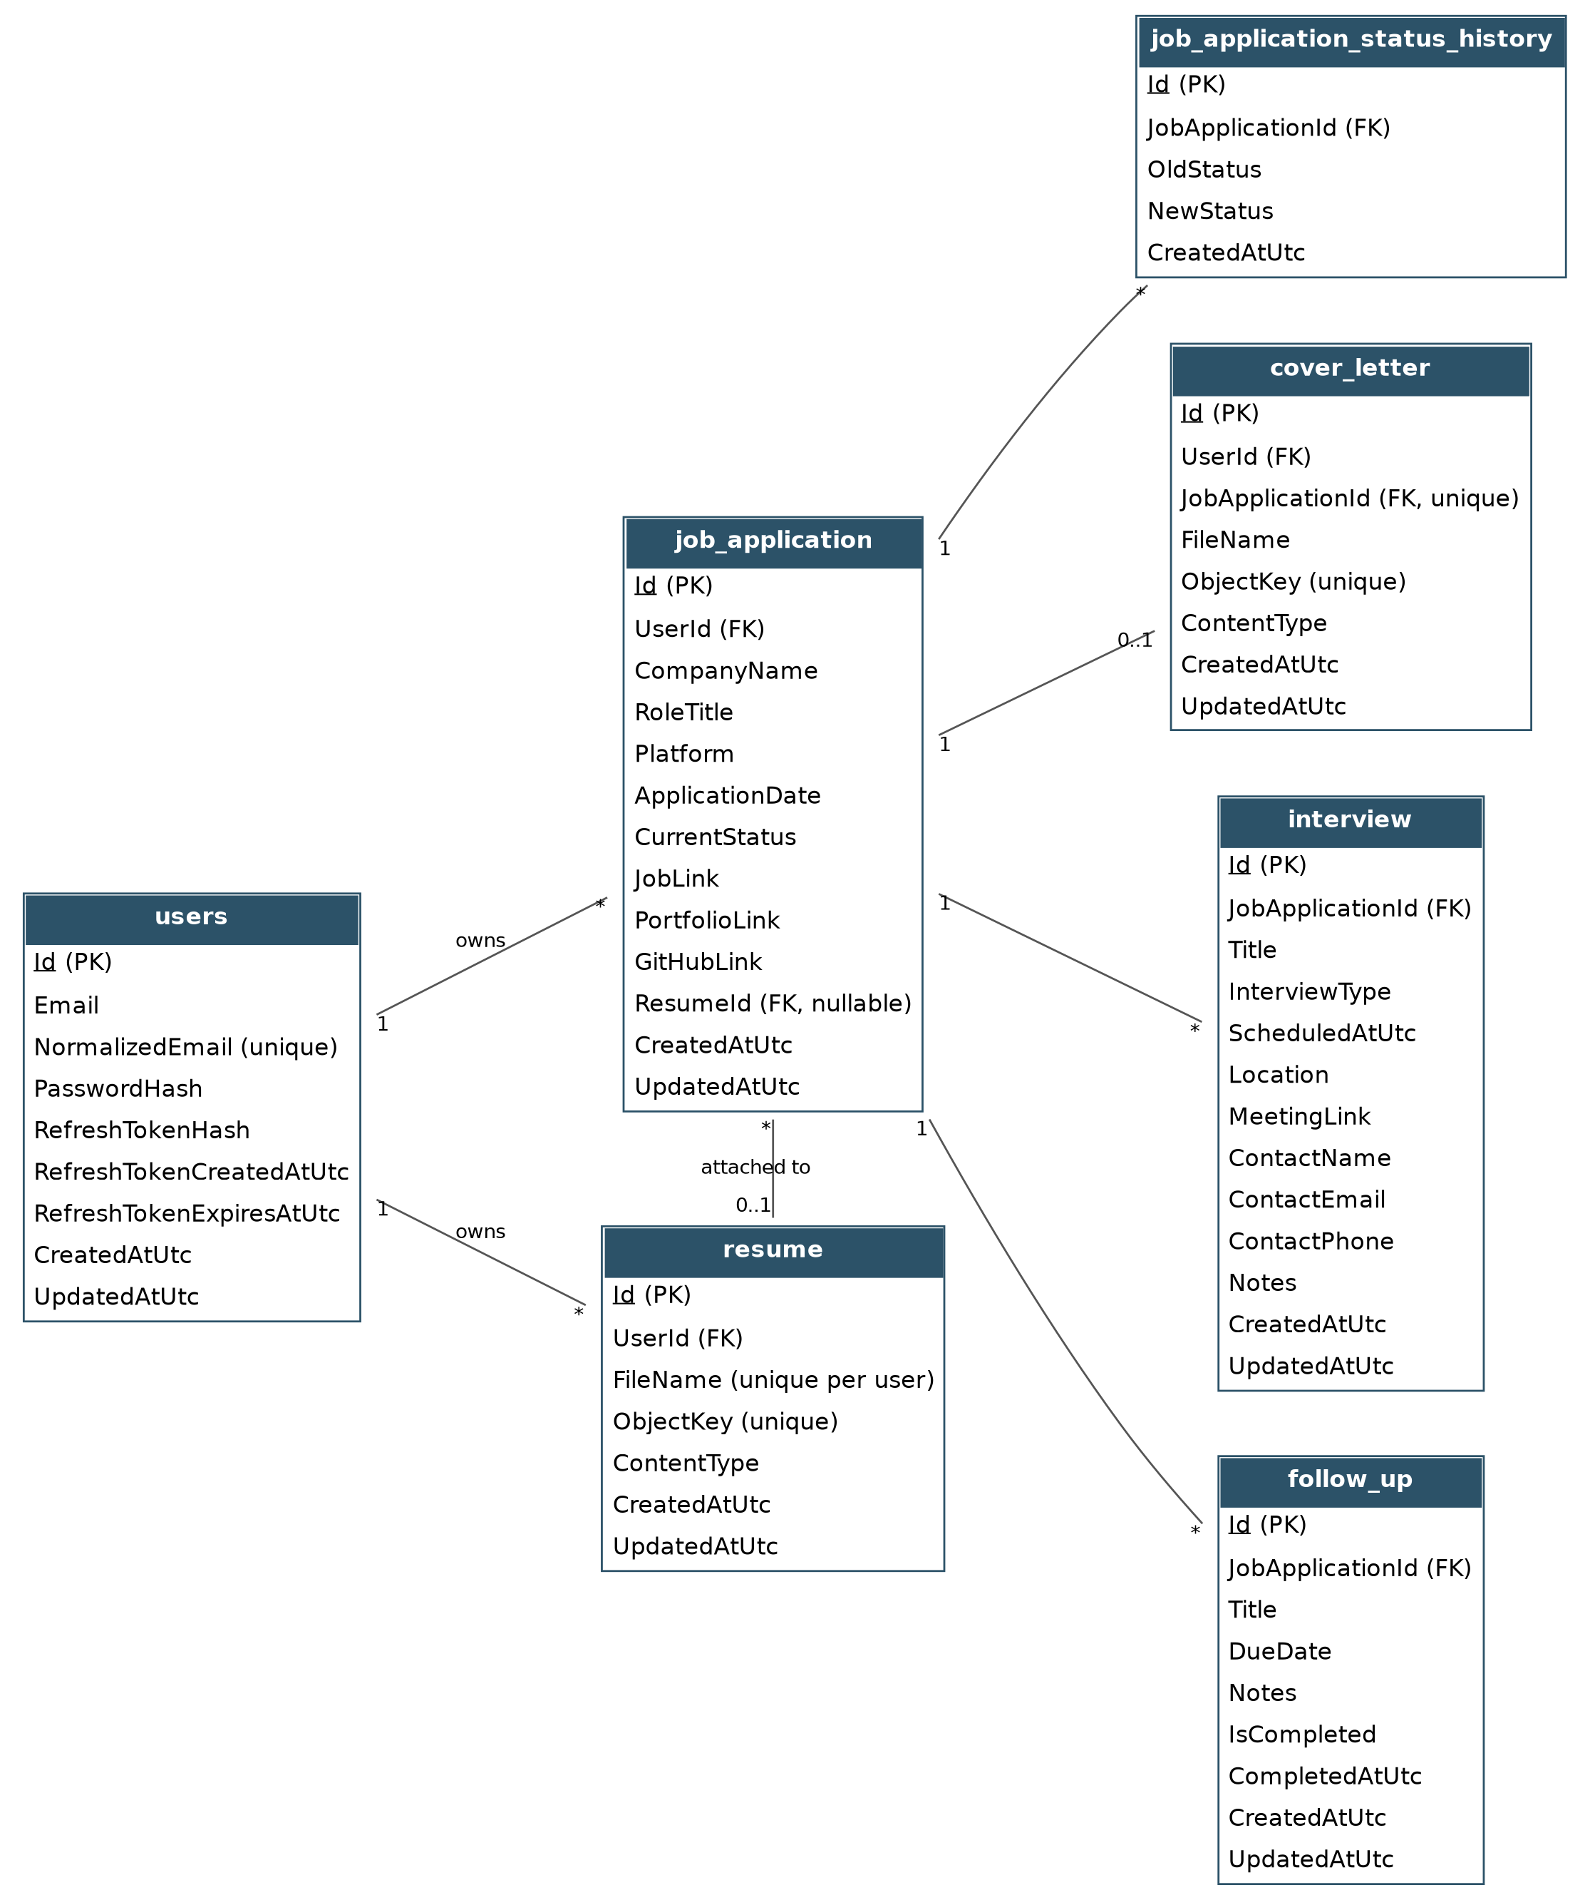
Figure 3. JobTrack entity-relationship diagram (as implemented).

Entity | Key Attributes | Notes
User (users) | Id, Email, NormalizedEmail, PasswordHash, RefreshTokenHash, RefreshTokenCreatedAtUtc, RefreshTokenExpiresAtUtc | One user owns many applications and resumes. Email is unique (case-insensitive).
JobApplication (job_application) | Id, UserId, CompanyName, RoleTitle, Platform, ApplicationDate, CurrentStatus, JobLink, PortfolioLink, GitHubLink, ResumeId | Core entity. ResumeId points to the resume version used (optional).
StatusHistory (job_application_status_history) | Id, JobApplicationId, OldStatus, NewStatus, CreatedAtUtc | One application has many status history entries.
Resume (resume) | Id, UserId, FileName, ObjectKey, ContentType | Reusable resume library per user; file name unique per user; file stored in AWS S3 under ObjectKey.
CoverLetter (cover_letter) | Id, UserId, JobApplicationId, FileName, ObjectKey, ContentType | At most one cover letter per application; file stored in AWS S3.
Interview (interview) | Id, JobApplicationId, Title, InterviewType, ScheduledAtUtc, Location, MeetingLink, ContactName, ContactEmail, ContactPhone, Notes | One application can have many interview rounds.
FollowUp (follow_up) | Id, JobApplicationId, Title, DueDate, Notes, IsCompleted, CompletedAtUtc | Used to compute overdue follow-ups for the dashboard and Follow-ups page.
All tables also hold CreatedAtUtc and UpdatedAtUtc audit columns. Primary keys are GUIDs.

9. User Stories and Acceptance Criteria
Story ID | User Story | Acceptance Criteria | Ref
US-01 | As a job seeker, I want to register and log in, so that my applications are private to me. | Given a new email and a password that meets the rules, when I register, then an account is created and I can log in; another user cannot view my data; when I log out, protected pages send me to the login page. | FR-AUTH-01/02/03/04/05
US-02 | As a job seeker, I want to add a new job application, so that I can start tracking it immediately. | Given company, role and platform, when I save, then the application appears in my list with status 'Applied' and today's date; missing mandatory fields are reported before saving. | FR-APP-01
US-03 | As a job seeker, I want to search and filter my applications, so that I can quickly find a specific one. | Given multiple applications, when I search by company or role, or filter by status, platform or date range, then only matching records are shown, and I can clear all criteria in one click. | FR-APP-02/05/06
US-04 | As a job seeker, I want to update an application's status, so that it reflects the real stage of the process. | Given an application in 'Applied', when I choose 'Move to interview' and confirm, then the status updates and a history entry is logged; only valid next steps are offered and invalid transitions are rejected with an explanation. | FR-STA-01/02/03/04/05
US-05 | As a job seeker, I want to record which resume and cover letter I used, so that I remain consistent if contacted. | Given an application, when I upload a resume or cover letter (PDF, DOC, DOCX) or select a saved resume, then it is shown on the application detail page and can be previewed. | FR-DOC-01/02/04/05
US-06 | As a job seeker, I want to record interview rounds and follow-ups, so that I don't miss important dates. | Given an application, when I add an interview round and a follow-up, then both appear on the application, the interview appears on the Interviews page and dashboard (if within 7 days), and the follow-up appears on the Follow-ups page. | FR-INT-01/02/03/05/06
US-07 | As a job seeker, I want to see overdue follow-ups on my dashboard, so that I know who to contact. | Given an open follow-up whose due date has passed, when I open the dashboard, then it appears in the overdue follow-ups list and I can mark it done there. | FR-INT-04, FR-DASH-03
US-08 | As a job seeker, I want a dashboard summary of my applications, so that I can review my progress at a glance. | Given any number of applications, when I open the dashboard, then I see the active count, counts by status and by platform, and upcoming interviews, excluding archived applications. | FR-DASH-01/02/04/05
US-09 | As a job seeker, I want to archive and restore applications, so that closed applications don't clutter my active list. | Given an Offer, Rejected or Withdrawn application, when I archive it, then it disappears from the active list and dashboard counts but is shown when I filter by 'Archived'; when I restore it, it returns to its previous status. | FR-APP-04, FR-APP-06
US-10 | As a job seeker, I want to keep my job listing, portfolio and GitHub links with each application, so that I can reopen them quickly. | Given an application, when I add or edit a link on the detail page, then it is saved and opens in a new tab; invalid URLs are rejected. | FR-APP-03, FR-DOC-03

10. Requirements Traceability
Each functional requirement links to one or more use cases (Section 7) and user stories (Section 9), and each story's acceptance criteria map to automated test IDs in the JobTrack automation suite (Web Application/automation-tests). API-… tests exercise the REST API directly; UI-… tests drive the application in a browser. Results are recorded per test ID (Pass / Fail / Blocked / Not run) in the test summary workbook.

10.1 Traceability Matrix
Requirement | Use Case | User Story | Automated Tests
FR-AUTH-01, 04 | — | US-01 | API-AUTH-01–04, UI-AUTH-02, 04–07
FR-AUTH-02 | — | US-01 | API-AUTH-05–09, UI-AUTH-02, 03, UI-NAV-03
FR-AUTH-03 | All | US-01 | API-AUTH-10, API-JA-07, 11, API-FU-07
FR-AUTH-05 | — | US-01 | UI-AUTH-01, UI-NAV-03
FR-APP-01 | UC-01 | US-02 | API-JA-01–05, UI-JA-02–05
FR-APP-02 | UC-05 | US-03 | API-SF-01, 08, 09, UI-JA-01, UI-SF-01
FR-APP-03 | UC-07 | US-10 | API-JA-06, 08–10, UI-JA-06, 07
FR-APP-04 | UC-06 | US-09 | API-WF-06–08, UI-WF-04
FR-APP-05, 06 | UC-05 | US-03 | API-SF-02–07, UI-SF-02–08
FR-STA-01–05 | UC-02 | US-04 | API-WF-01–05, 09, UI-WF-01–05
FR-DOC-01–05 | UC-08 | US-05, US-10 | Manual testing (requires S3 credentials); API-JA-10 for links
FR-INT-01, 02, 05 | UC-03 | US-06 | API-IV-01–05
FR-INT-03, 04, 06 | UC-03 | US-06, US-07 | API-FU-01–07, UI-FU-01–05
FR-DASH-01–05 | UC-04 | US-07, US-08 | API-DB-01–04, UI-NAV-01, 02

10.2 Implementation Status
Requirement | Implementation note | Status
FR-AUTH-01–05 | Email/password registration and login with JWT access and refresh tokens. | Implemented
FR-APP-01–06 | Application date is set automatically; job listing link added; archive is part of the status workflow. | Implemented (changed)
FR-APP-07 | No permanent delete; archive/restore is used instead. | Deferred
FR-STA-01–02, 04–05 | Workflow enforced in the API; UI shows only valid actions with confirmation. | Implemented
FR-STA-03 | History is stored for every change but is not yet displayed in the UI. | Partially implemented
FR-DOC-01–05 | Real file uploads to AWS S3 instead of typed version names; reusable resume library. | Implemented (changed)
FR-INT-01–06 | Contacts recorded per interview round; follow-ups are separate items; new Interviews and Follow-ups pages. | Implemented (changed)
FR-DASH-01–05 | Dashboard shows active count, status and platform counts, upcoming interviews, overdue follow-ups. | Implemented
FR-DASH-06 | No period-based outcome summary. | Deferred
Known issue: clearing a saved link from the detail page sends an empty value that the API's URL validation rejects (automated test API-JA-10). Confirm against the latest test run before release.

11. Sign-off
This document is considered approved as the version 2.0 (as-built) baseline once reviewed and accepted by the project team and, where required, the unit coordinator.
Name | Role | Signature | Date
Trinh Hieu Tran (s394100) | Developer and DBA
Pooja Tiwari (s396163) | Business Analyst, Report Analyst, Data Analyst (DA) and Quality Assurance (QA)
Prince Kumar Sah (s388535) | Data Analyst and Tester

