USER MANUAL
JobTrack
Job Application Tracking System
Version 1.0
Group 3
Prepared by: Pooja Tiwari (s396163)
Business Analyst, Report Analyst, Data Analyst and QA
Date: 5 October 2026

Table of Contents
1. About JobTrack 3
2. Before you start 4
3. Your account: sign up, sign in and sign out 5
4. Finding your way around 7
5. The Dashboard 8
6. Adding a job application 10
7. Viewing and editing an application 12
8. Moving an application through its stages 14
9. Interviews 16
10. Follow-ups 18
11. Resumes and cover letters 20
12. Searching and filtering your applications 21
13. Troubleshooting and FAQ 23
14. Quick reference and glossary 25

1. About JobTrack
JobTrack is a private workspace for your job search. It keeps every job application, interview, follow-up and the resume and cover letter you sent in one place, so you always know where each opportunity stands and what to do next.
With JobTrack you can:
- Record each application with the company, role, platform and useful links.
- Move each application through its stages: Applied, Interview, Offer, Rejected, Withdrawn and Archived.
- Schedule interview rounds with times, meeting links and contact details.
- Set follow-up reminders and see which ones are overdue.
- Attach the exact resume and cover letter you used.
- See your whole job search at a glance on the Dashboard.

Your data is private. Only you can see the applications, documents, interviews and follow-ups in your account.
How to use this manual. Sections 3 to 5 cover signing in and finding your way around. Sections 6 to 12 each cover one task, with numbered steps. If something doesn't work as expected, go to Section 13. Words in bold are the exact labels you will see on screen.

2. Before you start
You only need a web browser and the JobTrack web address. JobTrack runs on your computer in this release, so someone in your team must have started it first.
You need | Details
A web browser | A current version of Chrome, Edge or Firefox on a laptop or desktop. A window at least 1024 pixels wide works best.
The JobTrack address | Usually http://localhost:5173. Ask the person who set it up if a different address was used.
An email address | Used as your sign-in name. It does not need to be verified.
Your documents (optional) | Your resume and cover letters as PDF, DOC or DOCX files, if you want to attach them.

If the page doesn't load at all, JobTrack is not running. See Section 13.
Dates and times. JobTrack shows dates like 5 October 2026 and shows all times in Sydney time (Australia/Sydney).

3. Your account: sign up, sign in and sign out
You need an account before you can use JobTrack. Opening any JobTrack page while signed out takes you to the sign-in page.
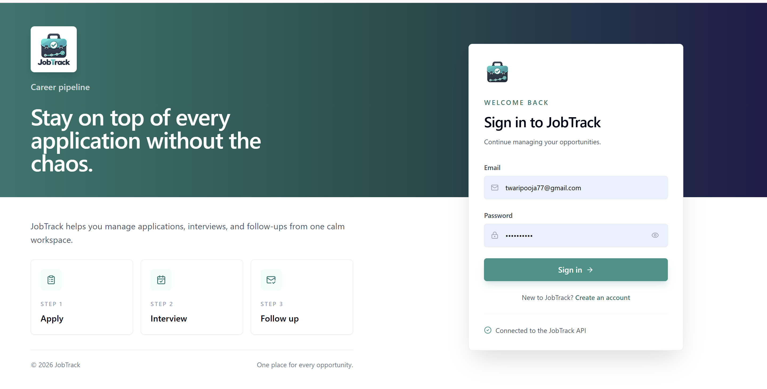
Figure 1. The JobTrack sign-in page

Create an account
- Open JobTrack. The Sign in to JobTrack page appears.
- Under the sign-in button, select Create an account.
- Enter your Email and a Password that meets the rules below.
- Select Create account.
- The message Account created. Please sign in. appears and you return to the sign-in form. Sign in with your new details.

Your password must have:
- 8 to 128 characters
- at least one uppercase letter (A–Z)
- at least one lowercase letter (a–z)
- at least one number (0–9)
- at least one special character, such as ! @ # or $

Example of a valid password: Str0ng!Pass. Select the eye icon in the password box to show or hide what you typed.

Sign in
- On the sign-in page, enter your Email and Password.
- Select Sign in. The Dashboard opens.

If you see Invalid email or password., check both and try again. The message is the same for an unknown email and a wrong password, to protect your privacy.

Staying signed in
JobTrack keeps you signed in on the same browser, and renews your session automatically in the background. You don't need to sign in each time you open it unless you sign out.

Sign out
- In the left sidebar, select Sign Out at the bottom.
- In the confirmation box, select Logout.

You return to the sign-in page. Always sign out on a shared or public computer.
Note: There is no password reset in this version. Keep your password somewhere safe.

4. Finding your way around
Every page has the same layout: a sidebar on the left to move between pages, and a header at the top showing the page name and your email address.
Sidebar item | What you do there
Dashboard | See your whole job search at a glance (Section 5).
Job application | List, search, add and open your applications (Sections 6, 7 and 12).
Interviews | See upcoming interview rounds across all applications (Section 9).
Follow-ups | See every open follow-up, sorted by when it is due (Section 10).
Sign Out | Sign out of JobTrack (Section 3).

On a small screen the sidebar is hidden. Select the menu icon at the top left to open it, and the X to close it.
Confirmation boxes. Before anything that can't easily be undone, such as a status change or a delete, JobTrack asks you to confirm. Read the message, then choose the action button to continue or the other button to cancel.
Messages. A short message appears at the corner of the screen after most actions, for example Send thank-you email added. Errors in forms appear in red under the field to fix.

5. The Dashboard
The Dashboard is the first page after you sign in. It answers three questions: how many applications are active, what is coming up this week, and what is overdue.
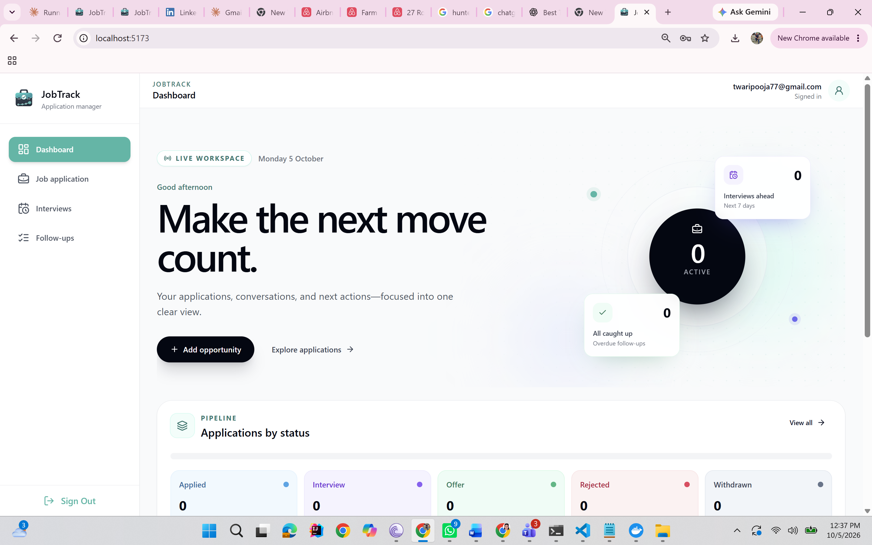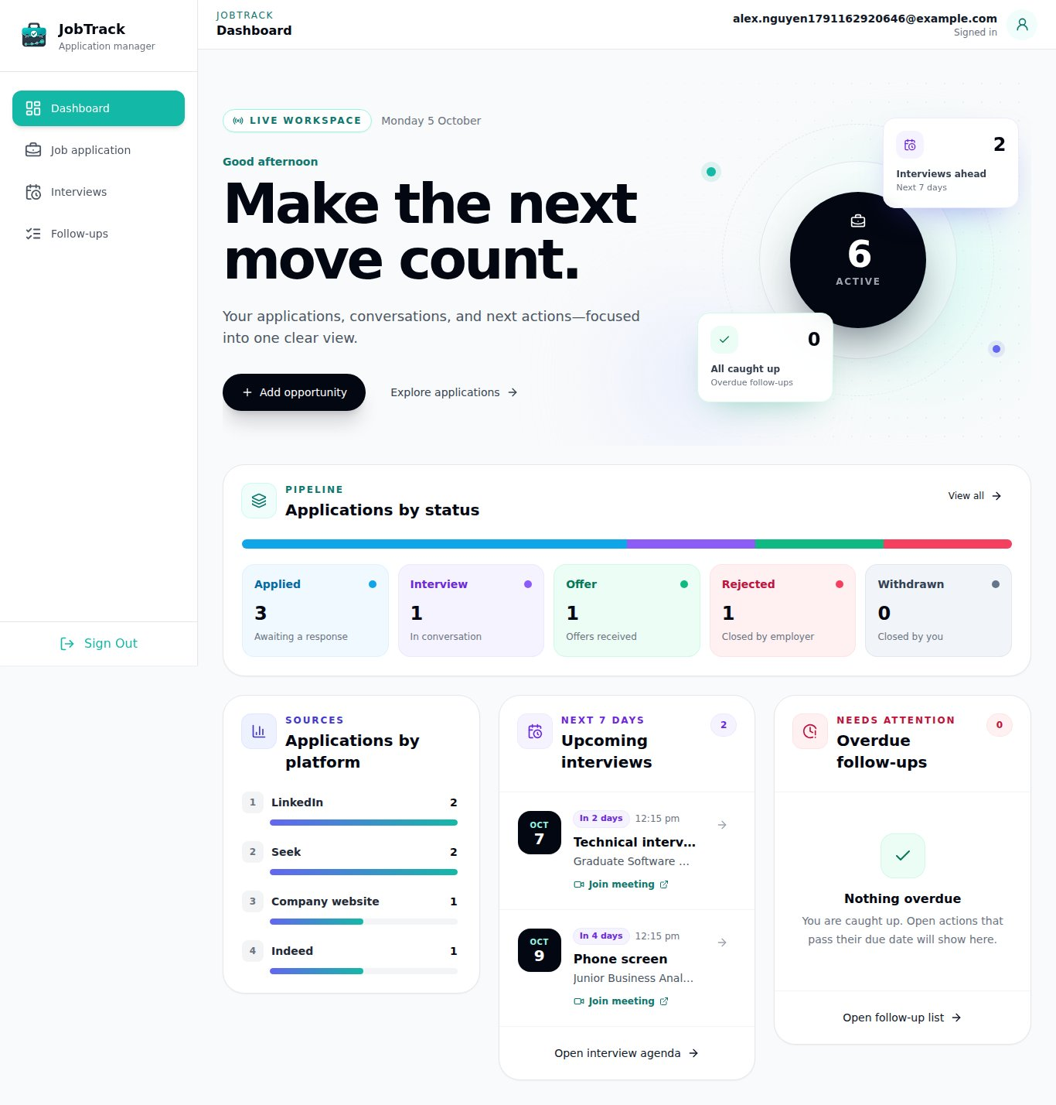
Figure 2. The Dashboard with sample data
Area | What it shows
Active count (the circle at the top) | Applications that are not archived. Select it to open your application list.
Interviews ahead and All caught up tiles | How many interviews are coming up and how many follow-ups are overdue.
Applications by status | A count for Applied, Interview, Offer, Rejected and Withdrawn. Archived applications are not counted.
Applications by platform | How many active applications came from each platform, such as LinkedIn or Seek.
Upcoming interviews | Interviews in the next 7 days, with time and meeting link. Select one to open its application.
Overdue follow-ups | Follow-ups whose due date has passed. Select the circle to mark one done. Nothing overdue means you are up to date.

Use Add opportunity on the Dashboard to add a new application without leaving the page.

6. Adding a job application
Add an application as soon as you apply. JobTrack sets the date to today and the status to Applied for you.
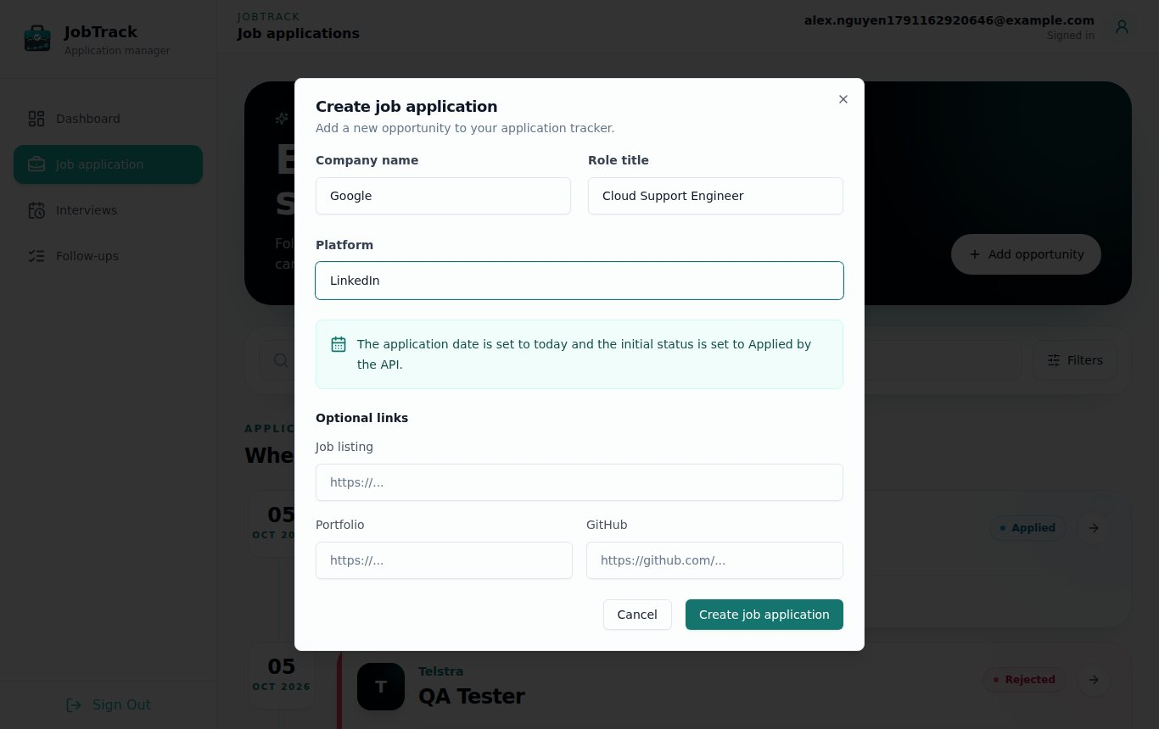
Figure 3. The Create job application form
- In the sidebar, select Job application.
- Select Add opportunity (top right of the banner). The Create job application form opens.
- Fill in the required fields: Company name, Role title and Platform (where you found the job, such as LinkedIn, Seek or Company website).
- Optionally add links under Optional links: Job listing, Portfolio and GitHub. Each must start with http:// or https://.
- Select Create job application.

The form closes and the application appears at the top of your list. To leave without saving, select Cancel.
Field | Required | Limit
Company name | Yes | 150 characters
Role title | Yes | 150 characters
Platform | Yes | 50 characters
Job listing, Portfolio, GitHub links | No | Must be a full web address starting with http:// or https://

Tips
- Type the platform the same way each time (for example always LinkedIn). Capital letters don't matter, but spelling does, for filters and the Dashboard.
- If you applied on a different day, add the application now and change the Application date on its detail page (Section 7).
- Add your resume, cover letter, interviews and follow-ups after saving, from the application's detail page.

If you see Company name is required (or similar), that field is empty. If you see Enter a valid HTTP or HTTPS URL, the link is missing http:// or https://.

7. Viewing and editing an application
Each application has its own detail page that holds everything about it: its details, current stage, interviews, follow-ups, documents and links.
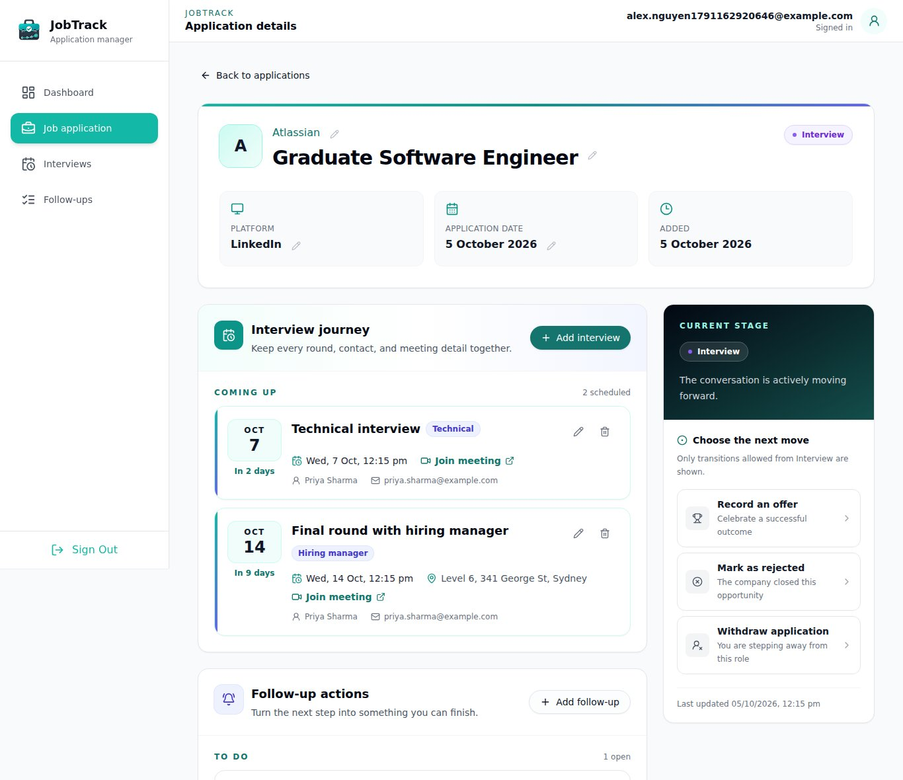
Figure 4. An application's detail page

Open an application
- In the sidebar, select Job application.
- Select the application's card. Its detail page opens.
- To go back, select Back to applications at the top.

What's on the detail page
Part of the page | What it holds
Header | Company name, role title and the current status badge (for example Interview).
Platform, Application date, Added | Where you applied, when you applied, and when you added it to JobTrack.
Current stage panel (right) | The status actions you can take next (Section 8).
Interview journey | Your interview rounds (Section 9).
Follow-up actions | Your reminders for this application (Section 10).
Application documents | The resume and cover letter you used (Section 11).
Application links | Job listing, portfolio and GitHub links. Select a link to open it in a new tab.

Edit a detail
You can change the company name, role title, platform, application date and links right on the page.
- Select the pencil icon next to the item you want to change.
- Type the new value, or pick a new date.
- Select the tick to save, or the cross to cancel.

If a value isn't allowed, a red message explains why and nothing is saved. To add a missing link, select Add link under it.
Note: The status and documents have their own controls (Sections 8 and 11). You can't change them with the pencil icon.

8. Moving an application through its stages
Every application has one status that shows where it stands. JobTrack only offers the next steps that make sense, and asks you to confirm each change because it can't be undone.
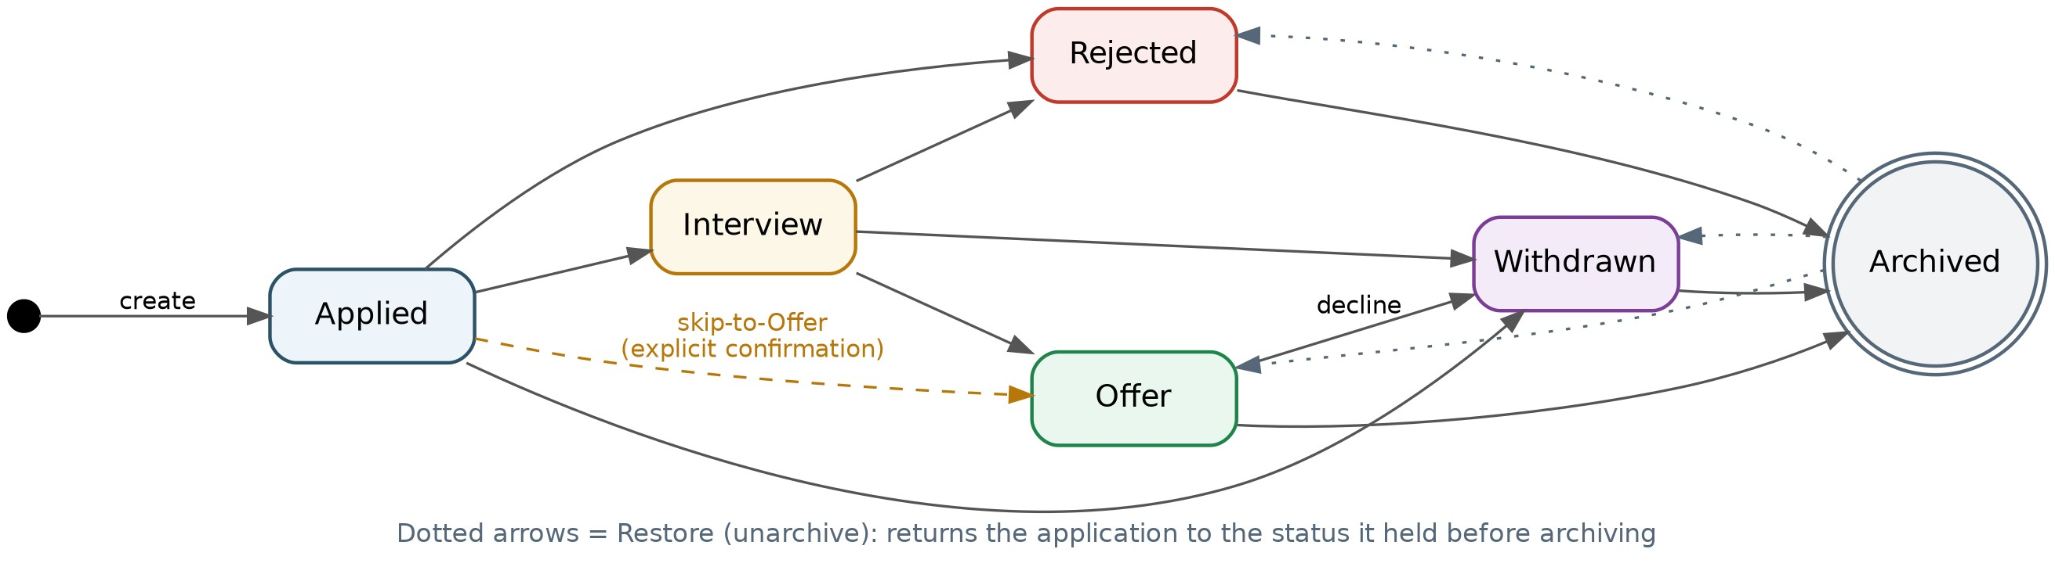
Figure 5. How an application moves between statuses
Status | Meaning | What you can do next
Applied | You sent the application and are waiting to hear back. | Move to interview, Record an offer, Mark as rejected, Withdraw application
Interview | The employer contacted you and interviews are under way. | Record an offer, Mark as rejected, Withdraw application
Offer | You received a job offer. | Decline offer, Archive application
Rejected | The employer said no. | Archive application
Withdrawn | You stepped away, or declined an offer. | Archive application
Archived | Closed and hidden from your active list and Dashboard counts. | Restore application

Change the status
- Open the application (Section 7).
- In the Current stage panel, select the action you want, for example Move to interview.
- Read the confirmation message and select the button that confirms the change, for example Move to Interview.

The status badge updates straight away. To back out, select Keep current status instead.
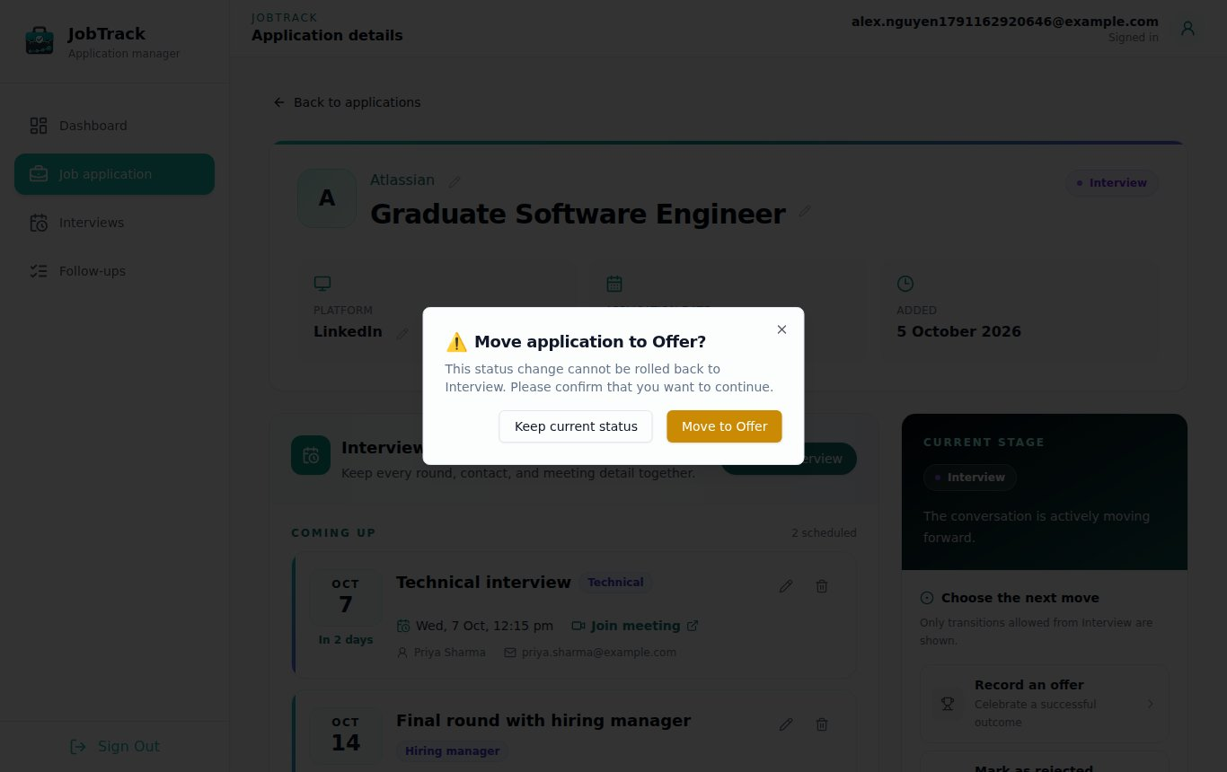
Figure 6. The confirmation box before a status change

Got an offer without an interview?
From Applied, select Record an offer. JobTrack asks Skip straight to offer? because this skips the Interview stage. Select Record offer to confirm.

Archive an application
Archive applications that are finished (Offer, Rejected or Withdrawn) to keep your list tidy. Nothing is deleted.
- Open the application and select Archive application.
- Select Archive to confirm.

Find and restore an archived application
- Go to Job application, select Filters and set Status to Archived, then select Apply filters (Section 12).
- Open the application.
- Select Restore application, then confirm.

The application returns to the status it had just before you archived it.
Note: Applications can't be permanently deleted in this version. Archive them instead.

9. Interviews
Record each interview round separately, so a phone screen, a technical interview and a final round each keep their own time, link and contact.

Add an interview round
- Open the application (Section 7).
- In Interview journey, select Add interview.
- Enter a Title (for example Technical interview) and an Interview type. Type your own, or pick a suggestion such as Phone screen, Technical, Behavioural, Recruiter or Hiring manager.
- Set the date and time.
- Optionally add a location, meeting link, contact name, contact email, contact phone and notes.
- Select Add interview.

The round appears in Interview journey, ordered by date.
Tip: Adding an interview doesn't change the application's status. Use Move to interview (Section 8) when the first interview is booked.

Edit or delete a round
- To change a round, select its pencil icon, update the details and select Save interview.
- To remove a round, select its bin icon, then Delete interview to confirm. This can't be undone.

The Interviews page
The Interviews page lists every upcoming interview across all your applications, grouped by day.
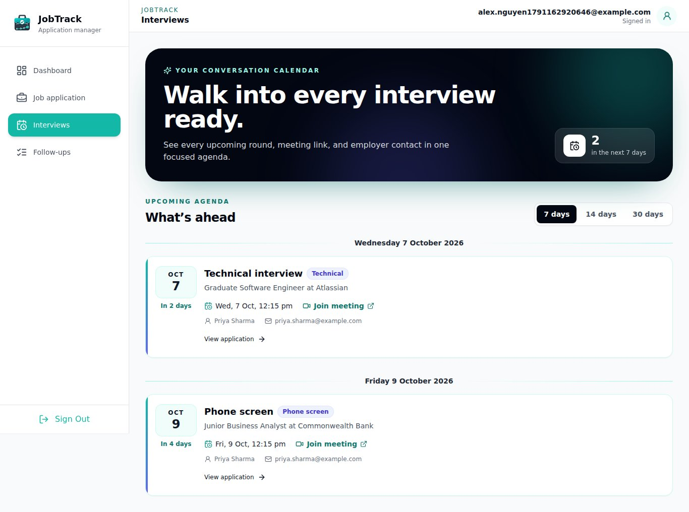
Figure 7. The Interviews page
- In the sidebar, select Interviews.
- Choose how far ahead to look: 7 days, 14 days or 30 days.
- Select View application under an interview to open its application.

Interviews in the next 7 days also appear on the Dashboard.

10. Follow-ups
A follow-up is a reminder to do something for an application by a certain date, such as sending a thank-you email or checking on your application. JobTrack marks it overdue if the date passes and you haven't marked it done.

Add a follow-up
- Open the application (Section 7).
- In Follow-up actions, select Add follow-up.
- Enter a Title (for example Send thank-you email) and a Due date. The due date can be today or later, not in the past.
- Optionally add Notes, such as what to mention.
- Select Add follow-up.

Mark a follow-up done, or reopen it
- Select the circle next to the follow-up to mark it done.
- Select it again to reopen it if you marked it by mistake.

You can also mark overdue follow-ups done straight from the Dashboard.

Edit or delete a follow-up
- To change a follow-up, select its pencil icon, update it and select Save follow-up.
- To remove it, select its bin icon, then Delete follow-up to confirm. This can't be undone.

The Follow-ups page
The Follow-ups page lists every open follow-up across all your applications, sorted by due date. The numbers at the top show how many are Open and how many are Overdue.
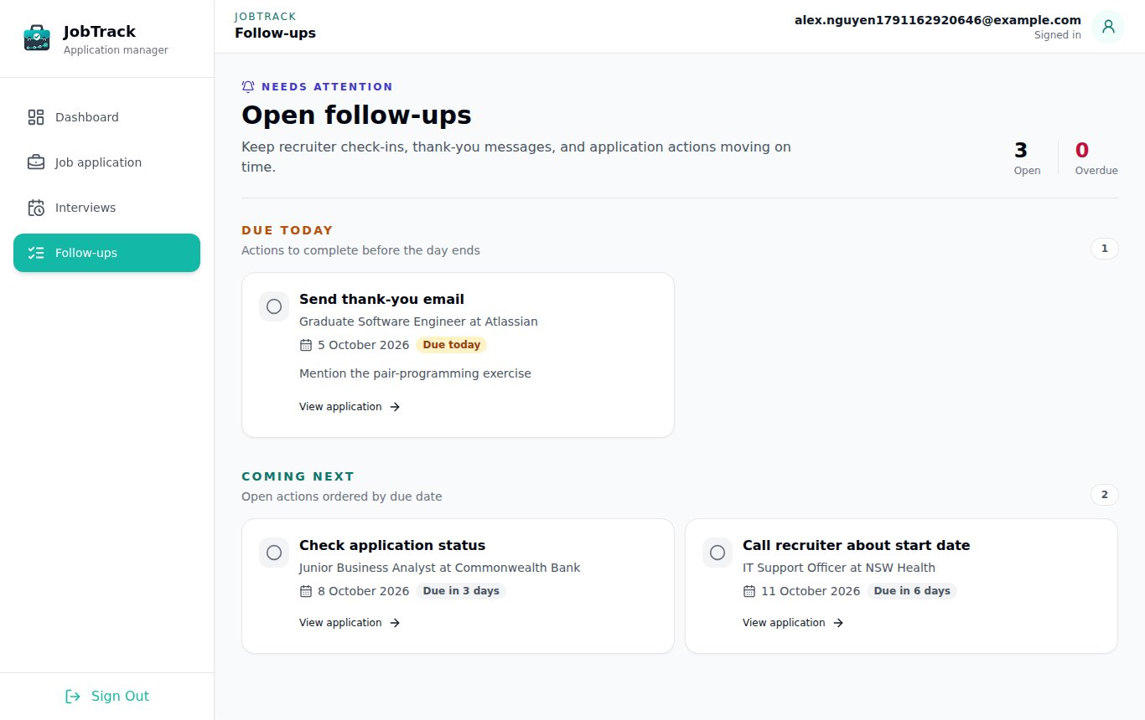
Figure 8. The Follow-ups page
Follow-ups are grouped by urgency:
- Overdue: the due date has passed. Do these first.
- Due today: due today.
- Coming next: due on a later date.

Select View application under a follow-up to open its application.

11. Resumes and cover letters
Record the exact resume and cover letter you sent, so you know what the employer has in front of them when they call. Each application holds one resume and one cover letter. Both show Not recorded until you add them.
Files must be PDF, DOC or DOCX, with a file name of up to 255 characters.

Add a resume
JobTrack keeps a library of every resume you upload, so you can reuse one without uploading it again.
To use a resume you uploaded before:
- Open the application and go to Application documents.
- Under Resume, open Select a saved resume and pick it from the list.

To upload a new resume:
- Under Resume, select Upload resume.
- Choose one file from your computer.

The new resume is attached to this application and added to your library for next time.
Tip: Give each resume version a clear file name, such as Alex_Nguyen_Resume_Data_v2.pdf. JobTrack won't accept two resumes with the same file name. If you see A resume version named … already exists, rename the file or select the saved version instead.

Add or replace a cover letter
- Under Cover letter, select Upload cover letter.
- Choose one file from your computer.

To replace it later, select Change cover letter and choose the new file. Cover letters are kept per application and aren't shared between applications.

View a document
Select the recorded resume or cover letter to preview it.
Note: Uploading and previewing documents needs the file storage your team configured. If uploads fail with an error, contact the person who set up JobTrack (Section 13).

12. Searching and filtering your applications
The Job application page lists your active applications, newest first, 20 per page. Use search and filters to find one quickly, or to check whether you've already applied somewhere.
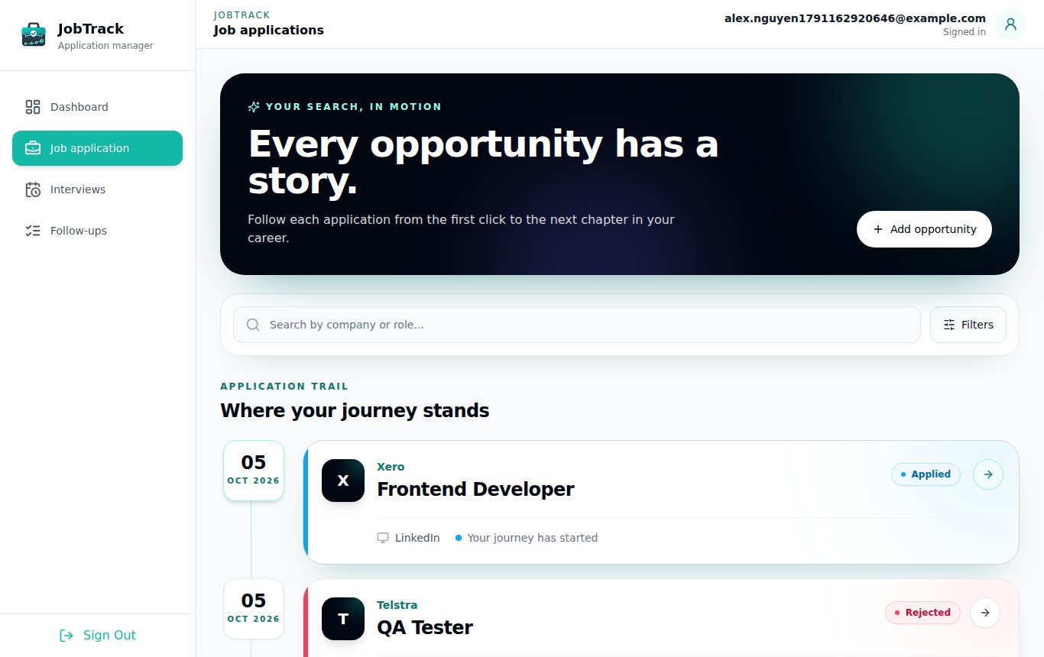
Figure 9. The application list

Search
Type part of a company name or role title in Search by company or role.... The list updates as you type. Capital letters don't matter, so goog finds Google.

Filter
- Select Filters.
- Set any of these:
  - Status: one status, including Archived. Leave it as All active statuses to see everything except archived applications.
  - Platform: the full platform name, such as LinkedIn. Capital letters don't matter, but it must match the whole name.
  - From date and To date: show applications made between these dates. Both dates are included.
- Select Apply filters.

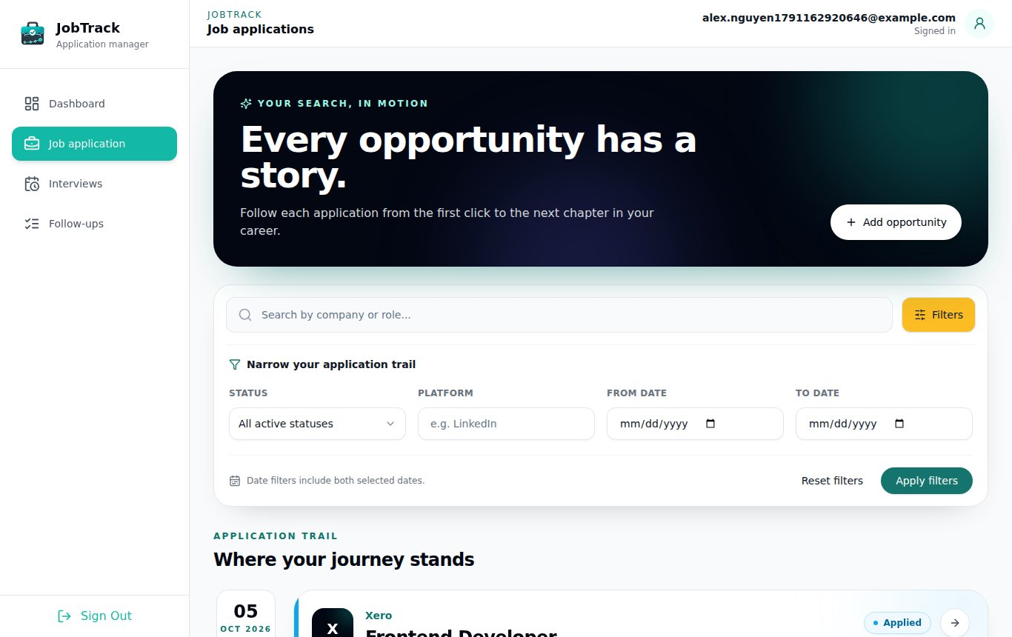
Figure 10. The filter panel
The Filters button shows how many filters are active. You can search and filter at the same time.

Clear search and filters
- Reset filters clears the filters but keeps your search text.
- Clear all clears both search and filters.
- If nothing matches, you'll see No opportunities match. Select Clear search and filters to see everything again.

Move between pages
At the bottom of the list, Showing 1–20 of 34 opportunities (for example) tells you where you are. Use Previous and Next to move between pages.

13. Troubleshooting and FAQ
Most problems are fixed by checking what you typed against the rules in this manual. If JobTrack itself won't load, contact the person who set it up.

Messages you might see
Message or problem | What it means | What to do
The page won't load, or the browser says the site can't be reached | JobTrack isn't running on this computer. | Ask the person who set it up to start the backend and frontend.
Invalid email or password. | The email or password is wrong, or the account doesn't exist. | Check both, including capital letters in the password. Create an account if you don't have one.
The email address is already registered. | An account already uses this email. | Sign in instead.
Password must contain at least one … | The password breaks one of the rules. | Follow the password rules in Section 3.
… is required | A required field is empty. | Fill in the field shown in red.
Enter a valid HTTP or HTTPS URL | A link is missing http:// or https://. | Paste the full link from your browser's address bar.
Follow-up due date cannot be in the past. | The due date is before today. | Choose today or a later date.
A resume version named … already exists | A resume with this file name is already in your library. | Rename the file, or select the saved version (Section 11).
Only PDF, DOC, and DOCX files are supported. | The file type isn't allowed. | Save the document as PDF or Word first.
The status action you want isn't shown | That move isn't allowed from the current status. | Check the allowed moves in Section 8.
You were sent back to the sign-in page | You signed out, or your session ended. | Sign in again. Your data is safe.

Frequently asked questions
Can I delete an application? Not in this version. Archive it instead (Section 8). You can delete interview rounds and follow-ups.
Can I undo a status change? No. That's why JobTrack asks you to confirm. If you archived by mistake, use Restore application.
Where did my archived application go? It's hidden from the active list. Filter by Status: Archived to see it (Section 12).
Why isn't my application counted on the Dashboard? Archived applications aren't counted. Check the platform spelling if it's missing from the platform breakdown.
I forgot my password. There's no password reset in this version. Ask the person who set up JobTrack for help.
Can other people see my data? No. Each account only sees its own applications, documents, interviews and follow-ups.

14. Quick reference and glossary

Quick reference
I want to… | Go to | Select
Add an application | Job application | Add opportunity
Open an application | Job application | The application's card
Change company, role, platform, date or a link | Application detail page | Pencil icon, then the tick
Change the status | Application detail page, Current stage | The action, then confirm
Archive a finished application | Application detail page | Archive application, then Archive
Restore an archived application | Job application, Filters, Status Archived | Open it, Restore application
Add an interview round | Application detail page | Add interview
Add a follow-up | Application detail page | Add follow-up
Mark a follow-up done | Detail page, Follow-ups page or Dashboard | The circle next to it
Attach a resume | Application detail page, Application documents | Upload resume or Select a saved resume
See interviews coming up | Interviews | 7 days, 14 days or 30 days
See what's overdue | Dashboard or Follow-ups | —
Sign out | Sidebar | Sign Out, then Logout

Glossary
Term | Meaning
Application | One job you applied for, with its company, role, platform and links.
Platform | Where you found or applied for the job, such as LinkedIn, Seek or a company website.
Status | The stage an application is at: Applied, Interview, Offer, Rejected, Withdrawn or Archived.
Archive | Close an application and hide it from your active list without deleting it.
Restore | Bring an archived application back to the status it had before.
Interview round | One interview, such as a phone screen or final round, with its own time and contact.
Follow-up | A reminder to do something for an application by a due date.
Overdue | A follow-up whose due date has passed and which isn't marked done.
Resume library | Every resume you've uploaded, ready to attach to other applications.
Active applications | All applications except archived ones.

