“Modeling the Relationship between the Distribution of Acer saccharum (Sugar Maple) and Climate Variables Using WorldClim Data”
Trinity Tobin

Background & Question (Recap)
My research question looks at temperature and precipitation through the use of WorldClim bioclimatic variables and how their combined influence is affecting/ affects the distribution of sugar maples across North America using predictive modeling to simulate the effects of climate change on the species.
My hypothesis is that temperature and precipitation are having a negative impact on the distribution of sugar maple species in North America.
My prediction is that as temperatures and amount of precipitation rise, there will be a decrease in both the spatial distribution and the abundance of sugar maples.

Methods
My original plan was to use a linear regression model as my baseline model. This model is appropriate because the relationships between maple distribution, temperature, and precipitation as inherently linear, as both temperature and precipitation are continuous numeric variables. In addition to the linear regression, I have decided to use a ridge regression model as well. This model allows me to assess the multicollinearity within my climate variables without eliminating any variables. The ridge regression shrinks all of the coefficients toward zero and stabilizes them, resulting in a model that is stabilized due to having each predictor impact the target variable equally.
Both preprocessing and exploratory data analysis were conducted prior to the creation of the baseline models. A principal component analysis (PCA) was also run as a preliminary model. My data was split into training and test data sets by an 80-20 split.
K-fold cross validation was conducted on both of the models. It was conducted on the training data set in RStudio using the code cv( ). This code generates an output with the average RMSE, average R-squared, and the variability across the folds.
The assumptions of the linear regression model are:
- That the relationship between the variables is linear
- That each occurrence (observation) is independent
- Constant variance
- Normal distribution
- No multicollinearity
The assumptions of the ridge regression model are:
- That the relationship between the variables is linear
- That each occurrence (observation) is independent
- Constant variance
- Normal distribution
The main difference between the models is that the ridge regression does not assume no multicollinearity and instead, factors it into the mode and manages it. This is especially helpful for me, as meteorological variables typically have high multicollinearity.
The assumptions of the linear model and the ridge regression model were tested in R using the function lm( ). This function generates four residual plots that assess the assumptions of the model. Additionally, the Durbin-Watson test was conducted for both models, analyzing the independence of the variables.

Results (Tables or Visualizations, if needed, and Brief Interpretations)
Linear Regression
- Fitted Model
  - R-squared: 0.791
  - Adjusted R-squared: 0.791 : 0.758
These R-squared values indicate that around 80% of the variation in log_abundance can be attributed to the GBIF and climate predictors.
  - F-statistic: p-value < 2.2e-16
This statistic indicates that the model itself was statistically significant, with the predictors being able to explain the variation in a meaningful way.
The top 5 predictors (out of 22) were:
  - Lag_log_abundance (p < 2e-16)
  - Lag_abundance (p < 0.001)
  - Occurrences ( p < 2e-16)
  - Density (p < 0.001)
  - Year (p = 0.0016)
This indicates that the temporal variables are playing a larger role on species distribution, as the most significant variables are temporal and many of the climate variables were not as significant.

- Assumptions
IS IT RELATIONSHIP LINEAR?
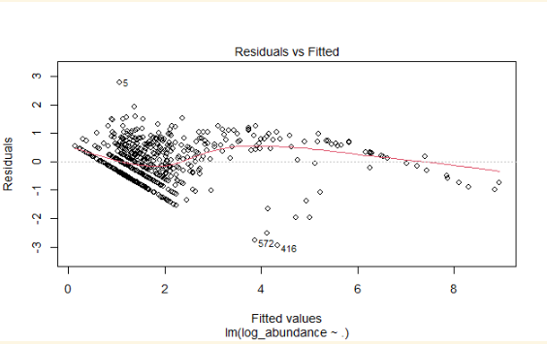
Figure 1. Graph of the residuals for linear regression model. This graph shows a randomly scattered pattern, indicating general linearity.

CONSTANT VARIANCE?
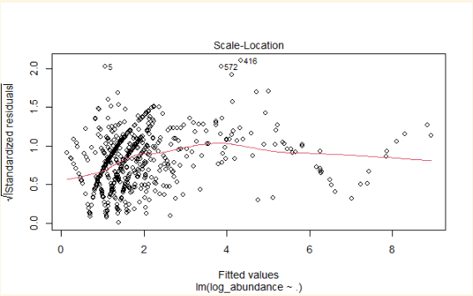
Figure 2. Graph of fitted values vs. standardized residuals. This graph shows the variance is not perfectly constant but the trend is not severe enough to invalidate the model.
IS IT NORMAL?
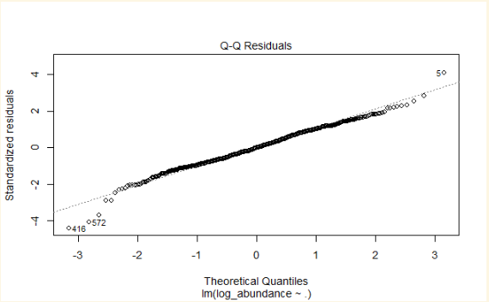

Figure 3. Graph of QQ residuals. This graphs shows that the points follow the qq line with a slight deviation at the tails, indicating an overall normal distribution.

OUTLIERS

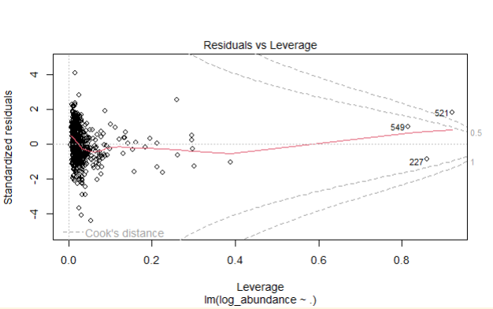
Figure 4. Graph of residuals v. leverage. This graph shows that some outliers are present but most of the data are within the bounds of Cook’s distance.

INDEPENDENT OBSERVATIONS (DURBIN-WATSON)?
-DW: 1.948 (p-value = 0.7608)
-no evidence of autocorrelation
-independence is satisfied

The assumptions of the linear model are met, which leads me to conclude that the model can be treated as reliable, as well as interpretable.
- Overfitting
  - Train-test performance:
    - Training RMSE: 0.67
    - Test RMSE: 0.53
  - Cross validation (5-fold):
    - RMSE: 0.73
    - R-squared: 0.76
From the train-test performance, there are no clear signs of overfitting. In terms of the cross-validation, the consistency of the validation with the test performance shows that the model is stable when ran on different splits. The linear regression also shows that multicollinearity exists (which we already know).

Ridge Regression
- Fitted Model
The ridge regression was fitted using cross-validation to find the best lambda value that would both balance the fitting of the model and the ridge regression’s characteristic coefficient shrinking.
  - Training R-squared: 0.685
  - Test R-squared: 0.509
  - Training RMSE: 0.794
  - Test RMSE: 0.509
When averaged together, the R-squared values indicate that 50-70% of the variation in log_abundance in this model can be attributed to the GBIF and climate predictors.

- Assumptions
IS IT RELATIONSHIP LINEAR?

-residual patterns are somewhat random
-for the most part, yes (generally linear with slight nonlinear structure)

IS IT NORMAL?
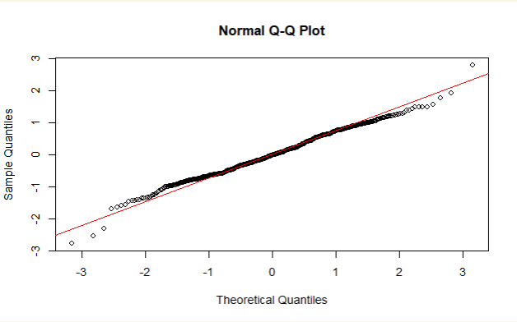
Figure 5. QQ plot for normalcy for the ridge regression. This graph shows that the points are close to the line, showing that the data is approximately normally distributed.
CONSTANT VARIANCE?

-variance is relatively stable
INDEPENDENT OBSERVATIONS (DURBIN-WATSON)?

-DW: 1.98 (p-value = 0.4019)
-no evidence of auto correlation
-independence is satisfied
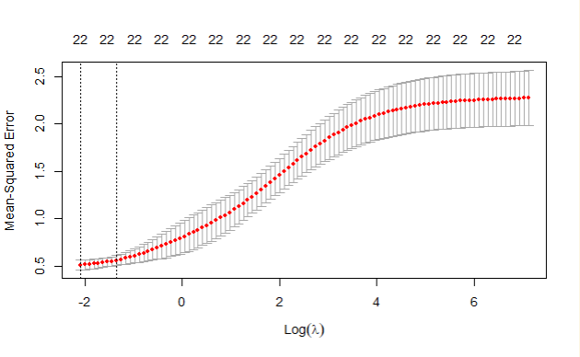
Figure 6. Cross-validation curve for the ridge regression model. This graph shows constant variance in the consistent error lines. The multicollinear effects on the model can be seen as well, showing that it is indeed present but being controlled for within the model.

- Overfitting
  - Train-test performance:
    - Training R-squared: 0.68
    - Test R-squared: 0.51
From the training to test, there is a drop in performance, as seen by the decrease in the R-squared value. This is possibly indicative of the model underfitting.
  - Cross validation (5-fold):
The cross-validation curve shows that the error is stable across the folds (the lines surrounding the points).

Discussion & Next Steps
When the two models are compared based on their RMSE and R-squared values, the linear regression performed better than the ridge regression. This shows that the multicollinearity is not as big of an issue as we initially thought it would be. Through both the models, there were no signs of overfitting, but there is underfitting in the ridge regression that will need to be mitigated, if possible. Relating to my research question, this shows that temporal factors play a larger role on species distribution than climate, which (with more evidence) can lead to a larger conclusion that the distribution is shifted more by time rather than variations in the climate variables.
The additional models that I plan to run are a random forest model and a lasso model. The reason I chose to run the ridge regression as a baseline model with the linear regression was in part to assess the need for the lasso model, as they tackle the same issues. I am also considering the creation of a neural network predictive model, as a means of creating models that showcase increasingly complex relationships. With these three models, I would be able to analyze complex nonlinear relationships and refine my feature selection.
For all future models, I intend to validate them with the k-folds cross validation in a similar fashion to what I did with these models. To strengthen my analysis, I might look into a second form of validation, but I do think the k-folds did a good job.
For these models specifically, hyperparameter tuning is necessary to get them performing optimally (especially with the ridge regression). Tuning the regularization strength of the ridge regression with better cross-validation will help the model to be more robust. The random forest model will need to be tuned via the number of trees and model depth. Finally, the neural network will be tuned within the model creation though the layers of the network and the number of neurons.
Given that the climate variables did not play a large role in my linear regression model, I am now planning to reduce redundant climate variables. The baseline linear regression model also showed that the more significant climate variables were my derived ones so removing the BIO variables not associated with those would be my best bet for now (and I would use the linear regression output to justify my choice of removal [Appendix B]). Moving forward, my goals are to improve my model performance (both these two and the new three) and create models that are flexible and responsive to more complex relationships in my data set.

Appendix
Appendix A. Data Dictionary
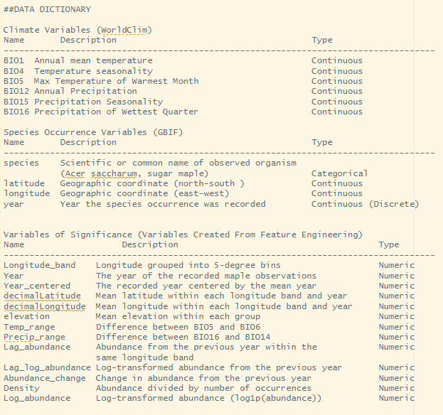

Appendix B. LINEAR REGRESSION OUTPUT
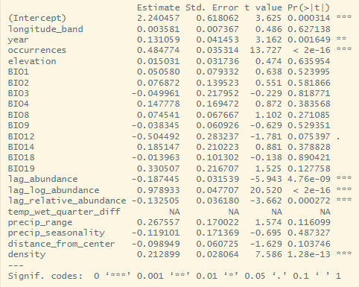

Appendix C. GITHUB REPO LINK
LINK TO GITHUB REPO: https://github.com/trini-png/DataScienceCapstone

