“Modeling the Relationship between the Distribution of Acer saccharum (Sugar Maple) and Climate Variables Using WorldClim Data”
Trinity Tobin
5-10-2026

Abstract
Temperature and precipitation are key environmental factors changing the range of sugar maple distribution. Using WorldClim bioclimatic variables and GBIF occurrence data, predictive modeling was used to see if the distribution of sugar maples could be predicted based on past data. Linear regression, ridge regression, and random forest models were used, with the random forest model best capturing the nonlinear relationships in the data set. A baseline and spatially cross-validated random forest were created, with the spatially cross-validated model performing better when analyzed through an ecological lens. The model was able to accurately analyze and depict relationships between temperature, precipitation, and occurrence count.

Question
How do temperature and precipitation affect the distribution of sugar maples across North America? Can the effects of these environmental variable be predicted through the use of predictive modeling?

Introduction
Predictive modeling and machine learning had been used in recent conservation initiative, with its usage being partially debated given the toll it takes on the environment [4]. Nevertheless, it can be use to simulate past, present, and future climate conditions, thus leading to possible advancements in climate research. Combing these techniques with easily recognizable plant and animal species will inspire more public interest and thus increase funding for the USFS.
The sugar maple is a landmark species in North American temperate forests. It’s distribution range typically falls east of Kansas to the Atlantic and extends as Southern as Tennessee and upwards into Canada [Appendix B., 5]. However, recent studies have shown that there has been a slight extension of the range of the sugar maple into Georgia [6].
Modeling the distribution of a species is a well-studied scientific technique that can be used to understand the behavioral patterns of a given species. As a member of the United States Forest Service (USFS), this technique can be utilized to study any species of interest from a given forest ecosystem. This particular modeling project is based on the tree species Acer saccharum and can be easily adapted to other maples species, as well as other tree species in North American temperate forests.
The data used for this distribution modeling comes from WorldClim and Global Biodiversity Information Facility (GBIF) . The WorldClim variables are a compilation of 19 variables related to temperature and precipitation aggregated from data collected from global weather stations [3]. While comprehensive, these variables are highly correlated, which could result in mode overfitting. Similar limitation are seen in GBIF data, as bias occurs based on human sampling limitations. Occurrences will be used from the GBIF data to quantify the abundance of the maple species in a given location, with each row within the data set being treated as an occurrence. This helps to limit the bias prone in abundance data, with us not knowing if a species is in a given location because it hasn’t been found by a human yet. By using only the occurrences found by humans, we can get an accurate depiction of the abundance within the combined data set, while acknowledging that distributions can be incomplete and varied.
The temporal structure will be controlled for through the use of time-lagged variables. Time-lagged variables take the data from a previous data point to predict the data for a future data point [1] . In this study, the previous year’s data will be used to predict the next year’s data. This is appropriate for this study, as the previous year’s environmental conditions in a given area will impact the next year’s conditions, with species distribution also responding accordingly.
The geographic structure will be controlled for through the use of longitudinal slices. This tactic will separate the species distribution range into 5-degree segments. This aggregation will reduce the noise in the model. However, while this will help control for spatial autocorrelation, given the time constraints of the project, not all of the geographic structure will be controlled for (ex. elevation, latitude, etc.) . If further, more comprehensive measures should be undertaken.
The combined data set contains temperature, precipitation, temporal, and spatial predictors to create a holistic picture of the environmental variables impacting the distribution. While caveats exist for both individual data sets, they create a robust data set with many predictors that can help explain the sugar maple’s current and future distribution patterns.
Hypothesis
My hypothesis is that temperature and precipitation are having a negative impact on the amount of sugar maples, resulting in a decrease in the distribution of sugar maple species in North America.

Prediction
My prediction is that as temperatures and amount of precipitation rise, there will be a decrease in both the spatial distribution and the occurrence count of sugar maples.

Data
The chosen data sets combined characterize the environmental conditions sugar maples may be found in and where the sugar maple has been found through human sampling efforts. The combined data sets allow for efficient climate-distribution modeling and a spatial-temporal analysis for the sugar maple population in North America.
The first data set consists of the WorldClim bioclimatic variables, which is a set of 19 variables depicting various meteorological conditions related to temperature and precipitation. The focus of the exploratory data analysis was on six of the variables linked to temperature and precipitation to provide a baseline for the environmental trends present (Figure 1). Later processing efforts expanded the data to include all 19 variables to create the most robust analysis possible.
The second data set is a set of GBIF (Global Biodiversity Information Facility) occurrences of sugar maples extending back from 1850 to present, with these occurrences centralized on the East Coast of the United States, extending up into Canada (Figure 2). Both data sets were downloaded from public databases. All of the WorldClim variables are numerical and continuous. After preprocessing, all of the GBIF variables were also numerical and continuous, as they consist of locality data for each of the occurrences. These two data sets were joined together to create one data set containing the coordinates and the date (year) of each occurrence.
It is important to note substantial limitations exist within each data set. The WorldClim variables are all highly correlated, as the environmental conditions in a given area define the ecosystem that the sugar maples inhabit (Figure 4). GBIF data is limited by the human efforts placed behind sampling, as well as the physical limitations in the environment leading to occurrences being cataloged based on what the human has access to. Additionally, missing observations do not actually mean that a tree is missing from a given area, just that the area was not sampled for. The multicollinearity of WorldClim variables and the missingness of uneven sampling efforts and human sampling bias are taken into account during the model creation process.
The response (target) variable used is “occurrence_count”. This variable was derived from the “individualCount” variable. To aid in the quantification of occurrence_count, the variable “individualCount” had its missing values replaced with “1” (as each row of the data set is an occurrence). This is made possible due to the human sampling bias. By making each row of the data set a single occurrence, we can use occurrences as a proxy variable for abundance.
The preliminary GBIF data was cleaned and formatted in Excel before the data analysis began. This cleaning was conducted to fix the formatting of the download. The data was separated by dividing the text based on “ “ characters to separate the data. Using this character as the delimiter divided the individual columns, with each column being a potential feature that can be a predictor variable in the later model. Additionally, any coordinate points that were missing either a latitude or a longitude value or were not part of North America were filtered out of the analysis with the use of a bounding box. No additional cleaning was done on the raw data set of WorldClim variables.
The downloaded WorldClim raster values were extracted and mapped onto the GBIF occurrence points (Figure 2). They were then combined into one preliminary dataset consisting of the coordinate points, year, and the climate variables.

Models
In preprocessing, the occurrence data was first converted into spatial points. After the data was merged to one data set, any variables that were irrelevant were removed (ex. taxonomic IDs). Then the individualCount variable was imputed with “1” for each occurrence. Next, the longitudinal bands were created and the occurrence_count variable was transformed. The split was created and then the time-lagged variable was created. After this, median imputation was conducted on the missing values (on the training and test sets separately). Lastly, numerical predictors were normalized and scaled, outliers were removed, and a principal component analysis was conducted.
Missing values were encountered and managed as a first step in preprocessing. Due to low proportions of missingness, median imputation was conducted. Median imputation is useful when the amounts of missingness are low. The imputation serves to be more robust for my data because there are many predictors with skewness and outliers and the median is less sensitive to extreme values. Additionally, rows that were missing lag variables were also removed, as their missingness was created from the lagging. The GBIF occurrence data was cleaned by removing missing latitude/longitude points, filtering the coordinates to North America, and combined with extracted WorldClim variables to create a singular joined data set. The resulting data set was created using an 80/20 train-test split to prepare the set for future modeling. The numeric predictors were normalized and scaled in the two data sets, so their scales were comparable.
Features were selected based on importance to the spatial and temporal analysis of the species. Therefore, many of the GBIF variables related to identifiers, taxonomy, and collection were dropped from the data set. Variables related to space and time (including elevation, latitude, longitude, year, and the climate predictors) were kept. To aid in the quantification of abundance, the variable “individualCount” had its missing values replaced with “1” (as each row of the data set is an occurrence). Many new predictor variables were created from the GBIF and climatic variables to further look at relationships in the data set. The “longitude_band” variable was created based on 5-degree longitudinal slices to aggregate the abundance data. Lag variables were created within the longitudinal bands to further depict the space-time dependency of the sugar maples (Appendix A).
The variable “occurrence_count” was log transformed into “log_occurrence_count”, which will be the target variable in modeling. Lag variables (“lag_occurrence_count”, “lag_log_occurrence_count”, “lag_relative_occurrence”) were created within the longitudinal bands to further depict the space-time dependency of the sugar maples (Appendix A). Overall, these preprocessing methods were employed to reduce noise in future models, isolate meaningful predictors and create new ones, and reduce missingness in the data set.
Both supervised and unsupervised algorithms were utilized to inform model development and the choice of the best mode. The unsupervised algorithm used was Principal Component Analysis (PCA). The PCA was used to preliminarily analyze the multicollinearity present in the data set. The output of the algorithm indicated that the majority of the variation within the model occurred within the first few components (Figure 3). This led to the conclusion of high multicollinearity among the variables and a potential leakage issue, as the initial components in the model may have been skewing the analysis.

Algorithms
The supervised algorithms used were linear regression, ridge regression, and random forest. The linear and ridge regression models were chosen as baseline models to explore the direct, linear relationships between the occurrence_count target and the predictors. These models were chosen based on the linear trends that appeared between the bioclimatic variables and occurrences during exploratory data analysis. Baseline models are useful for initial exploration of relationships in a data set and to be used as a comparison point for more complex models.
The ridge regression expanded on the logic of the linear regression by including regularization, which shrinks all of the coefficients towards zero and allowing for an assessment on the multicollinearity of the predictors. Additionally, k-fold cross validation was conducted on both of these models’ training data sets, with the resulting average RMSE, average R-squared, and variability across the folds being used to evaluate model efficiency.
The linear regression and ridge regressions’ model assumptions were tested for with residual plots. The assumptions of linear model include linearity in the data set, constant variance, normal distribution and independence for each data point. The assumption of independence when looking at ecological observations, with the observations being spatially and temporally dependent on one another. Lagged variables and longitudinal banding were introduced to the model as a way to account for this. Overfitting controls varied from the baseline models to the random forest model. The regression model’s overfitting was controlled for with standard cross-validation, an 80/20 train/test split, and ridge regularization. The random forest’s overfitting was further controlled for with hyperparameter tuning, leakage removal, and spatial cross-validation.

Final/Best Model
The baseline random forest mode was hyperparameter tuned using two different functions in RStudio. These functions controlled the number of predictors in each split, which was set to up to 15 predictors with the use of a tuning grid.
The final model created was the random forest model with the spatial cross-validation. This model proved to be the best at handling the nonlinear relationships present in the data, as well as capturing the ecological realism of sugar maple’s environment (Table 1). Additionally, the model demonstrated the strongest predictive performance and did a better job at controlling for leakage. For future tuning of the mode, a temporal split can be added and processed through the use of OneHotEncoding to create decades of occurrence count. These additions to the random forest model would allow for the direct comparison of occurrence values in a given area over time.
The variable importance plot also shows that the spatial CV random forest is performing better (Figure 7). With the baseline model, the most important variables were found to be the climate variables, but this was due to strong multicollinearity not actual importance. In the spatial random forest, year was found to be the most important variable. This is a more sound ecologically speaking, as the previous year’s conditions play a large role on the present year’s conditions.

Discussion & Next Steps
Temperature and precipitation conditions for sugar maples were able to be predicted with WorldClim bioclimatic variables, GBIF occurrence data, and machine learning. Nonlinear algorithms (such as random forest) are better able to capture the interactions present in ecological data sets, when compared to linear algorithms (linear regression, ridge regression). While the hypothesis of a negative impact was not supported and the prediction of decline in occurrence count was not observed, the model is clearly capturing pivotal interactions between the climate drivers temperature and precipitation.
When modeling ecological systems, complexity is inevitable, with the modeling approach being used to describe the majority of variation within a given data set. The random forest outperforming the linear models reinforces this fact by providing evidence of sugar maple distribution not being driven by one-to-one relationships between the environment’s temperature and precipitation. The climate variables will always interact with the study species and each other, and additional interactions not accounted for in the model will always exist.
The spatial cross-validation did result in a decrease in the performance of the model but an increase in the model’s realism. This cross-validation furthered the random forest’s capabilities by including the surrounding areas of an occurrence, accounting for nearby locations sharing environmental conditions. If the spatial split was not present, the model would overestimate ecological performance through the creation of each occurrence being independent. Additionally, the temporal consideration of lagged variables reaffirmed the previous year’s conditions being incredibly important in predicting sugar maple distribution for a chosen year. This also indicates that the sugar maple’s populations are stable, at least temporarily, and that a species’ responses to climate change are gradual. The expansion of the model to include either more occurrence points or more years may give a better approximation of the trends shifting sugar maple distribution in North America.

Further Directions and Caveats
The current work can be adapted to other plants or animal species in the region. Another keystone species that may be of interest would be the Eastern hemlock (Tsuga canadensis). This keystone species resides within the range of sugar maple and may be similarly affected by the climate conditions. Additionally, the model can be extended to include the effects of interspecies relationships with environmental conditions, as the relationship between the tree species and the woolly adelgid is detrimental and well-documented [7]. Member of the USFS can directly apply the findings of this study to conservation planning for sugar maples and habitat monitoring, so that if the range shifts, it can be predicted and planned for.
The current model can be expanded on to better capture the full range of conditions and interactions impacting sugar maple distribution. The addition of a spatial cross-validation including latitudinal banding can create a grid structure that could better characterize occurrence environmental conditions. The addition of altitude as a variable can showcase the effects of both changes in air pressure and wind conditions of the sugar maple. Finally, the inclusion of a time-aware split would help prevent leakage and better show changes over time.
The model’s performance is dependent on both the data provided and the mitigation of internal and external threats to the model’s validity. Internal threats to validity include multicollinearity from highly correlated variables making it difficult to isolate the largest driver of the ecological conditions. Leakage was partially addressed through the spatial cross-validation, but temporal lag variables and scaling could also be introducing leakage. Spatial dependence was partially controlled by longitudinal banding, but full spatial autocorrelation is still a threat. External threats to validity include human sampling bias, missing environmental variables, topographical limitations, and interspecies relationships. Sources of bias unaccounted for include sampling bias, measurement error (ex. inaccuracies with coordinated in GBIF), and temporal error (older occurrence being less accurate).
The current model is unable to account for interspecies interactions that could limit the range of the sugar maples. Additionally, while human sampling bias may be able to partially consider it, topographical characteristics (lakes, mountain ranges, etc.) were not considered within the occurrence data set. Adding the variables of elevation, altitude, and cross-referencing the species range with a raster layer of another species could further enhance the species distribution model.
The final random forest model relies on critical assumptions being made. The most critical assumption is that the occurrences taken from GBIF meaningfully reflect the sugar maple’s ecological distribution. There is an assumption that the longitudinal bands are able to accurately reflect spatial structure. Finally, we adopt the assumption that these relationships can inform on future climate relationships. Overall, while the model was able to predict, the complexity of the ecological system that the sugar maples inhabit are impacted by many different conditions and processes that are unable to capture within the current model.

Sources Cited
Source 1: https://milvus.io/ai-quick-reference/what-are-lagged-variables-in-time-series-forecasting
Source 2: https://www.gbif.org/species/3189859
Source 3: https://www.worldclim.org/data/bioclim.html
Source 4: https://mitsloan.mit.edu/ideas-made-to-matter/climate-change-and-machine-learning-good-bad-and-unknown
Source 5: https://www.srs.fs.usda.gov/pubs/misc/ag_654/volume_2/acer/saccharum.htm
Source 6 : https://explorer.natureserve.org/Taxon/ELEMENT_GLOBAL.2.145639/Acer_saccharum
Source 7 : https://dec.ny.gov/nature/animals-fish-plants/insects-and-other-species/hemlock-woolly-adelgid
Code Availability
Link to GitHub Repository: https://github.com/trini-png/DataScienceCapstone

Appendix
Appendix A. Data Dictionary
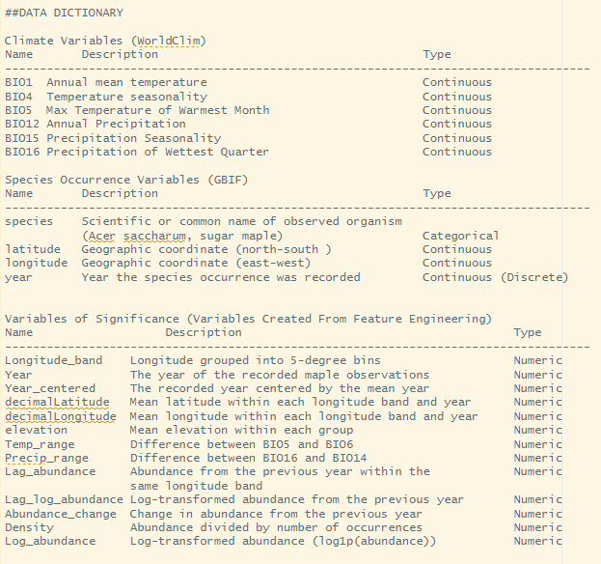

Appendix B. Historical Range of Sugar Maple North America
https://www.srs.fs.usda.gov/pubs/misc/ag_654/volume_2/acer/saccharum.htm

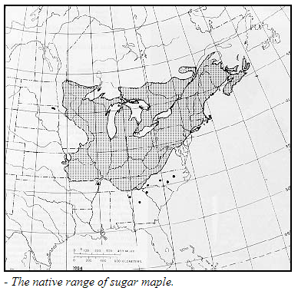
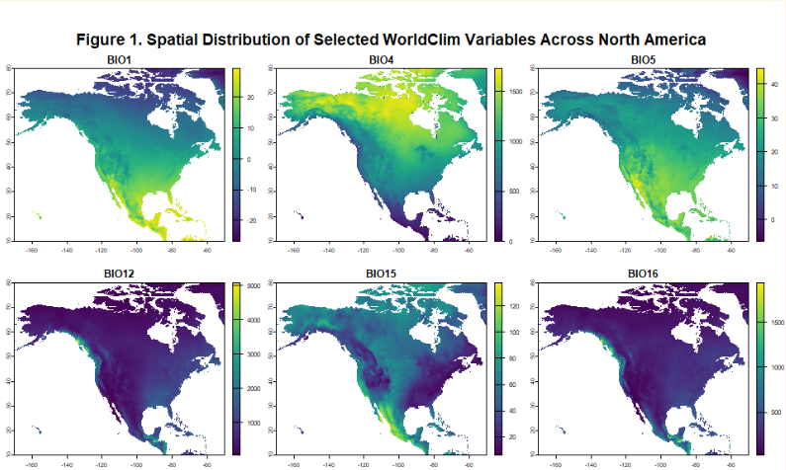
Figure 1. Spatial distribution of selected WorldClim variables across North America. BIO1 = Annual Mean Temperature, BIO4 = Temperature Seasonality, BIO5 = Maximum Temperature of Warmest Month, BIO12 = Annual Precipitation, BIO15 = Precipitation Seasonality, and BIO16 = Minimum Temperature of Coldest Month. These maps show the range of temperature and precipitation patterns that could be impacting the distribution of the sugar maple.
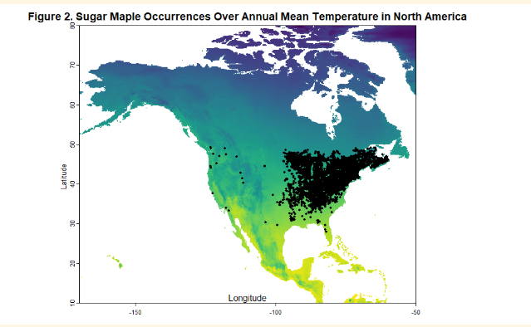
Figure 2. Sugar maple occurrence records overlaid on the BIO1 raster layer (Annual Mean Temperature) across North America. The background-colored map represents temperature, with lighter colors indicating warmer temperatures and darker colors indicating cooler temperatures. Black points represent GBIF observations of sugar maple. The figure shows that sugar maple occurrences are concentrated in regions with moderate temperature conditions, particularly in the northeastern United States and Canada.

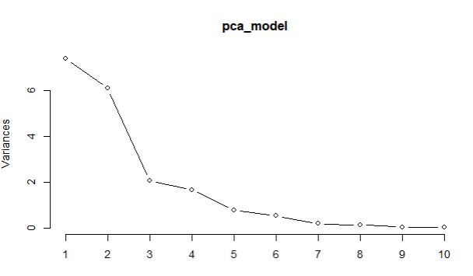
Figure 3. PCA Model Output

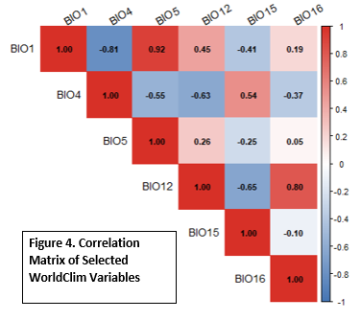
Figure 4. Correlation matrix of selected WorldClim bioclimatic variables across sugar maple occurrence locations. Values represent Pearson correlation coefficients, with warmer colors (red) indicating positive relationships and cooler colors (blue) indicating negative relationships.

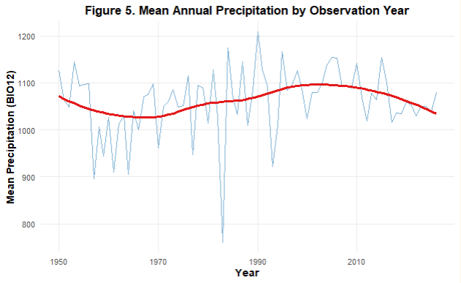
Figure 5. Mean annual precipitation (BIO12) across sugar maple occurrence records by observation year. A smoothed trend line is included to highlight overall patterns.
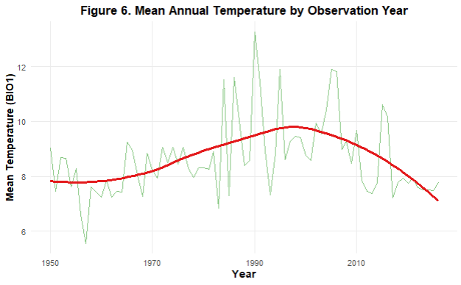
Figure 6. Mean annual temperature (BIO1) across sugar maple occurrence records by observation year. The smoothed trend line illustrates general variation over time.

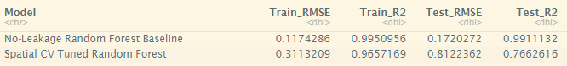
Table 1. This table compares the root mean squared error and R-squared values of the training and test sets for the baseline and spatial cross-validation random forest. We see a decrease in R-squared and an increase in RMSE from the baseline to the spatial random forest, showing that it is better accounting for leakage and the present ecological relationships.

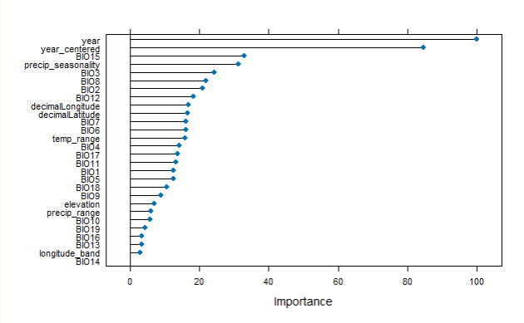
Figure 7. Variable importance plot generated post-spatial random forest. This plot shows that the most important variables are “year” and “year-centered”, followed by seasonal precipitation (BIO15).

