“Modeling the Relationship between the Distribution of Acer saccharum (Sugar Maple) and Climate Variables Using WorldClim Data”
Trinity Tobin

Background & Question (Recap)
My research question looks at temperature and precipitation through the use of WorldClim bioclimatic variables and how their combined influence is affecting/ affects the distribution of sugar maples across North America using predictive modeling to simulate the effects of climate change on the species.
My hypothesis is that temperature and precipitation are having a negative impact on the distribution of sugar maple species in North America. Additionally, I hypothesize that the random forest model will be more robust to my data set than the linear and ridge regressions.

My prediction (based on my baseline models) is that the addition of spatial split to the data will create a more robust model with a greater correlation of the values. Ecologically speaking, this will create a more accurate account of the occurrences

Methods
Hyperparameter Tuning: Overview
  - Removing variables that could cause leakage
  - Created spatial folds based on longitude
  - Created and trained my random forest model using spatial cross-validation
  - Tuned the model with grid searching, mtry, and ntree
  - Evaluated model on RMSE and on test data

My model tuning plan was based upon the results of my baseline models. I initially tested linear regression and ridge regression as my baselines models, due to the linear nature of precipitation and temperature (recorded on continuous numeric scales). However, the models shows that the assumptions of linear nature was limiting for my ecological data. This rationale was why I chose to create a random forest model.
The random forest model is a nonlinear model, which allows it to capture nonlinear patterns. The additional draws of the random forest model include that it can capture interactions, handles multicollinearity, and had less strict assumptions (when compared to the linear baseline models). My starting point before creating the model was adjusting my target predictor to be “occurrence_data” instead of abundance to have a more conservative estimate of actual occurrence density, as each row of the data is an occurrence
After creating the model, I identified leakage variables. With this, my goal of the tuning was to make sure that the random forest model was learning based on the predictors and not on the closely related variables. Next, spatial (by longitude) and temporal (year) splits were created and applied to my no leakage data sets. I added spatial cross-validation (CV) as a control for overfitting (to ensure the training and validation data sets were independent). This was done by converting the data to a spatial object with longitude, creating spatial folds, and making sure the training and test data sets are geographically separated. Additionally, the spatial CV can allow the model to predict new geographic areas. Grid searching was also done to test parameter values and then evaluated the models across the folds. The mtry function was tuned to control the number of predictors in each split. The ntree function was held constant (fixed) at 500 and used to reduce tree variance. After this tuning, the best model was chosen based on the lowest root-mean squared error (RMSE).

Results (Tables or Visualizations, if needed, and Brief Interpretations)
- Fitted Model
The no leakage random forest was used as a baseline for hyperparameter tuning.
    - Training RMSE: 0.117
    - Training R-squared: 0.996
    - Test RMSE: 0.172
    - Test R-squared: 0.991
Both the training and test R-squared values are really high, which would indicate that the model explain almost all of the variance in the data sets. Additionally, the low RMSE is indicative of the model being able to predict accurately.
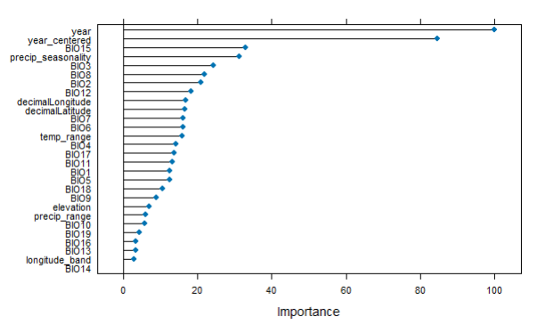
The variable importance plot above shows the positive effects of the leakage control. The model is now showing the temperature and precipitation variables, as opposed to the variables that could have been contributing to leakage.
- Assumptions
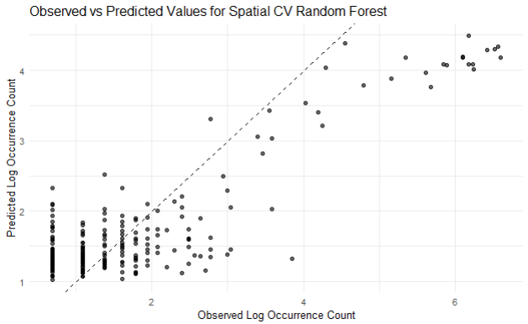

This graph assesses if the overall fit of the model is good. This shows that the model is good for higher occurrence values but is less accurate at lower levels.

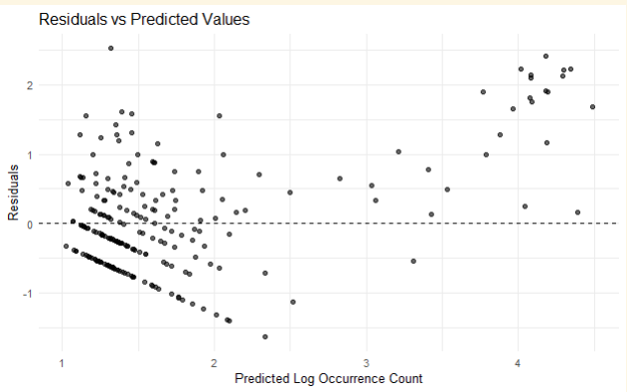

This graph assesses the assumption of constant variance. This is showing that constant variance is violated and that there is larger error in higher occurrence values.
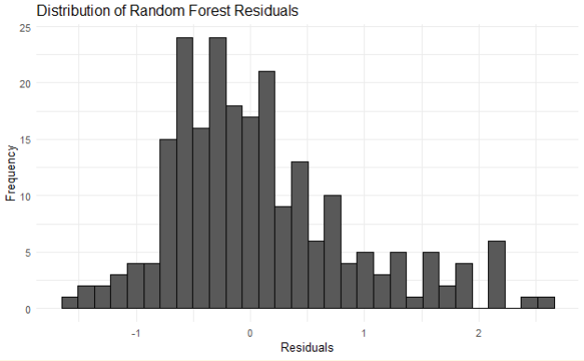
This histogram assesses the assumption of residuals being centered around zero. This shows that there is a slight right skew but they are centered near zero.

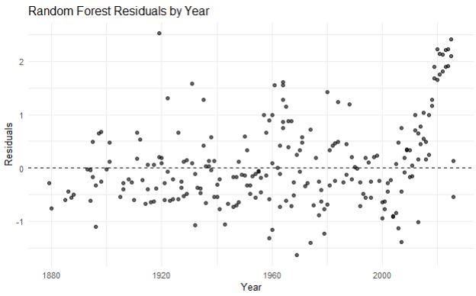

This plot assesses the assumption of no temporal patterns being present. This plot shows that there is no trend in the temporal aspects of the model.

- Overfitting
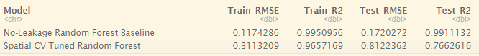
The baseline random forest’s RMSE and R-squared values were very similar, indicating that little overfitting was occurring with that model. The spatial CV random forest had a larger gap in the RMSE and R-squared values, indicating that moderate overfitting was occurring.

Random Forest: Hyperparameter Tuning
This above table also shows that there is a drop in performance from the baseline random forest to the leakage controlled random forest, as indicated by the increase in the RMSE. Even though that is the case, this shows that the model with the spatial cross validation is producing more realistic results. The increase in RMSE accompanied with the decrease in R-squared shows that the model does have some overfitting occurring.

Discussion & Next Steps
The random forest model is able to accurately capture the interactions between climate and species. The addition of the spatial cross-validation made the model especially robust for ecological modeling. The performance of the model (high R-squared, low RMSE) is great, but it is very high when considering ecological data. This indicates that some further tuning (possibly with node size) will need to be done in the coming days before the final submission. Nevertheless, this shows that baseline random forest had better performance, but the spatial CV model is depicting the data more realistically, controlling data leakage better, and is able to achieve my general goal of modeling species distribution.

Appendix
Appendix A. Data Dictionary
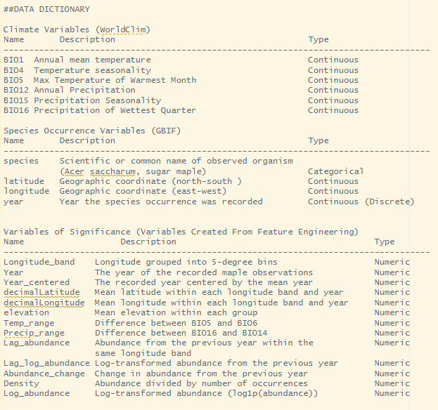

Appendix B. GITHUB REPO LINK
LINK TO GITHUB REPO: https://github.com/trini-png/DataScienceCapstone

Appendix C. Tuned Random Forest Code
