A2C CRM

System Software Design Document (SDD)

Table of Contents
Table of Contents 2
1. Introduction 3
2. System Overview 3
3. System Architecture Diagram 3
4. Data Model Overview 4
5. API Design 5
Authentication Service 5
Customers Service 5
Orders Service 5
Logging Service 6
Notification Service 6
6. REST API Diagram 7
7. Sequence Diagrams 8
User Valid Login –Sequence Diagram: 8
User Valid Login Sequence Explanation 9
1. User enters email & password in Client App 9
2. Client sends POST /login (JSON) to Server API 9
3. Server validates Email, Password in Database 9
4. Email & Password are valid → Generate JWT 9
5. Server returns token to Client 9
6. Client stores token for future requests includes Authorization: Bearer <token> 9
8. Docker File 9
9. Docker-Compose 10

Introduction
This Software Design Document (SDD) describes the architecture, components, and design decisions for the A2C (Application-to-Client) CRM system. It serves as a technical blueprint for developers and stakeholders.

System Overview
A2C is a cloud-based CRM system built on a microservices architecture, using a web-based frontend, a containerized backend, and event-driven communication through Kafka.

System Architecture Diagram
The following diagram illustrates the high-level system architecture of the A2C CRM system:
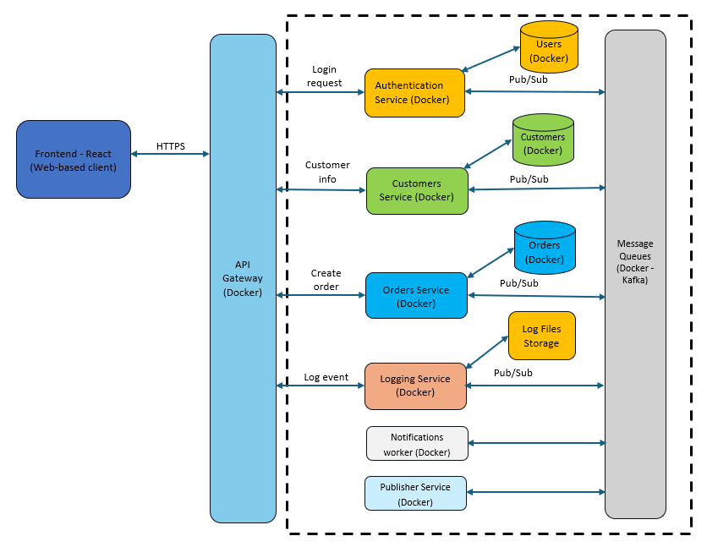
Figure 1 - High-Level Architecture

Data Model Overview
This section describes the Entity Relations Diagram (ERD) of all entities.
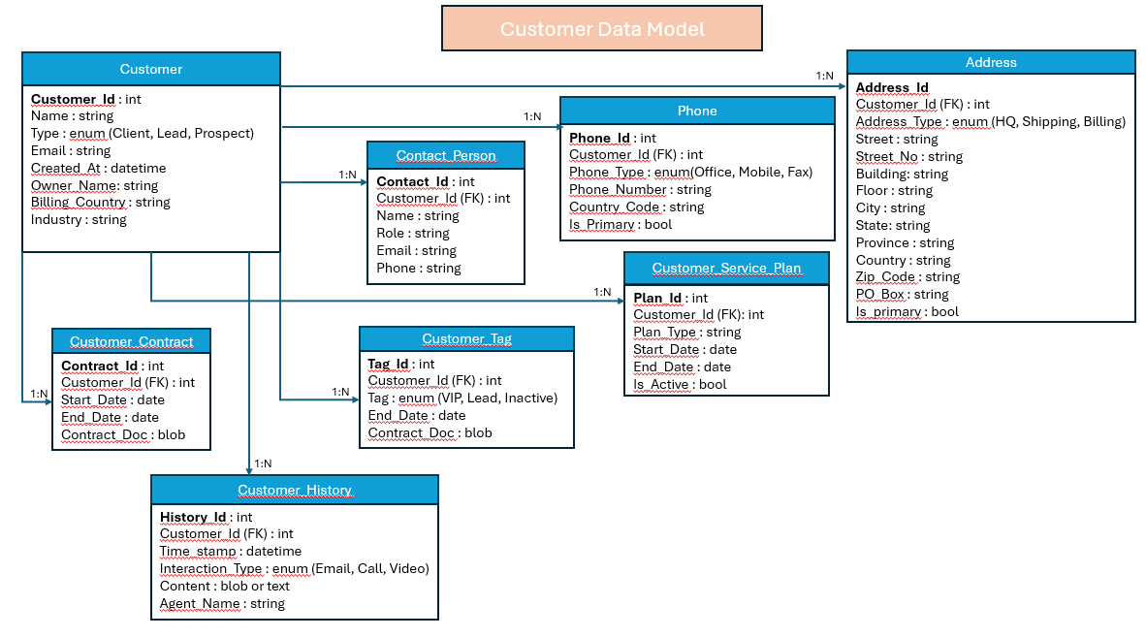

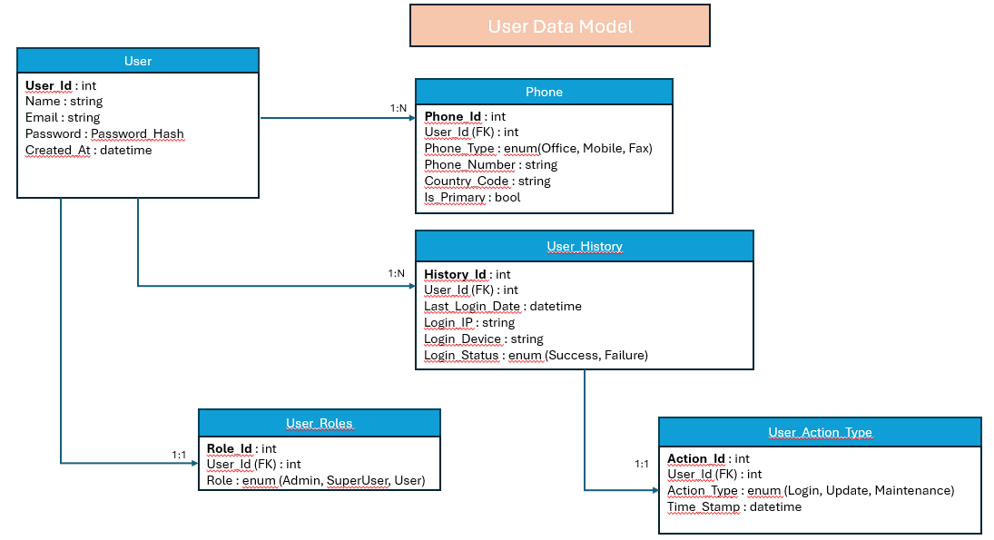

API Design
This section describes the REST API endpoints for each microservice in the A2C CRM system. The APIs follow REST principles and return JSON responses.

Authentication Service
Endpoint | Method | Description | Request Parameters / Body | Response | Auth Required
/api/auth/login | POST | Authenticate user and return JWT | JSON: {email, password} | 200 OK: {token} | No
/api/auth/register | POST | Register a new user | JSON: {name, email, password} | 201 Created: User object | No
/api/auth/refresh | POST | Refresh JWT token | JSON: {refreshToken} | 200 OK: {token} | Yes

Customers Service
Endpoint | Method | Description | Request Parameters / Body | Response | Auth Required
/api/customers | GET | Get list of customers | Query: filter, sort, page | 200 OK: [Customer] | Yes
/api/customers/{id} | GET | Get customer by ID | Path: id | 200 OK: Customer object | Yes
/api/customers | POST | Create a new customer | JSON: {name, email, ...} | 201 Created: Customer object | Yes
/api/customers/{id} | PUT | Update customer details | Path: id, JSON: updated fields | 200 OK: Updated customer | Yes
/api/customers/{id} | DELETE | Delete customer | Path: id | 204 No Content | Admin

Orders Service
Endpoint | Method | Description | Request Parameters / Body | Response | Auth Required
/api/orders | GET | Get all orders | Query: filter, sort, page | 200 OK: [Order] | Yes
/api/orders/{id} | GET | Get order by ID | Path: id | 200 OK: Order object | Yes
/api/orders/customer/{customerId} | GET | Get orders for a customer | Path: customerId | 200 OK: [Order] | Yes
/api/orders | POST | Create a new order | JSON: {customerId, productName, price, ...} | 201 Created: Order object | Yes
/api/orders/{id} | PUT | Update order details | Path: id, JSON: updated fields | 200 OK: Updated order | Yes

Logging Service
Endpoint | Method | Description | Request Parameters / Body | Response | Auth Required
/api/logs | GET | Get system logs | Query: level, dateRange | 200 OK: [LogEntry] | Admin
/api/logs/{id} | GET | Get log by ID | Path: id | 200 OK: LogEntry | Admin

Notification Service
Endpoint | Method | Description | Request Parameters / Body | Response | Auth Required
/api/notifications | GET | Get all notifications | Query: status, type | 200 OK: [Notification] | Yes
/api/notifications/{id} | PUT | Mark notification as read | Path: id | 200 OK: Updated notification | Yes

REST API Diagram
The following diagram illustrates the basic request-response flow in a REST API:
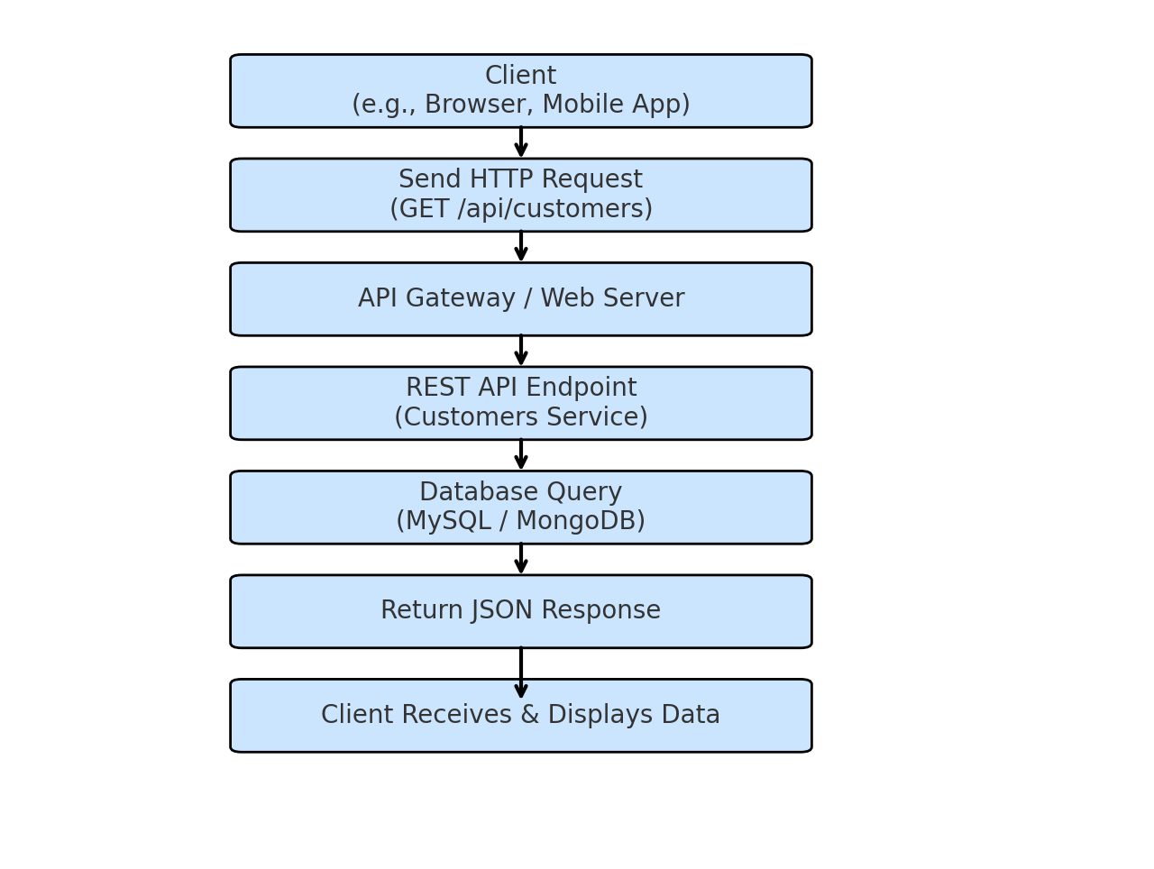

Sequence Diagrams

User Valid Login –Sequence Diagram:
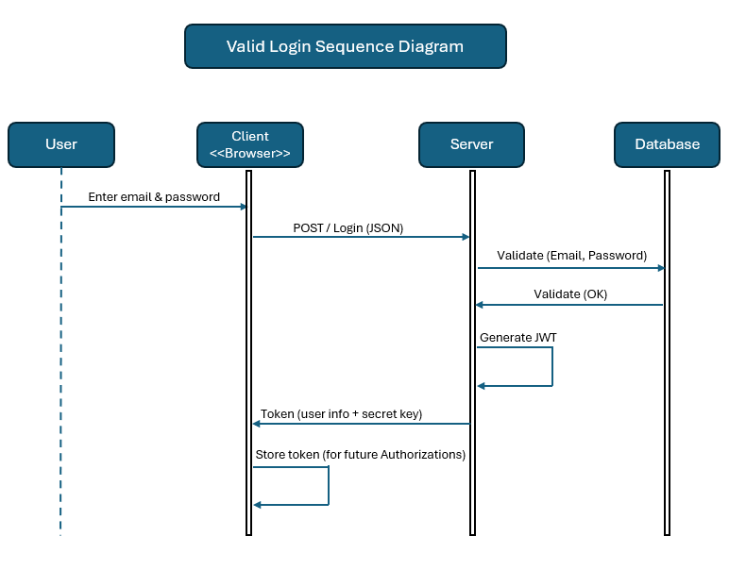

User Valid Login Sequence Explanation

User enters email & password in Client App

Client sends POST /login (JSON) to Server API

Server validates Email, Password in Database

Email & Password are valid → Generate JWT

Server returns token to Client

Client stores token for future requests includes Authorization: Bearer <token>

Docker File
# See https://aka.ms/customizecontainer to learn how to customize your debug container and how Visual Studio uses this Dockerfile to build your images for faster debugging.

# This stage is used when running from VS in fast mode (Default for Debug configuration)
FROM mcr.microsoft.com/dotnet/aspnet:8.0 AS base
USER root
WORKDIR /app
EXPOSE 8080
EXPOSE 8081

# This stage is used to build the service project
FROM mcr.microsoft.com/dotnet/sdk:8.0 AS build
ARG BUILD_CONFIGURATION=Release
WORKDIR /src
# Copy the service project file and restore dependencies
# COPY ["A2C.CRM.Api/A2C.CRM.Api.csproj", "A2C.CRM.Api/"]
COPY ["A2C.CRM.Api.csproj", "."]
# Restore the dependencies
RUN dotnet restore "./A2C.CRM.Api.csproj"
# RUN dotnet restore "./A2C.CRM.Api/A2C.CRM.Api.csproj"
COPY . .
# WORKDIR "/src/A2C.CRM.Api"
RUN dotnet build "./A2C.CRM.Api.csproj" -c $BUILD_CONFIGURATION -o /app/build

# This stage is used to publish the service project to be copied to the final stage
FROM build AS publish
ARG BUILD_CONFIGURATION=Release
RUN dotnet publish "./A2C.CRM.Api.csproj" -c $BUILD_CONFIGURATION -o /app/publish /p:UseAppHost=false

# This stage is used in production or when running from VS in regular mode (Default when not using the Debug configuration)
FROM base AS final
WORKDIR /app
COPY --from=publish /app/publish .
ENTRYPOINT ["dotnet", "A2C.CRM.Api.dll"]

Docker-Compose
services:
api:
build:
context: ./A2C.CRM.Api
dockerfile: Dockerfile
ports:
- "8080:80"
depends_on:
- db
environment:
-ConnectionStrings__DefaultConnection=Host=db;Port=5432;Database=a2c_crm;Username=postgres;Password=postgres
db:
image: postgres:15
restart: always
environment:
POSTGRES_DB: a2c_crm
POSTGRES_USER: postgres
POSTGRES_PASSWORD: postgres
ports:
- "5432:5432"
volumes:
- pgdata:/var/lib/postgresql/data
volumes:
pgdata:
services:
api:
build:
context: ./A2C.CRM.Api
dockerfile: Dockerfile
ports:
- "8080:80"
depends_on:
- db
environment:
- ConnectionStrings__DefaultConnection=Host=db;Port=5432;Database=a2c_crm;Username=postgres;Password=postgres

db:
image: postgres:15
restart: always
environment:
POSTGRES_DB: a2c_crm
POSTGRES_USER: postgres
POSTGRES_PASSWORD: postgres
ports:
- "5432:5432"
volumes:
- pgdata:/var/lib/postgresql/data
volumes:
pgdata:

