

**A Tutorial: Genome-based RNA-Seq Analysis**

**Using the TUXEDO Package**

The following details the steps involved in:

* Aligning RNA-Seq reads to a genome using Tophat
* Assembling transcript structures from read alignments using Cufflinks
* Visualizing reads and transcript structures using IGV
* Performing differential expression analysis using Cuffdiff
* Expression analysis using CummeRbund

All required software and data are provided pre-installed on a VirtualBox image. See companion ‘Rnaseq_Workshop_VM_installation.pdf’ for details. Data content and environment configurations are described therein and referenced below.

**Before Running:**

After installing the VM, be sure to quickly update the contents of the rnaseq_workshop_data directory by:

% cd rnaseq_workshop_data

% svn up

This way, you’ll have the latest content, including any recent bugfixes.

**Automated and Interactive Execution of Activities**

To avoid having to cut/paste the numerous commands shown below into a unix terminal, the VM includes a script ‘runTrinityDemo.pl’ that enables you to run each of the steps interactively. To begin, simply run:

% runTuxedoDemo.pl -I --DE

The -I parameter indicates to run interactively, and --DE indicates to include the differential expression analysis activities.

**Use Tophat and Cufflinks to align reads and assemble transcripts**

**a. process condition A reads**

# run Tophat to generate alignments for condition A reads

% tophat -I 1000 -i 20 -o condA_tophat_out genome condA.left.fa condA.right.fa

# index the alignment bam file for use by downstream tools including visualization

% samtools index condA_tophat_out/accepted_hits.bam

# generate transcript structures using Cufflinks

% cufflinks -o condA_cufflinks_out condA_tophat_out/accepted_hits.bam

**b. process condition B reads**

# run Tophat to generate alignments for condition B reads

% tophat -I 1000 -i 20 -o condB_tophat_out genome condB.left.fa condB.right.fa

# index the resulting bam file

% samtools index condB_tophat_out/accepted_hits.bam

# generate transcript structures using cufflinks

% cufflinks -o condB_cufflinks_out condB_tophat_out/accepted_hits.bam

**Merge separately assembled transcript structures into a cohesive set:**

First, create a file that lists the names of the files containing the separately reconstructed transcripts, which can be done like so:

# first writes the file

% echo condA_cufflinks_out/transcripts.gtf > assemblies.txt

# writes in append mode to add the second filename

% echo condB_cufflinks_out/transcripts.gtf >> assemblies.txt

# verify that this file now contains both filenames:

% cat assemblies.txt

condA_cufflinks_out/transcripts.gtf

condB_cufflinks_out/transcripts.gtf

And now we’re ready to merge the transcripts using cuffmerge:

% cuffmerge -s genome.fa assemblies.txt

The merged set of transcripts should now exist as file “merged_asm/merged.gtf’.

**View the reconstructed transcripts and the tophat alignments in IGV**

% java -jar $IGV/igv.jar -g `pwd`/genome.fa `pwd`/merged_asm/merged.gtf,`pwd`/genes.bed,`pwd`/condA_tophat_out/accepted_hits.bam,`pwd`/condB_tophat_out/accepted_hits.bam

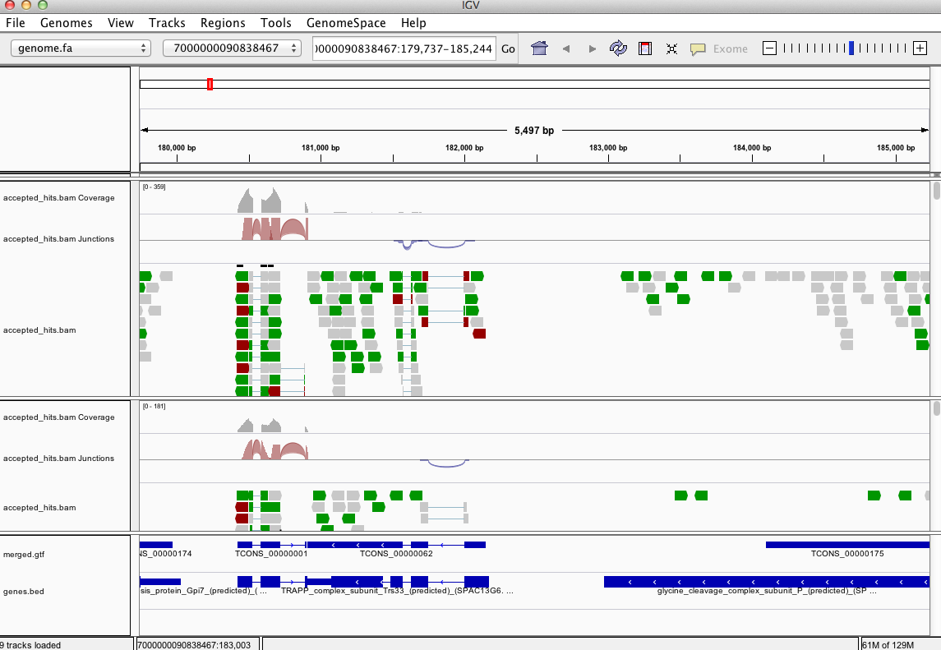

Pan the genome, examine the alignments, known genes and reconstructed genes.

Do the alignments agree with the known gene structures (ex. Intron placements)?

Do the cufflinks-reconstructed transcripts well represent the alignments?

Do the cufflinks-reconstructed transcripts match the structures of the known transcripts?

**Differential expression analysis using cuffdiff and cummeRbund:**

% cuffdiff -o diff_out -b genome.fa -L condA,condB -u merged_asm/merged.gtf condA_tophat_out/accepted_hits.bam condB_tophat_out/accepted_hits.bam

Examine the output files generated in the diff_out/ directory.

A table containing the results from the gene-level differential expression analysis can be found as ‘diff_out/gene_exp.diff’. Examine the top lines of this file like so:

% head diff_out/gene_exp.diff

Use ‘cummeRbund’ to analyze the results from cuffdiff:

% R

(note, to exit R, type cntrl-D, or type “q()” ).

**Optional: To automate running of the steps below interactively, you can do the following:**

**> source(“cummeRbund.demo.R”)**

**and then follow along below.**

# load the cummerbund library into the R session

> library(cummeRbund)

# import the cuffdiff results

>cuff = readCufflinks('diff_out')

# examine the distribution of expression values for the reconstructed transcripts

>csDensity(genes(cuff))

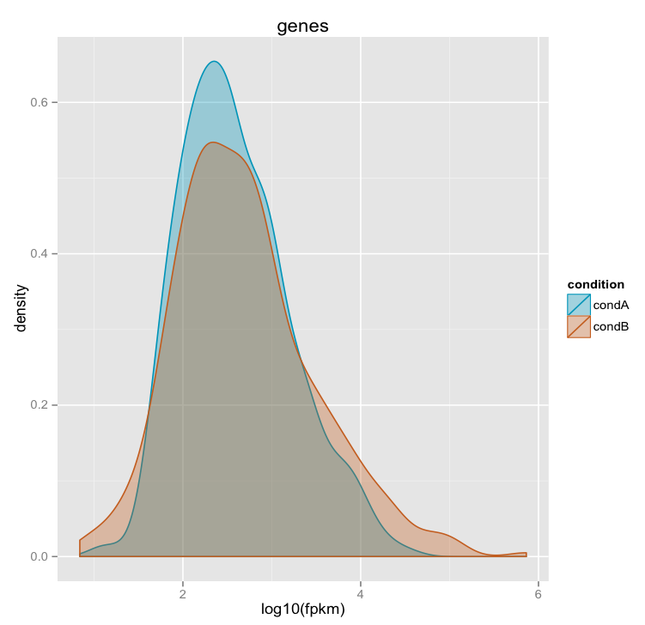

# Examine transcript expression values in a scatter plot

Expression values are typically log-normally distributed. This is just a sanity check.

>csScatter(genes(cuff), 'condA', 'condB')

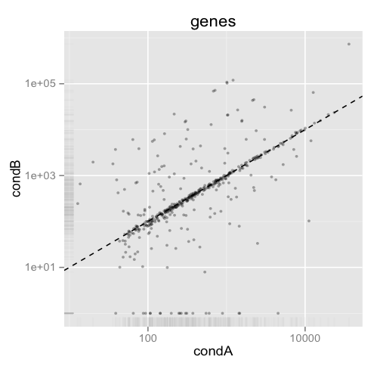

Strongly differentially expressed transcripts should fall far from the linear regression line.

# Examine individual densities and pairwise scatterplots together.

> csScatterMatrix(genes(cuff))

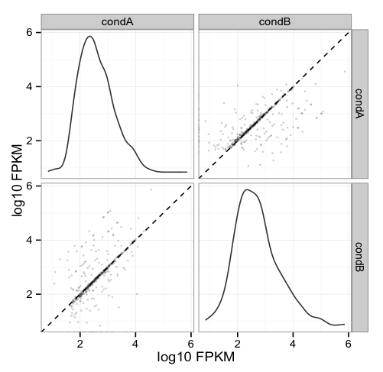

# Volcano plots are useful for identifying genes most significantly differentially expressed.

> csVolcanoMatrix(genes(cuff), 'condA', 'condB')

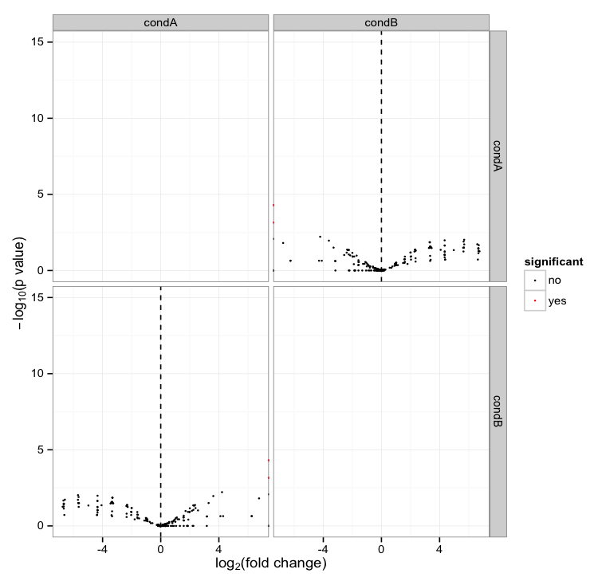

## Extract the ‘genes’ that are significantly differentially expressed (red points above)

# retrieve the gene-level differential expression data

> gene_diff_data = diffData(genes(cuff))

# how many ‘genes’?

> nrow(gene_diff_data)

# from the gene-level differential expression data, extract those that

# are labeled as significantly different.

# note, normally just set criteria as “significant=’yes’”, but we’re adding an

# additional p_value filter just to capture some additional transcripts for   
# demonstration purposes only. This simulated data is overly sparse and actually  
# suboptimal for this demonstration (in hindsight).

>sig_gene_data = subset(gene_diff_data,(significant=='yes' | p_value < 0.1))

# how many?

> nrow(sig_gene_data)

# Examine the entries at the top of the unsorted data table:

> head(sig_gene_data)

gene_id sample_1 sample_2 status value_1 value_2 log2_fold_change

4 XLOC_000004 condA condB OK 307.128 0.000 -Inf

8 XLOC_000008 condA condB OK 266.134 0.000 -Inf

11 XLOC_000011 condA condB OK 322.349 10143.700 4.97582

15 XLOC_000015 condA condB OK 199.150 0.000 -Inf

17 XLOC_000017 condA condB OK 4317.350 821.552 -2.39372

22 XLOC_000022 condA condB OK 134.732 650.882 2.27230

test_stat p_value q_value significant

4 NA 0.00005 0.00243125 yes

8 NA 0.00005 0.00243125 yes

11 3.16109 0.04565 0.34149700 no

15 NA 0.00070 0.01945000 yes

17 -2.57482 0.06720 0.40845000 no

22 2.15938 0.05690 0.36890200 no

# You can write the list of significantly differentially expressed genes to a file like so:

> write.table(sig_gene_data, 'sig_diff_genes.txt', sep = '\t', quote = F)

# examine the expression values for one of your genes that’s diff. expressed:

# select expression info for the one gene by its gene identifier:

# (note we’re naming the variable the same as the

# transcript name, so don’t be confused by this)

> var_XLOC_000011 = getGene(cuff, 'XLOC_000011')

# now plot the expression values for the gene under each condition

# (error bars are only turned off here because this data set is both simulated

# and hugely underpowered to have reasonable confidence levels)

> expressionBarplot(var_XLOC_000011, logMode=T, showErrorbars=F)

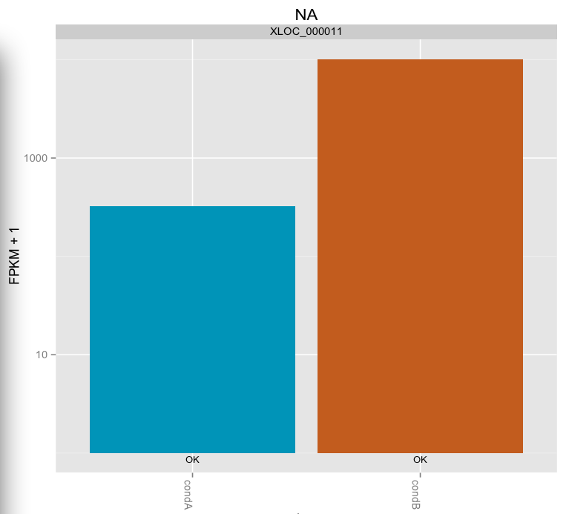

## Draw a heatmap showing the differentially expressed genes

# first retrieve the ‘genes’ from the ‘cuff’ data set by providing a

# a list of gene identifiers like so:

>sig_genes = getGenes(cuff, sig_gene_data$gene_id)

# now draw the heatmap

csHeatmap(sig_genes, cluster='both')

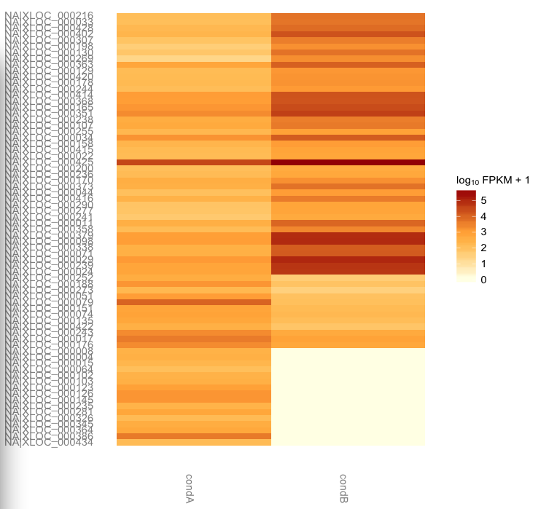

**More information on using the Tuxedo package can be found at:**

Trapnell C, Roberts A, Goff L, Pertea G, Kim D, Kelley DR, Pimentel H, Salzberg SL, Rinn JL, Pachter L.

Differential gene and transcript expression analysis of RNA-seq experiments with TopHat and Cufflinks. Nat Protoc. 2012 Mar 1;7(3):562-78. doi: 10.1038/nprot.2012.016.

<http://www.nature.com/nprot/journal/v7/n3/full/nprot.2012.016.html>

The CummeRbund manual:

<http://compbio.mit.edu/cummeRbund/manual_2_0.html>

(note, most of the tutorial provided here is based on the above two resources)

and the Tuxedo tool websites:

TopHat: <http://tophat.cbcb.umd.edu/>

Cufflinks: <http://cufflinks.cbcb.umd.edu/>

CummeRbund: <http://compbio.mit.edu/cummeRbund/>