

**A Tutorial: Genome-based RNA-Seq Analysis**

**Using the TUXEDO Package**

**The following data and software resources**

**are required for following the tutorial.**

**Data:**

<ftp://ftp.broad.mit.edu/pub/users/bhaas/rnaseq_workshop/rnaseq_workshop_data.tgz>

**Software requirements:**

**Bowtie**

<http://sourceforge.net/projects/bowtie-bio/files/bowtie/0.12.7/>

**TopHat** (install **version 1.3.2**)

<http://tophat.cbcb.umd.edu/downloads/>

Cufflinks

<http://cufflinks.cbcb.umd.edu/>

**Samtools**

<http://sourceforge.net/projects/samtools/files/samtools/0.1.18/samtools-0.1.18.tar.bz2/download>

**GenomeView**

<ftp://ftp.broad.mit.edu/pub/users/bhaas/rnaseq_workshop/genomeview_1951_package.tgz>

**R** and **CummeRbund** (Bioconductor) installed:

<http://www.r-project.org/>

Install CummeRbund and like so:

source("http://bioconductor.org/biocLite.R")

biocLite("cummeRbund")

**Align Illumina paired-end reads to the genome using TopHat (v1.3.2):**

(~30 seconds each)

% tophat -I 1000 -i 20 -o condA_tophat_out genome condA.left.fa condA.right.fa

% tophat -I 1000 -i 20 -o condB_tophat_out genome condB.left.fa condB.right.fa

**Run Cufflinks to assemble transcripts from the tophat alignments:**

(~30 seconds each)

% cufflinks -o condA_cufflinks_out condA_tophat_out/accepted_hits.bam

% cufflinks -o condB_cufflinks_out condB_tophat_out/accepted_hits.bam

**Merge separately assembled transcript structures into a cohesive set:**

First, create a file that lists the names of the files containing the separately reconstructed transcripts, which can be done like so:

# first writes the file

% echo condA_cufflinks_out/transcripts.gtf > assemblies.txt

# writes in append mode to add the second filename

% echo condB_cufflinks_out/transcripts.gtf >> assemblies.txt

# verify that this file now contains both filenames:

% cat assemblies.txt

condA_cufflinks_out/transcripts.gtf

condB_cufflinks_out/transcripts.gtf

And now we’re ready to merge the transcripts using cuffmerge:

(~30 seconds)

% cuffmerge -s genome.fa assemblies.txt

View the reconstructed transcripts and the tophat alignments like so:

% java -jar $GENOMEVIEW/genomeview.jar genome.fa merged_asm/merged.gtf genes.bed condA_tophat_out/accepted_hits.bam condB_tophat_out/accepted_hits.bam

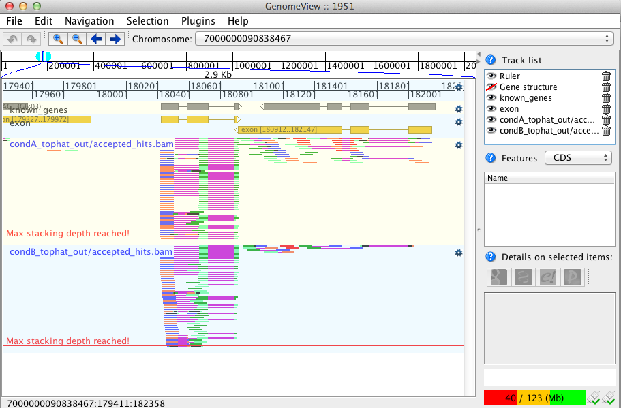

Pan the genome, examine the alignments, known genes and reconstructed genes.

Do the alignments agree with the known gene structures (ex. Intron placements)?

Do the cufflinks-reconstructed transcripts well represent the alignments?

Do the cufflinks-reconstructed transcripts match the structures of the known transcripts?

**Differential expression analysis using cuffdiff and cummeRbund:**

(~ 1 ½ minutes)

% cuffdiff -o diff_out -b genome.fa -L condA,condB -u merged_asm/merged.gtf condA_tophat_out/accepted_hits.bam condB_tophat_out/accepted_hits.bam

Examine the output files generated in the diff_out/ directory.

(the rest is interactive with little to no waiting time)

Use ‘cummeRbund’ to analyze the results from cuffdiff:

% R

(note, to exit R, type cntrl-D, or type “q()” ).

# load the cummerbund library into the R session

> library(cummeRbund)

# import the cuffdiff results

>cuff = readCufflinks('diff_out')

# examine the distribution of expression values for the reconstructed transcripts

>csDensity(genes(cuff))

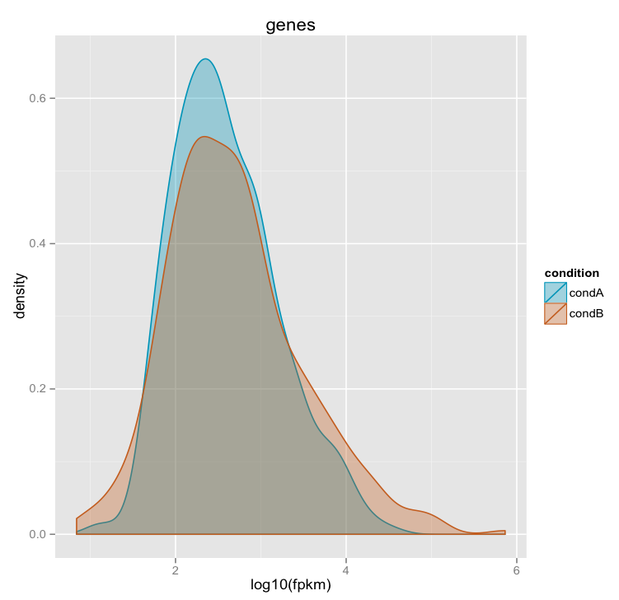

# Examine transcript expression values in a scatter plot

Expression values are typically log-normally distributed. This is just a sanity check.

>csScatter(genes(cuff), 'condA', 'condB')

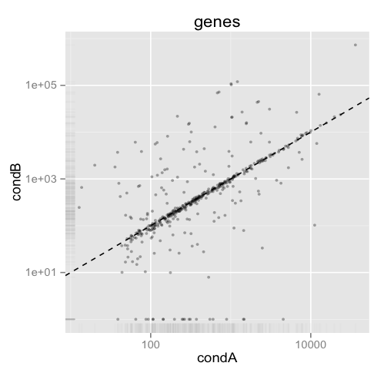

Strongly differentially expressed transcripts should fall far from the linear regression line.

# Examine individual densities and pairwise scatterplots together.

> csScatterMatrix(genes(cuff))

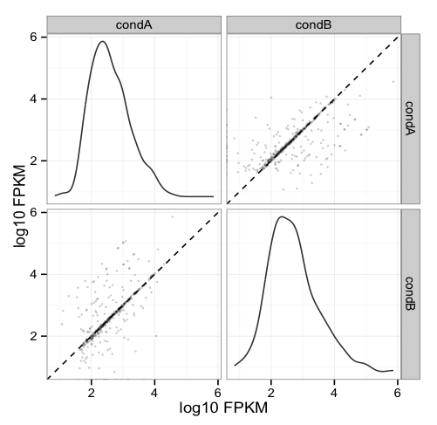

# Volcano plots are useful for identifying genes most significantly differentially expressed.

> csVolcanoMatrix(genes(cuff), 'condA', 'condB')

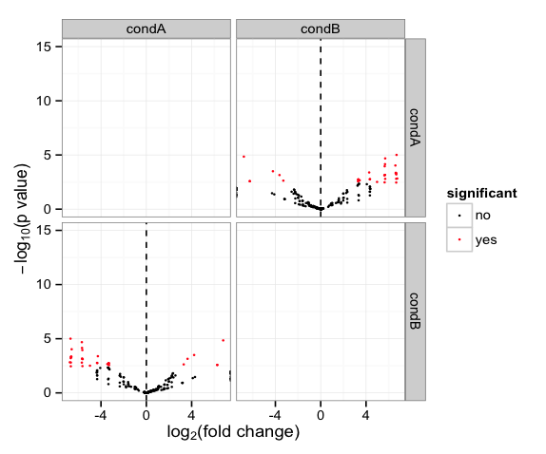

## Extract the ‘genes’ that are significantly differentially expressed (red points above)

# retrieve the gene-level differential expression data

> gene_diff_data = diffData(genes(cuff))

# how many ‘genes’?

> nrow(gene_diff_data)

# from the gene-level differential expression data, extract those that

# are labeled as significantly different.

> sig_gene_data = subset(gene_diff_data, (significant == 'yes'))

# how many?

> nrow(sig_gene_data)

# Examine the entries at the top of the unsorted data table:

> head(sig_gene_data)

gene_id sample_1 sample_2 status value_1 value_2 log2_fold_change

11 XLOC_000011 condA condB OK 320.122 10051.2000 4.97261

24 XLOC_000024 condA condB OK 680.167 68932.0000 6.66314

29 XLOC_000029 condA condB OK 1211.090 119654.0000 6.62642

33 XLOC_000033 condA condB OK 112.935 5556.4400 5.62059

44 XLOC_000044 condA condB OK 102.436 1109.5000 3.43711

51 XLOC_000051 condA condB OK 1097.570 88.2133 -3.63717

test_stat p_value q_value significant

11 -2.95865 0.003089880 0.0398694 yes

24 -2.91993 0.003501110 0.0424377 yes

29 -3.48117 0.000499220 0.0181535 yes

33 -3.36348 0.000769672 0.0192418 yes

44 -3.06523 0.002175050 0.0348008 yes

51 3.38382 0.000714839 0.0190624 yes

# You can write the list of significantly differentially expressed genes to a file like so:

> write.table(sig_gene_data, 'sig_diff_genes.txt', sep = '\t', quote = F)

# examine the expression values for one of your genes that’s diff. expressed:

# select expression info for the one gene by its gene identifier:

# (note we’re naming the variable the same as the

# transcript name, so don’t be confused by this)

>XLOC_000079 = getGene(cuff, 'XLOC_000079') # use your gene from above, since these may be numbered differently from here.

# now plot the expression values for the gene under each condition

# (error bars are only turned off here because this data set is both simulated

# and hugely underpowered to have reasonable confidence levels)

>expressionBarplot( XLOC_000079, logMode=T, showErrorbars=F)

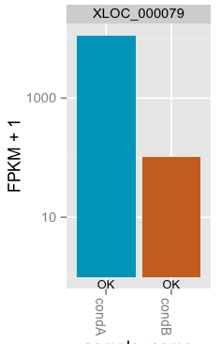

## Draw a heatmap showing the differentially expressed genes

# first retrieve the ‘genes’ from the ‘cuff’ data set by providing a

# a list of gene identifiers like so:

>sig_genes = getGenes(cuff, sig_gene_data$gene_id)

# now draw the heatmap

csHeatmap(sig_genes, cluster='both')

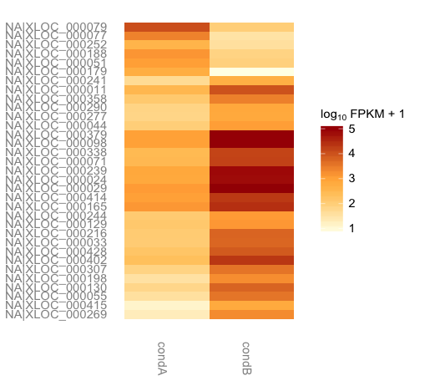

**More information on using the Tuxedo package can be found at:**

Trapnell C, Roberts A, Goff L, Pertea G, Kim D, Kelley DR, Pimentel H, Salzberg SL, Rinn JL, Pachter L.

Differential gene and transcript expression analysis of RNA-seq experiments with TopHat and Cufflinks. Nat Protoc. 2012 Mar 1;7(3):562-78. doi: 10.1038/nprot.2012.016.

<http://www.nature.com/nprot/journal/v7/n3/full/nprot.2012.016.html>

The CummeRbund manual:

<http://compbio.mit.edu/cummeRbund/manual_2_0.html>

(note, most of the tutorial provided here is based on the above two resources)

and the Tuxedo tool websites:

TopHat: <http://tophat.cbcb.umd.edu/>

Cufflinks: <http://cufflinks.cbcb.umd.edu/>

CummeRbund: <http://compbio.mit.edu/cummeRbund/>