

**A Tutorial: Genome-based RNA-Seq Analysis**

**Using the TUXEDO Package**

**(updated: 2013-10-22)**

The following details the steps involved in:

* Aligning RNA-Seq reads to a genome using Tophat
* Assembling transcript structures from read alignments using Cufflinks
* Visualizing reads and transcript structures using IGV
* Performing differential expression analysis using Cuffdiff
* Expression analysis using CummeRbund

All required software and data are provided pre-installed on a VirtualBox image. See companion ‘Rnaseq_Workshop_VM_installation.pdf’ for details. Data content and environment configurations are described therein and referenced below.

**Before Running:**

After installing the VM, be sure to quickly update the contents of the rnaseq_workshop_data directory by:

% cd rnaseq_workshop_data

% svn up

This way, you’ll have the latest content, including any recent bugfixes.

**Data Content:**

This demo uses RNA-Seq data corresponding to Schizosaccharomyces pombe (fission yeast), involving paired-end 76 base strand-specific RNA-Seq reads corresponding to four samples: Sp_log (logarithmic growth), Sp_plat (plateau phase), Sp_hs (heat shock), and Sp_ds (diauxic shift).

There are ‘left.fq’ and ‘right.fq’ FASTQ formatted Illlumina read files for each of the four samples. Also included is a ‘genome.fa’ file corresponding to a genome sequence, and annotations for reference genes (‘genes.bed’ or ‘genes.gff3’).

*Note, although the genes, annotations, and reads represent genuine sequence data, they were artificially selected and organized for use in this tutorial, so as to provide varied levels of expression in a very small data set, which could be processed and analyzed within an approximately one hour time session and with minimal computing resources.*

**Automated and Interactive Execution of Activities**

To avoid having to cut/paste the numerous commands shown below into a unix terminal, the VM includes a script ‘runTrinityDemo.pl’ that enables you to run each of the steps interactively. To begin, simply run:

% ./runTuxedoDemo.pl

**Use Tophat and Cufflinks to align reads and assemble transcripts**

First, prepare the ‘genome.fa’ file for tophat alignment:

% bowtie-build genome.fa genome

**(a) Align reads and assemble transcripts for sample: Sp_ds:**

Align reads using tophat:

% tophat -I 1000 -i 20 --bowtie1 --library-type fr-firststrand -o tophat.Sp_ds.dir genome Sp_ds.left.fq Sp_ds.right.fq

Rename the alignment (bam) output file according to this sample name:

% mv tophat.Sp_ds.dir/accepted_hits.bam tophat.Sp_ds.dir/Sp_ds.bam

Index this bam file for later viewing using IGV:

% samtools index tophat.Sp_ds.dir/Sp_ds.bam

Reconstruct transcripts for this sample using Cufflinks:

% cufflinks --overlap-radius 1 --library-type fr-firststrand -o cufflinks.Sp_ds.dir tophat.Sp_ds.dir/Sp_ds.bam

Rename the cufflinks transcript structure output file according to this sample:

% mv cufflinks.Sp_ds.dir/transcripts.gtf cufflinks.Sp_ds.dir/Sp_ds.transcripts.gtf

Now, you’re done with running Tuxedo on this sample. You now need to repeat these operations for each of the three other samples, as below:

**(b) Align reads and assemble transcripts for sample: Sp_hs:**

% tophat -I 1000 -i 20 --bowtie1 --library-type fr-firststrand -o tophat.Sp_hs.dir genome Sp_hs.left.fq Sp_hs.right.fq

% mv tophat.Sp_hs.dir/accepted_hits.bam tophat.Sp_hs.dir/Sp_hs.bam

% samtools index tophat.Sp_hs.dir/Sp_hs.bam

% cufflinks --overlap-radius 1 --library-type fr-firststrand -o cufflinks.Sp_hs.dir tophat.Sp_hs.dir/Sp_hs.bam

% mv cufflinks.Sp_hs.dir/transcripts.gtf cufflinks.Sp_hs.dir/Sp_hs.transcripts.gtf

**(c) Align reads and assemble transcripts for sample: Sp_log:**

% tophat -I 1000 -i 20 --bowtie1 --library-type fr-firststrand -o tophat.Sp_log.dir genome Sp_log.left.fq Sp_log.right.fq

% mv tophat.Sp_log.dir/accepted_hits.bam tophat.Sp_log.dir/Sp_log.bam

% samtools index tophat.Sp_log.dir/Sp_log.bam

% cufflinks --overlap-radius 1 --library-type fr-firststrand -o cufflinks.Sp_log.dir tophat.Sp_log.dir/Sp_log.bam

% mv cufflinks.Sp_log.dir/transcripts.gtf cufflinks.Sp_log.dir/Sp_log.transcripts.gtf

**(d) Align reads and assemble transcripts for sample: Sp_plat:**

% tophat -I 1000 -i 20 --bowtie1 --library-type fr-firststrand -o tophat.Sp_plat.dir genome Sp_plat.left.fq Sp_plat.right.fq

% mv tophat.Sp_plat.dir/accepted_hits.bam tophat.Sp_plat.dir/Sp_plat.bam

% samtools index tophat.Sp_plat.dir/Sp_plat.bam

% cufflinks --overlap-radius 1 --library-type fr-firststrand -o cufflinks.Sp_plat.dir tophat.Sp_plat.dir/Sp_plat.bam

% mv cufflinks.Sp_plat.dir/transcripts.gtf cufflinks.Sp_plat.dir/Sp_plat.transcripts.gtf

**Merge separately assembled transcript structures into a cohesive set:**

First, create a file that lists the names of the files containing the separately reconstructed transcripts, which can be done like so, writing each of the four Cufflinks transcript GTF files to a newly created ‘assemblies.txt’ file.

% echo cufflinks.Sp_ds.dir/Sp_ds.transcripts.gtf >> assemblies.txt

% echo cufflinks.Sp_hs.dir/Sp_hs.transcripts.gtf >> assemblies.txt

% echo cufflinks.Sp_log.dir/Sp_log.transcripts.gtf >> assemblies.txt

% echo cufflinks.Sp_plat.dir/Sp_plat.transcripts.gtf >> assemblies.txt

# verify that this file now contains both filenames:

% cat assemblies.txt

cufflinks.Sp_ds.dir/Sp_ds.transcripts.gtf

cufflinks.Sp_hs.dir/Sp_hs.transcripts.gtf

cufflinks.Sp_log.dir/Sp_log.transcripts.gtf

cufflinks.Sp_plat.dir/Sp_plat.transcripts.gtf

And now we’re ready to merge the transcripts using cuffmerge:

% cuffmerge -s genome.fa assemblies.txt

The merged set of transcripts should now exist as file “merged_asm/merged.gtf’.

**View the reconstructed transcripts and the tophat alignments in IGV**

% java -Xmx2G -jar /Users/bhaas/IGV/current//igv.jar -g `pwd`/genome.fa `pwd`/merged_asm/merged.gtf,`pwd`/genes.bed,`pwd`/tophat.Sp_ds.dir/Sp_ds.bam,`pwd`/tophat.Sp_hs.dir/Sp_hs.bam,`pwd`/tophat.Sp_log.dir/Sp_log.bam,`pwd`/tophat.Sp_plat.dir/Sp_plat.bam

*(Note, you may need to resize the individual alignment patterns in the viewer by dragging the panel boundaries. Afterwards, go to menu “Tracks” -> “Fit Data To Window” to re-space the contents of the viewer)*

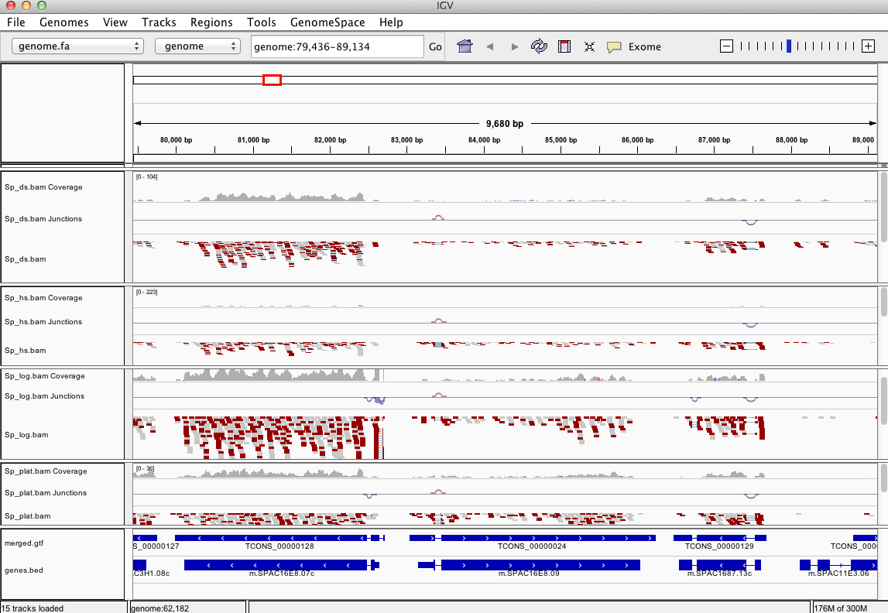

Pan the genome, examine the alignments, known genes and reconstructed genes.

Do the alignments agree with the known gene structures (ex. intron placements)?

Do the cufflinks-reconstructed transcripts well represent the alignments?

Do the cufflinks-reconstructed transcripts match the structures of the known transcripts?

**Identify differentially expressed transcripts using Cuffdiff:**

% cuffdiff --library-type fr-firststrand -o diff_out -b genome.fa   
-L Sp_ds,Sp_hs,Sp_log,Sp_plat -u merged_asm/merged.gtf tophat.Sp_ds.dir/Sp_ds.bam tophat.Sp_hs.dir/Sp_hs.bam tophat.Sp_log.dir/Sp_log.bam tophat.Sp_plat.dir/Sp_plat.bam

Examine the output files generated in the diff_out/ directory.

A table containing the results from the gene-level differential expression analysis can be found as ‘diff_out/gene_exp.diff’. Examine the top lines of this file like so:

% head diff_out/gene_exp.diff

**Study transcript expression and analyze DE using CummeRbund:**

Use ‘cummeRbund’ to analyze the results from cuffdiff:

% R

(note, to exit R, type cntrl-D, or type “q()” ).

# load the cummerbund library into the R session

> library(cummeRbund)

# import the cuffdiff results

>cuff = readCufflinks('diff_out')

# examine the distribution of expression values for the reconstructed transcripts

>csDensity(genes(cuff))

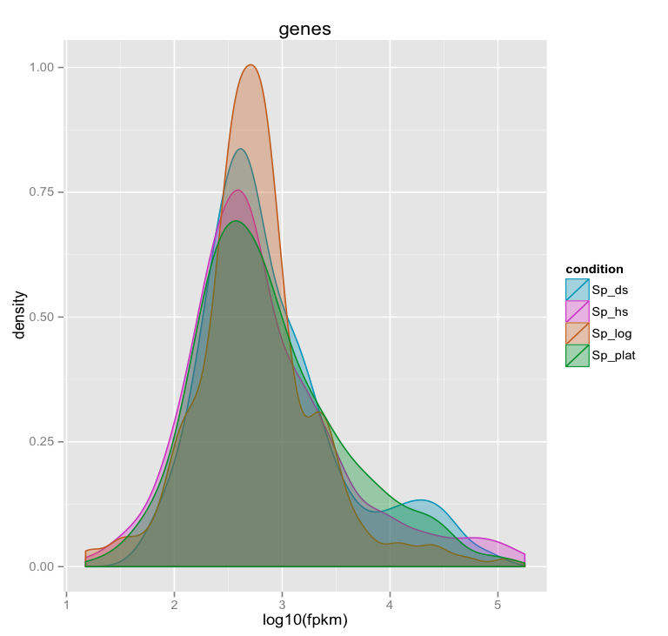

*(Note, in the Ubuntu VM, you may need to resize the graphics window in order for the plot to render correctly. This is a bug with the version of R being used.)*

# Examine transcript expression values in a scatter plot

Expression values are typically log-normally distributed. This is just a sanity check.

>csScatter(genes(cuff), ‘Sp_log’, ‘Sp_plat’)

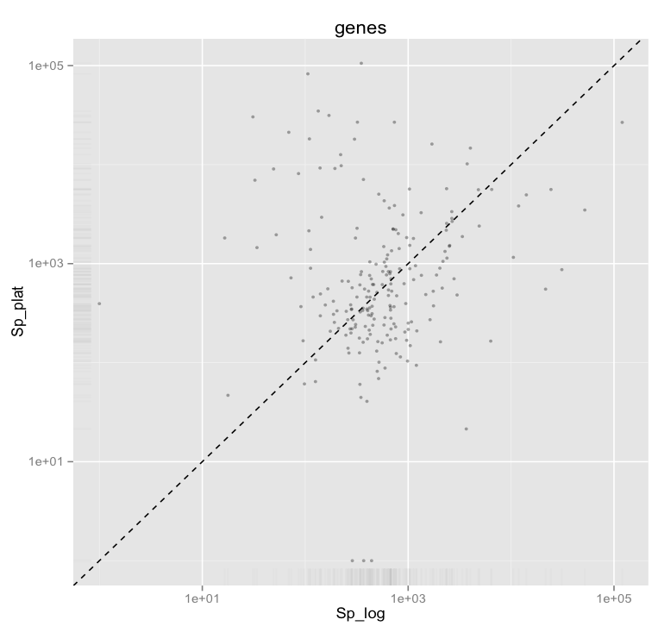

Strongly differentially expressed transcripts should fall far from the linear regression line.

*(Note, in the Ubuntu VM, you may need to resize the graphics window in order for the plot to render correctly. This is a bug with the version of R being used.)*

# Examine individual sample distributions of gene expression values and the pairwise scatterplots together in a single plot.

> csScatterMatrix(genes(cuff))

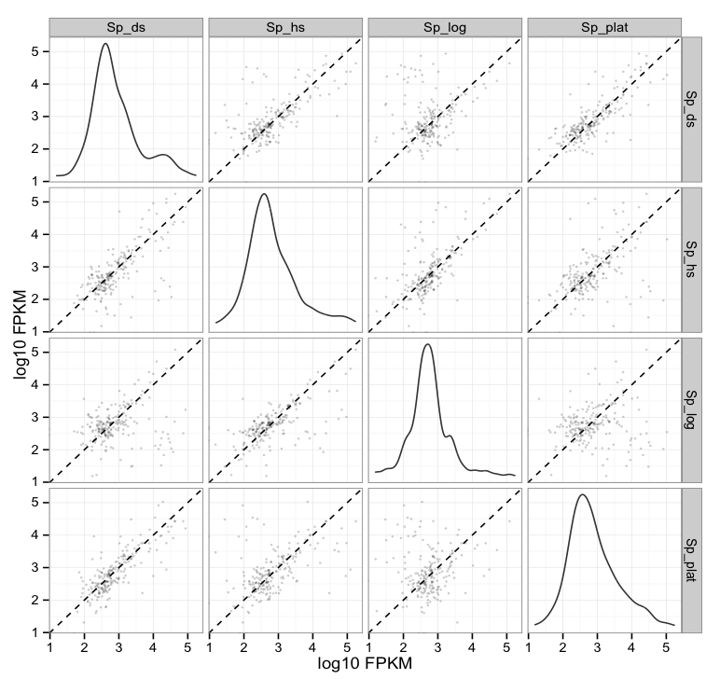

*(Note, in the Ubuntu VM, you may need to resize the graphics window in order for the plot to render correctly. This is a bug with the version of R being used.)*

# Volcano plots are useful for identifying genes most significantly differentially expressed.

> csVolcanoMatrix(genes(cuff))

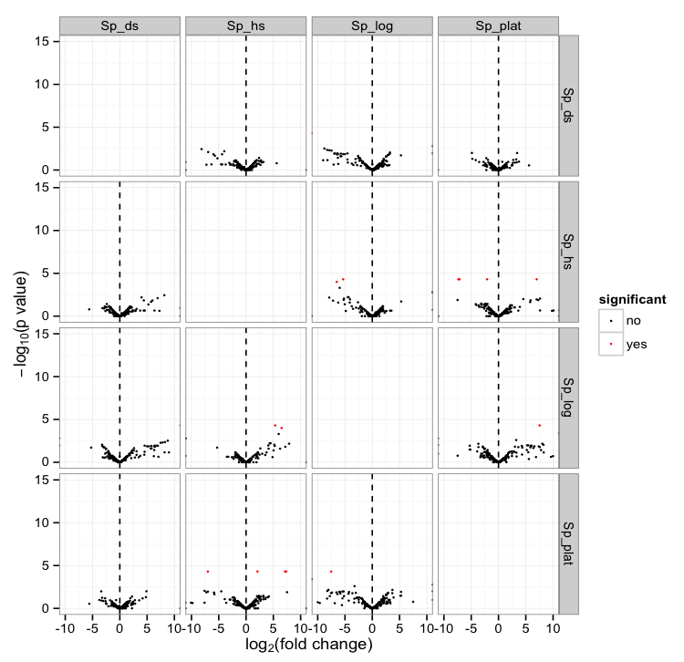

*(Note, in the Ubuntu VM, you may need to resize the graphics window in order for the plot to render correctly. This is a bug with the version of R being used.)*

## Extract the ‘genes’ that are significantly differentially expressed (red points above)

# retrieve the gene-level differential expression data

> gene_diff_data = diffData(genes(cuff))

# how many ‘genes’ are there?

> nrow(gene_diff_data)

# from the gene-level differential expression data, extract those that

# are labeled as significantly different.

# note, normally just set criteria as “significant=’yes’”, but we’re adding an

# additional p_value filter just to capture some additional transcripts for   
# demonstration purposes only. This simulated data is overly sparse and actually  
# suboptimal for this demonstration (in hindsight).

>sig_gene_data = subset(gene_diff_data,(significant=='yes' | p_value < 0.01))

# how many genes are significantly DE according to these criteria?

> nrow(sig_gene_data)

# Examine the entries at the top of the unsorted data table:

> head(sig_gene_data)

gene_id sample_1 sample_2 status value_1 value_2 log2_fold_change

56 XLOC_000056 Sp_ds Sp_hs OK 33560.500 117.6900 -8.15563

136 XLOC_000136 Sp_ds Sp_hs OK 30094.800 246.0650 -6.93433

146 XLOC_000146 Sp_ds Sp_hs OK 1125.700 70.9957 -3.98694

269 XLOC_000056 Sp_ds Sp_log OK 33560.500 108.8130 -8.26877

315 XLOC_000102 Sp_ds Sp_log OK 0.000 440.3590 Inf

336 XLOC_000123 Sp_ds Sp_log OK 753.187 0.0000 -Inf

test_stat p_value q_value significant

56 -4.86421 0.00360 0.257929 no

136 -4.49008 0.00795 0.291731 no

146 -3.99117 0.00640 0.291731 no

269 -4.76096 0.00450 0.291731 no

315 NA 0.00160 0.143550 no

336 NA 0.00005 0.008700 yes

# You can write the list of significantly differentially expressed genes to a file like so:

> write.table(sig_gene_data, 'sig_diff_genes.txt', sep = '\t', quote = F)

# examine the expression values for one of your genes that’s diff. expressed:

# select expression info for the one gene by its gene identifier:

# let’s take the first gene identifier in our sig_gene_data table:

# first, get its gene_id

> ex_gene_id = sig_gene_data$gene_id[1]

# print its value to the screen:

>ex_gene_id

# get that gene ‘object’ from cummeRbund and assign it to variable ‘ex_gene’

>ex_gene = getGene(cuff, ex_gene_id)

# now plot the expression values for the gene under each condition

# (error bars are only turned off here because this data set is both simulated

# and hugely underpowered to have reasonable confidence levels)

> expressionBarplot(ex_gene, logMode=T, showErrorbars=F)

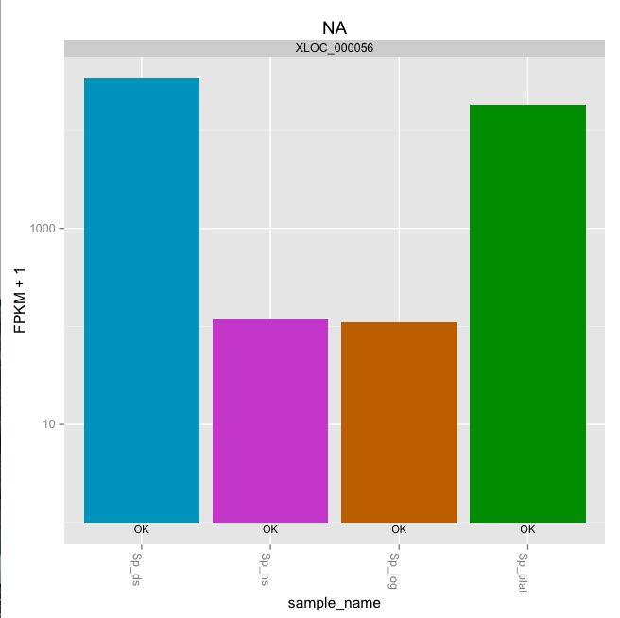

*(Note, in the Ubuntu VM, you may need to resize the graphics window in order for the plot to render correctly. This is a bug with the version of R being used.)*

## Draw a heatmap showing the differentially expressed genes

# first retrieve the ‘genes’ from the ‘cuff’ data set by providing a

# a list of gene identifiers like so:

>sig_genes = getGenes(cuff, sig_gene_data$gene_id)

# now draw the heatmap

>csHeatmap(sig_genes, cluster='both')

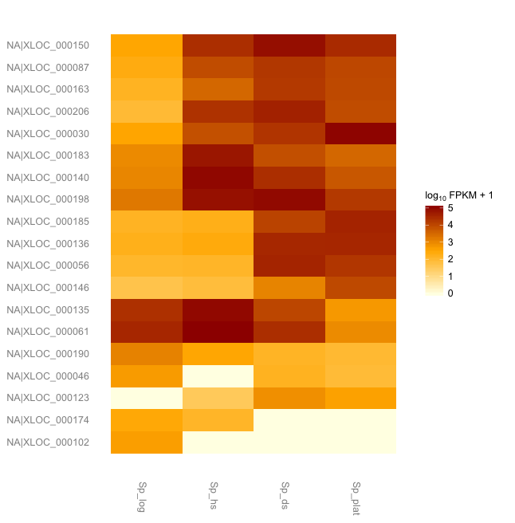

*(Note, in the Ubuntu VM, you may need to resize the graphics window in order for the plot to render correctly. This is a bug with the version of R being used.)*

**More information on using the Tuxedo package can be found at:**

Trapnell C, Roberts A, Goff L, Pertea G, Kim D, Kelley DR, Pimentel H, Salzberg SL, Rinn JL, Pachter L.

Differential gene and transcript expression analysis of RNA-seq experiments with TopHat and Cufflinks. Nat Protoc. 2012 Mar 1;7(3):562-78. doi: 10.1038/nprot.2012.016.

<http://www.nature.com/nprot/journal/v7/n3/full/nprot.2012.016.html>

The CummeRbund manual:

<http://compbio.mit.edu/cummeRbund/manual_2_0.html>

(note, most of the tutorial provided here is based on the above two resources)

and the Tuxedo tool websites:

TopHat: <http://tophat.cbcb.umd.edu/>

Cufflinks: <http://cufflinks.cbcb.umd.edu/>

CummeRbund: <http://compbio.mit.edu/cummeRbund/>