Butterfly Landing

Overview: Setting

You’re a butterfly on a picnic table and you’re looking for the best leaf to sleep on. How many can you grab until you make up your mind?

Controls: Mouse Clicks to start and quit. Arrow keys to move butterflies.

Topics to improve/learn: Week 11-12 / Week 13-16.

Game Diagram:

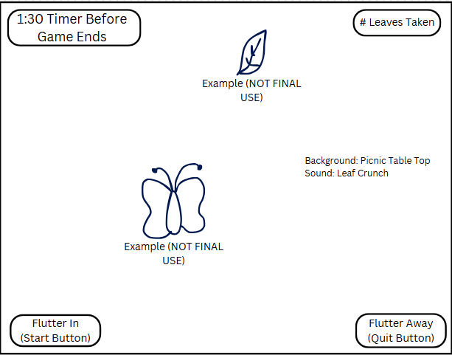

Game States:

Intro ▶️ gamePlay ▶️ endGame (quit)

* Intro
  + Show Title (top middle)
  + Show Description (below title)
  + Show Start (Flutter in) and Quit (Flutter away) button
  + Everything else hidden
* gamePlay
  + Title hidden
  + Start and Quit hidden
  + All Sprites Show
  + Show Timer and Score
* endGame (quit)
  + Title hidden
  + Sprites hidden
  + Show Quit button

Sprites:

* Butterfly
  + User-controlled character
  + Moves left, right, down, up with arrow keys
  + When moving to leaf, reset leaf and add a point.
* Leaf
  + Computer controlled element
  + When Butterfly moves to leaf, reset/regenerate new leaf
  + reset/regenerate leaf – new position on board
  + Only 1 leaf on screen

UI Components

* Background
  + Picnic table top
    - Summer time, sunny
  + Butterflies and Leaves stick out and are easy to see.
* Title
  + Title and description screen multilabel
  + When clicked on “Flutter in” (start), game starts
* LblTimer
  + Label will alway show time left before the game ends.
    - Game ends at 0
  + Game ends
    - Show quit button
* LblScore
  + Label showing current score
  + Adds a point for each leaf collected
* BtnQuit (Flutter Away)
  + Appears when timer ends
  + When clicked, exits entire game

Sound Effects

* leafCrunch
  + Played when butterfly gets leaf

Milestones

* Gather placeholder
* Get basic form of game class
  + Butterfly class
  + Leaf class
* Add scorekeeping and lblScore
* Add timekeeping and lblTime
* Ad quit (Flutter away) button
* Add start (Flutter In) button
* Add intro

Game Tuning Parameters

* Speed of butterfly
* reset/regenerate leaves
  + Number of leaves on screen (1 per collecting)