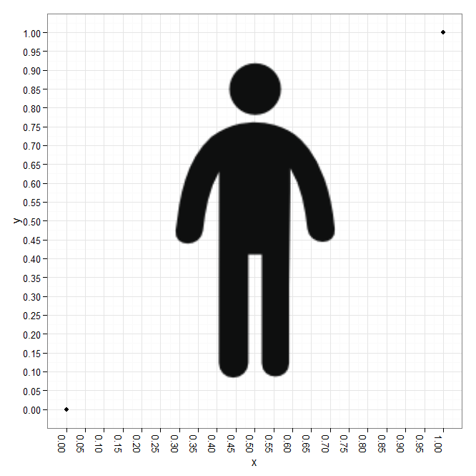

|  |  |
| --- | --- |
| x | Y |
| 1 | 1 |
| .87 | .73 |
| .75 | .65 |
| .67 | .6 |
| .525 | .4 |
| .475 | .35 |
| .28 | .27 |
| 0 | 0 |