Lapwing

About Lapwing

Lapwing is a free, open-source program to help birders analyze their personal eBird sightings. Lapwing runs on Windows, MacOS, and Ubuntu.
Lapwing lets you generate reports, such as
- species lists,
- location lists,
- checklists lists,
- maps with points indicating sightings (hover your mouse over the points to see the location names),
- family reports,
- species totals by date (year, month, date),
- species totals by location (country, state, county, location),
- list comparisons (species seen only on one list, species seen only on the other list, species seen on both lists),
- “big report” showing species seen, map of locations, new species for time periods, new species for locations, etc., and
- view web sites natively inside the application for species (Wikipedia, Audubon, Maculay Library, All About Birds).
Lapwing also lets you print each report to a paper printer, as well as to create PDF files of your reports.
Lapwing lets you filter your reports by
- Country, state, county, and location
- Order, family, and species
- Date range (e.g., this current year)
- Seasonal range (e.g., “summer,” or specific ranges, such as May 1 to May 10 of all years)

Sample Lapwing Windows

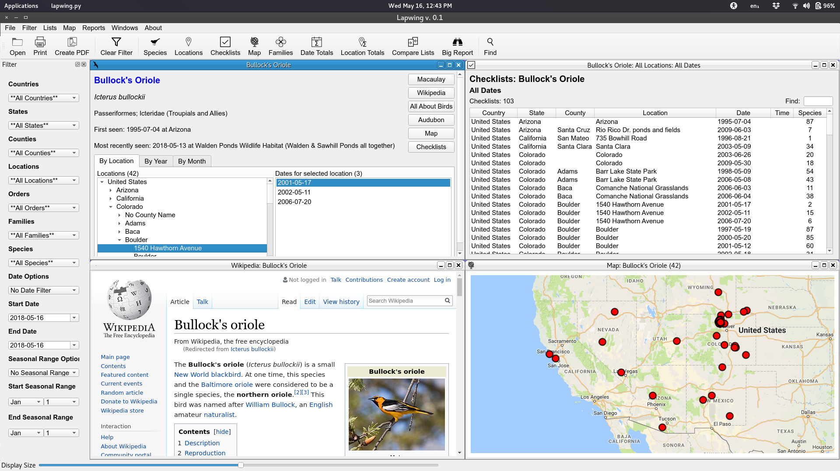
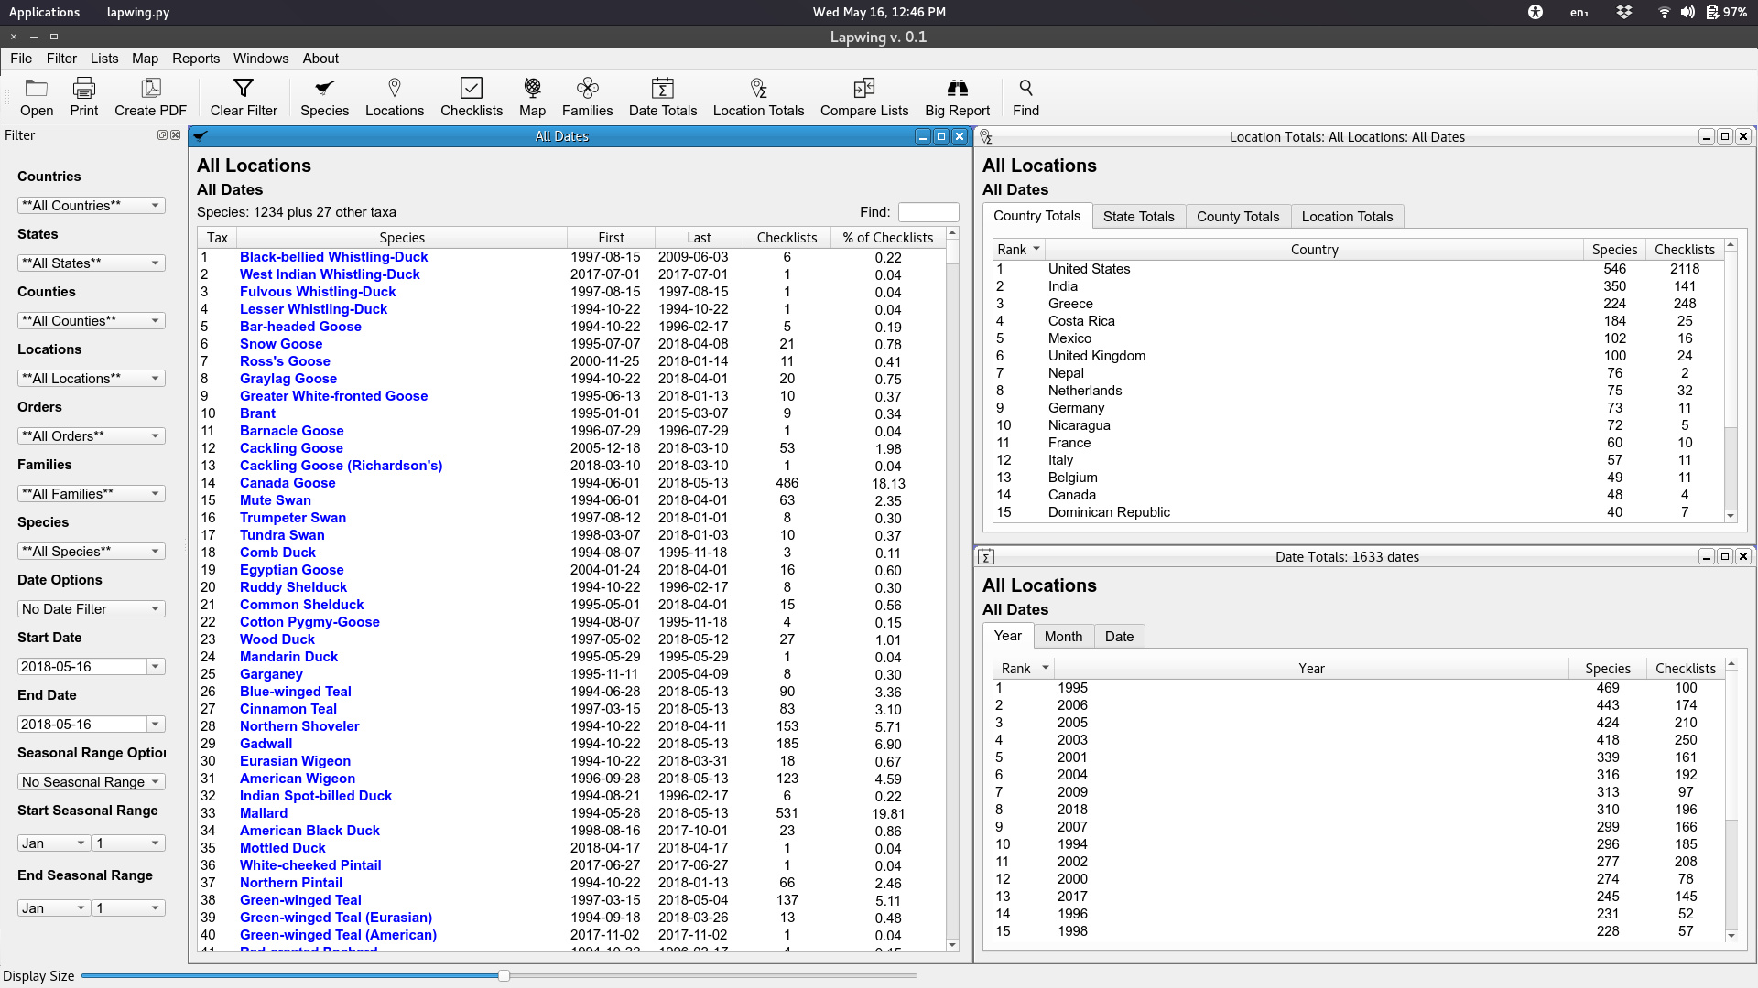
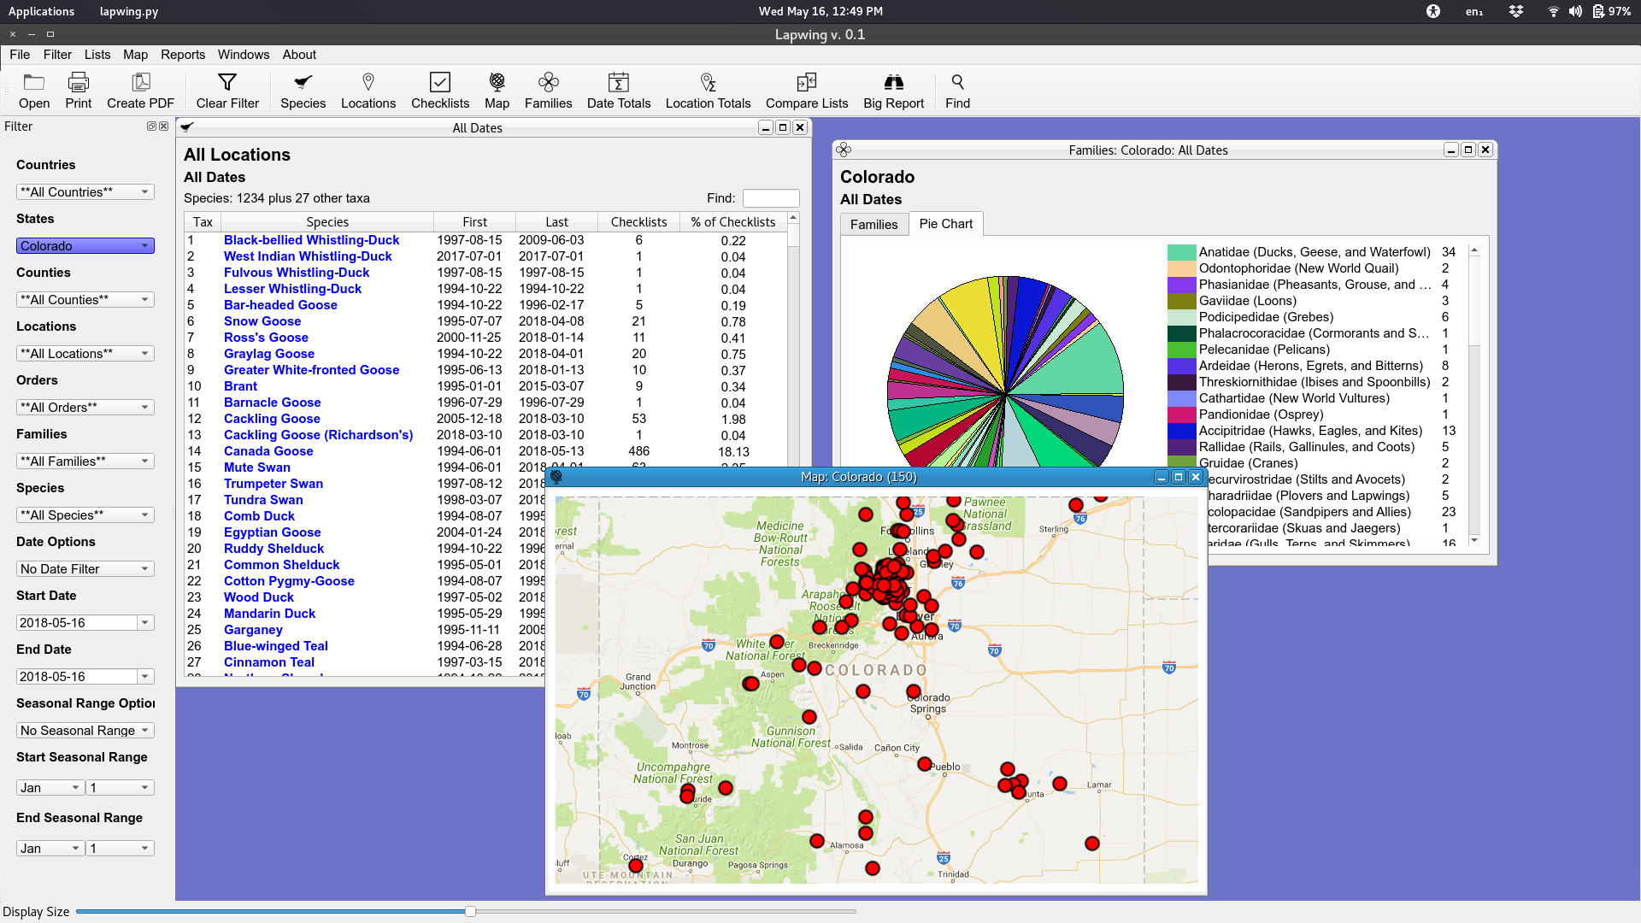

Installing and Starting Lapwing

There is no installation program for Lapwing. All you need to do is download it, upzip it, and double-click the program file.
- Download the lapwing.zip file from the Internet. Remember the folder where you save it.
- Use your computer’s file manager to navigate to the folder where you saved the zip file.

  - On Windows, use “Windows Explorer.”
  - On MacOS, use “Finder.”
  - On Ubuntu, use “Nautilus” or “Files.”

- Right-click on the zip file and select “Extract to Here” or the similar command for your operating system.
- Use your computer’s file manager again to navigate to the newly created folder.
- Inside this folder, double-click the lapwing app file.
  - On Windows, find “lapwing.exe”.
  - On MacOS, find “lapwing”.
  - On Ubuntu, find“lapwing”.

Downloading your eBird Data File

Lapwing needs an eBird data file to analyze your sightings. You download this file from the eBird web site.
- Open your browser and go to www.ebird.org.
- Log in, if you aren’t logged in automatically.
- Click “My eBird” at the top of the web page.
- Click “Download My Data,” located at the bottom right of the My eBird page.
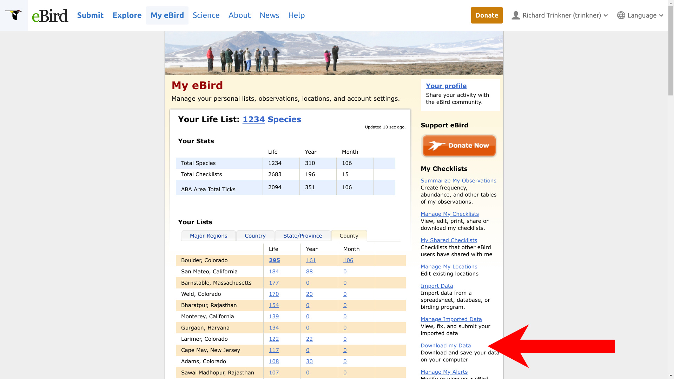
- After you click this link, eBird will display a confirmation message. Click the confirmation link.
- ebird will then send you an email, usually within a few seconds. Open the email and click the download link to retrieve your data file. Remember where you save it.

Opening your Data File In Lapwing

- Start Lapwing. (See above for how to start Lapwing.)
- Click the Open icon.
- Inside the Open dialog, navigate to the folder where you saved your downloaded data file.
- Select the file.
- Click “Open.”
- Lapwing will open your data file, display the filter panel, and display your life list.

Using Lapwing
You can double-click most sighting data and Lapwing will display a new window with the appropriate data for you. For example, if you double-click on a species name, Lapwing will open the Individual report window for that species.
You can right-click on most sighting data, and Lapwing will offer you choices that you can send to the Filter.
Nearly all windows and reports in Lapwing rely on the Filter.
To run a report,
- Set as many options on the Filter as you want.
- Click the icon of the report that you want from the toolbar at the top of the Lapwing window.
To clear the filter,
- Click the “Clear Filter” icon on the toolbar.

Tips
- Lapwing cannot edit your data. It only helps you analyze it. To edit your data, use the eBird web site.
- Download a new data file whenever you want updated data. Lapwing’s data is only as recent as your data file.
- Set the filter quickly by right-clicking on sighting data to send options to the filter.
- In map displays, zoom in and out by scrolling your mouse or by two-finger scrolling on your touchpad (if your laptop has two-finger scrolling).
- Don’t run the “Big Report” report on large time periods because the report will take a long time to generate. Instead, set the filter to create a smaller data set. For example, select a weekend or a month for the Big Report.
- To compare two lists, first generate the two lists you want to compare. After creating the two lists, click the “Compare Lists” icon. Your generated lists will appear in the drop-down boxes at the top of the Compare Lists window.
- You can maximize windows to take up all the space of the application window. Click the middle of the three small icons at the top of the window.
- Sort tabular data in any window by clicking the table’s column header.
- To shrink a mazimized report window back down to regular size, click the middle of the three little window control buttons at the top of the window. See arrow below.
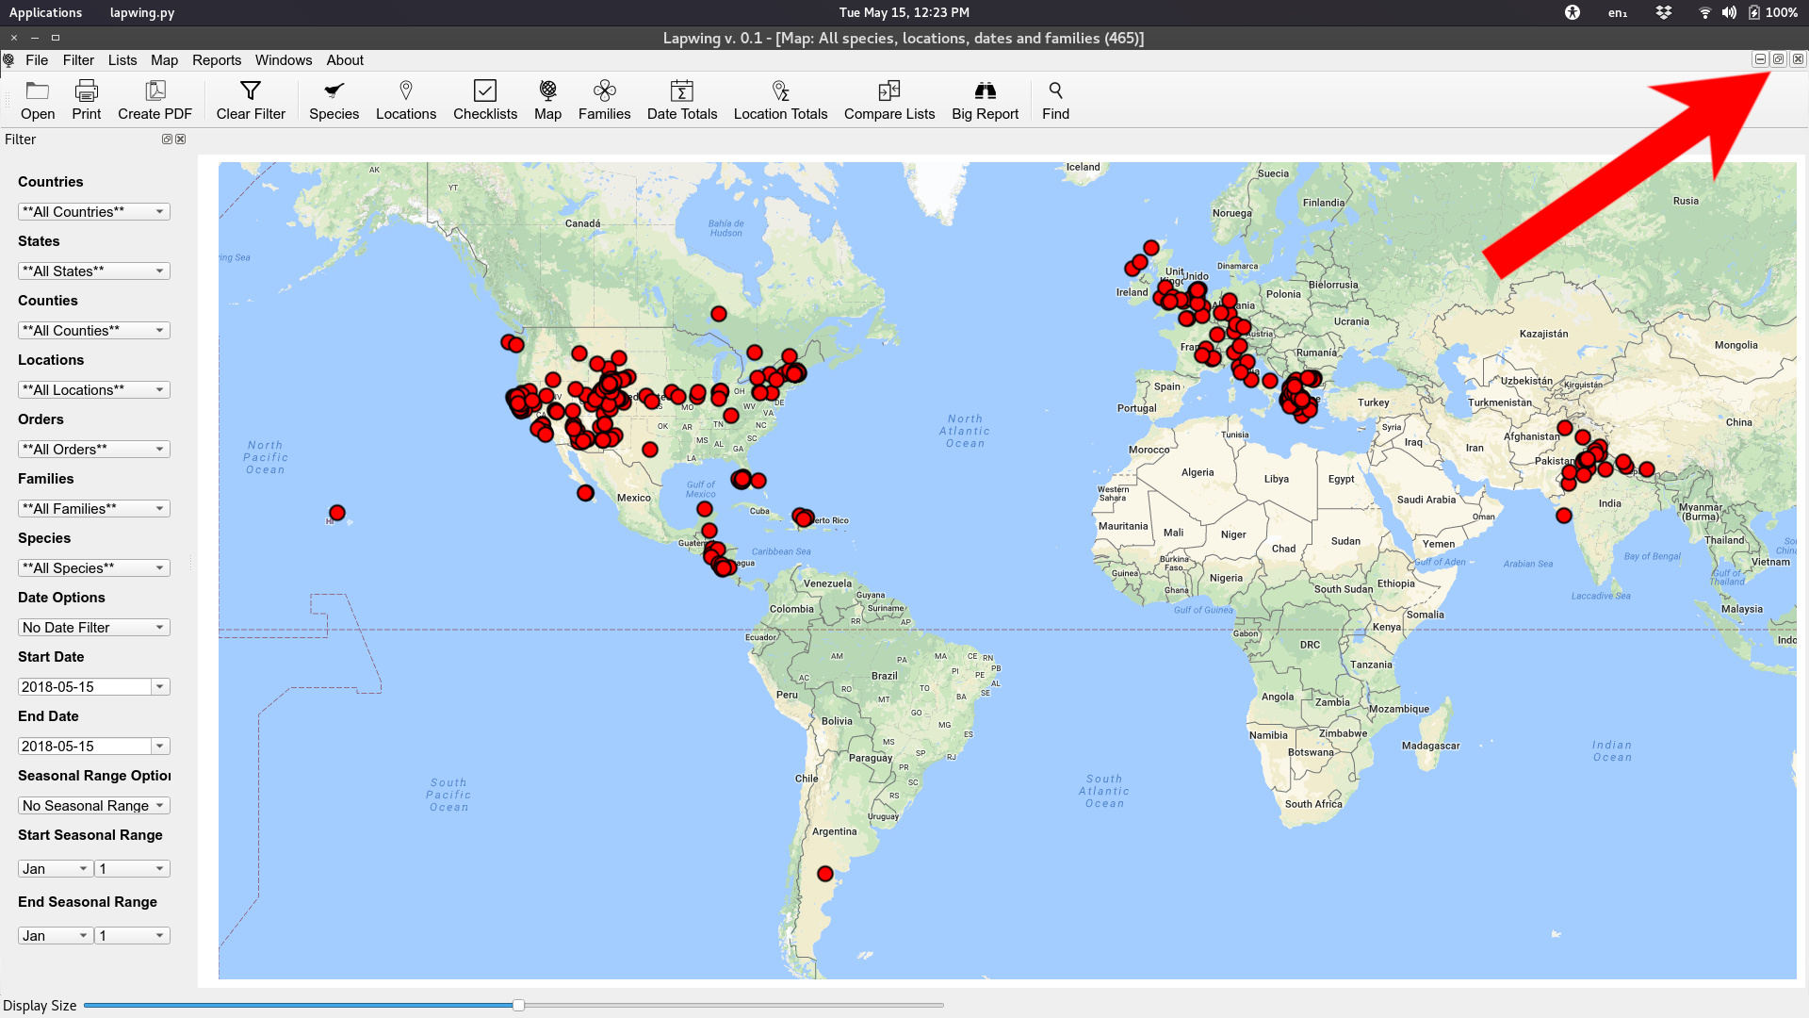
- Change the zoom factor for Lapwing by sliding the slider at the bottom of the application. See arrow below.
