Dressage Application Documentation
using UNITY

UHCL | Fall 2012 | SWEN 6837 | Capstone - Project

Project Team Members
Douglas A. Stewart
Anuradha Chintakindi
Uduak Udomon

Documentation Prepared By:
Douglas A. Stewart
Introduction 4
Purpose 4
Software 4
Unity 4
Requirements 4
Installation 4
Purpose 4
Additional Resources 5
Architectural Design 5
Use-Case 5
Details 5
Diagram 6
Algorithms 6
Load External XML 6
Extract Movement Data 6
Process Movement Data 7
Move “Horse” Along Straight-Line Paths 7
Move “Horse” Along Half-Circle Paths 7
Move “Horse” Along Full-Circle Paths 8
Move “Horse” Along Serpentine Path 9
Pause Movement 10
Display HUD 10
Camera Toggle 10
Bezier Curves 11
Creation of 3D Environment 11
Main Menu 11
Creating “mainMenu” Scene 11
Pause Menu 13
3D World 13
Creating “main” Scene 13
Create “Terrain” 13
Create “Arena” 20
Create “Sunlight” and adjusting ambient light 21
Cameras and HUD 26
CameraAbove: 26
CameraWestStand 26
CameraEastSide 29
CameraHorse 31
Horse (Object) 31
Implementation 31
Important Notes About Code 31
Using Lerp() in Unity 31
Using Slerp() in Unity 31
The Resource.load() vs. WWW class 32
Bezier Curves 32
Execution Order of System Functions 32
Coroutines and Yields 32
Global Settings Script 33
External Data 33
XML Data Structure 33
Basic Structure Outline 33
XML Element Description and Values 34
Important Notes About XML Documents 35
Application “Pertenate” File Structure 35
File Structure 36
Future Implementations 37
“Horse” Object Gait 37
Suggested Implementation Method 37
Replay of Past Movements 38
Suggested Implementation Method 38
“Horse” Object Directed Movement 38
Suggested Implementation Method 38
Movement Speed Adjustment 38
Suggested Implementation Method 38
Fix Large Half-Circle Path Speed Variation 39
Suggested Implementation Method 39
Draggable HUD 39
Suggested Implementation Method 39
Important Notes About Unity 39
Building Project 39
Web Player 40
PC and Mac Standalone 40
Flash Player (Preview) 40
iOS 40
Android 41
XBOX 360 41
Wii 41
PS3 41
Resources 41
Unity 41
General Scripting Information 41
Execution Order of Event Functions 41
GUI Menu Systems 42
Movement Along Paths 42

Introduction

Purpose
The application is meant for dressage riders to be able to learn the movements of the tests for dressage without the worry of exhaustion of the horse in the process. Since the main time spent is the rider's memorization of movments, it is unrealistic to expect a horse to consistently run the tests as often as the rider needs to be able to memorize. The program allows for the rider to view the movements through several different percpectives since the program is 3-dimensional. The rider will also eventually be able to move throughout the test freely, being able to replay or move forward without restraints to test sequences. Because the program uses a standard set of xml file movement descriptions, it should be capable of playing all and any future tests that are produced.

Software

Unity

Requirements
- Windows: XP SP2 or later; Mac OS X: Intel CPU & "Leopard" 10.5 or later. Note that Unity was not tested on server versions of Windows and OS X.
- Graphics card with DirectX 9 level (shader model 2.0) capabilities. Any card made since 2004 should work.
- Using Occlusion Culling requires GPU with Occlusion Query support (some Intel GPUs do not support that).
- The rest only depends on the complexity of your projects!.

Installation
Unity3d setup execution file can be found at http://unity3d.com/unity/download/. Because of the robust installation procedures, it is recommended to follow the default installation procedures as dictated by the setup wizard during installation, once the setup file is executed.

Purpose
Unity3d, or better referred to as just Unity, is a robust 3d game creation software suite. The primary reason for the use of this program is it's relative low learning curve approach to development. Much of the difficult items are based on the GUI and allows you to produce in the authoring mode a WYSIWYG experience. There is a strong open source following with many resources for outside, pre-made, assets and prefabs that borderline cutting-edge gaming quality 3d. The 3d engine, the editor incorporates, uses a physics collision engine, and can be used to represent realistic motions and interactions as you would expect in the real physical world. The editor allows for scripting with object-oriented languages such as C#, which was chosen for this implementation, and javascript. The program can also build for environments such as XBOX 360, Wii, PS3, IOS, MacOS, and Android besides the traditional Windows application approach.

Additional Resources
You can find many tutorials, many of which are hosted by the official distributor website, at http://unity3d.com/support/documentation/.

Architectural Design

Use-Case

Details
Start Application: The user can begin the runtime of the Dressage 3D Application.
Run Test: The user selects the test to run from a selection choice menu and at what speed the test will run at.
Pause: The user will be able to pause the execution of the movement of the “Horse” at any time during the movement.
Display HUD: Will be activated by the execution of the “Horse” object movement and the invocation of the pause command.
Replay Movement: Will be accessible at any time during the execution of the movement of the “Horse” movement via the pause menu.
Toggle Camera: The user will be able to select a camera view at any time during the movement of the “Horse” object.
Return to Main Menu: Using the pause menu, the user can select at any time to return to the main menu.
Move “Horse”: The run test command initiates the execution of the movement of the “Horse” object.
End Application: Either via the pause menu or the main menu the user can quit the application's execution.

Diagram
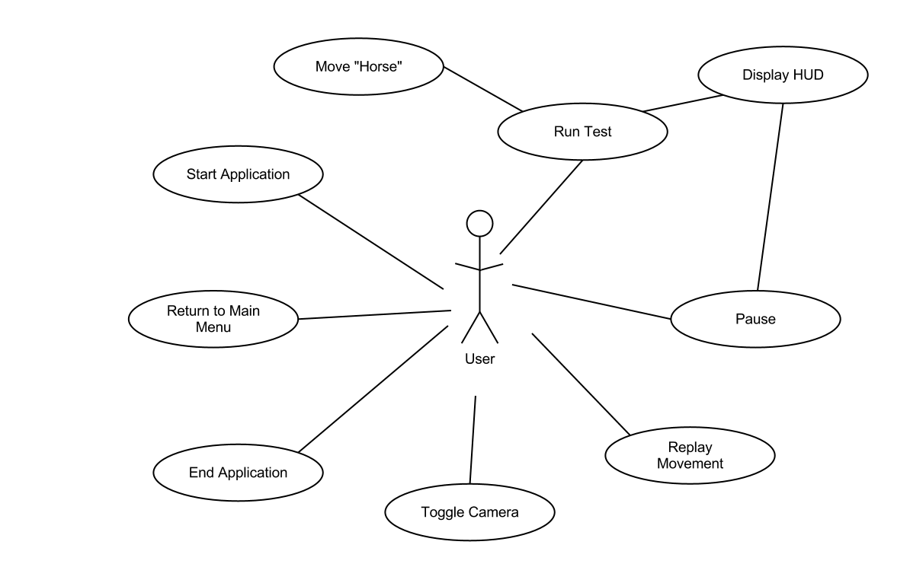

Algorithms

Load External XML
- Obtain external URL from global settings
- Setup a connection using the WWW class
- Wait for connection to be established until continuing
- Setup a temporary XML object that will hold data extracted from external source
- Load data from external source into the temporary object created
- Pass temporary XML object to extraction method

Extract Movement Data
- Create a temporary movement object that will only exist during the current iteration of the movement extraction and process.
- Extract the name of the test and pass to global settings
- Setup a foreach loop to pass through each node directly under Xpath “Test/Movement”, so basically any of the direct child nodes of the Movement tag in the XML file.
- Extract and set to the current movement object's attributes that correspond to “MovementID” and “MoveementDesc” nodes.
- Within the “Test/Movement” foreach loop create a sub loop to move through the child nodes of “MovementDetails”
- Extract and set to the current movement object's attributes that correspond to “SequenceID”, “Path”, “PathDesc”, and “Gait”.
- Pass current movement object to be processed for movement of “Horse” object

Process Movement Data
- Set temporary holders to place extracted way-point positioning into
- Split the wording extracted for “Path”, “PathDesc”, and “MovementDesc” (These were all separated by special characters)
- Assign global settings with current movement information
- Always assign a “firstPosition” and a “secondPosition”, since all extracted paths have at least 2 way-point identifiers
- Check for the length of the extracted way-point collections and assign additional way-point positions appropriately.
- Check “PathDesc” to determine what type of path is to be processed
- If “PathDesc” = Line or Diagonal, assign the “move” method to process the movement of the “Horse”
- Depending on number of positions extracted from “Path” information, run “move” method multiple times using appropriate temporary positioning data
- If “PathDesc” = HalfCircle, assign the “halfCircle” method to process the movement of the “Horse” using only the first two temporary positioning data
- If “PathDesc” = FullCircle, assign the “fullCircleMovement” method to process the movement of the “Horse” using only the first temporary positioning data
- If “PathDesc” = Serpentine”, assign the “serpentineMovement” method to process the movement of the “Horse” using only the first two temporary positioning data

Move “Horse” Along Straight-Line Paths
- Check the distance between the two way-points' positioning
- Using linear interpolation, move “horse” from first way-point to second way-point at a fraction of the distance based on the rate of movement during the average refresh time interval
- Repeat step 2 until reached second way-point.

Move “Horse” Along Half-Circle Paths
- Depending on data extracted, assign a clockwise or counter-clockwise direction for the “horse” to move along arc path.
- Determine the straight-line distance between the first and second way-point
- If using way-point markers labeled (H to K or K to H) assign radius as 3d positioning with the (0,0, arc-direction times 20 (this is because this is the diameter of the width of the arena) divided by 2
- Else assign the 3d positioning of the radius as, arc-direction times distance divided by 2
- In order to create dynamic Bezier curves several temporary 3d positionings that are relative to one another must be created as follows
  - A center to the arc created is created by adding the first and second 3d positions and then dividing by 2
  - A temporary positioning realative to the first way-point based on the radius is created by adding the radius to the first way-point positioning
  - A temporary positioning realative to the second way-point based on the radius is created by adding the radius to the second way-point positioning
  - The midpoint in the arc's motion is created by adding the radius to the center positioning
  - To create an approximated distance that the “horse” travels throughout the arc path is done by finding the circumference of the circle based on the radius and dividing by 2 (because it is a half-circle)
  - For every arc segement of the half-circle (there will be two) the “horse” object is interpolated based on the Bezier calculations using the 3 points per each arc segment

Move “Horse” Along Full-Circle Paths
- Set the diameter of the circle so that during “big” circles the “horse” doesn't run into the fence
- If the way-point markers are any of the middle ones, set the diameter to one less than the officially stated one in the xml documentat
- Calculate the radius by dividing the diameter by 2
- Calculate the distance by finding the circumference of the circlar path being created
- If the way-point marker is A or C
  - Set the circle direction based on left or right compared to the current movement direction of the “horse”
  - If the A is compared to C, flip the path across the z-axis
  - Set a temporary second way-point positioning based on the original first way-point's positioning but add to the x-axis the diameter
- If the way-point marker is any along the sides of the arena running length-wise
  - Set the circular direction based on the discription of either left or right
  - If the way-point markers are any along the side of marker M, set the flip across the x-axis
  - Set a temporary second way-point positioning based on original first way-point positioning but add to the z-axis the diameter
- If the way-poiint marker is any along the center of the arena
  - Set the circular direction and the flip across the x-axis based on the discription of either left or right
  - Set a temporary second way-point positioning based on original first way-point positioning but add to the z-axis the diameter
- If marker is A or C
  - Create a temporary position relative to the start of the arc segment plus the circle direction times the radius for the z coordinate
  - Create a temporary position relative to the center of the arc segment plus the circle direction times the radius for the z coordinate
  - Create a temporary position relative to the end of the arc segment plus the circle direction times the radius for the z coordinate
- If marker is are not A or C
  - Create a temporary position relative to the start of the arc segment plus the circle direction times the radius for the x coordinate
  - Create a temporary position relative to the center of the arc segment plus the circle direction times the radius for the x coordinate
  - Create a temporary position relative to the end of the arc segment plus the circle direction times the radius for the x coordinate
- Repeat steps 8 and 9 twice
- Flip the radius
- Reverse the positions of the first way-point and the second-way-point
- Repeat steps 8-10 once again

Move “Horse” Along Serpentine Path
- Determine whether the path begins its travel left or right and assign a direction
- Determine the distance from first way-poiint to second way-poiint
- Calculate the path distance by finding the circumference of 1 ½ circles (since the path concists of three half-circles)
- Set the initial x axis translation and prepare the initial radius and its direction because of it
- Set the path segment to travel to 1/3 the total length to traverse in 3 half-circles
- Setup initial temporary Bezier points of
  - Center = start position plus 1/3 the traversal diveded by 2
  - Temporary position relative to start position by adding the radius to the start position data
  - End position relative to start position by adding 1/3 to the initial start position
  - Temporary position relative to the end position by adding the radius to the end position data
  - Midpoint position in the arc path by adding the radius to the center position
- Step through the Bezier movement along along both segments created
- Flip the movement over the x-axis
- Set new start position at 1/3 additional to original start position
- Set both temporary positions, midpoint, and end position by adding 1/3 the original distance
- Repeat steps 6-10 twice more

Pause Movement
- During updating of frame check for user input of space bar
- If space bar is pressed and current data store shows that pause is not activated, activate pause by setting time scale to zero
- If space bar is pressed and current data store shows that pause is activated, deactivate pause by setting time scale to 1

Display HUD
- Check for user input of down arrow
- If down arrow is pressed and current data store shows that hud display shows false, activate the hud display
- If down arrow is pressed and current data store shows that hud display shows true, deactivate the hud display
- During each frame update refresh on screen hud with data from data store
- If pause is detected as true, display pause menu

Camera Toggle
- During every frame update check for user input of alpha keys 1,2,3,4
- If input from one of these keys process depth of all camera to 0 except the camera that is represented by that keycode

Bezier Curves

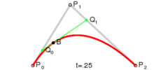

Creation of 3D Environment

Main Menu

Creating “mainMenu” Scene
Because Unity is a game designer, scenes implement difference in “levels” or viewable information, in this case the main menu or start menu.
- Start by selecting from the menu bar File → New Scene
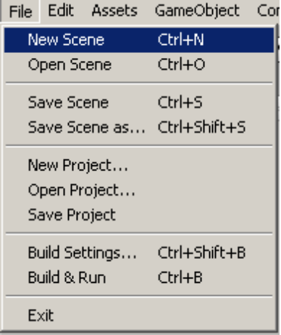
- A blank scene will be created in the scene view mode.
- You must save the scene in order for it to show up in the Project pane
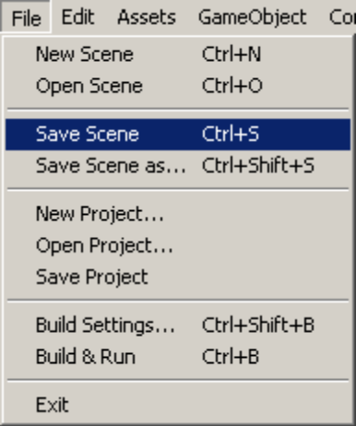
- You will now need to apply a OnGui layer for the “Main Camera” that is automatically created with every scene
- To create the new scripts you will need to go to the Project pane and select Create → C# Script
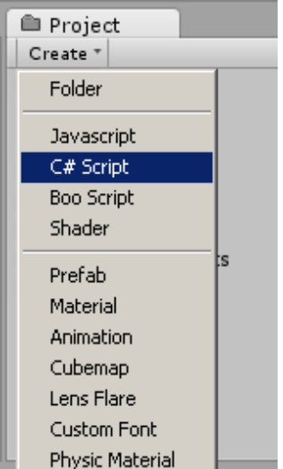
- This will create a new script within your Project pane at the top level, it is recommended that you create a Script folder for all the scripts that are used in the program
- Rename the scripts appropriately and code using GUI tools that are available in Unity, recommend looking at the Reference section of this document to find resources on such coding practices.

Pause Menu

3D World

Creating “main” Scene
Since developing the 3D World was first on the priority list, the original scene that was created automatically when the new project was started was made to contain the 3D World. To save it, just go to the menubar and select File → Save Scene. It will give you a new file save as window, and name the new scene “main”.

Create “Terrain”
To make the 3D World seem more realistic beyond the active arena area, a terrain was created by performing the following steps:
- Select Terrain → Create Terrain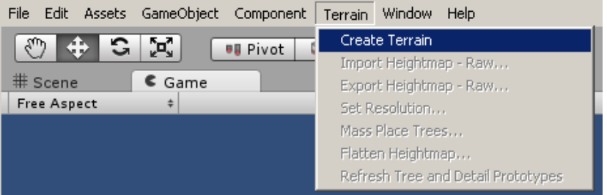
- A default Terrain will show up in your hierarchy pane
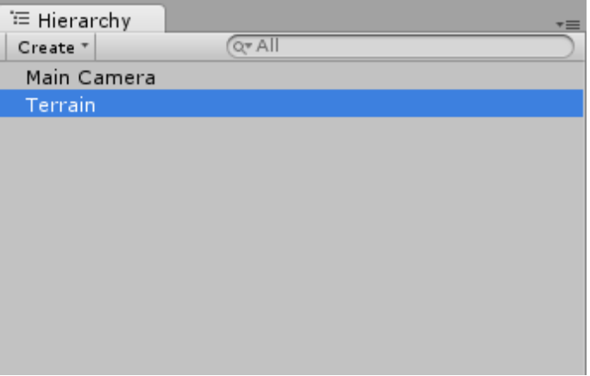
- Double-Click the Terrain to focus your view in the Scene editor on the Terrain that was created
- Rename the “New Terrain” in the Project pane to “Terrain”
- Because the default assets that come with a new project do not include any materials to paint texture onto the terrain, we will need to go to the menubar and select Assets → Import Package → Terrain Assets
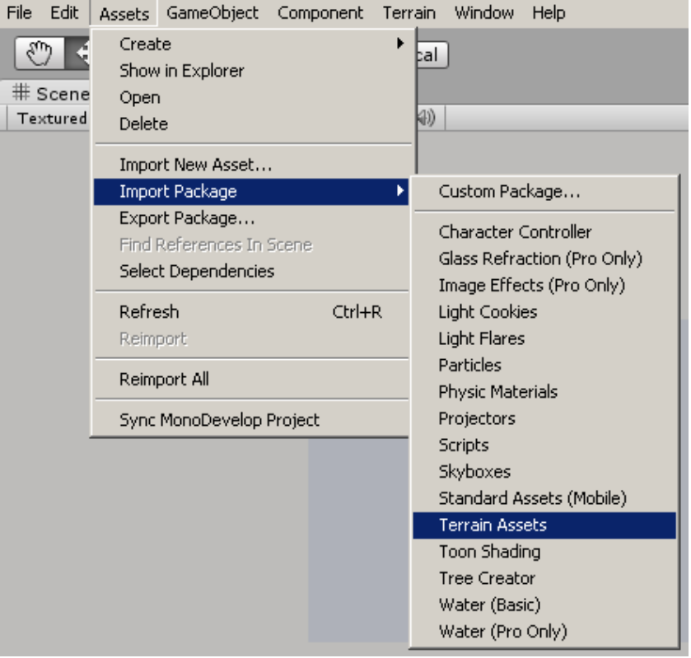
- When the selection window pops-up, make sure all assets are selected and click Import.
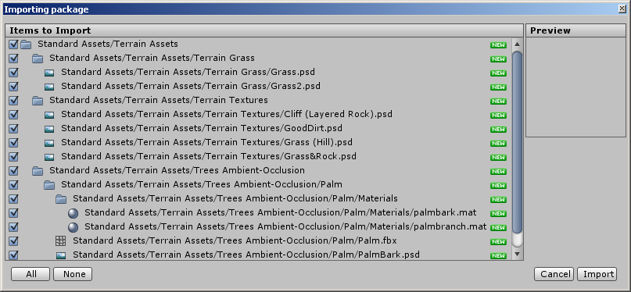
- A new folder will be created under the Project pane called “Standard Assets”.
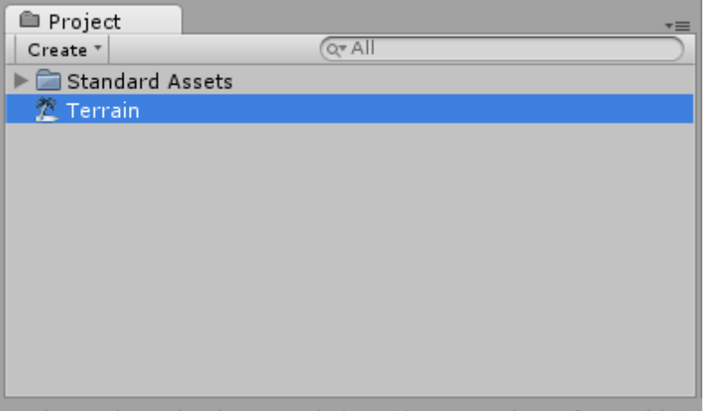
- Select the “Terrain” in the Hierarchy pane and look at the inspector pane at the right of the project window. We will start by painting a texture on the terrain using the paintbrush tool.
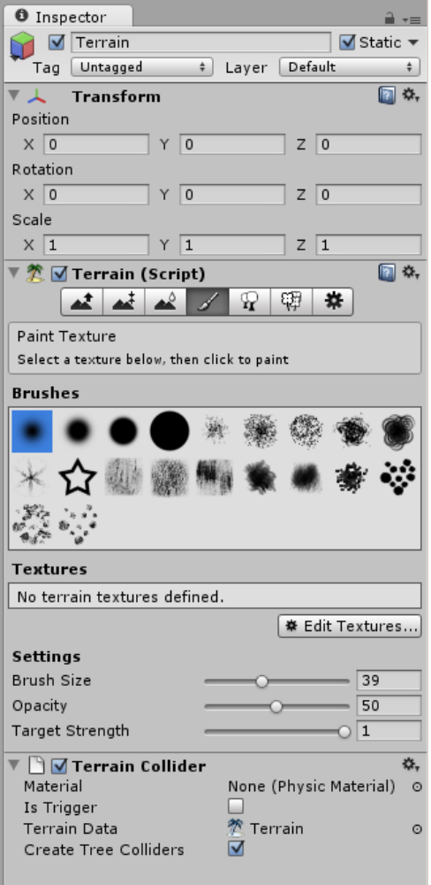
- We will need to select Edit Textures → Add Texture, which will bring up a new texture editor box.
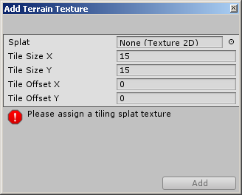
- We will select Splat and apply the Grass texture using the pop-up selection window.
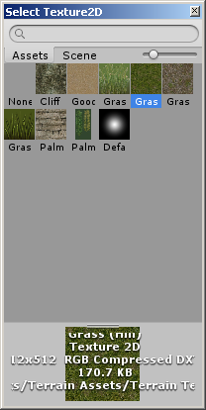
- You should now see the applied texture on the Terrain object in the Scene editor pane.
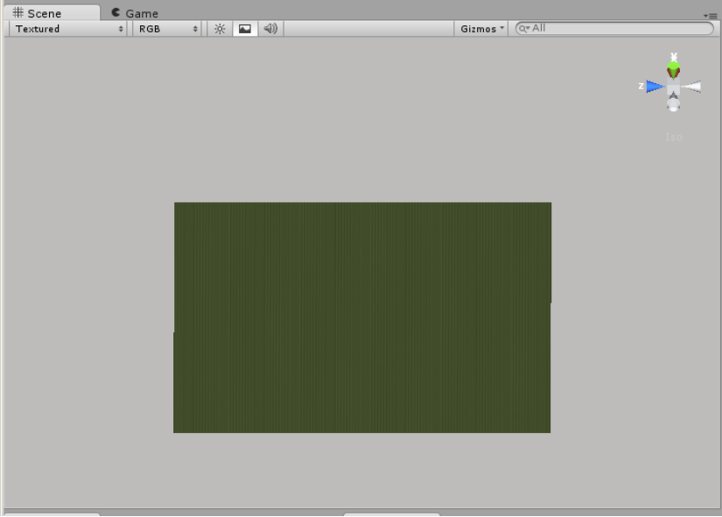
- It is recommended to create mountains to avoid the plane with a dropoff view along the herizon effect. To do this you will make sure that “Terrain” is selected in the Hierarchy pane and look at the Inspector pane, where you will select under Terrain (Script) the Raise / Lower Terrain field. From here you can choose any number of settings, the larger the brush size, and the more consistent the brush, the better the mountains will be when you create them.
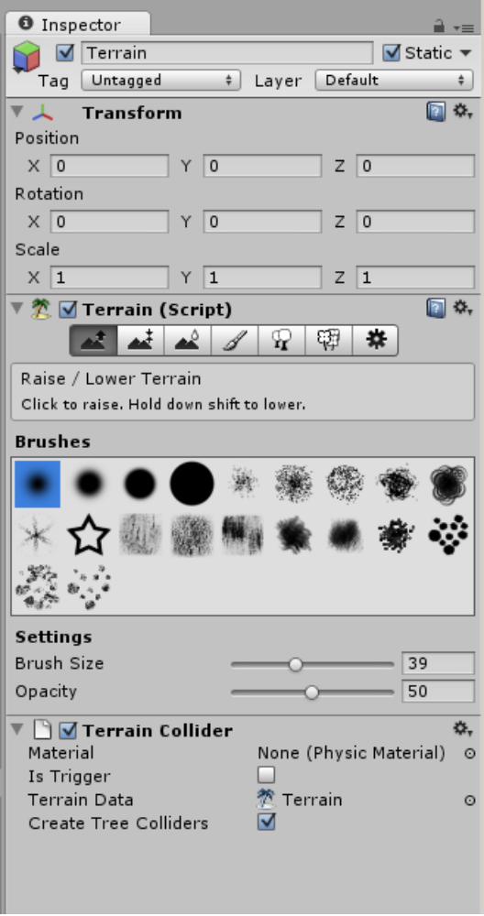
- To better facilitate creating the mountains or variations in terrain, you will need to change your editor percpective, using the x,y,z coordinate module in the top right of the Scene pane, or better yet use the right mouse button and drag to change your orientation of view.
- This should be the finalized view, or something similar, when you have finished creating your terrain.
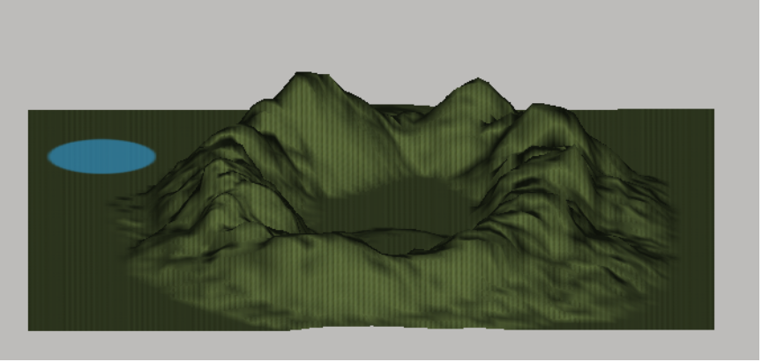

Create “Arena”
Because of the intense tedium that it is to create the Arena, it was created into a prefab and can be loaded into any project using the importing package option as described below.
- Go to the menubar and select Assets → Import Package → Custom Package...
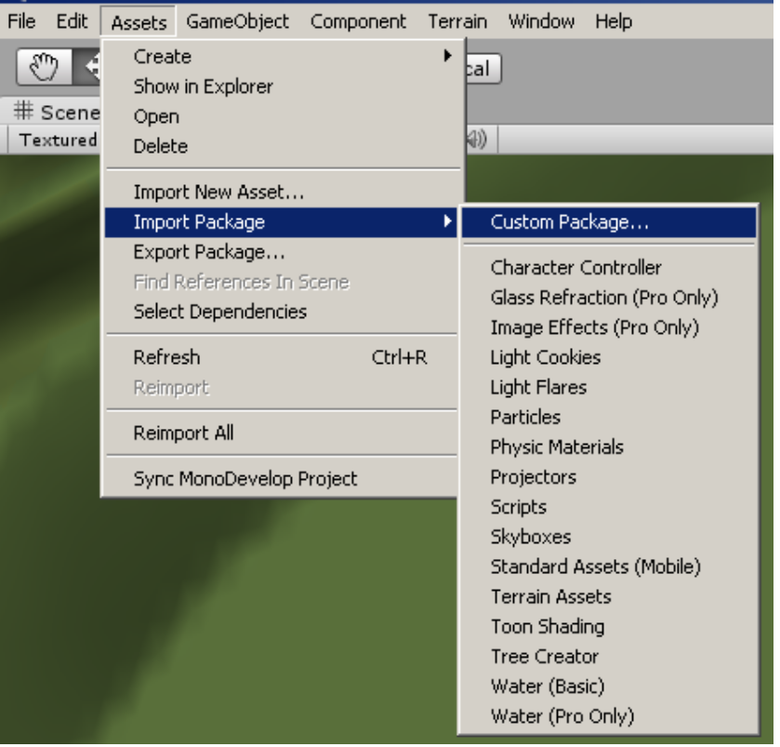
- You will then need to locate the dressage_arena_prefab that should be included within the Prefab folder where you found this document.
- This will place the prefab of the “Arena” in the Project pane. You will then need to drag and drop this into your Hierarchy pane and it will place a pre-made dressage arena with all child objects on your terrain. You can then adjust its positioning using the Inspector window and the Position options, or by physically moving it using the mouse.
- You are now finished having created the “Arena” in its entirety. If you wish to make changes, it will ask if you want to lose connection to the prefab, you can select yes without worry as long as you realize your edits will only effect this single instance of the prefab.

Create “Sunlight” and adjusting ambient light
We now need to create a way for us to see everything. Giving us sunlight is the most appropriate method, but because of the singular direction of the directional lighting, we will also need to create some ambient light because of real life effects of reflection of of surfaces and the atmosphere.

- Go to the menubar and select GameObject → Create Other → Directional Light.
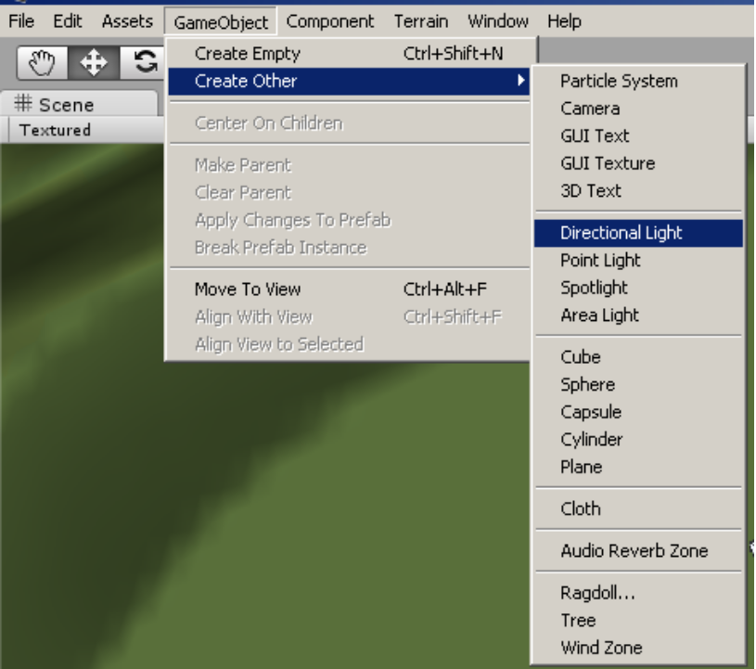
- This will create a default directional lighting in the Hierarchy pane, change the name to “Sunlight”.
- Now we need to import some new assets, namely Light Flares. To do this, go to menubar and select Assets → Import Package → Light Flares.
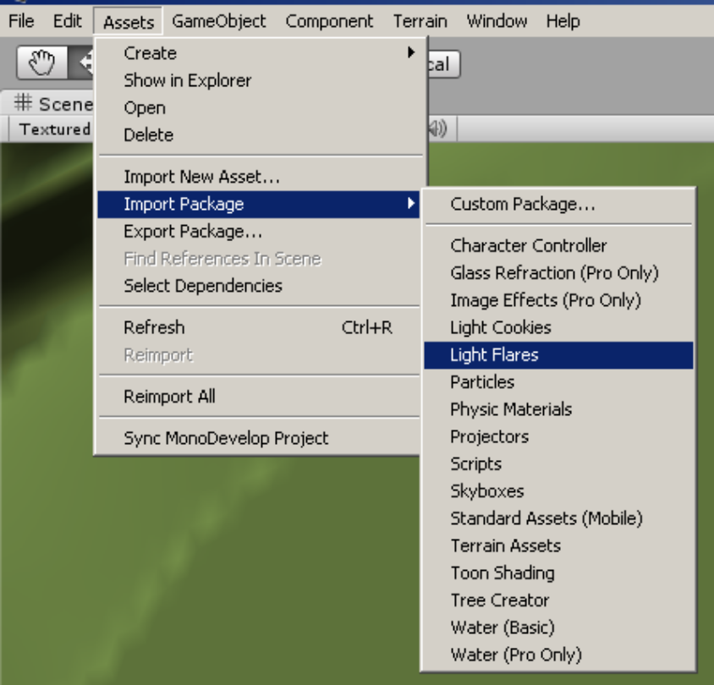
- Make sure all assets are selected, and click Import.
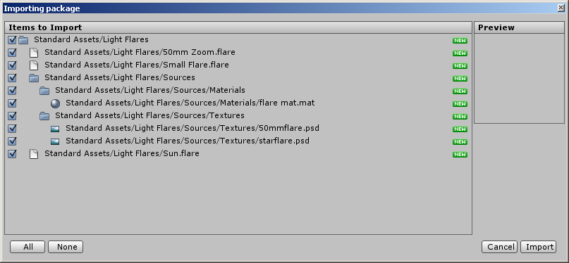
- Select “Sunlight” in the Hierarchy pane and go to the Inspector pane to find the Flare settings.
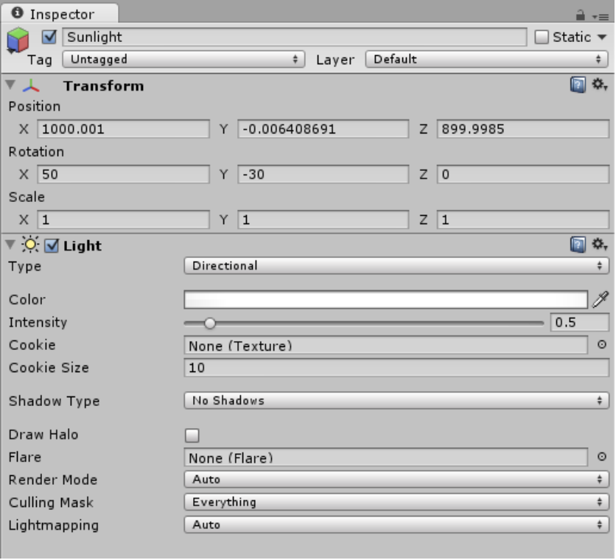
- Select the Flare option button, and in the window that pops up, select Sun.
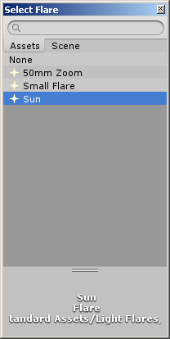
- Now place the “Sunlight” up above the “Terrain” at a large height, something like 1000 should work, and direct the light towards the “Arena” using the Rotation properties in the Inspector pane.
- The sunlight is now completed.
- To set the ambient light, which will allow the shadows to be less dark, since it is sunlight. You must go to the menubar and select Edit → Render Settings
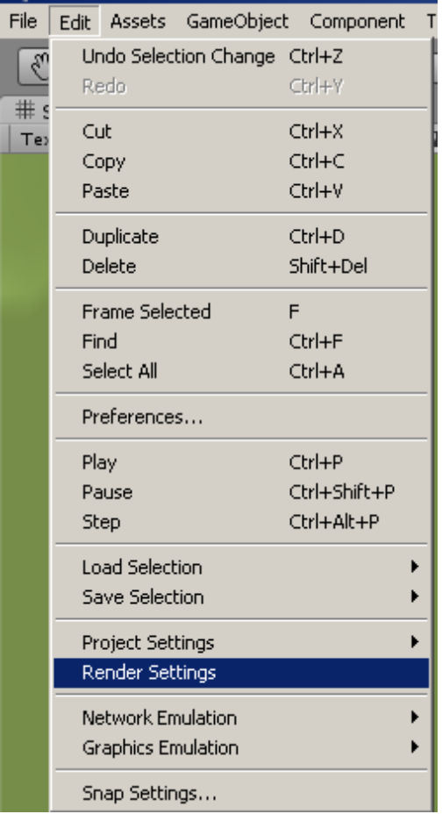
- In the Inspector pane you will need to select the ambient light color you wish to have.
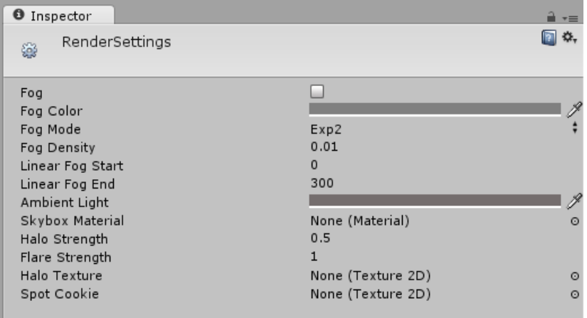
- You are now finished with creating the “Sunlight” and adjusting the ambient light.

Cameras and HUD
There are 4 cameras spread throughout the Arena to give a different perspective on the “Horse” object.

CameraAbove:
- Using the defualt “main camera”, move and orient the camera so that it gives us a top-down view. We will rename it “CameraAbove”
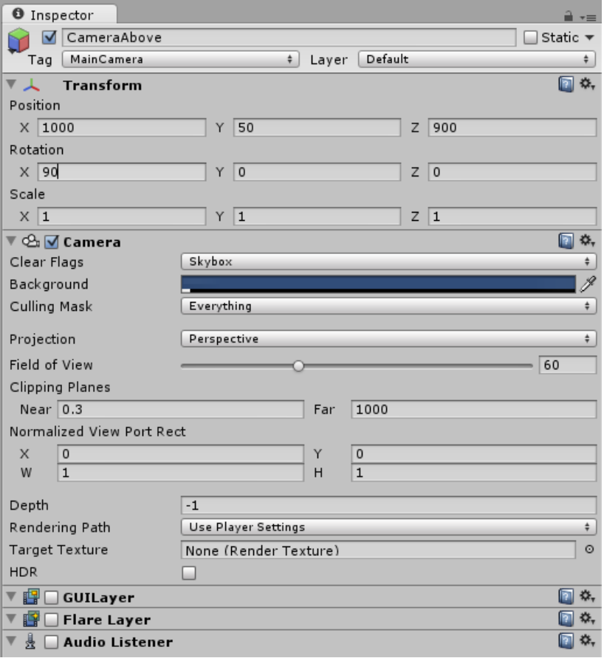
- Make sure that GUILayer, FlareLayer, and AudioListener are turned off.

CameraWestStand
- We will create a camera angle from the West Stands by going to the menubar and selecting GameObject → Create Other → Camera
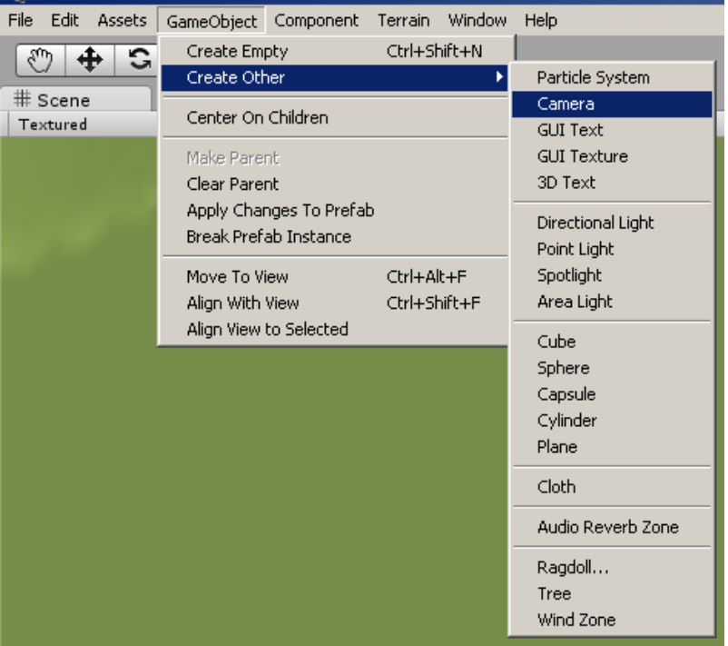
- This will create a new camera in the Hierarchy pane, change the name to “CameraWestStand”.
- Move the “CameraWestStand” to the west stands, and orient it so that the arena can be seen clearly.
- We need to apply a Skybox so that the sky looks more realistic, and not just deep blue.
- Go to the menubar and select Component → Rendering → Skybox
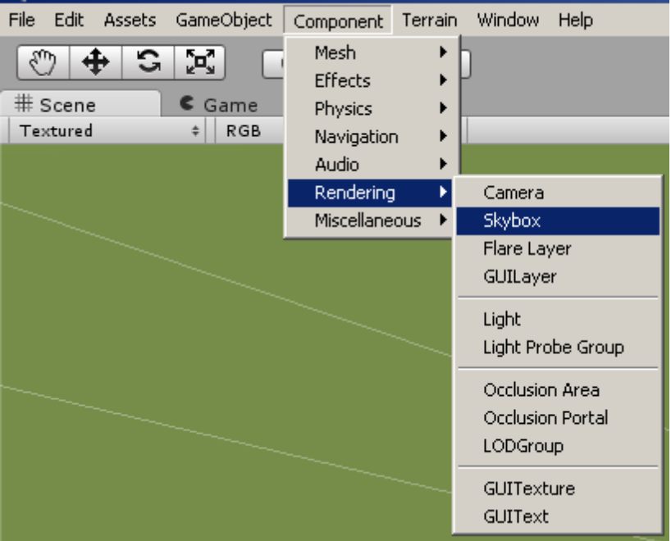
- This will place the Skybox property in the Inspector pane of the “CameraWestStand”. We now need to select the custom Skybox.
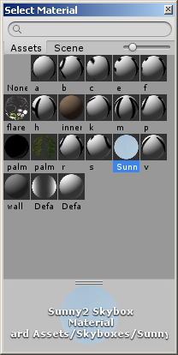
- Select Sunny, this material was imported when you imported the dressage_arena_prefab, but if it wasn't you will need to Import skyboxes using the same method we did when we imported any of the other assets.
- The skybox should now be applied, and you should see a prettier background in your camera view.

CameraEastSide
- We will create a camera angle from the East Stands by going to the menubar and selecting GameObject → Create Other → Camera
- This will create a new camera in the Hierarchy pane, change the name to “CameraEastStand”.
- Move the “CameraEastStand” to the west stands, and orient it so that the arena can be seen clearly.
- We need to apply a Skybox so that the sky looks more realistic, and not just deep blue.
- Go to the menubar and select Component → Rendering → Skybox
- This will place the Skybox property in the Inspector pane of the “CameraEastStand”. We now need to select the custom Skybox.
- Select Sunny, this material was imported when you imported the dressage_arena_prefab, but if it wasn't you will need to Import skyboxes using the same method we did when we imported any of the other assets.
- The skybox should now be applied, and you should see a prettier background in your camera view.

CameraHorse
- “CameraHorse” is already included in the dressage_arena_prefab that you imported.
- Since it is a child element of “Horse” object, as the “Horse” object moves around, so will the “CameraHorse” relative to the postion of the “Horse” object.

Horse (Object)
Was included in the dressage_arena_prefab. It has an initial starting point set to behind the stands, and will move from this location to the initial starting point based on the scripting that is associated with it.
To attach scripts to this object, we simply create the script in the Project pane, write the script, and drag it onto the objeect that the script is to be controlling.

Implementation

Important Notes About Code

Using Lerp() in Unity
Because of the basics of game development is to have moving objects, there is a function that provides native support for linear interpolation referred to as lerp. You will find much more documentation on this on the websites provided in the Reference section of this document. But it was worth to note the importance of this particular function, since it was used exclusively to move the “horse” object around.

Using Slerp() in Unity
Slerp is the spherical interpolation, and can cause objects to move along paths that are defined by radial arc distance from one another, but it only does this within “Great” circles, which means for situations where elongated circles are required this method is useless. It was originally implemented for all arc movements, but it showed to take up a significant amount of code to achieve the appropriate results and was limited compared to the later implementation of the Bezier curvers.

The Resource.load() vs. WWW class
Originally the program used the WWW class to create an object that dowloaded the xml files from an internet resource, however, it showed that while internet would be ideal to keep all programs using the same data source, it would not be able to run the program when not connected of course. So Resource.load() function was implemented in its place. It would be a worth-while endevour to later implement a situation where depending on the users needs that a source could be selected rather than to have the program choose for you.

Bezier Curves
While in the Algorithms section of this document it explained roughly how the Bezier curves where to be implemented and the actual pure mathematical formula that could be used to implement it, it was best to use the lerp funciton and to apply calculus methodology to provide a computer the movement this way rather than to use the pure mathematical expression for the curve (it would be possible and could possibly reduce code size and resource load, but would be substantially harder for future programmers to interpret the meanings of the changes in the expression based on variations of the movement).

Execution Order of System Functions
There are several funcitons that are listed in the Reference section of this document that are processed in a particular order. It is extremely important to understand this order, because game development with Unity is all about the change of the values from one frame to the next and some of these functions will update each frame, others not at all, and others will update more often depending on user input. This is especially important to know about in order to grasp the concept of why the coroutines where used in having programmed this application.

Coroutines and Yields
A coroutine in general tells the system that it will go and begin running another method while another proces is running, in this case we want the overall time and frame update to keep running. By placing a yield command it tells the system to not process any other code within the script until the method finishes, and once it is done to continue after where the coroutine was called from within the script. This allows for use to manipulate exactly what we want and when we want while still using the same script to run all the other information that pertains to the object that it is working on. Because a coroutine represents multiple operations happening at the same time, the system needs to be given explicit pathways that will be processed, otherwise an infinite loop will be created, so this is why the compiler will not allow for any Ienumerator method, which is need to be used as a coroutine, to run without having a yeild command. To stop that method from running any further a null can be returned with the yield command.

Global Settings Script
It is extremely important to note that there is a Global Settings script that was created to store all global data and variables that would or could be used by the user either to view or change. One of these important variables is the rateOfMovement, this should substantially ease the transition to being able to change the movement during any point in the “horse” object's path. It should also be noted that all variables are encapsulated and are done so by using getters and setters, this keeps from allows direct access to these variables. This could prove useful if it is necessary to provide parsing of colleced data and to simplify the overall structure of the application.

External Data

XML Data Structure

Basic Structure Outline
<?xml version="1.0" encoding="utf-8" ?>
<Test>
<Name> </Name>
<TestId> </TestId>
<Movement>
<MovementId> </MovementId>
<MovementDesc> </MovementDesc>
<MovementDetail>
<SequenceId> </SequenceId>
<Path> </Path>
<PathDesc> </PathDesc>
<Gait> </Gait>
</MovementDetail>
</Movement>
</Test>

- The first line is the XML declaration. It defines the XML version (1.0) and the encoding used.
- The next line describes the root element of the document. <Test> is the root element of the document.
- <Name>, <TestId>, <Movement> are the sub elements of root element <Test>
- <MovementId>, <MovementDesc>, <MovementDetail> are sub elements of <Movement> element.
- <SequenceId>, <Path>, <PathDesc>, <Gait>, <SpeedFactor> are sub elements of <MovementDetail>
- Every element has a closing tag and the elements in the XML document form a document tree.

XML Element Description and Values

XML element | Description | Values used
Test | It is the root element of the XML document. | Sub elements described by Name, TestId, and Movement.
Name | Name of the Test | - 2011 First Level Test 1  - 2011 First Level Test 2  - 2011 First Level Test 3  - 2011 Second Level Test 1  - 2011 Second Level Test 2  - 2011 Second Level Test 3  - 2011 Third Level Test 1  - 2011 Third Level Test 2  - 2011 Third Level Test 3  - 2011 Fourth Level Test 1  - 2011 Fourth Level Test 2  - 2011 Fourth Level Test 3
TestId | Unique Id for each test | - 11, 12, 13  - 21, 22, 23  - 31, 32, 33  - 41, 42, 43
Movement | Has sub elements that describes each movement of the test. | Described by MovementId, MovementDesc, MovementDetail.
MovementId | It is the movement number that corresponds to every movement in the test. | 1, 2, 3, 4, 5, ….. (depends on the number of movements a test has)
MovementDesc | Describes the test movement. | Description is taken from the test pdf.
MovementDetail | Have sub elements to describe the details of every step / sequence inside a movement. | Described by SequenceId, Path , PathDesc, Gait
SequenceId | The number for each step / sequence inside a movement. | 1, 2, 3, …. (Describes one or more steps that make up a movement).
Path | All the points on a path corresponding to a step / sequence. | Format:  [Point1-Point2-Point3-……]  They are start point, end point of a line, diagonal or circle, along with those points where the line shape changes – for example: line shape is changed along a corner, so corner points are included.
PathDesc | Describes the geometry or shape of the path. | - Line  - Diagonal  - FullCircle_[Right/Left]_[20/15/10/8/5]_[LSide/RSide]  (diameter 5 is for: turn on haunches and Piroutte)  - HalfCircle_ [Right/Left]_[20/10/48]_ [Up/Down]  - Serpentine_ [Right/Left]
Gait | Describes the type of gait of the corresponding sequence id / sub-step. | - [Medium/Collected/Extended]_Walk  - [Working/Medium/Collected/Extended]_Trot  - [Working/Medium/Collected/Extended]_Canter  - Extended_[Walk/Trot/Canter] (for: Lengthen Stride)  - Extended_Walk (for: Free Walk)  - Turn_[Walk/Canter] (for: half pirouette, half turn on haunches)  For Half Pass, Shoulder In, Travers, Renver, Leg yeild gait values are:  - Half[Right/Left]_[Trot/Canter]  - Shoulder[Right/Left]_ Trot  (Note: In fourth level test 2, third level test 1 -Shoulder Right in downward direction is RenverLeft_Trot, Shoulder Left in downward direction is RenverRight_Trot)  - Renver[Right/Left]_ Trot  - Travers[Right/Left]_Trot  - Leg[Right/Left]_Trot  (Note: Leg yield in the downward direction in first level test 2 is considered as HalfRight_Trot)
*Note that the previous two sub-sections where developed by the previos team from Spring 2012, which is the same xml structure that the current application is implementing.

Important Notes About XML Documents

- Because of limitations by the build in loading functions in C# for Unity, it was necessary to save the files as an Encode with UTF-8 w/o BOM.
  - There are means to script for the inclusion for BOM encoded, however, it is easier and doesn't change the operation of the program to save in the non-BOM encoded format.

Application “Pertenate” File Structure
The following shows a list of the pertenate files and their structure within the main folder “Dressage”. Any omittions are due to the realitive importance, which is primarily because the Unity editor creates these dynamically.

File Structure
- Dressage
  - Alternative_Code = Any important code that once was used
    - slerp_circle_alternative.cs
  - Assets = All useful stuff for working with current application
    - Materials = Images and objects of images that are used
    - Resources = Folder that contains information that can be loaded
      - FristLevelTest1.xml
      - FirstLevelTest2.xml
      - FirstLevelTest3.xml
      - SecondLevelTest1.xml
      - SecondLevelTest2.xml
      - SecondLevelTest3.xml
      - ThirdLevelTest1.xml
      - ThirdLevelTest2.xml
      - ThirdLevelTest3.xml
      - FourthLevelTest1.xml
      - FourthLevelTest2.xml
      - FourthLevelTest3.xml
    - Scripts = All scripts used in application
      - Camera
        - CameraToggle.cs
      - HorseMovement
        - HorseMovement.cs
        - Movement.cs
      - MainMenu
        - ComboBox.cs
        - MainMenu.cs
        - TestSelection.cs
      - GlobalSettings.cs
    - Standard Assets = Assets that were loaded from other sources
    - Arena.prefab
    - main = The scene that is run during test exacution
    - mainMenu = The scene that is shown to user for test selection
    - Terrain.asset
  - Prefabs = All prefabricated 3d items (mainly the arena)
    - dressage_arena_prefab
  - DressageForPC.exe = The executable file for normal PC operations.
  - DressageForWeb = Contains build for online implementation

Future Implementations

“Horse” Object Gait
It was recommended that the “horse” object use a “bounce-like” motion to describe the different types of gaits that the “horse” object must reference.

Suggested Implementation Method
The thought occurred to me that since Unity will allow for child objects within the Hierarchy pane to inherit anything from their parant object, this includes the movement scripts for our “horse” object, we could in theory create an invisible parent object that would give us a reference point and relative coordinates for our child object to move up and down because of it. All the complex xml movement scripts would be attached to our parant object that is invisible, while the child would inherit this movement we could extend it by including a new script that bounces based on the global variable of gait and then just move it up and down repeatedly in a inifinite while loop or during the update of the frame funciton of that child object.

*It must be noted that I had achieved the results desired using the above method, however, there are several things that must be accounted for, such as the frame rates refreshing using the update function. So to fix this it is recommended to use the FixedUpdate method provided as one of the standard methods in Unity, and adjust the speed of the frame upade in the project settings either statically at the prior to build, or dynamically as a reference in the script at the start of the program. Either way, the above suggested method proves to be the easiest fix, otherwise you will need to apply a third dimension movement on the object during any given movement, which could possibly break the code for movement in 2-dimensions.

Replay of Past Movements
Currently the application reads through the “xml document” object created when downloaded from external source. The program needs to be capable of replaying past movements, or even future movements at any point in the exacution of the current movement iteration.

Suggested Implementation Method
The application was specifically setup to have a temporary movement object that held the current movement information that we move our “horse” object from, but since this is just a container of an object, we could create an array of these objects at the movement detail level and then apply the movement through a loop that can be controlled at which index it is currently on at any given time by the user so that in essence you can move to any point within the movement path description you wish.

“Horse” Object Directed Movement
Because the “Horse” object is being played by a sphere, it isn't noticed that the sphere isn't turning towards the next waypoint. To achieve a realistic movement of a horse, we must assume an object to have a non-symetrical shape to adjust the direction of movement of the body. It was suggested to use an elongated spheroid.

Suggested Implementation Method
Because there are several movements that require the “Horse” object to demonstrate a diferentiation of objectdirection while it procedes in the same direction, it is suggested to replace the sphere with a spheriod and define a head and a tail. To create a smooth facing of the object towards the next movement objective, it is recommended to provide a leading object that is traveling the same path directly before the current “Horse” ojbect, and to constantly have the horse face this object throughout it's movement, except for the instances that the horse must perform a diferentiation of that standard direciton, such as shoulder in or out.

Movement Speed Adjustment
Originally the dressage application on the Windows Phone platform allowed for the user to select the speed of the run of the program. It is suggested to allow for this as well, but go one step further and be able to change this during exacution of the test.

Suggested Implementation Method
As stated earlier, a rateOfMovement variable was created and is set in the Global Setttings script. It is recommended to just implement a set of code that identifiies what each gate represents and then apply the value to the rateOfMovement variable. This will immediately change the movement of the “horse” object at any time during it's path.

Fix Large Half-Circle Path Speed Variation
Currently the arcing paths were written using Bezier curve algorithms. There was not a direct method in which to indiiviually change the individual arc segments path's speeds to match the overall movement.

Suggested Implementation Method
The best idea is to create some sort of calculus deriviative of the Bezier quadratic formula so as to determine the distance along that segment and apply that to the distance rather than the circumference approximations.

Draggable HUD
Currently the HUD is static and can cause an issue with being able to read the movements easily while still watching the movements play out. It was suggested that the HUD be draggable so as to allow the user the ability to dynamically place each HUD window.

Suggested Implementation Method
Unfortunately I don't really have any thoughts on this. My recommendation is to look at the advanced features of GUI control on the reference material provided in the Resource section of this document.

Important Notes About Unity
There are some things that just don't fit under any of the other catagories, but I feel are just as important.

Building Project
The eventuality of any development is to build to a final product that can be used on the end-users device. In this case, Unity is pretty amazing, it can not only create a functioning executable under a standard Windows PC, but also many other platforms.
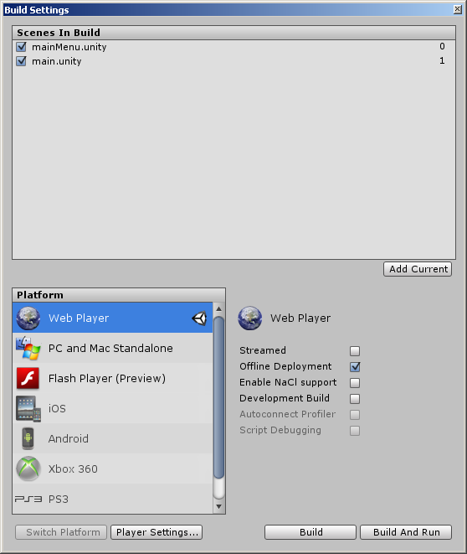

Web Player
This option has been proven to work and you can find a premade deployement for offline use within the main folder of this project. You can also find one on my website at: http://dougstewart.biz/DressageForWeb/WebPlayer/WebPlayer.html

PC and Mac Standalone
This is the most often used selection to create a standalone application to be run on the PC or Mac platform. Be aware that a data file is also created with the executable and must be present with that executable in order to run the program.

Flash Player (Preview)
While it was tried, it never posted a build of the project as a swf. This might be an issue with this version of Unity, or the computer's version of Flash installed, but should be tried in future versions.

iOS
Was unable to perform this build using the free version of Unity, the professional version should include this capability. And seeing how well it translated to the web player, the iOS should have no issues.

Android
Was unable to perform this build using the free version of Unity, the professional version should include this capability. And seeing how well it translated to the web player, the Android should have no issues. In fact, it was recently that I had run a full 3d game on my Android enabled phone that was developed in Unity, so this should be a native solution to creating the dressage application for it.

XBOX 360
Was unable to perform this build using the free version of Unity, the professional version should include this capability. And seeing how well it translated to the web player, the XBOX 360 should have no issues.

Wii
Was unable to perform this build using the free version of Unity, the professional version should include this capability. And seeing how well it translated to the web player, the Wii should have no issues. The only concerns I would have are the resolutions, however, this is probably taken care of in the build of the application.

PS3
Was unable to perform this build using the free version of Unity, the professional version should include this capability. And seeing how well it translated to the web player, the PS3 should have no issues.

Resources

Unity

General Scripting Information
- The most robust and comprehensive repository of information for scripting with Unity can be found at this website
http://docs.unity3d.com/Documentation/ScriptReference/index.html

Execution Order of Event Functions
- There are predefined event functions available in all scripts used in Unity. These premade functions have an order in which they are called during the processing of a “frame”. This information was included in the above linked repository, but since it is so helpful, I felt that it was imperative that it would be given its own category here.
http://docs.unity3d.com/Documentation/Manual/ExecutionOrder.html

GUI Menu Systems
- Creating a drop-down list “combobox” effect was tedious and was not an automatic item that could be implemented. The current version implements a rudemntory version of the information gathered from the following website.
http://wiki.unity3d.com/index.php?title=PopupList
- Moving from one scene to another is very simple, but the information that was used to find out about this was at the following website.
http://answers.unity3d.com/questions/53844/level-selection-from-main-menu.html
- While it was not done, the GUI can be changed using what is called GUI Skins, a good resource is on the following website.
http://docs.unity3d.com/Documentation/Components/class-GUISkin.html
- An awesome starter guid to working with GUI controls in unity, highly recommend looking over it before changing or adding components to the GUI.
http://docs.unity3d.com/Documentation/Components/gui-Basics.html

Movement Along Paths
- The greatest challenge was deciding on how to implement the movement along curved paths , it was originally written using the SLERP function built into Unity, the problem was the manipulation of the pre-made method and how to incorporate more complex versions that were not based on a “Great” circle. Bezier curves was the only option and having read Wikipedia's article made it very easy to understand.
http://en.wikipedia.org/wiki/Bezier_curve
- If you don't understand the pure mathematics behind the Bezier curves, reading through this forum posting may be worth while, since it correlates the use of the bezier curve implementation using the LERP method avaiable in Unity.
http://forum.unity3d.com/threads/134810-bezier-curves-through-script

