Windows Phone App to PC
using UNITY

UHCL | Fall 2012 | SWEN 6837 | Capstone - Project

Project Team Members
Douglas Stewart
Anu Chintakindi
Keith Udomon

Introduction 4
Purpose 4
Software 4
Unity 4
Requirements 4
Installation 4
Purpose 4
Additional Resources 5
Architectural Design 5
Creation of 3D Environment 5
Main Menu 5
3D World 5
Creating “main” Scene 5
Create “Terrain” 5
Create “Arena” 12
Create “Sunlight” and adjusting ambient light 13
Cameras and HUD 18
CameraAbove: 18
CameraWestStand 18
CameraEastSide 21
CameraHorse 23
Horse (Object) 23
HorseMovementScript.cs 23
Implementation 23
Algorithms 23
Code 23

Introduction

Purpose
The primary request was to develop a 3-dimensional windows application for PC based on the previous semester student's capstone project of a Dressage Windows Phone App. The main use of the application will be the learning of movements that is required of the horse rider without tiring out the horse. The application was expected to minimally match the capabilities of the original Windows Phone App. However, it was encouraged that improvements be designed and implemented into the PC version.

Software

Unity

Requirements
- Windows: XP SP2 or later; Mac OS X: Intel CPU & "Leopard" 10.5 or later. Note that Unity was not tested on server versions of Windows and OS X.
- Graphics card with DirectX 9 level (shader model 2.0) capabilities. Any card made since 2004 should work.
- Using Occlusion Culling requires GPU with Occlusion Query support (some Intel GPUs do not support that).
- The rest only depends on the complexity of your projects!.

Installation
Unity3d setup execution file can be found at http://unity3d.com/unity/download/. Because of the robust installation procedures, it is recommended to follow the default installation procedures as dictated by the setup wizard during installation, once the setup file is executed.

Purpose
Unity3d, or better referred to as just Unity, is a robust 3d game creation software suite. The primary reason for the use of this program is it's relative low learning curve approach to development. Much of the difficult items are based on the GUI and allows you to produce in the authoring mode a WYSIWYG experience. There is a strong open source following with many resources for outside, pre-made, assets and prefabs that borderline cutting-edge gaming quality 3d. The 3d engine the editor incorporates uses a physics collision engine, and can be used to represent realistic motions and interactions as you would expect in the real physical world. The editor allows for scripting with object-oriented languages such as C#, which was chosen for this implementation, and javascript. The program can also build for environments such as XBOX 360, Wii, PS3, IOS, MacOS, and Android besides the traditional Windows application approach.

Additional Resources
Useful Documentation:
You can find many tutorials, many of which are hosted by the official distributor website, at http://unity3d.com/support/documentation/.

Architectural Design

Use-Case

Details
Start Application: The user can begin the runtime of the Dressage 3D Application.
Run Test: The user selects the test to run from a selection choice menu and at what speed the test will run at.
Pause: The user will be able to pause the execution of the movement of the “Horse” at any time during the movement.
Display HUD: Will be activated by the execution of the “Horse” object movement and the invocation of the pause command.
Replay Movement: Will be accessible at any time during the execution of the movement of the “Horse” movement via the pause menu.
Toggle Camera: The user will be able to select a camera view at any time during the movement of the “Horse” object.
Return to Main Menu: Using the pause menu, the user can select at any time to return to the main menu.
Move “Horse”: The run test command initiates the execution of the movement of the “Horse” object.
End Application: Either via the pause menu or the main menu the user can quit the application's execution.

Diagram
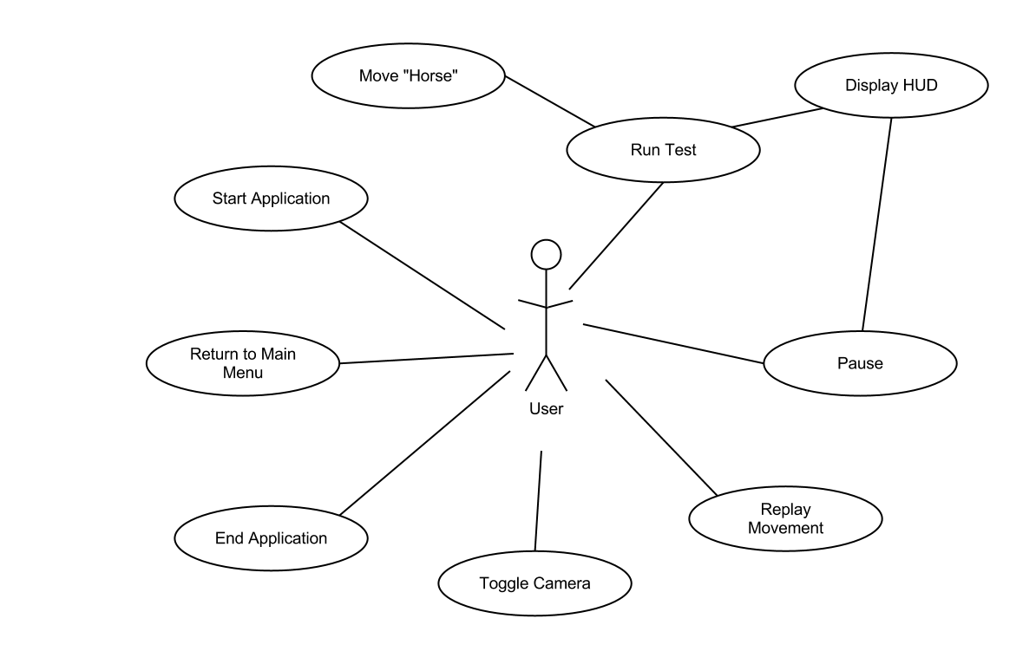

Creation of 3D Environment

Main Menu

3D World

Creating “main” Scene
Since developing the 3D World was first on the priority list, the original scene that was created automatically when the new project was started was made to contain the 3D World. To save it, just go to the menubar and select File → Save Scene. It will give you a new file save as window, and name the new scene “main”.

Create “Terrain”
To make the 3D World seem more realistic beyond the active arena area, a terrain was created by performing the following steps:
- Select Terrain → Create Terrain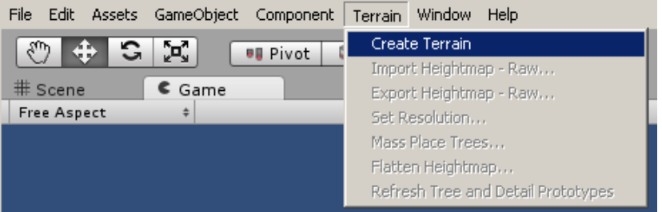
- A default Terrain will show up in your hierarchy pane
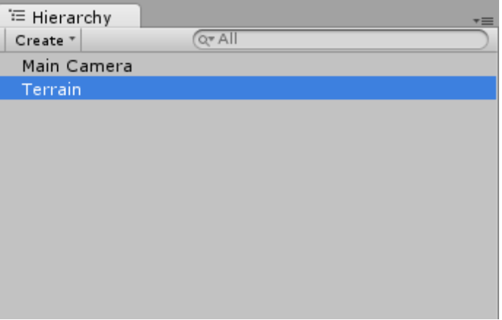
- Double-Click the Terrain to focus your view in the Scene editor on the Terrain that was created
- Rename the “New Terrain” in the Project pane to “Terrain”
- Because the default assets that come with a new project do not include any materials to paint texture onto the terrain, we will need to go to the menubar and select Assets → Import Package → Terrain Assets
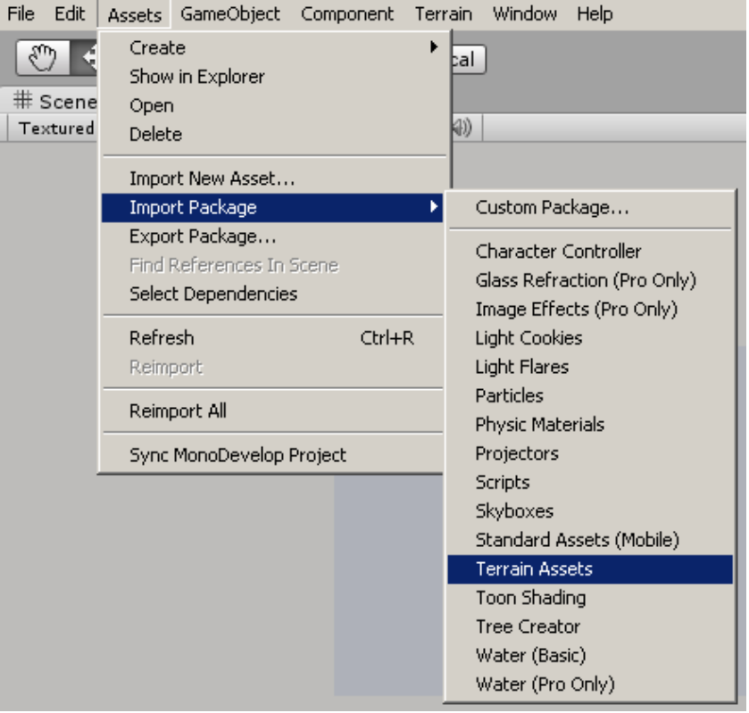
- When the selection window pops-up, make sure all assets are selected and click Import.
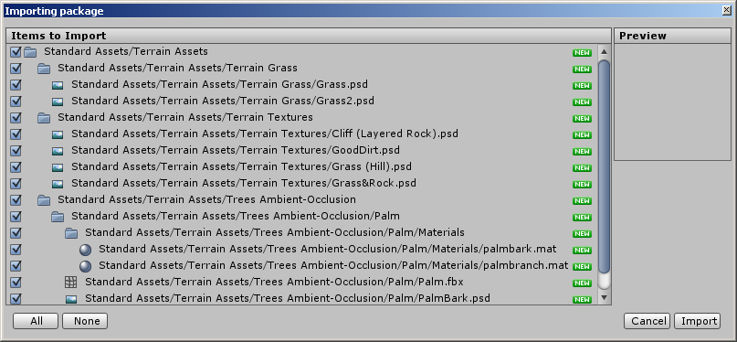
- A new folder will be created under the Project pane called “Standard Assets”.
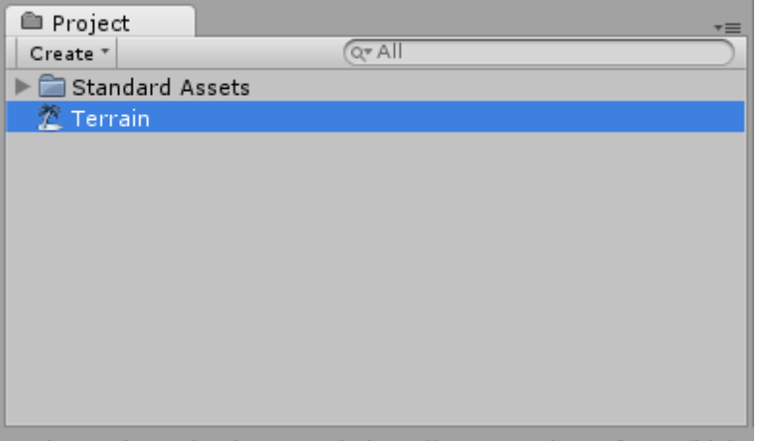
- Select the “Terrain” in the Hierarchy pane and look at the inspector pane at the right of the project window. We will start by painting a texture on the terrain using the paintbrush tool.
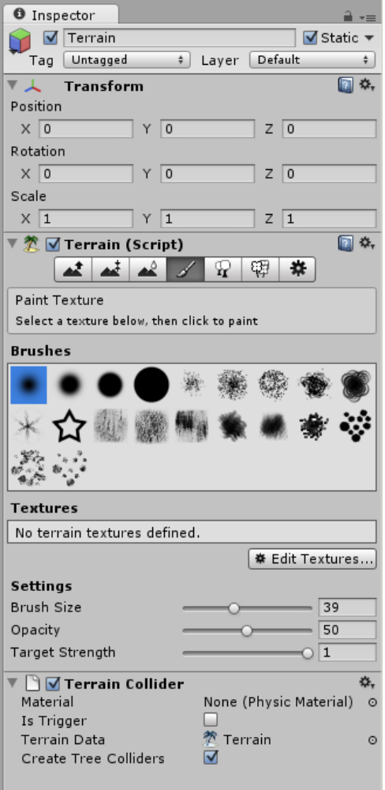
- We will need to select Edit Textures → Add Texture, which will bring up a new texture editor box.
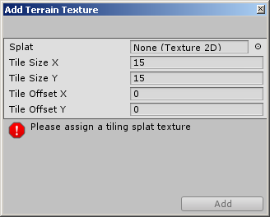
- We will select Splat and apply the Grass texture using the pop-up selection window.
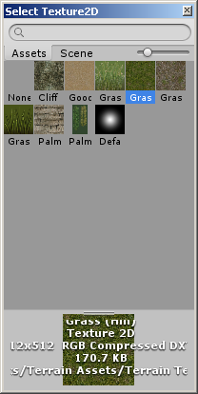
- You should now see the applied texture on the Terrain object in the Scene editor pane.
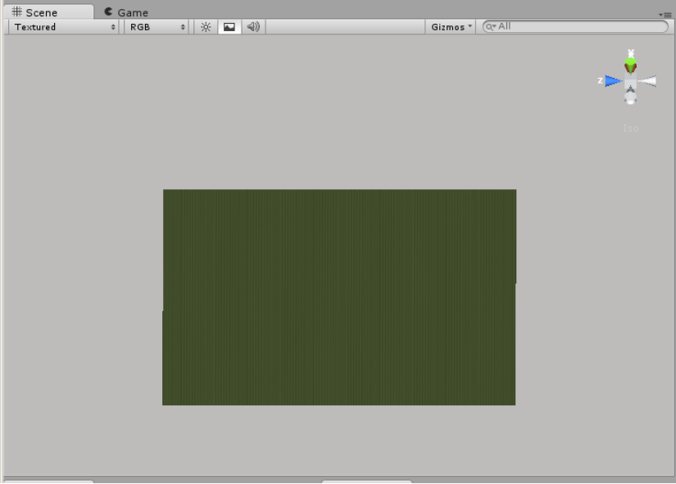
- It is recommended to create mountains to avoid the plane with a dropoff view along the herizon effect. To do this you will make sure that “Terrain” is selected in the Hierarchy pane and look at the Inspector pane, where you will select under Terrain (Script) the Raise / Lower Terrain field. From here you can choose any number of settings, the larger the brush size, and the more consistent the brush, the better the mountains will be when you create them.
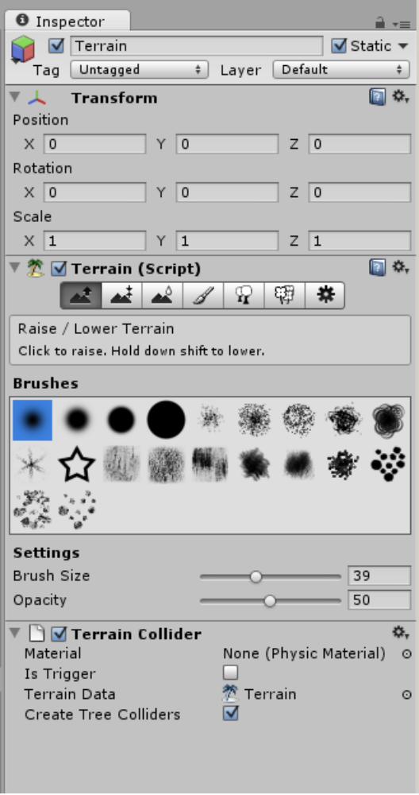
- To better facilitate creating the mountains or variations in terrain, you will need to change your editor percpective, using the x,y,z coordinate module in the top right of the Scene pane, or better yet use the right mouse button and drag to change your orientation of view.
- This should be the finalized view, or something similar, when you have finished creating your terrain.
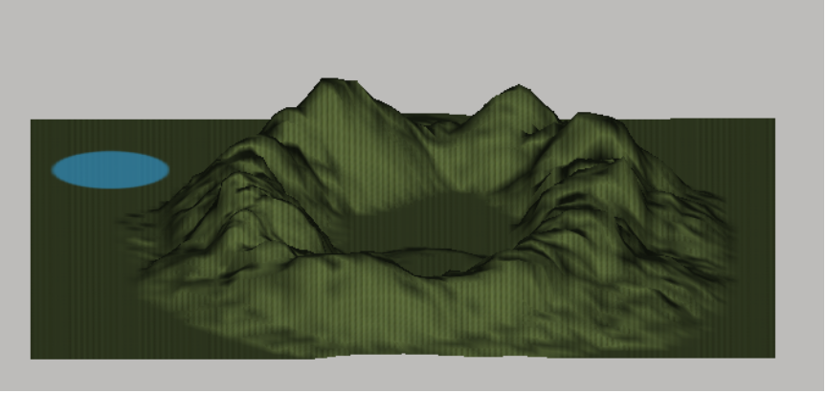

Create “Arena”
Because of the intense tedium that it is to create the Arena, it was created into a prefab and can be loaded into any project using the importing package option as described below.
- Go to the menubar and select Assets → Import Package → Custom Package...
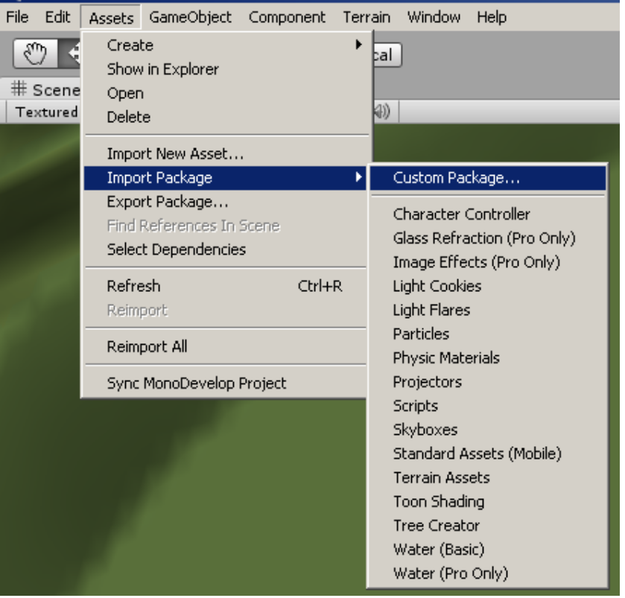
- You will then need to locate the dressage_arena_prefab that should be included within the Prefab folder where you found this document.
- This will place the prefab of the “Arena” in the Project pane. You will then need to drag and drop this into your Hierarchy pane and it will place a pre-made dressage arena with all child objects on your terrain. You can then adjust its positioning using the Inspector window and the Position options, or by physically moving it using the mouse.
- You are now finished having created the “Arena” in its entirety. If you wish to make changes, it will ask if you want to lose connection to the prefab, you can select yes without worry as long as you realize your edits will only effect this single instance of the prefab.

Create “Sunlight” and adjusting ambient light
We now need to create a way for us to see everything. Giving us sunlight is the most appropriate method, but because of the singular direction of the directional lighting, we will also need to create some ambient light because of real life effects of reflection of of surfaces and the atmosphere.

- Go to the menubar and select GameObject → Create Other → Directional Light.
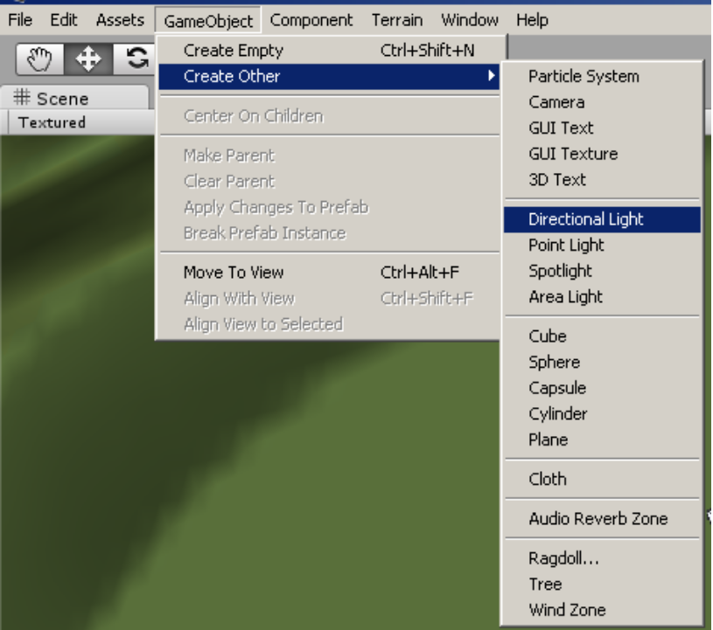
- This will create a default directional lighting in the Hierarchy pane, change the name to “Sunlight”.
- Now we need to import some new assets, namely Light Flares. To do this, go to menubar and select Assets → Import Package → Light Flares.
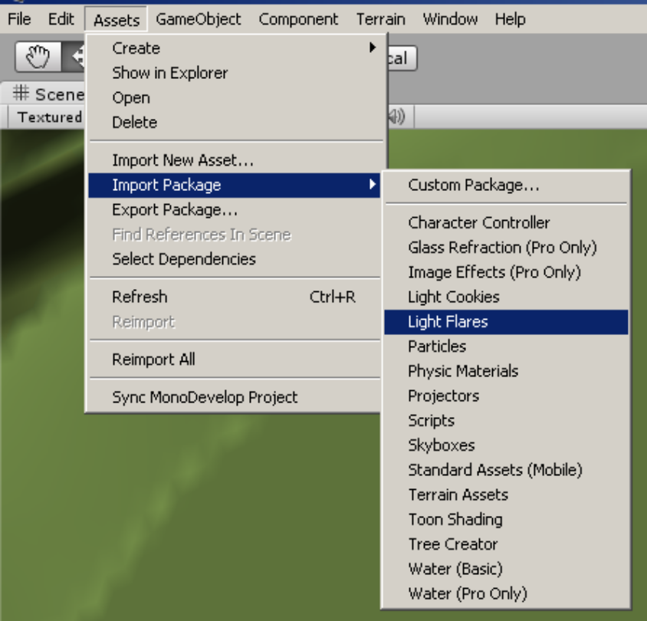
- Make sure all assets are selected, and click Import.
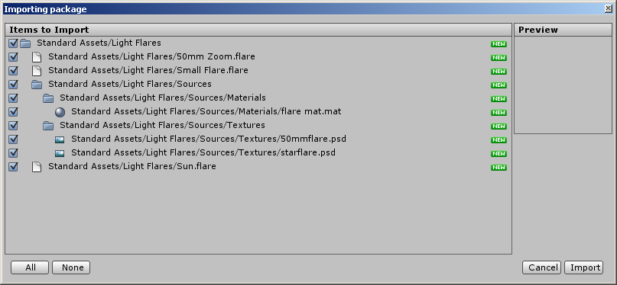
- Select “Sunlight” in the Hierarchy pane and go to the Inspector pane to find the Flare settings.
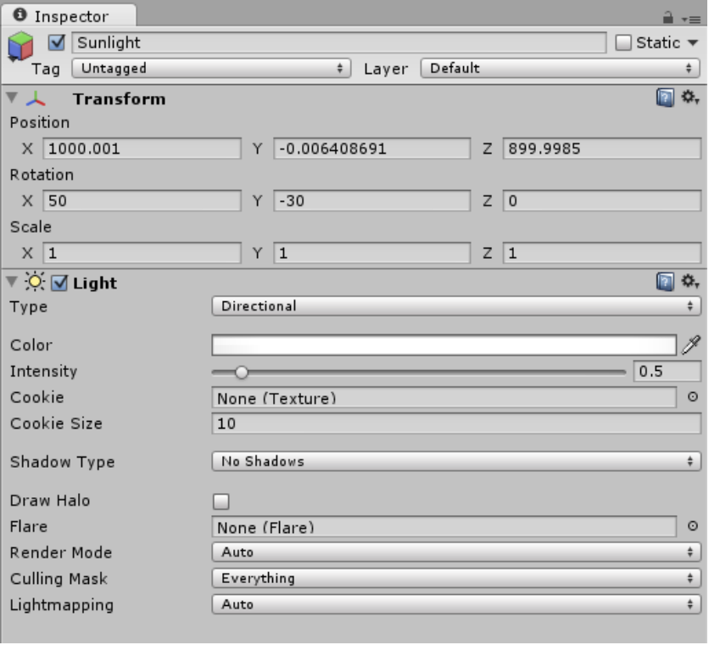
- Select the Flare option button, and in the window that pops up, select Sun.
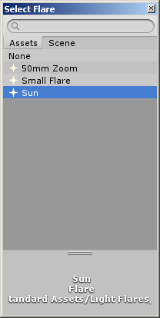
- Now place the “Sunlight” up above the “Terrain” at a large height, something like 1000 should work, and direct the light towards the “Arena” using the Rotation properties in the Inspector pane.
- The sunlight is now completed.
- To set the ambient light, which will allow the shadows to be less dark, since it is sunlight. You must go to the menubar and select Edit → Render Settings
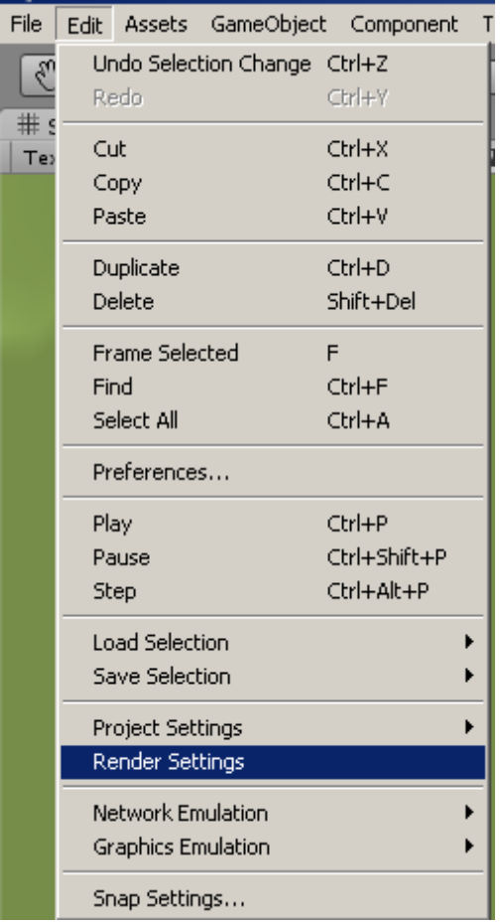
- In the Inspector pane you will need to select the ambient light color you wish to have.
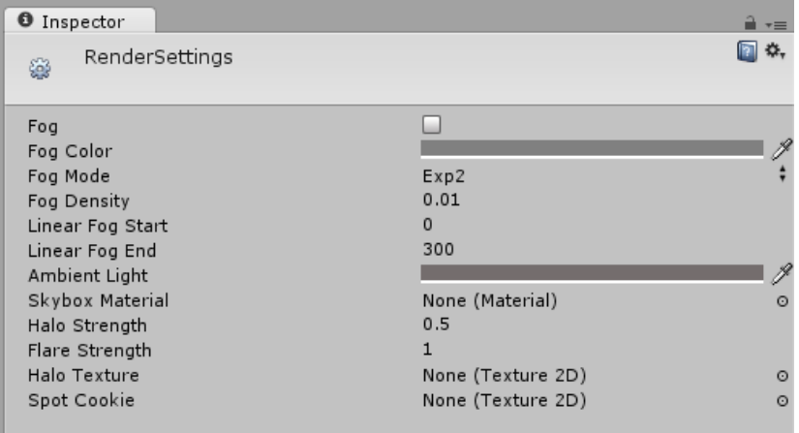
- You are now finished with creating the “Sunlight” and adjusting the ambient light.

Cameras and HUD
There are 4 cameras spread throughout the Arena to give a different perspective on the “Horse” object.

CameraAbove:
- Using the defualt “main camera”, move and orient the camera so that it gives us a top-down view. We will rename it “CameraAbove”
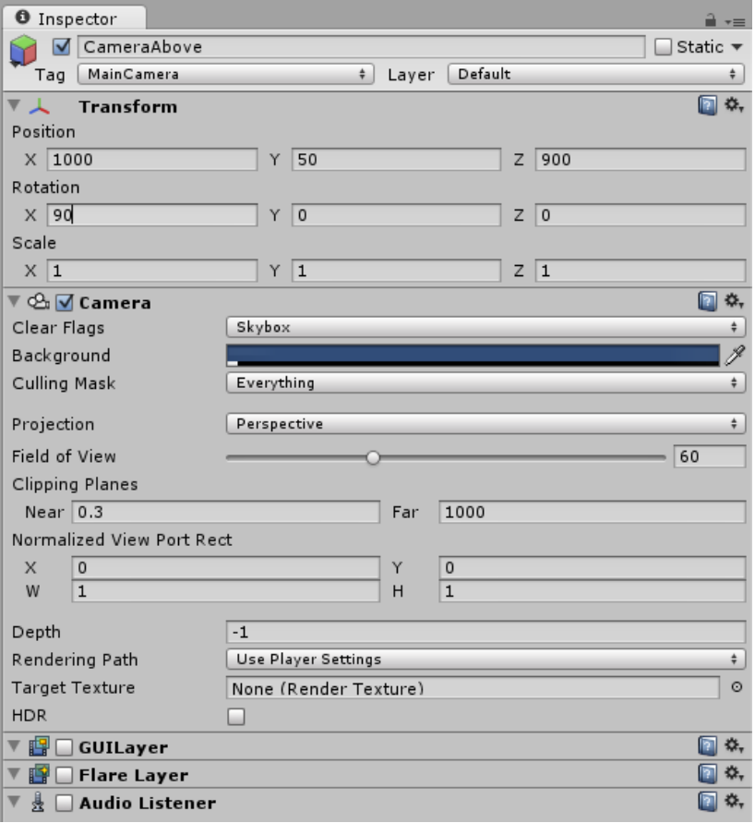
- Make sure that GUILayer, FlareLayer, and AudioListener are turned off.

CameraWestStand
- We will create a camera angle from the West Stands by going to the menubar and selecting GameObject → Create Other → Camera
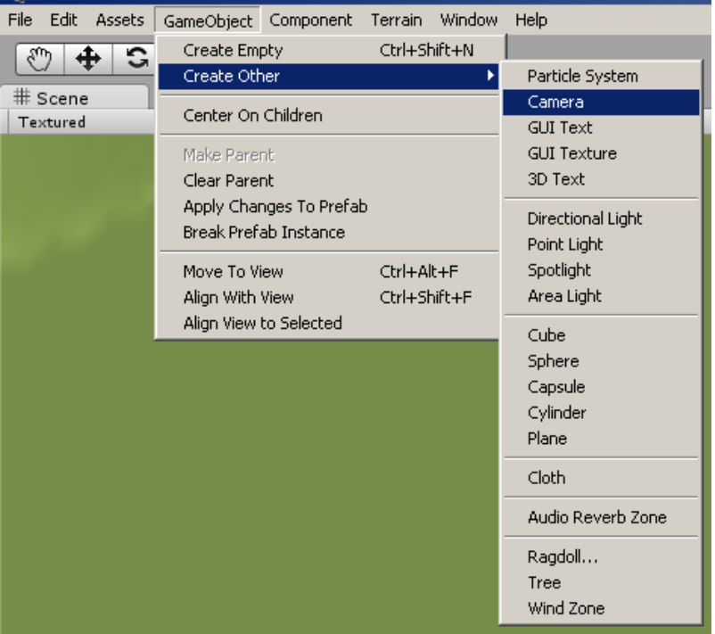
- This will create a new camera in the Hierarchy pane, change the name to “CameraWestStand”.
- Move the “CameraWestStand” to the west stands, and orient it so that the arena can be seen clearly.
- We need to apply a Skybox so that the sky looks more realistic, and not just deep blue.
- Go to the menubar and select Component → Rendering → Skybox
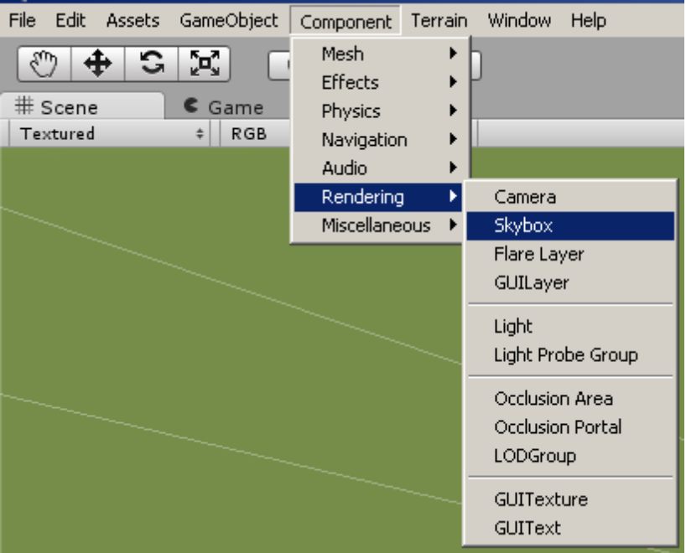
- This will place the Skybox property in the Inspector pane of the “CameraWestStand”. We now need to select the custom Skybox.
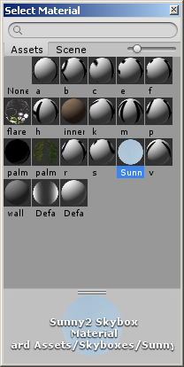
- Select Sunny, this material was imported when you imported the dressage_arena_prefab, but if it wasn't you will need to Import skyboxes using the same method we did when we imported any of the other assets.
- The skybox should now be applied, and you should see a prettier background in your camera view.

CameraEastSide
- We will create a camera angle from the East Stands by going to the menubar and selecting GameObject → Create Other → Camera
- This will create a new camera in the Hierarchy pane, change the name to “CameraEastStand”.
- Move the “CameraEastStand” to the west stands, and orient it so that the arena can be seen clearly.
- We need to apply a Skybox so that the sky looks more realistic, and not just deep blue.
- Go to the menubar and select Component → Rendering → Skybox
- This will place the Skybox property in the Inspector pane of the “CameraEastStand”. We now need to select the custom Skybox.
- Select Sunny, this material was imported when you imported the dressage_arena_prefab, but if it wasn't you will need to Import skyboxes using the same method we did when we imported any of the other assets.
- The skybox should now be applied, and you should see a prettier background in your camera view.

CameraHorse
- “CameraHorse” is already included in the dressage_arena_prefab that you imported.
- Since it is a child element of “Horse” object, as the “Horse” object moves around, so will the “CameraHorse” relative to the postion of the “Horse” object.

Horse (Object)
Was included in the dressage_arena_prefab. It has an initial starting point set to behind the stands, and will move from this location to the initial starting point based on the scripting that is associated with it.
To attach scripts to this object, we simply create the script in the Project pane, write the script, and drag it onto the objeect that the script is to be controlling.

HorseMovementScript.cs
See code section of this document for more details.

Implementation

Algorithms

Code

