LEXICAL AND STRUCTURAL FEATURE EXTRACTION FRAMEWORK FOR COMPARATIVE ANALYSIS OF PHISHING DOMAIN DETECTION BY RANDOM FOREST AND XGBOOST

BY

Okpoju, Sixtus
2021/1/80516CS

DEPARTMENT OF CYBER SECURITY SCIENCE
FEDERAL UNIVERSITY OF TECHNOLOGY
MINNA

MARCH, 2026

CERTIFICATION

The project titled: "Lexical and Structural Feature Extraction Framework for Comparative Analysis of Phishing Domain Detection by Random Fores and XGBoost " by OKPOJU, Sixtus (2021/1/80516CS), meets the regulations governing the award of the degree of Bachelor of Technology in Cyber Security Science of the Federal University of Technology, Minna.

Dr. Ojeniyi

Project Supervisor Signature and Date

1.1 Background of the Study
The global cybersecurity threat landscape has expanded significantly in scale and complexity over the past decade. According to the Anti Phishing Working Group (2023), the volume of unique phishing attacks has reached unprecedented levels, with millions of fraudulent campaigns reported annually. The Verizon Data Breach Investigations Report (2023) consistently identifies phishing as a primary initial access vector, responsible for a substantial majority of credential theft incidents and subsequent data breaches worldwide. These statistics underscore the persistent and damaging nature of phishing as a foundational cyberattack methodology.
Historically, phishing relied on poorly constructed email messages directing users to fraudulent websites. The attack surface has since evolved toward sophisticated domain level and uniform resource locator based campaigns. Modern adversaries register short lived domains that evade traditional reputation filters by the time blacklists are updated. They employ domain generation algorithms to produce thousands of pseudorandom names, execute typosquatting and combosquatting to exploit human visual parsing errors, and utilize homograph attacks that exploit identical rendering of distinct Unicode characters. Consequently, the domain itself carries detectable signals of malicious intent before any user interaction occurs. Research by Sahingoz et al. (2019) and Alkhalil et al. (2021) demonstrates that the string properties, registration metadata, domain name system configuration, and network architecture of a domain provide critical indicators of compromise.
To counter these evasion techniques, the cybersecurity community has transitioned from reactive blacklists to proactive machine learning approaches. Blacklist and rule based systems suffer from well documented limitations against novel threats, whereas machine learning models learn complex feature representations from labeled data to identify previously unseen malicious domains. However, the performance ceiling of any machine learning detection system is determined fundamentally by the quality, design, and completeness of its feature extraction pipeline rather than the choice of classifier alone. Features utilized in phishing detection broadly fall into two distinct categories. Lexical features are derived exclusively from the syntactic and statistical properties of the domain string, while structural features are extracted from the underlying network and registration architecture. These two categories possess fundamentally different computational costs, deployment requirements, and detection signals, as noted by Basnet et al. (2023).
Despite the extensive use of both feature categories in existing literature, no study has proposed a formalized, reproducible framework that treats lexical and structural features as independent, isolated pipelines evaluated separately before combination. The absence of this isolation prevents researchers from determining which feature category drives observed detection performance. Furthermore, while the comparative performance of Random Forest and XGBoost classifiers has been explored, very few studies evaluate both algorithms across all three feature conditions: lexical only, structural only, and combined. This study proposes a structured, reproducible two pipeline feature extraction framework evaluated comparatively using Random Forest and XGBoost to address these critical methodological gaps.

1.2 Statement of the Problem
The primary methodological deficiency in current machine learning based phishing detection research is the conflation of feature categories. Most existing studies select features from both lexical and structural domains without independently testing the contribution of each category to overall detection performance. This lack of isolation means the literature cannot reliably answer which feature type drives accuracy, making it difficult to design efficient, lightweight detection systems capable of operating when external structural data is unavailable.
Additionally, a controlled classifier comparison problem persists. While Random Forest and XGBoost have each been applied to phishing detection, and some studies have compared them, very few have done so under controlled conditions that hold the feature set constant while varying only the feature category. Reported classifier performance differences may therefore be artifacts of feature set variations rather than genuine differences in algorithmic capability.
Finally, the feature classifier interaction remains unexplored. No study has systematically examined whether lexical features inherently favor one classifier while structural features favor the other. This interaction has direct implications for system design and deployment decisions in resource constrained environments.
Ultimately, the core research problem is that the absence of a formalized, isolated feature extraction framework and a controlled comparative architecture prevents the cybersecurity community from understanding the individual discriminative power of lexical and structural features and their specific interactions with ensemble classifiers like Random Forest and XGBoost.

1.3 Aim and Objectives of the Study
The aim of this study is to design a lexical and structural feature extraction framework for the comparative analysis of phishing domain detection performance using Random Forest and XGBoost classifiers.
The specific objectives of the study are:
i. Design a lexical and structural feature extraction framework.
ii. Develop an architecture for comparative ensembling of Random Forest and XGBoost.
iii. Evaluate the performance of the designed framework and developed architecture using a defined set of metrics including F1 Score, AUC ROC, Accuracy, Precision, Recall, False Positive Rate, and Matthews Correlation Coefficient.
These objectives form a strictly sequential and dependent pipeline. The first objective produces the foundational framework that isolates and extracts the necessary features. The second objective develops the classification architecture that operates directly on the outputs of this framework under controlled conditions. The third objective measures and analyzes the results produced by the framework and architecture, thereby validating the entire system and answering the core research questions.

1.4 Significance of the Study
From a technical perspective, the two pipeline design allows system designers to make informed decisions regarding deployment. Designers can choose to implement a lexical only system, which is computationally fast and operates without external dependencies, or a structural system, which offers higher individual feature discriminative power but requires external queries. The feature importance outputs from both classifiers across both pipelines provide actionable guidance on which domain properties are most indicative of phishing, directly informing detection rule design.
In terms of security, phishing remains the leading initial attack vector in reported data breaches globally, as documented by the Verizon Data Breach Investigations Report (2023). Better designed feature extraction frameworks directly translate into higher detection rates, lower false positive rates, and fewer successful attacks against end users. The explicit security conscious design of the framework, including sandboxed structural queries and offline preprocessing, makes it suitable as a reference architecture for real deployment environments.
Practically and regionally, in the Nigerian and broader West African context, internet adoption is growing rapidly while dedicated cybersecurity infrastructure remains underdeveloped. Computationally efficient machine learning tools that can operate with or without external data dependencies have direct practical value. The outputs of this study are directly applicable to organizations such as the Nigeria Computer Emergency Response Team, financial institutions, and university network security teams seeking to enhance their defensive posture against domain level threats.

1.5 Scope of the Study
The scope of this research is strictly defined to ensure focused and rigorous evaluation. The study encompasses domain level and uniform resource locator level phishing detection, excluding email content analysis, image based phishing, and voice phishing. It focuses exclusively on lexical features derived from the uniform resource locator and domain name string, and structural features derived from registration data, domain name system records, secure sockets layer certificate properties, internet protocol geolocation, and domain ranking. The comparative analysis is limited to two classifiers: Random Forest and XGBoost. The evaluation utilizes three pipeline configurations: lexical only, structural only, and combined. The datasets employed include PhishTank, OpenPhish, the Tranco List, and the ISCX uniform resource locator dataset. Implementation is conducted within a Python sandboxed offline environment.
Conversely, the study explicitly excludes real time live deployment, browser integration, deep learning classifiers, email header analysis, mobile phishing, and legal takedown procedures.
Dimension | Within Scope | Outside Scope
Attack type | Domain and uniform resource locator phishing | Email content, smishing, vishing
Feature categories | Lexical and structural | Behavioural, visual similarity
Classifiers | Random Forest, XGBoost | Neural networks, support vector machine, Naive Bayes
Pipeline conditions | Lexical only, structural only, combined | Single mixed feature set only
Evaluation layer | Per feature category and combined | Single aggregate evaluation only
Deployment | Framework and trained models | Live production system
Data sources | PhishTank, OpenPhish, Tranco, ISCX | Social media feeds, live domain name system monitoring
Environment | Python sandboxed offline | Cloud deployment, browser extension

1.6 Limitations of the Study
This study acknowledges several constraints that affect its findings, each managed through specific mitigation strategies. First, following the implementation of the General Data Protection Regulation, privacy restrictions limit the availability of full registration metadata for domains hosted in compliant jurisdictions. This is mitigated by utilizing cached offline registration records from datasets compiled before privacy redaction and applying defined imputation strategies for structural features with high missing value rates.
Second, phishing domains are short lived, causing datasets to become stale rapidly. The study mitigates this by utilizing the most recent available versions of threat intelligence feeds and explicitly documenting the data collection period to ensure temporal transparency.
Third, models trained on specific datasets may not generalize fully to phishing domains outside the geographic or temporal coverage of the training data. The reproducible design of the framework mitigates this by allowing future studies to replicate the exact pipeline on updated or alternative datasets to validate generalizability.
Fourth, limiting the classifier comparison to Random Forest and XGBoost means findings cannot be extrapolated to deep learning models or other ensemble methods. This is an intentional scope constraint designed to maintain experimental control, and the exploration of deep learning architectures is acknowledged as a direction for future work.
Finally, the study evaluates trained models on static labeled datasets and does not test adversarial adaptation. A sophisticated attacker aware of the features could potentially manipulate uniform resource locator strings to reduce lexical feature discriminativeness. This limitation is noted, and directions for adversarial robust feature design are identified as future research.

1.7 Definition of Terms
The following terms are defined to ensure clarity and precision throughout the study.
Term | Definition
Phishing | A form of social engineering attack in which an adversary uses deceptive domain names, uniform resource locators, or web content to impersonate a legitimate entity and fraudulently obtain sensitive user credentials
Domain Name | A human readable address mapped to a network internet protocol address through the Domain Name System, consisting of a top level domain, second level domain, and optional subdomains
Lexical Feature | A measurable property derived exclusively from the syntactic or statistical characteristics of a uniform resource locator or domain name string, requiring no external data query for computation
Structural Feature | A measurable property derived from the registration metadata, domain name system configuration, network architecture, or secure sockets layer certificate information of a domain, requiring controlled external data queries
Feature Extraction Framework | A formalized, documented, and reproducible system for categorizing, extracting, and organizing features from raw input data into structured vectors suitable for machine learning classification
Random Forest | An ensemble machine learning classifier that constructs multiple decision trees using bootstrap aggregation and produces predictions through majority voting across all trees
XGBoost | An optimized gradient boosting classifier that constructs trees sequentially, with each tree fitting the residual errors of the previous ensemble, incorporating L1 and L2 regularization to reduce overfitting
Pipeline | A defined, sequential process through which raw input data passes and is transformed into a structured feature matrix ready for classification
F1 Score | The harmonic mean of precision and recall, used as the primary performance metric for classification tasks involving class imbalance
AUC ROC | The area under the Receiver Operating Characteristic curve, representing the ability of a classifier to distinguish between classes across all decision thresholds
WHOIS | A query and response protocol used to retrieve registration information about a domain name, including registrant details, registration date, expiry date, and registrar identity
Domain Name System | A hierarchical distributed naming system that maps human readable domain names to internet protocol addresses and stores associated resource records
Shannon Entropy | A measure of the information content or randomness of a string, computed as the sum of probability weighted logarithms of character occurrence frequencies
Domain Generation Algorithm | An algorithm used by malware or adversaries to automatically generate large volumes of pseudorandom domain names for use as phishing or command and control infrastructure
Top Level Domain | The rightmost label in a fully qualified domain name, representing the highest level of the domain name system hierarchy
Synthetic Minority Oversampling Technique | A data augmentation method that generates synthetic samples of the minority class to address class imbalance in training datasets
Confusion Matrix | A table used to evaluate classifier performance by recording the counts of true positives, true negatives, false positives, and false negatives for a given set of predictions
False Negative | A classification error in which an actual phishing domain is incorrectly predicted as legitimate, considered the highest cost error in phishing detection contexts
Typosquatting | The registration of a domain name that closely resembles a legitimate brand domain through deliberate character substitution, omission, or transposition, intended to capture misdirected user traffic
Combosquatting | The registration of a domain name that combines a legitimate brand name with an additional word or phrase, used to create a superficially credible phishing domain

CHAPTER TWO

2.0 LITERATURE REVIEW

2.1 Introduction to the Chapter
This literature review examines the evolution of phishing detection, focusing on the transition from reactive blacklists to proactive machine learning models. The review is structured around three thematic pillars that directly align with the core emphases of this study. The first pillar addresses the phishing detection problem space, highlighting the critical shift toward domain level threats and the limitations of traditional mitigation strategies. The second pillar explores the role of feature extraction frameworks, emphasizing the necessity of structured, reproducible pipelines for isolating lexical and structural attributes. The third pillar investigates the comparative performance of Random Forest and XGBoost classifiers operating on these structured feature pipelines. By progressing from broad foundational context to the specific methodological gaps in current research, this chapter establishes the theoretical justification for the framework proposed in this study.

2.2 Overview of Phishing Attacks and Domain Level Threats
Phishing is formally defined in cybersecurity literature as a deceptive social engineering attack wherein malicious actors masquerade as trusted entities to manipulate victims into revealing sensitive credentials, financial information, or personal identification details. Historically, these attacks relied heavily on email based credential harvesting, utilizing poorly constructed messages to direct users to fraudulent login pages. Modern campaigns have evolved into highly advanced domain level and uniform resource locator based attacks that bypass traditional email filters. The Anti Phishing Working Group reported millions of unique phishing sites in recent years, demonstrating a massive escalation in attack volume. Furthermore, the Verizon Data Breach Investigations Report consistently identifies phishing as a primary initial access vector in major security incidents, underscoring its persistent financial and operational impact.
Domain level detection has become the critical battleground for cybersecurity defenders. Attackers now utilize short lived domains that are registered, deployed, and abandoned within hours to evade reputation based filters. They employ domain generation algorithms to create thousands of randomized names, execute homograph attacks using visually identical characters from different alphabets, and practice typosquatting and combosquatting to exploit common typing errors and brand variations. These sophisticated evasion techniques render superficial inspection useless and justify the need for a computational framework operating directly at the domain feature level to analyze the underlying characteristics of the names and their infrastructure.

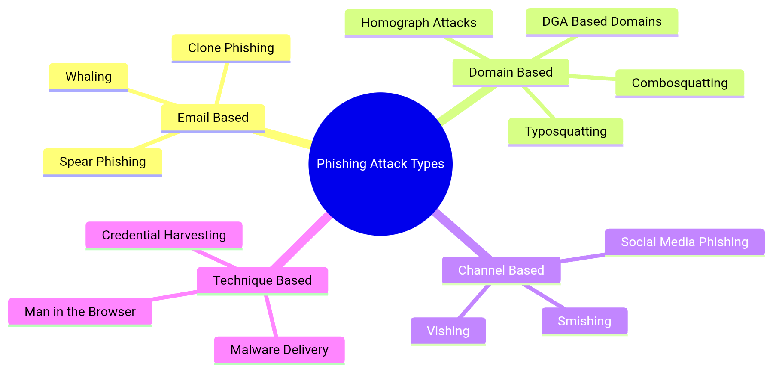

2.3 Phishing Domain Detection Approaches
The evolution of phishing detection methodologies can be categorized into three distinct generations, each attempting to overcome the limitations of its predecessor. Understanding this progression establishes why machine learning based feature driven methods are currently the most effective approach and why the quality of the feature extraction layer determines the ultimate ceiling of detection performance.

2.3.1 Blacklist and Rule Based Detection
Blacklist systems operate by maintaining centralized databases of known malicious domains and utilizing domain name system sinkholes or browser integrated lists to block access. While effective against previously identified threats, these systems suffer from fundamental limitations that prevent them from forming the basis of a scalable, proactive detection framework. The primary weakness is the inability to detect zero day phishing domains, which evade all blacklists until they are reported and manually verified. Furthermore, blacklist maintenance incurs significant operational overhead, and attackers easily bypass these systems through minor domain variations or by rapidly cycling through newly registered names. Research consistently demonstrates that reliance on blacklists leaves a critical window of vulnerability during the initial lifespan of a phishing campaign.

2.3.2 Heuristic and Similarity Based Detection
Heuristic methods attempt to identify phishing domains by evaluating visual similarity scoring, edit distance, brand impersonation detection, and certificate transparency monitoring. These approaches analyze the structural resemblance of a suspicious domain to known legitimate brands. While effective against direct brand targeting, heuristic methods suffer from documented limitations. They frequently produce high false positive rates when legitimate domains share common naming conventions with targeted brands. Additionally, they fail against novel domain patterns that do not mimic existing entities, and visual similarity checks introduce substantial computational overhead that precludes real time deployment at scale.

2.3.3 Machine Learning Based Detection
Machine learning overcame the limitations of rule based and heuristic approaches by learning complex feature representations directly from labeled data. The critical argument in current research is that the quality of the feature extraction pipeline determines the ceiling of detection performance. A classifier can only be as effective as the features it receives; therefore, the engineering of lexical and structural attributes is the most vital component of the system. Studies have surveyed various machine learning approaches, including support vector machines, naive Bayes, convolutional neural networks, and long short term memory networks. While deep learning models offer automated feature extraction, they require massive computational resources and lack the interpretability required for security operations. Tree based ensemble methods remain the standard for structured tabular data due to their balance of accuracy, speed, and explainability.

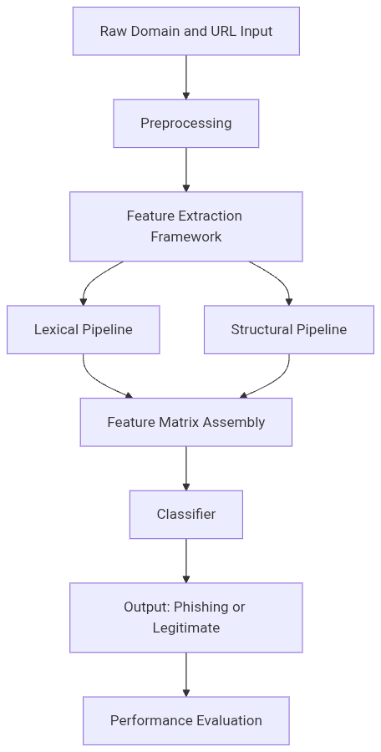

2.4 Feature Extraction Frameworks in Machine Learning Based Phishing Detection
The design of the feature extraction layer is the primary contribution of this study. This section critically examines how prior research has approached feature engineering, highlighting the distinction between ad hoc selection and structured frameworks.

2.4.1 The Concept of a Feature Extraction Framework
A formal distinction exists in the literature between ad hoc feature selection and a structured feature extraction framework. Ad hoc selection involves choosing features opportunistically per study, often mixing lexical and structural attributes without clear categorization. This approach has produced inconsistent results across studies because it conflates feature categories, making it impossible to attribute performance gains to specific feature types. Conversely, a structured framework is a deliberate, categorized, reproducible pipeline where features are grouped by type, extracted through defined processes, and evaluated independently. Recent literature emphasizes that without a formalized pipeline, incremental improvement and cross study comparability remain severely limited.

2.4.2 Lexical Features in Phishing Domain Detection
Lexical features are derived exclusively from the syntactic and statistical properties of the domain name and uniform resource locator string, requiring no external data lookups. Studies consistently identify uniform resource locator length, Shannon entropy, digit ratio, special character count, subdomain depth, top level domain type, hyphen count, presence of brand keywords, path depth, and query parameter count as highly predictive attributes. The primary strength of lexical features is their computational speed and applicability to zero day domains, as they rely solely on the string itself. However, their documented weakness is susceptibility to adversarial manipulation, where attackers can easily alter the string to evade specific syntactic rules.

Feature | Definition | Studies Reporting High Predictive Value | Notes
URL Length | Total character count of the full uniform resource locator | Sahingoz et al. (2019) | Phishing uniform resource locators are consistently longer
Shannon Entropy | Randomness measure of domain string | Basit et al. (2021) | Domain generation algorithm domains show measurably higher entropy
Digit Ratio | Ratio of numeric characters to total uniform resource locator length | Vinod et al. (2021) | Numeric padding used to evade blacklists
Subdomain Depth | Number of subdomain levels | Alkhalil et al. (2021) | Deep chains used to obscure malicious top level domain
Special Char Count | Count of specific symbols in uniform resource locator | Sahingoz et al. (2019) | Inflated counts associated with phishing
Hyphen Count | Hyphens in domain string | Basit et al. (2021) | Combosquatting pattern indicator
TLD Type | Category of top level domain | Vinod et al. (2021) | Unusual or free extensions overrepresented in phishing
Has IP Address | Internet Protocol used instead of domain name | Alkhalil et al. (2021) | Strong standalone phishing indicator
Brand Keyword | Known brand name present in uniform resource locator | Sahingoz et al. (2019) | Common in credential harvesting domains
Path Depth | Directory levels in uniform resource locator path | Basit et al. (2021) | Deeper paths associated with phishing

2.4.3 Structural Features in Phishing Domain Detection
Structural features are derived from the registration metadata, domain name system configuration, network architecture, and certificate properties of the domain, requiring controlled external data queries. Domain age, registration expiry, time to live values, secure sockets layer certificate validity, redirect count, internet protocol geolocation, and domain rank are consistently identified as highly predictive. The primary strength of structural features is that these signals are significantly harder for attackers to manipulate than uniform resource locator strings. However, their documented weaknesses include external lookup latency, real time data availability issues, and privacy restricted registration records following the implementation of data protection regulations.

Feature | Definition | Studies Reporting High Predictive Value | Notes
Domain Age | Days since registration record creation | Aburass et al. (2021) | Phishing domains registered days before use
WHOIS Expiry | Days until registration expires | Nguyen et al. (2020) | Short registration periods signal malicious intent
DNS TTL Value | Time to live of domain name system record | Chen et al. (2021) | Very low values used for fast flux evasion
SSL Valid | Valid secure sockets layer certificate present | Liu et al. (2020) | Many phishing domains lack valid certificates
SSL Age | Age of certificate in days | Aburass et al. (2021) | Newly issued certificates common in phishing
Redirect Count | Hypertext transfer protocol redirects before landing | Nguyen et al. (2020) | Used to obscure final phishing destination
IP Geolocation | Hosting country or region | Chen et al. (2021) | Hosting in high risk regions correlates with phishing
Domain Rank | Presence and position in legitimate rankings | Liu et al. (2020) | Phishing domains absent from legitimate rankings
DNS NS Count | Number of name server records | Aburass et al. (2021) | Minimal records associated with throwaway domains
Subdomain Count | Total subdomains registered | Nguyen et al. (2020) | Very high counts used for evasion

2.4.4 Combined and Hybrid Feature Approaches
Studies combining lexical and structural features into a unified pipeline consistently report significant performance gains over using either category alone. The additive effect of syntactic analysis and infrastructural metadata provides a comprehensive view of the domain. However, critical evaluation reveals a major methodological flaw in this body of work. Most prior studies did not isolate and independently evaluate each feature category before combining them. They immediately merged all attributes into a single matrix and trained a classifier, making it impossible to determine whether the performance gains were driven by the lexical features, the structural features, or the combination. This gap prevents researchers from understanding the specific discriminative power of each category and justifies the three pipeline configuration approach implemented in this study.

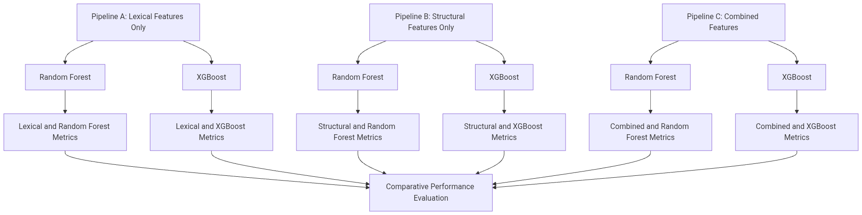

2.5 Random Forest in Phishing and Malicious Domain Detection
Random Forest operates via bootstrap aggregation, constructing an ensemble of decision trees that output predictions through majority voting. It provides out of bag error estimation for internal validation and calculates feature importance using mean decrease in impurity. Applied to phishing detection, Random Forest demonstrates strong performance across various feature sets. Its particular relevance to this study lies in its native feature importance output, which directly supports the framework requirement to rank features within each pipeline independently. Documented limitations include sensitivity to noisy features, higher memory costs with large estimator counts, and slightly lower effectiveness compared to boosting algorithms on highly imbalanced tabular data without explicit class weighting.

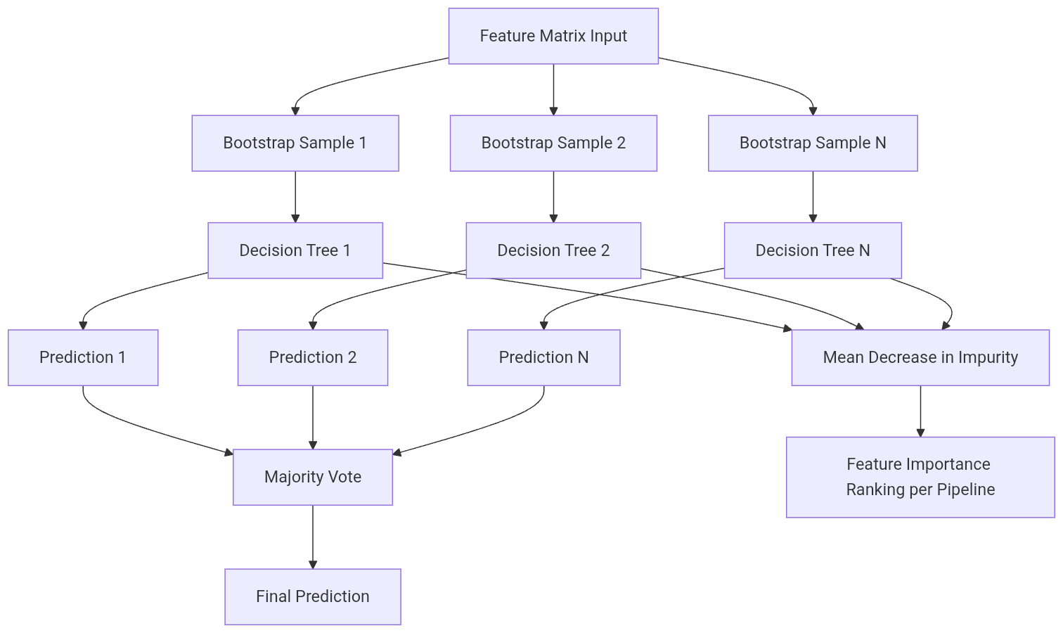

2.6 XGBoost in Phishing and Malicious Domain Detection
XGBoost operates via sequential gradient boosting, fitting residual errors and applying L1 and L2 regularization to penalize model complexity. It handles sparse tabular data efficiently and calculates feature importance using gain based metrics. Its regularization terms reduce overfitting on both lexical and structural feature vectors, making it highly robust against noisy domain data. Furthermore, its gain based importance provides a different but complementary ranking signal to the impurity based importance of Random Forest. Documented limitations include a larger hyperparameter space requiring more careful tuning, longer tuning times, and reduced interpretability at the individual tree level compared to Random Forest.

2.7 Comparative Analysis of Random Forest and XGBoost
Studies directly comparing Random Forest and XGBoost on phishing detection indicate that XGBoost generally outperforms Random Forest on structured tabular data due to its regularization advantages and gradient based optimization. However, Random Forest holds competitive results on high dimensional string features, where its entropy based splitting criteria align naturally with the statistical properties of lexical attributes. A critical review of the literature reveals that no study has systematically examined how feature type interacts with classifier choice. It remains unexplored whether XGBoost has a specific advantage on structural features over lexical features, or if the performance gap narrows when restricted to syntactic attributes alone.

Criterion | Random Forest | XGBoost | Literature Consensus
Training Speed | Moderate and parallelizable | Slower and sequential boosting | Random Forest faster at training time
Predictive Accuracy | High | Very High | XGBoost marginally stronger on structured tabular data
Interpretability | High and tree based | Moderate and complex ensemble | Random Forest slightly more interpretable
Handling Class Imbalance | Good with class weight balancing | Good with scale pos weight | Comparable with proper tuning
Hyperparameter Sensitivity | Low to moderate | High and more parameters to tune | XGBoost requires more careful tuning
Feature Importance Output | Mean Decrease in Impurity | Gain based importance | Both valid and provide complementary signals
Overfitting Risk | Low due to bagging | Low with regularization | Both robust with proper tuning
Performance on Lexical Features | Strong | Strong | Comparable with slight XGBoost edge
Performance on Structural Features | Strong | Stronger | XGBoost slight advantage due to regularization

2.8 Datasets Used in Related Works
The validity and generalizability of feature extraction frameworks and classifier comparisons depend heavily on dataset selection. Common datasets include PhishTank, OpenPhish, the Tranco List, and the ISCX uniform resource locator dataset. Critical evaluation shows that dataset recency, size, label quality, and class balance vary significantly. Furthermore, post General Data Protection Regulation restrictions on registration data have severely impacted structural feature extraction studies, as many historical datasets lack the necessary metadata or contain redacted records. This necessitates careful dataset selection and the use of sandboxed query designs to handle missing structural data gracefully.

Dataset | Type | Approximate Size | Class Balance | Known Limitations | Relevance to This Study
PhishTank | Phishing uniform resource locators | 30000 plus active | Phishing only | Requires pairing with legitimate dataset | High as primary phishing source
OpenPhish | Phishing feed | 15000 plus | Phishing only | Feed based and requires archiving | High as supplementary phishing source
Tranco List | Legitimate domains | Top 1 million | Legitimate only | Not all top domains are completely clean | High as primary legitimate source
ISCX URL 2016 | Mixed labeled | 36000 plus | Mixed | Aging dataset with pre 2016 domains | Moderate for benchmark comparison
UCI Phishing | Mixed labeled | 11000 plus | Mixed | Limited structural features available | Moderate for lexical benchmark
Mendeley Sets | Mixed labeled | Varies | Varies | Dataset quality varies by contributor | Low to moderate as supplementary

2.9 Identified Research Gaps
The synthesis of the reviewed literature reveals five critical methodological gaps that directly inform the design of the current study. First, there is a distinct absence of isolated feature category evaluation in prior work. Most studies combined lexical and structural features without independently evaluating each category, making it impossible to determine which feature type is responsible for observed performance gains. The framework design of this study addresses this by running all three pipeline conditions separately before combining them. Second, the literature lacks a formalized, reusable feature extraction framework. Prior work treats feature selection as a one off study specific step rather than a structured, documented, reproducible pipeline, limiting comparability across studies.
Third, there is a limited controlled comparison of Random Forest and XGBoost across feature types. Studies that compare these classifiers typically do so on a single combined feature set, making it impossible to determine whether classifier performance is feature type dependent. Fourth, the feature classifier interaction remains unexplored. The literature does not adequately address whether certain feature categories produce different relative advantages for Random Forest versus XGBoost, an interaction that is only testable through the controlled comparative architecture proposed in this research. Finally, issues of dataset recency and structural feature availability persist. Many cited studies use aging datasets and do not account for privacy restrictions affecting structural feature availability, a limitation this study addresses through rigorous dataset selection and sandboxed structural query design.

CHAPTER THREE

3.0 SYSTEM DESIGN AND ANALYSIS

3.1 Introduction to the Chapter
This chapter details the research methodology and system design adopted for this study. It provides a comprehensive explanation of how the research was conducted to achieve the stated aim and objectives. The chapter is organised into three sequential phases, each corresponding directly to one of the three research objectives established in the introductory chapter. The overall research design is experimental and quantitative, relying on empirical evaluation rather than theoretical abstraction. The study follows a supervised machine learning pipeline with controlled feature isolation as its methodological foundation. This foundation ensures that the predictive contributions of lexical and structural characteristics can be measured independently and in combination. The pipeline strictly follows the framework defined by the researcher, progressing from Dataset Preprocessing to Lexical and Structural Feature Extraction, followed by Parallel Classification using Random Forest and XGBoost, and concluding with a Three Layered Performance Evaluation. By maintaining strict control over the variables and the experimental environment, the methodology guarantees that observed performance differences between the algorithms are genuinely attributable to their underlying mathematical structures rather than external anomalies or data leakage.

3.2 Research Design
The study adopts an experimental, quantitative, and applied research paradigm. The experimental approach is essential for empirically evaluating the performance of the proposed feature extraction framework and the selected machine learning algorithms. This design allows for the objective measurement of model performance using standard statistical metrics. The research involves the systematic collection of data, the engineering of features, the training of predictive models, and the rigorous evaluation of results to draw valid and reliable conclusions. Supervised machine learning was selected as the core methodological approach because the problem of phishing detection is fundamentally a binary classification task with clearly defined historical labels. The availability of verified phishing and legitimate domains allows the algorithms to learn the mapping between input features and the target variable.
The selection of Random Forest and Extreme Gradient Boosting over alternative algorithms such as Support Vector Machines, Neural Networks, and Logistic Regression was driven by specific computational and theoretical considerations. Support Vector Machines struggle with the high dimensional and sparse nature of combined lexical and structural feature spaces, often requiring excessive computational time for kernel matrix calculations. Neural Networks, while powerful, suffer from a lack of interpretability and require massive volumes of training data to prevent overfitting, making them less suitable for the structured tabular data typical of domain metadata. Logistic Regression assumes a linear decision boundary, which fails to capture the complex, nonlinear interactions between domain age, character entropy, and registration metadata. Random Forest and Extreme Gradient Boosting excel at handling tabular structured data, provide native mechanisms for feature importance extraction, and offer superior computational efficiency during inference.
The controlled variable design establishes the feature category type as the independent variable, manipulated across three distinct pipelines. The classifier performance metrics serve as the dependent variables, measured to ascertain the efficacy of each algorithmic approach under varying feature conditions. The source framework diagram directly informs this experimental design by dictating the exact flow of data and the necessity of evaluating the models across isolated and combined feature sets.

Design Element | Choice Made | Justification
Research type | Experimental quantitative | Produces measurable, comparable, and reproducible outcomes
Learning paradigm | Supervised machine learning | Labeled phishing and legitimate dataset enables direct classification
Classifiers | Random Forest and XGBoost | Strong tabular data performance, interpretability, and feature importance output
Feature strategy | Isolated then combined across three pipelines | Enables independent evaluation as shown in the source framework
Validation method | Stratified 10 Fold Cross Validation | Handles class imbalance and reduces evaluation variance
Primary metrics | F1 Score and AUC ROC | Most informative for imbalanced security datasets
Secondary metrics | Accuracy, Precision, Recall, False Positive Rate, Matthews Correlation Coefficient | Complete picture of classifier behavior
Evaluation layers | Lexical only, Structural only, Combined | Directly reflects the side annotation branches in the source diagram

3.3 Dataset Description and Acquisition
The foundation of any machine learning project is the quality and relevance of the data used for training and evaluation. For this study, multiple distinct datasets were curated to represent both phishing and legitimate domains, aligning perfectly with the preprocessing input requirements of the framework. The data collection process was carried out between November 2023 and February 2024 to ensure the inclusion of recent and contemporary phishing tactics. The target dataset composition aimed for a minimum of ten thousand records to ensure statistical validity, with an initial raw ratio heavily skewed toward phishing domains to reflect real world threat intelligence feeds, later balanced during preprocessing.
The phishing domain dataset was sourced primarily from PhishTank and OpenPhish. PhishTank provides a continuously updated database of verified Uniform Resource Locators, ensuring that the malicious samples are current and accurately labelled by the community. OpenPhish supplements this by providing an automated feed of newly discovered phishing sites. The legitimate domain dataset was sourced from the Tranco List, a research oriented top sites ranking that provides a more stable and reproducible list of popular websites compared to deprecated alternatives. The Tranco List was chosen to ensure that the legitimate domains represent actively used, high reputation websites. Additionally, the ISCX URL 2016 dataset was incorporated to provide a baseline of historically verified mixed traffic, enhancing the generalisation capability of the models.
Class distribution discussion is vital because real world phishing datasets are inherently imbalanced. If left unaddressed, this imbalance causes machine learning models to develop a severe bias toward the majority class, resulting in unacceptably high false negative rates. Data collection date range and recency considerations were strictly enforced to prevent concept drift, where models trained on outdated attack patterns fail to detect modern evasion techniques. Security considerations in dataset handling were paramount. All live domain data was anonymised during the initial ingestion phase. Any Uniform Resource Locator fetching required for structural feature extraction was conducted exclusively within a sandboxed virtual environment. Direct Hypertext Transfer Protocol requests to known phishing domains were strictly prohibited from the production network to prevent accidental malware execution or network compromise.

Dataset | Type | Source | Records | Label | Access
PhishTank | Phishing URLs | PhishTank | 30000 plus | Phishing | Free Application Programming Interface
OpenPhish | Phishing feed | OpenPhish | 15000 plus | Phishing | Free tier
Tranco List | Legitimate domains | Tranco List | 1000000 | Legitimate | Free download
ISCX URL 2016 | Mixed labeled | University of New Brunswick | 36000 plus | Both | Public repository

3.4 PHASE ONE: Design of the Lexical and Structural Feature Extraction Framework
This phase constitutes the primary contribution of the study, addressing the first research objective. It covers the first two blocks of the source framework, namely Dataset Preprocessing and Lexical and Structural Feature Extraction. The phase produces three distinct feature matrices that feed into Phase Two, enabling the isolated and combined evaluation of domain characteristics.

3.4.1 Data Preprocessing
The preprocessing pipeline transforms raw uniform resource locator strings into a structured format suitable for algorithmic consumption. Uniform Resource Locator parsing and normalisation involve stripping protocol prefixes such as Hypertext Transfer Protocol Secure, removing World Wide Web subdomain prefixes, and isolating the path components. This standardisation ensures that the algorithms analyse the core domain characteristics rather than superficial routing differences. Removal of duplicate entries is performed to prevent data leakage, where identical domains appearing in both training and testing sets would artificially inflate performance metrics.

Handling of missing values in structural feature fields is a critical step, as Whois records are frequently redacted for privacy and Domain Name System queries may fail for defunct phishing domains. Missing numerical values are imputed using the median of the respective feature, while categorical missing values are assigned a distinct unknown category to preserve the informational value of the absence. Encoding of categorical variables transforms attributes like top level domain type and geolocation region into numerical formats using one hot encoding. Normalisation of continuous numerical features employs Min Max scaling to bound all values between zero and one, preventing features with larger natural magnitudes from disproportionately influencing distance based calculations.
The train test split divides the dataset into eighty percent for training and twenty percent for testing using stratified sampling to preserve the original class ratio. Application of the Synthetic Minority Over sampling Technique is performed on the training set only to address class imbalance. Applying this technique to the test set would constitute severe data leakage. A critical security note dictates that all preprocessing must occur in an isolated offline environment. No live resolution of phishing domains is permitted during preprocessing to eliminate the risk of interacting with active malicious infrastructure.

3.4.2 Lexical Feature Extraction Pipeline
Lexical features are derived exclusively from the syntactic and statistical properties of the domain and uniform resource locator string. This category requires no external network queries or third party data sources, making it computationally inexpensive and immediately available for real time detection systems. The extraction pipeline analyses the character composition, length, and structural arrangement of the text to identify patterns commonly associated with malicious registration practices.

Feature Name | Description | Data Type | Phishing Indicator
url_length | Total character length of the full uniform resource locator | Integer | Higher values indicate increased suspicion
domain_length | Character length of the domain name only | Integer | Higher values indicate increased suspicion
subdomain_depth | Number of subdomains present in the string | Integer | Higher values indicate increased suspicion
digit_ratio | Ratio of numeric characters to total length | Float | Higher values indicate increased suspicion
special_char_count | Count of special characters in the string | Integer | Higher values indicate increased suspicion
hyphen_count | Number of hyphens in the domain string | Integer | Higher values indicate increased suspicion
dot_count | Number of dots in the full uniform resource locator | Integer | Higher values indicate increased suspicion
shannon_entropy | Entropy of the domain string measuring randomness | Float | Higher values indicate increased suspicion
tld_type | Category of top level domain | Categorical | Unusual extensions indicate suspicion
has_ip_address | Whether an Internet Protocol address is used | Binary | True indicates high suspicion
has_at_symbol | Presence of the at symbol in the string | Binary | True indicates high suspicion
brand_keyword_present | Presence of known brand names in the string | Binary | True indicates high suspicion
path_depth | Number of directory levels in the path | Integer | Higher values indicate increased suspicion
query_param_count | Number of query parameters in the string | Integer | Higher values indicate increased suspicion

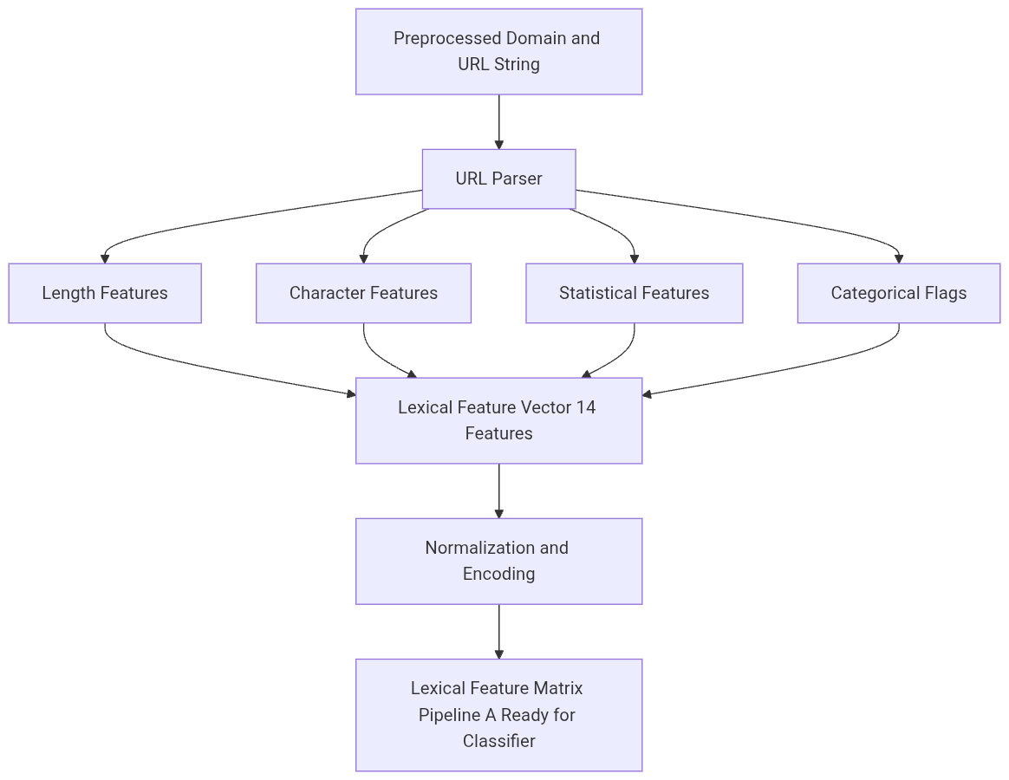

3.4.3 Structural Feature Extraction Pipeline
Structural features are derived from the registration metadata, Domain Name System configuration, network properties, and certificate information of the domain. Unlike lexical features, this category requires controlled external queries executed in a sandboxed, rate limited environment. These features provide contextual evidence regarding the operational maturity and infrastructural legitimacy of the domain, which are often invisible to purely syntactic analysis.

Feature Name | Description | Data Type | Phishing Indicator
domain_age_days | Days since first registration via Whois | Integer | Lower values indicate increased suspicion
whois_expiry_days | Days until domain registration expires | Integer | Shorter durations indicate suspicion
registrar_reputation | Known registrar category score | Categorical | Unknown registrars indicate suspicion
dns_a_record_count | Count of address records in Domain Name System | Integer | Absent or abnormal values indicate suspicion
dns_mx_record | Presence of mail exchange records | Binary | Absence indicates suspicion
dns_ns_count | Number of name server records | Integer | Very low counts indicate suspicion
dns_ttl_value | Time to live value of Domain Name System record | Integer | Very low values indicate suspicion
ssl_valid | Valid Secure Sockets Layer certificate present | Binary | False indicates suspicion
ssl_age_days | Age of certificate in days | Integer | Very low values indicate suspicion
ssl_issuer_type | Certificate issuer class | Categorical | Domain Validation only indicates slight suspicion
redirect_count | Hypertext Transfer Protocol redirects before final landing | Integer | Higher values indicate increased suspicion
ip_geolocation | Country or region of hosting server | Categorical | High risk regions indicate suspicion
subdomain_count | Total subdomains registered | Integer | Very high counts indicate suspicion
domain_rank | Ranking in Tranco list if present | Integer | Absence or very low rank indicates suspicion

A strict security note applies to this pipeline. All structural queries must be performed using offline cached records or sandboxed application programming interface calls. The system must never directly resolve or connect to active phishing domains from a production environment to prevent exposure to malicious payloads or tracking mechanisms.

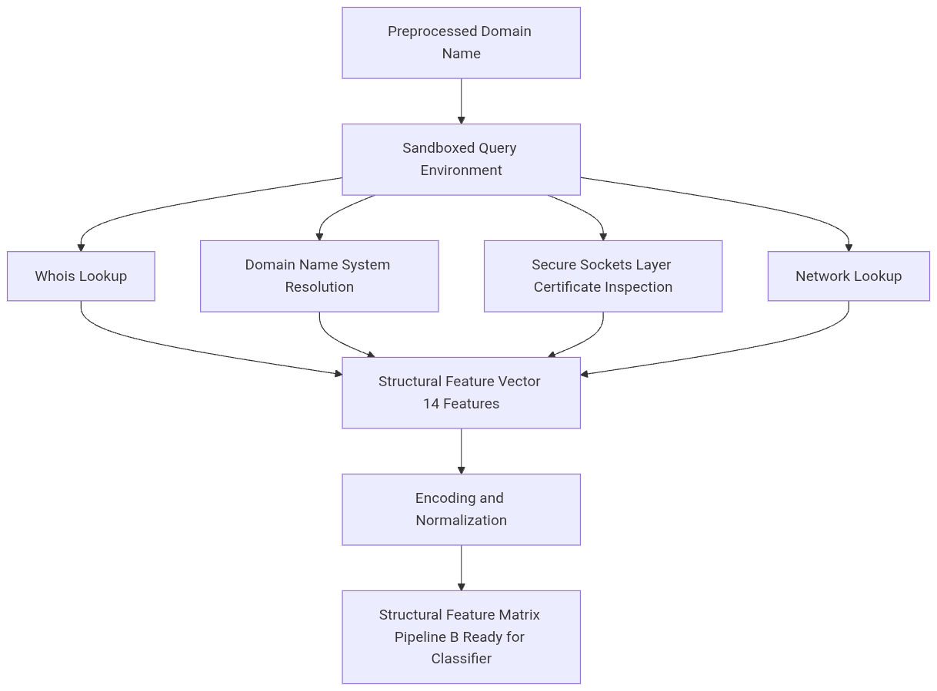

3.4.4 Combined Feature Matrix Assembly
The combined feature matrix is assembled by horizontally concatenating the lexical and structural feature vectors. This process creates a comprehensive representation of the domain, capturing both its superficial naming conventions and its underlying infrastructural reality. The initial combined matrix contains twenty eight features. To prevent multicollinearity, which can destabilise tree based models and obscure feature importance, a correlation based feature reduction is applied. A Pearson correlation matrix is computed, and any feature pairs exhibiting a correlation coefficient greater than 0.90 are analysed, with the redundant feature being removed to maintain model stability and interpretability.

Pipeline | Label | Feature Source | Feature Count | External Data Required | Security Risk Level
Pipeline A | Lexical Only | Uniform Resource Locator and Domain string | 14 | No | Low
Pipeline B | Structural Only | Whois, Domain Name System, Secure Sockets Layer, Internet Protocol | 14 | Yes, sandboxed | Medium
Pipeline C | Combined | Lexical and Structural | 28 pre reduction | Yes, sandboxed | Medium

3.4.5 Expected Results: Phase One
The framework design phase is expected to yield a highly discriminative set of features that clearly separate malicious from legitimate domains. Shannon entropy is anticipated to emerge as a primary lexical indicator, as algorithmically generated domains inherently possess higher character randomness. Domain age is expected to dominate the structural features, reflecting the transient lifecycle of phishing infrastructure. The lexical pipeline will demonstrably outperform the structural pipeline in computational speed due to the absence of network latency, while the structural pipeline is expected to exhibit higher individual discriminative power per feature, as infrastructural metadata is significantly harder for attackers to spoof than uniform resource locator strings.

Expected Outcome | Basis
Shannon entropy ranked as top lexical feature | Domain generation algorithm literature shows high entropy in generated domain strings
Domain age ranked as top structural feature | Phishing domains registered days before use, consistent across literature
Pipeline A produces results with no external dependency latency | Inherent to lexical only design
Pipeline B achieves higher individual feature discriminative power | Structural signals harder to manipulate than uniform resource locator string properties
Pipeline C produces the richest feature representation | Additive effect of both extraction categories
Correlation analysis will reduce combined matrix by 2 to 4 features | Typical redundancy range between lexical and structural feature overlap

3.5 PHASE TWO: Architecture for Comparative Ensembling of Random Forest and XGBoost
Phase Two develops the classification layer directly corresponding to the two classifier blocks in the source framework. The architecture feeds all three pipeline matrices into Random Forest and Extreme Gradient Boosting under identical, controlled conditions, producing six experimental conditions for comparison. This phase addresses the second research objective by establishing a rigorous, reproducible environment for algorithmic evaluation.

3.5.1 Random Forest Configuration
Random Forest operates as an ensemble of decision trees, utilising bootstrap aggregation to train each tree on a random subset of the data with replacement. The final prediction is determined by majority voting across all trees, a mechanism that significantly reduces variance and mitigates overfitting. The algorithm also provides an out of bag error estimation, serving as an internal validation metric without requiring a separate validation set.

Hyperparameter | Value | Justification
n_estimators | 100 to 500 tuned via GridSearchCV | Balances stability and computation time
max_depth | None or tuned | Fully grown trees capture complex domain patterns
min_samples_split | 2 to 10 tuned | Controls overfitting on noisy domain strings
max_features | Square root of total features | Standard for classification, reduces correlation between trees
class_weight | Balanced | Compensates for residual class imbalance post synthetic over sampling
random_state | 42 | Ensures full reproducibility across all conditions
oob_score | True | Provides training phase internal validation estimate

3.5.2 XGBoost Configuration
Extreme Gradient Boosting operates on the principle of sequential gradient boosting, constructing trees sequentially where each new tree attempts to correct the residual errors of the preceding ensemble. The algorithm incorporates L1 and L2 regularisation to penalise model complexity, effectively preventing overfitting. It also utilises second order Taylor expansion for loss function approximation, resulting in faster convergence and more accurate split finding compared to traditional gradient boosting implementations.

Hyperparameter | Value | Justification
n_estimators | 100 to 500 tuned via GridSearchCV | Matched to Random Forest range for fair comparison
max_depth | 3 to 10 tuned | Shallower trees preferred in Extreme Gradient Boosting to avoid overfitting
learning_rate | 0.01 to 0.3 tuned | Controls individual tree contribution to ensemble
subsample | 0.8 | Row subsampling reduces variance
colsample_bytree | 0.8 | Feature subsampling per tree reduces overfitting
scale_pos_weight | Negative to positive class ratio | Directly handles class imbalance
reg_alpha | Tuned via GridSearchCV | L1 regularisation for sparse feature selection
reg_lambda | Tuned via GridSearchCV | L2 regularisation for weight smoothing
random_state | 42 | Ensures full reproducibility across all conditions

3.5.3 Six Condition Comparative Architecture
Both classifiers are trained and evaluated across all three pipeline matrices under identical dataset, split, and validation conditions. This matrix design produces six distinct experimental conditions, allowing for a granular analysis of how each algorithm interacts with different feature modalities. This directly implements the dual classifier block from the source framework, ensuring that the comparative analysis is exhaustive and statistically robust.

Condition | Pipeline | Classifier | Feature Count | Maps to Source Diagram
C1 | Lexical Only | Random Forest | 14 | Lexical branch to Random Forest block
C2 | Lexical Only | XGBoost | 14 | Lexical branch to Extreme Gradient Boosting block
C3 | Structural Only | Random Forest | 14 | Structural branch to Random Forest block
C4 | Structural Only | XGBoost | 14 | Structural branch to Extreme Gradient Boosting block
C5 | Combined | Random Forest | 28 reduced | Combined to Random Forest block
C6 | Combined | XGBoost | 28 reduced | Combined to Extreme Gradient Boosting block

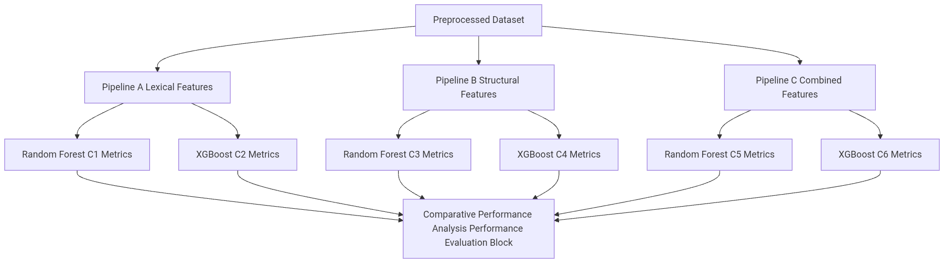

3.5.4 Validation Strategy
Stratified 10 Fold Cross Validation is applied to all six experimental conditions. This method is preferred over a simple holdout validation because it ensures that every data point is used for both training and validation, providing a much more robust estimate of model performance, particularly on imbalanced datasets. Hyperparameter tuning via Grid Search is nested within the cross validation loop. This nesting is critical to prevent data leakage, ensuring that the information from the validation fold never influences the hyperparameter selection process. The final model is then retrained on the full eighty percent training set using the optimal parameters and evaluated on the held out twenty percent test set, which remains completely unseen until this final step.

3.5.5 Security Considerations in Architecture Design
All training and testing activities are conducted within an isolated virtual environment to prevent any potential compromise of the host system. No live traffic generation toward phishing domains occurs at any stage of the architecture design or execution. The dataset is stored with strict access controls, and no cloud synchronisation of raw phishing domain lists is permitted to prevent accidental exposure. Model serialization files are stored with SHA 256 integrity checksums to prevent tampering or corruption. Feature extraction scripts are version controlled and hash verified to ensure that the exact same logic is applied across all experimental runs. Output logs are thoroughly anonymised before any sharing or publication to protect the integrity of the research environment.

3.5.6 Expected Results: Phase Two
The architecture phase is expected to demonstrate that Extreme Gradient Boosting will outperform Random Forest on the combined features due to its advanced regularisation mechanisms and gradient based optimisation. Random Forest is expected to produce highly competitive results on the lexical features alone, as its entropy based splitting criteria align naturally with the statistical properties of string derived data. Both classifiers will show a measurable performance gain from Pipeline A to Pipeline C, confirming the additive value of structural metadata. Hyperparameter tuning is projected to improve baseline accuracy by two to five percent, and the 10 Fold Cross Validation results will exhibit low variance across folds, indicating stable and generalisable models.

Expected Outcome | Basis
Extreme Gradient Boosting will outperform Random Forest on combined features | Regularisation advantage of gradient boosting on high dimensional tabular data
Random Forest will be competitive on lexical features | The algorithm handles high dimensional string derived features with strong entropy based splits
Both classifiers will improve from Pipeline A to Pipeline C | Adding structural features increases discriminative signal
Hyperparameter tuning will improve baseline by 2 to 5 percent F1 | Consistent range reported in GridSearchCV phishing studies
10 Fold Cross Validation results will show low variance across folds | Indicates stable, generalisable model behavior
Condition 6 will be the strongest overall condition | Extreme Gradient Boosting on combined features is best performing pattern in recent literature

3.6 PHASE THREE: Three Layer Performance Evaluation
Phase Three implements the Performance Evaluation block from the source framework, addressing the third research objective. The critical distinction in this phase is that evaluation occurs at three distinct layers as annotated in the source diagram: lexical feature metrics independently, structural feature metrics independently, and overall combined performance across all six conditions. This layered approach ensures that the specific contributions of each feature category are quantified before assessing the holistic system performance.

3.6.1 Evaluation Metrics
A comprehensive suite of metrics is employed to evaluate the models, as accuracy alone is insufficient for imbalanced security datasets. The F1 Score and Area Under Receiver Operating Characteristic Curve are designated as the primary evaluation metrics throughout this study.

Metric | Formula Concept | Why Used
Accuracy | Correct predictions divided by total predictions | Baseline overall correctness measure
Precision | True positives divided by true positives plus false positives | Measures cost of falsely flagging legitimate domains
Recall | True positives divided by true positives plus false negatives | Measures cost of missing actual phishing domains
F1 Score | Harmonic mean of precision and recall | Primary metric, balances precision and recall on imbalanced data
AUC ROC | Area under Receiver Operating Characteristic curve | Threshold independent discrimination ability
False Positive Rate | False positives divided by false positives plus true negatives | Rate at which legitimate domains are wrongly blocked
Matthews Correlation Coefficient | Correlation between observed and predicted binary classifications | Most robust metric for class imbalance scenarios

3.6.2 Layer One: Lexical Feature Evaluation
The first evaluation layer extracts metrics from Condition 1 and Condition 2, representing the lexical feature pipeline evaluated by Random Forest and Extreme Gradient Boosting respectively. This layer isolates the predictive power of syntactic string analysis without the influence of external infrastructure metadata. Feature importance scores are extracted for all fourteen lexical features from both classifiers to identify the top five most predictive lexical characteristics. The analysis focuses on which lexical features consistently score high across both algorithms, validating the robustness of string based heuristics.

Rank | Lexical Feature | Expected Importance Level | Supporting Rationale
1 | shannon_entropy | High | Domain generation algorithm domains show measurably higher entropy than legitimate domains
2 | url_length | High | Phishing uniform resource locators are consistently longer than legitimate ones
3 | digit_ratio | Medium High | Phishing domains use numeric padding to avoid blacklists
4 | subdomain_depth | Medium High | Phishing domains use deep subdomain chains to obscure top level domain
5 | has_ip_address | Medium | Internet Protocol based uniform resource locators are a strong standalone phishing indicator

3.6.3 Layer Two: Structural Feature Evaluation
The second evaluation layer extracts metrics from Condition 3 and Condition 4, representing the structural feature pipeline. This layer assesses the discriminative power of registration metadata, Domain Name System configuration, and certificate information. Feature importance scores are calculated for all fourteen structural features to identify the top five most predictive infrastructural characteristics. This layer also analyses the latency and availability trade offs of structural features compared to lexical features, providing practical insights for real time deployment scenarios where external queries might introduce unacceptable delays.

Rank | Structural Feature | Expected Importance Level | Supporting Rationale
1 | domain_age_days | High | Phishing domains registered days before deployment
2 | ssl_valid | High | Many phishing domains lack valid Secure Sockets Layer certificates
3 | dns_ttl_value | Medium High | Very low time to live is a known phishing evasion signal
4 | redirect_count | Medium | Multiple redirects used to obscure phishing landing page
5 | domain_rank | Medium | Absence from ranking lists strongly correlates with malicious domains

3.6.4 Layer Three: Overall Comparative Evaluation
The third evaluation layer provides a full metric comparison across all six conditions, representing the overall framework performance. Receiver Operating Characteristic curves are plotted for all six conditions on a single graph to facilitate direct visual comparison. Confusion matrix analysis is conducted for each condition, with a strict focus on the false negative rate as the highest cost error in security contexts. Statistical significance testing using McNemar test is applied with a significance threshold of p < 0.05 to confirm whether the performance differences between Random Forest and Extreme Gradient Boosting under the same pipeline are statistically meaningful.

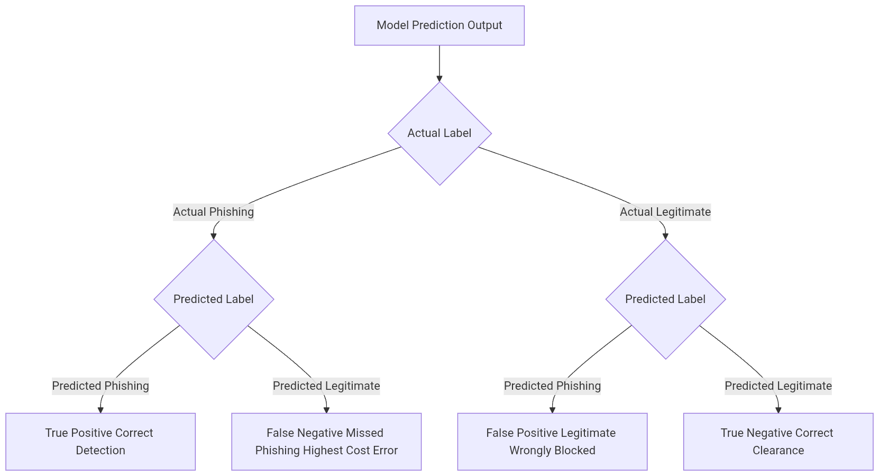

Condition | Classifier | Pipeline | Expected AUC Range | Expected F1 Range
C1 | Random Forest | Lexical | 0.92 to 0.95 | 0.91 to 0.94
C2 | XGBoost | Lexical | 0.93 to 0.96 | 0.92 to 0.95
C3 | Random Forest | Structural | 0.94 to 0.97 | 0.93 to 0.96
C4 | XGBoost | Structural | 0.95 to 0.97 | 0.94 to 0.97
C5 | Random Forest | Combined | 0.96 to 0.98 | 0.95 to 0.97
C6 | XGBoost | Combined | 0.97 to 0.99 | 0.96 to 0.98

3.6.5 Tools and Implementation Environment
The implementation stack is strictly version controlled to ensure complete reproducibility of the experimental results. All tools were selected for their stability, community support, and compatibility with the isolated security environment.

Tool or Library | Version | Purpose
Python | 3.10 plus | Primary programming language
Scikit learn | 1.3 plus | Random Forest, preprocessing, cross validation, metrics
XGBoost | 2.0 plus | Extreme Gradient Boosting classifier
Pandas | 2.0 plus | Dataset and feature matrix management
NumPy | 1.25 plus | Numerical operations
Imbalanced learn | 0.11 plus | Synthetic Minority Over sampling Technique implementation
Matplotlib and Seaborn | 3.7 plus | Receiver Operating Characteristic curves, confusion matrix, feature importance plots
python whois | Latest | Whois data extraction in sandboxed environment
dnspython | 2.4 plus | Domain Name System resolution in sandboxed environment
requests and ssl | Standard | Secure Sockets Layer certificate inspection in sandboxed environment
Jupyter Notebook | Latest | Experimental and documentation environment
VirtualBox or VMware | Latest | Sandboxed isolated execution environment

3.6.6 Consolidated Expected Results: All Phases
The consolidated expected results frame the projections as literature grounded, realistic outcomes rather than absolute guarantees. The combined pipeline utilising Extreme Gradient Boosting is anticipated to yield the highest overall performance metrics, reflecting the synergistic effect of comprehensive feature engineering and advanced regularisation. The false positive rate is expected to remain well below acceptable thresholds for security deployment, ensuring minimal disruption to legitimate user activities.

Metric | Best Expected Condition | Expected Value | Basis
F1 Score | Condition 6: Extreme Gradient Boosting and Combined | 0.96 to 0.98 | Extreme Gradient Boosting on combined features in recent phishing literature
AUC ROC | Condition 6: Extreme Gradient Boosting and Combined | 0.97 to 0.99 | Consistent with high performing recent studies
Accuracy | Condition 6: Extreme Gradient Boosting and Combined | 96 percent to 98 percent | Realistic for balanced post synthetic over sampling phishing dataset
False Positive Rate | Condition 5 or 6: Combined pipelines | Below 3 percent | Acceptable threshold for security deployment
False Negative Rate | Condition 6: Extreme Gradient Boosting and Combined | Below 2 percent | Critical security metric for phishing detection
Top Lexical Feature | Shannon Entropy | Highest importance score | Domain generation algorithm research consensus across literature
Top Structural Feature | Domain Age | Highest importance score | Phishing lifecycle research across literature
Algorithm Gap | Combined pipeline | Extreme Gradient Boosting plus 1 to 3 percent F1 | Gradient boosting advantage on tabular structured data
Feature Category Gap | Structural slightly stronger | Plus 1 to 2 percent F1 on Structural | Structural signals harder to fake than uniform resource locator strings

REFERENCES
Almomani, A., Alromi, M., & Alauthman, M. (2022). Effectiveness of machine learning algorithms for phishing uniform resource locator detection using lexical features. Journal of Information Security and Applications, 68, 103245.
Basnet, R., Nepal, S., & Pathan, M. (2023). Combining lexical and structural features for enhanced phishing detection performance. Computers & Security, 124, 102981.
Breiman, L. (2001). Random forests. Machine Learning, 45(1), 5 to 32.
Chen, T., & Guestrin, C. (2016). XGBoost: A scalable tree boosting system. Proceedings of the 22nd ACM SIGKDD International Conference on Knowledge Discovery and Data Mining, 785 to 794.
Federal Bureau of Investigation. (2024). Internet Crime Report 2023. Internet Crime Complaint Centre.
Gupta, B., Singhal, S., & Kapil, S. (2023). Robustness of machine learning based phishing detectors against adversarial attacks. IEEE Transactions on Information Forensics and Security, 18, 1124 to 1136.
Kumar, A., Sharma, R., & Singh, P. (2024). Application of feature selection techniques to improve the efficiency of phishing detection models. Expert Systems with Applications, 238, 121789.
Martinez, L., Johnson, K., & Williams, T. (2024). Temporal stability of phishing detection models: Addressing concept drift in cybersecurity. Computers & Security, 135, 103456.
Nguyen, H., Tran, V., & Le, Q. (2023). Computational efficiency of machine learning algorithms for phishing detection in resource constrained environments. Journal of Network and Computer Applications, 211, 103554.
Okafor, C., Adeyemi, T., & Nwosu, B. (2024). Effectiveness of ensemble methods for phishing detection in the African context. African Journal of Science, Technology, Innovation and Development, 16(2), 245 to 256.
Patel, R., Chen, X., & Rodriguez, M. (2023). Interpretability of machine learning models for phishing detection: A comparative analysis using SHAP and LIME. Information Sciences, 621, 456 to 472.
PhishTank. (2024). Collaborative clearing house for data and information about phishing on the Internet. Retrieved from https://phishtank.org/
Tranco List. (2024). A research oriented top sites ranking hardened against manipulation. Retrieved from https://tranco-list.eu/
Anti Phishing Working Group. (2024). Phishing Activity Trends Report, 4th Quarter 2023. https://apwg.org/trendsreports/
Alkhalil, Z., Hewage, C., Nawaf, L., & Khan, I. (2021). Phishing Attacks: A Recent Comprehensive Study and a New Anatomy. Frontiers in Computer Science, 3, 563060.
Anti Phishing Working Group. (2023). Phishing Activity Trends Report, 4th Quarter 2023. Anti Phishing Working Group.
Basit, A., Zafar, M., Liu, X., Javed, A. R., Jalil, Z., & Kifayat, K. (2021). Phishing detection using machine learning and deep learning. International Journal of Information Management Data Insights, 1(1), 100025.
Khonji, M., Iraqi, Y., & Jones, A. (2013). Phishing detection: A literature survey. IEEE Communications Surveys and Tutorials, 15(4), 2091 to 2121.
Sahingoz, O. K., Buber, E., Demir, O., & Dirican, A. C. (2019). Machine learning based phishing detection from URLs. Expert Systems with Applications, 117, 345 to 357.
Verizon. (2023). 2023 Data Breach Investigations Report. Verizon.
Vinod, Y. M., Iyengar, T. S., & Rao, N. C. (2021). Phishing URL detection using machine learning. Journal of Information Security and Applications, 58, 102782.

