Fall 2008
Lab Assignment L1: Defusing a Binary Bomb
qbyan (072021029@fudan.edu.cn) is the lead person and bomb squad chief for this lab.

1. Introduction
The nefarious boy qbyan has planted a slew of “binary bombs” on our machines. A binary bomb is a program that consists of a sequence of phases. Each phase expects you to type a particular string on stdin. If you type the correct string, then the phase is defused and the bomb proceeds to the next phase. Otherwise, the bomb explodes by printing "BOOM!!!" and then terminating. The bomb is defused when every phase has been defused.

Step 1: Login the Server
Each student will attempt to defuse their own personalized bomb. Each bomb is a Linux binary executable file that has been compiled from a C program. Everyone has an account on our Server, the address is 10.92.13.8, and username is stu+ your student number (ex:stu06300720001), the default password is csapp. You can get the access with putty. Remember to change your password when you login the server.
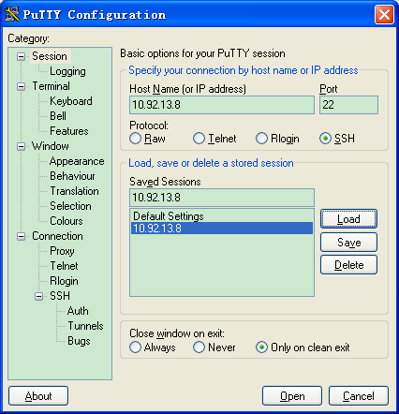

When login the server, you can see bomb(ID).tar, where is the unique number of your bomb. Then give the command:

tar xvf bomb(ID).tar. (just like tar xvf bomb1.tar)

This will create a directory called ./bombIDwith the following files:
- README: Identifies the bomb and its owners.
- bomb: The executable binary bomb.
- bomb.c: Source file with the bomb’s main routine.

Remember，you can only defuse the bombs on this server, if you copy the tar to other PCs, binary bomb will not be executable!!!

Step 2: Defuse Your Bomb
Your job is to defuse the bomb.
You can use many tools to help you with this; please look at the hints section for some tips and ideas. The best way is to use your favorite debugger to step through the disassembled binary.
Each time your bomb explodes it notifies the staff, and you lose 1/4 point (up to a max of 10 points) in the final score for the lab. So there are consequences to exploding the bomb. You must be careful!
Each phase is worth 10 points, for a total of 60 points.
The phases get progressively harder to defuse, but the expertise you gain as you move from phase to phase should offset this difficulty. However, the last phase will challenge even the best students, so please don’t wait until the last minute to start.
The bomb ignores blank input lines. If you run your bomb with a command line argument, for example,

linux> ./bomb psol.txt

then it will read the input lines from psol.txt until it reaches EOF (end of file), and then switch over to stdin. In a moment of weakness, qbyan added this feature so you don’t have to keep retyping the solutions to phases you have already defused.
To avoid accidently detonating the bomb, you will need to learn how to single-step through the assembly code and how to set breakpoints. You will also need to learn how to inspect both the registers and the memory states. One of the nice side-effects of doing the lab is that you will get very good at using a debugger. This is a crucial skill that will pay big dividends for the rest of your career.

Hand-In
There is no explicit hand-in. The bomb will notify your instructor automatically after you have successfully defused it. Any clarifications and revisions to the assignment will be posted on the class board and Web page. You can keep track of how you (and the other student) is doing by looking at bombfinal.html. You can view the page with method below:

linux> cd ..
linux> lynx /home/bomb/www/CSAPP2008.html

This web page is updated continuously to show the progress of each student.

Hints (Pleasereadthis!)
There are many ways of defusing your bomb. You can examine it in great detail without ever running the program, and figure out exactly what it does. This is a useful technique, but it not always easy to do. You can also run it under a debugger, watch what it does step by step, and use this information to defuse it. This is probably the fastest way of defusing it.
We do make one request, please do not use brute force! You could write a program that will try every possible key to find the right one. But this is no good for several reasons:
- You lose 1/4 point (up to a max of 10 points) every time you guess incorrectly and the bomb explodes.
- Every time you guess wrong, a message is sent to the staff. You could very quickly saturate the network with these messages, and cause the system administrators to revoke your computer access.
- We haven’t told you how long the strings are, nor have we told you what characters are in them. Even if you made the (wrong) assumptions that they all are less than 80 characters long and only contain letters, then you will have guesses for each phase. This will take a very long time to run, and you will not get the answer before the assignment is due.
There are many tools which are designed to help you figure out both how programs work, and what is wrong when they don’t work. Here is a list of some of the tools you may find useful in analyzing your bomb, and hints on how to use them.

- gdb
The GNU debugger, this is a command line debugger tool available on virtually every platform. You can trace through a program line by line, examine memory and registers, look at both the source code and assembly code (we are not giving you the source code for most of your bomb), set break points, set memory watch points, and write scripts. Here are some tips for using gdb.
- To keep the bomb from blowing up every time you type in a wrong input, you’ll want to learn how to set breakpoints.
- For other documentation, type “help” at the gdb command prompt, or type “man gdb”, or“info gdb” at a Unix prompt. Some people also like to run gdb under gdb-mode in emacs.

    - objdump -t
This will print out the bomb’s symbol table. The symbol table includes the names of all functions and global variables in the bomb, the names of all the functions the bomb calls, and their addresses. You may learn something by looking at the function names!

    - objdump -d
Use this to disassemble all of the code in the bomb. You can also just look at individual functions. Reading the assembler code can tell you how the bomb works.
Although objdump -d gives you a lot of information, it doesn’t tell you the whole story. Calls to system-level functions are displayed in a cryptic form. For example, a call to sscanf might appear as:

8048c36: e8 99 fc ff ff call 80488d4 <_init+0x1a0>

To determine that the call was to sscanf, you would need to disassemble within gdb.

    - strings
This utility will display the printable strings in your bomb.

Looking for a particular tool? How about documentation? Don’t forget, the commands apropos and man are your friends. In particular, man ascii might come in useful. Also, the web may also be a treasure trove of information. If you get stumped, feel free to ask your TA for help.

