PROJECT QUOTATION

Project Name: Lithin Transport Billing Software

Scope of Work

- Development of Invoice module.
- Development of LR (Lorry Receipt) module.
- Development of Quotation module.
- This quotation covers only the modules and requirements specifically discussed and approved by the client.
- Any new feature, enhancement, or change request after approval will be treated as additional work and will incur extra charges.
- After delivery, any bugs or errors related to the approved requirements will be supported free of charge for 30 days.

Project Budget
Description | Amount
Online Software Development | ₹9,500

Note: This quotation is valid only for the agreed scope mentioned above.



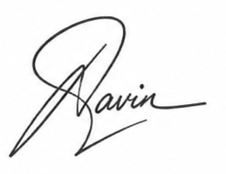

Authorized Signature

