PROJECT QUOTATION


Project Name: Lithin Transport Website

Scope of Work
The proposed solution includes the development and deployment of the official Lithin Transport Billing Software Website with the following services:
- Website Design & Development.
- Responsive website compatible with Desktop and Mobile devices.
- Domain registration: lithintransport.in
- Domain purchase and configuration.
- Web hosting setup and deployment.
- Business email setup with the company domain.
- SSL Certificate (HTTPS) configuration for secure website access.

Domain Information
- The proposed domain name is lithintransport.in, as it is the most suitable and professional domain for the business.
- The .in domain is recommended because it provides better branding, credibility, and recognition for businesses operating in India.
- Alternative domain extensions such as .com, .online, .site, .shop, etc., may have lower first-year pricing but generally have significantly higher renewal charges and are less preferred for professional businesses.
- If the client wishes to use a different domain name, it must be confirmed before the domain purchase.
- Once the domain has been purchased and registered, it cannot be changed or replaced, as domain registrations are non-refundable and permanently assigned.

Business Email
The quotation includes 3 professional business email mailboxes using the company domain.
Examples:
- info@lithintransport.in
- admin@lithintransport.in
- support@lithintransport.in

No additional charges will be collected for creating or configuring these business email accounts.


Project Timeline
- Estimated Development Duration: 2 Weeks
- Deployment & Go-Live: Within the same development period after successful testing.
- Maximum Delivery Timeline: The complete website will be delivered within 3 weeks from the date of advance payment confirmation, subject to timely client approvals and content availability.

Support & Maintenance
- Free support for 30 days after project delivery for any bugs or issues related to the approved requirements.
- Lifetime free assistance for domain renewal and purchase whenever required (domain renewal charges will be paid by the client).
- If the domain expires in the future, we will assist with the renewal process at no service charge.
- A free offline version of the Billing Software will be provided at no additional development cost (as discussed).

Payment Details
Description | Amount (₹)
Website Design & Development | ₹13,500
Domain Registration (lithintransport.in) – 1 Year (Including Taxes) | ₹1,800
Hosting Charges | ₹600
Business Email Setup (3 Mailboxes) – 1 Year (Including Taxes) | ₹1,650
Grand Total | ₹17,550

Terms & Conditions
- This quotation covers only the scope of work mentioned above.
- Any additional features, design modifications, integrations, or change requests requested after project approval will be considered additional work and will be charged separately.

- Domain registration charges are payable only once at the time of purchase. Renewal charges in future years will be the responsibility of the client.
- Hosting and business email renewal charges after the subscribed period will be payable by the client as per the service provider's pricings.

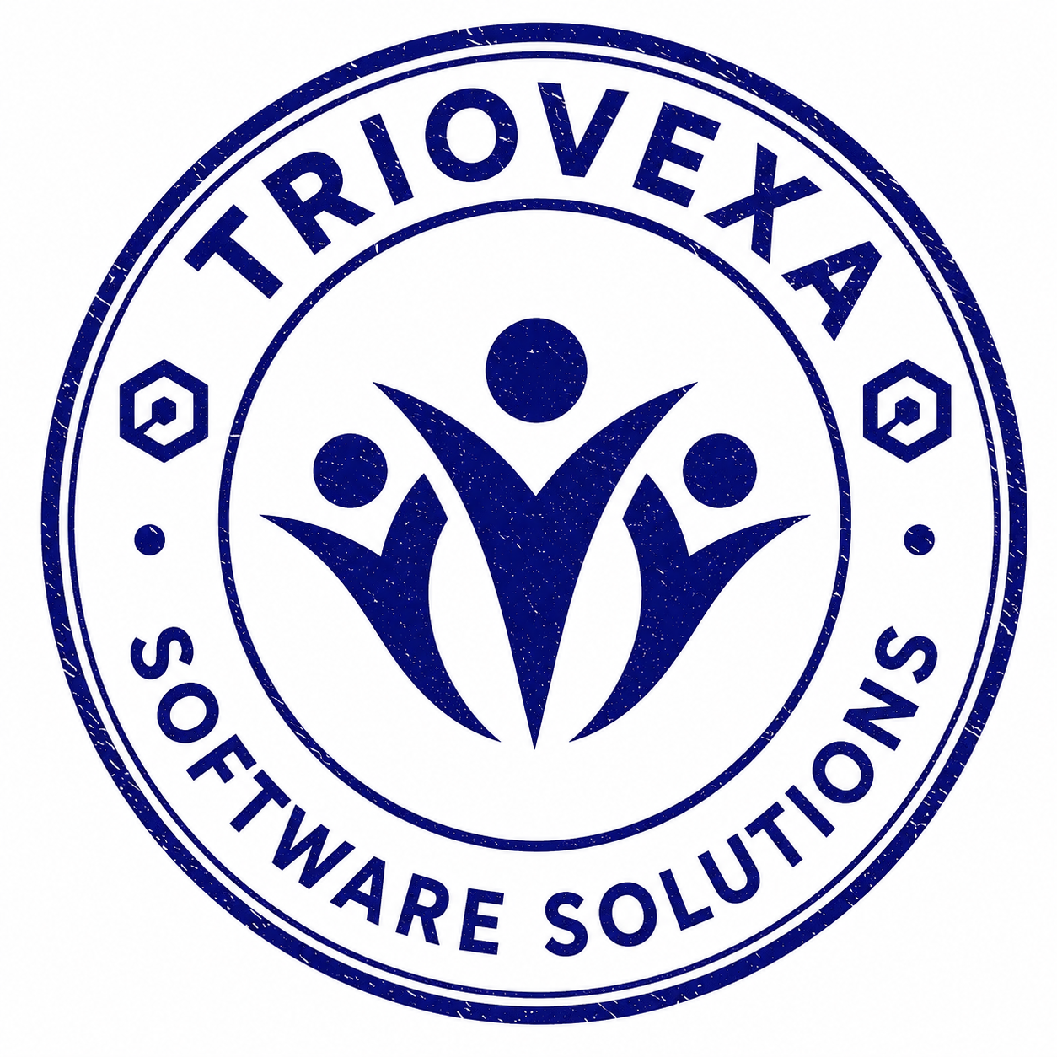

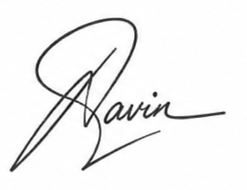

Authorized Signature

