Galapagos Islands
A place, everybody knows and dreams of to see... We did too. However realizing this dream is quite expensive, therefore we were thinking about it for a long time whether we should do it now. Considering that we had no real Christmas gifts, we thought this would be a good way to make up for it, so we did it. It also has to be added that we got a pretty good last minute offer... In total we spent 7 days on the Islands, 3 on our own in Puerto Ayora, on Santa Cruz Island and 4 days on a cruise.

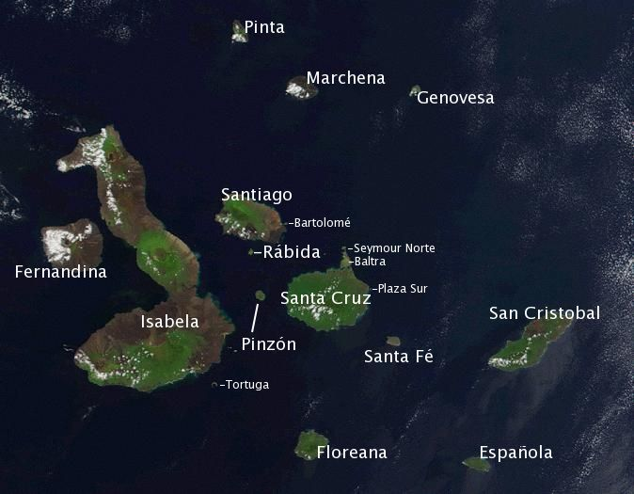
We started our trip from Guayaquil, Ecuador's largest city. All the flights to Galapagos go through Guayaquil, even the ones starting from Quito, the capital. We took an early morning flight at 8, but strangely we had to be at the airport 2 hours before departure, as if it had been a long distance international flight, not a domestic one. It turned out that getting to the Islands is not that easy, but the regulation of entry are almost as strict as to Australia. First you have to get your bags checked with the National Park, so they can disinfect them or something by radiation. Then you have to pay 10 USD as some sort of a tax of entry, and you get a nice plastic INGALA Migration Card. Only after all this may you check in.
Unfortunately, the sky was cloudy so we did not see much from the air, although the view of the islands must had been impressive. We only saw Baltra, a small island to the north of the main inhabited island Santa Cruz, where the airport is located (there is an other one on San Cristobal). Baltra was used as a military base during the Second World War, and due to the human activity hardly any native animals remained, including the land iguanas. The latter were reintroduced, so there is now a small population of about 100 animals. The landscape surprised me quite much, because it was very dry with little vegetation. As it turned out this is not a rare view on the islands. Interestingly, the amount of precipitation varies greatly between the islands, but also within one island. On Santa Cruz, for example the middle area which are called the Highlands (highest point is 826m) are very green with lush vegetation. On the other hand, the coastal areas are quite dry. It is quite similar to the mainland area of South America, where on the cost there is desert due to the cold Humboldt current, but in the mountains it is quite rainy.
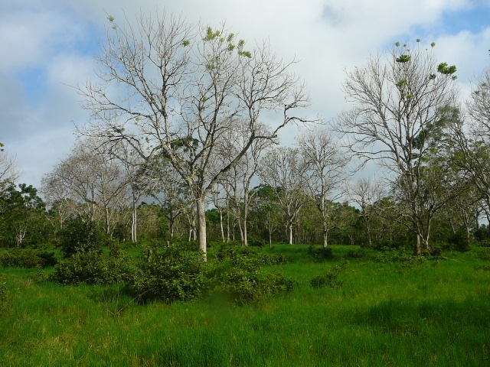Highlands on Santa Cruz
So we arrived and lined up for quite a long time at the immigration, even our carry-on-bags where checked again. No idea why it was necessary, because it is still part of Ecuador. Is it simply because otherwise if they only make you pay the 100 USD National Park fee, it might appear that they are not doing anything else but collecting money? Anyhow, the amount of money the NP is collecting must make a little fortune, considering that every day there are two incoming flights to Baltra, each of them flying in ca. 100 tourists. Where does it all go to?! Interestingly at the airport the tourist information did not even speak English...
After we were through with the bureaucracy, we got a free shuttle bus ride to a ferry which shipped us over through a narrow channel to Santa Cruz Island. There we took a bus to Puerto Ayora, the largest town on the archipelago. There was no tourist information in town, which is quite weird considering that this is THE tourist attraction in Ecuador... Later it turned out that there was an office... about 3 km out of town, in an area where there was nothing and therefore hardly any tourist would pass by... We did pass by, but only by accident when we were looking for some lava tunnels and we were glad we did, because it was there, next to the main road where we saw our first giant tortoises!! They were just grazing around, so casually... So cool!!
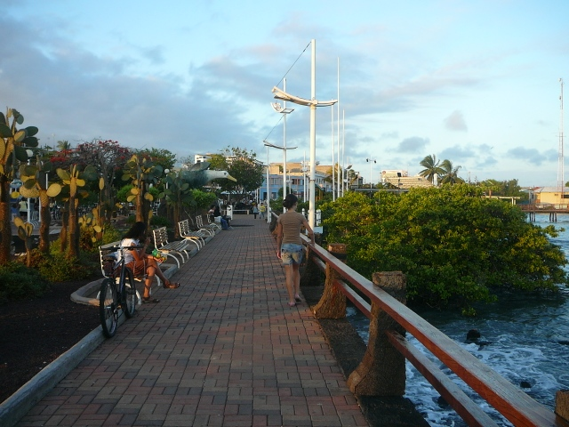Port in Puerto Ayora
Around Puerto Ayora there are quite a few things one can do on his/her own. The first thing is just to sit around in the port: one can observe quite a few bird species (boobies, frigatebirds, pelicans), marine iguanas in and out of the water, colorful crabs (sally light-footed crabs with red bodies and blue claws), sea lions hunting and playing among the boats...
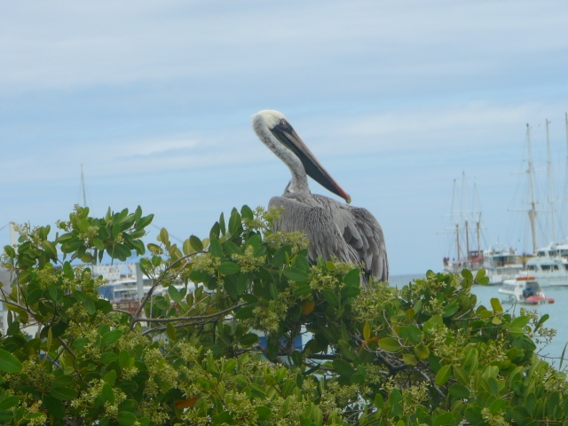Brown pelican in the port
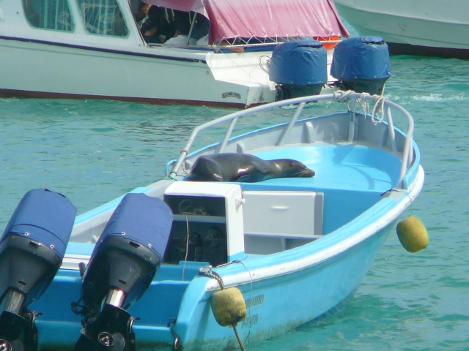Sea lion in a boat in the port

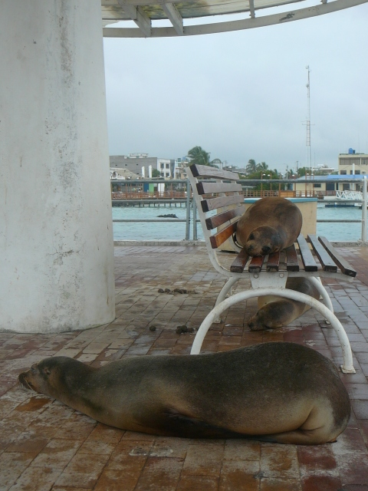Sea lions in the port
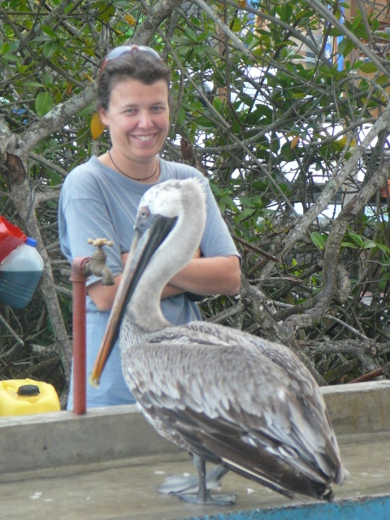Brown pelican in Puerto Ayora
The most amazing place close to town is Tortuga Bay. It is a mostly sandy beach, located about 45 minute walk away from town. There is a prepared road, made of small rocks, so it is not possible to get lost and it is not possible to leave the path either because there are huge, seemingly impenetrable cactus forests along the way. They also make the walk quite interesting, because on some of them there are bird nests, some of them are rotting away, leaving only a strange fiber structure behind and some of them are real giants. Between them one can spot lava lizards quite frequently.
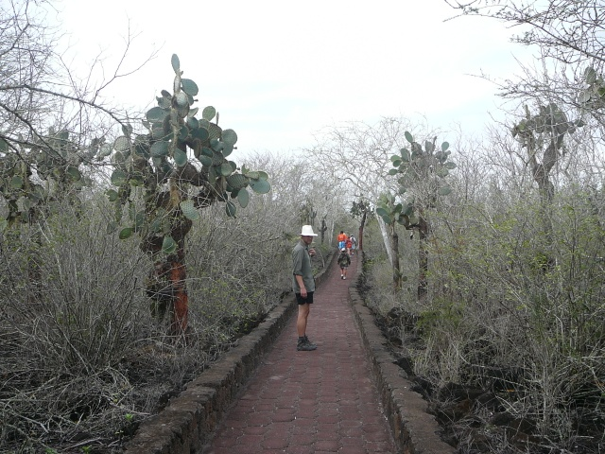Walkway to Tortuga Bay
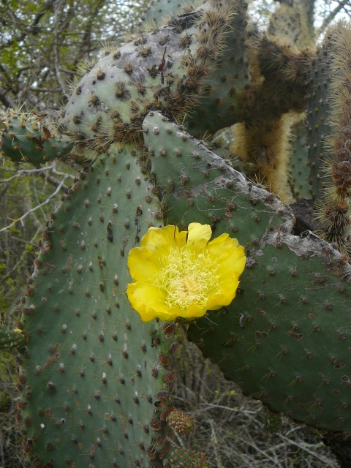
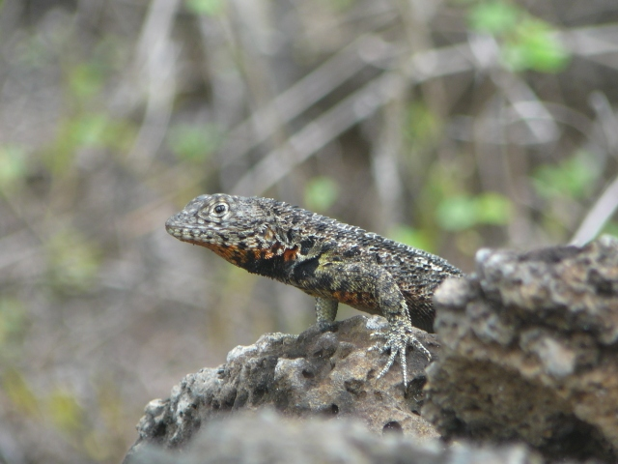Lava lizard

Probably the first thing one notices on the beach are the marine iguanas, either their traces or the sunbathing animals themselves.
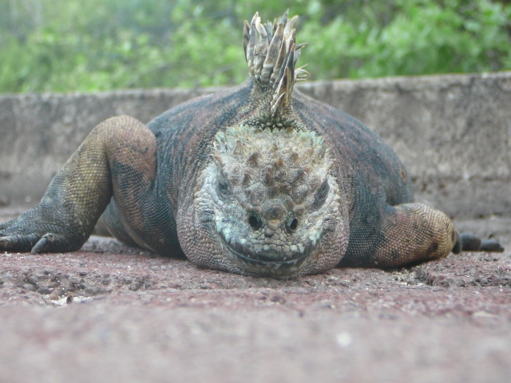
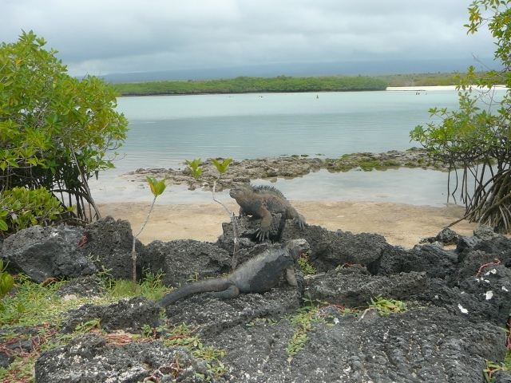
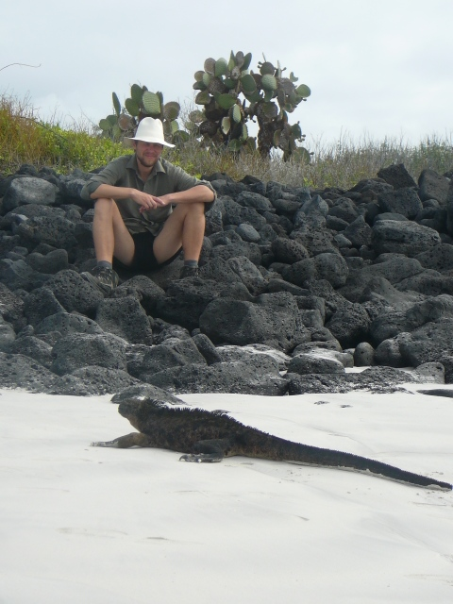
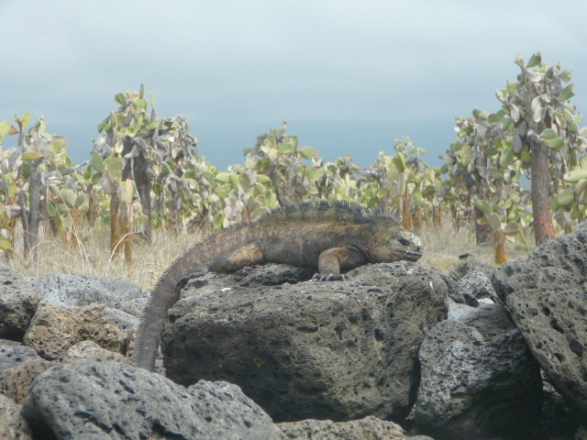
However, the joy of the first spotting is soon overtaken by the overwhelming sight of hundreds of these animals laying around in each others close proximity on the rocky beach a few hundred meters further away. They are really amazing creatures, with their dragon-like appearance and large spikes along their spine. As they are not afraid of humans, one can observe them from very close, as some of the huge males are threatening each other by vigorous head nodding and even fighting each other, while the smaller and darker females do not let themselves be bothered by the show the males put up. Nevertheless, when one gets really close they start sneezing as a kind of a warning (normally they do that on a regular basis anyhow, because this is how they get rid of the salt in their body) and only if one almost steps on them, do they run away. It might actually happen because the almost black females are very well camouflaged on the black lava rocks.
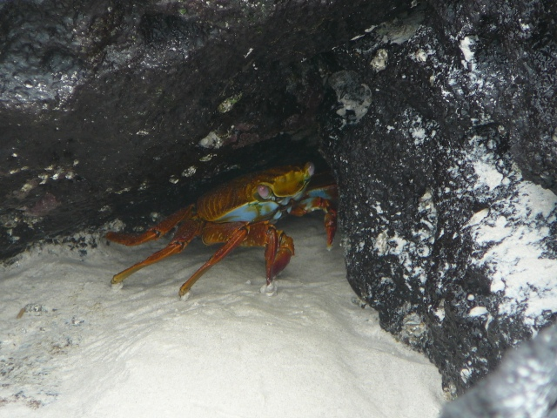Sally light-footed crab
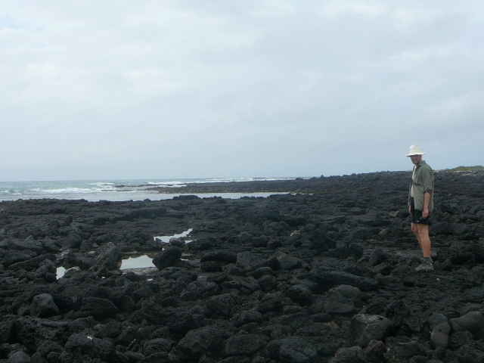Black lava rock in Turtuga Bay
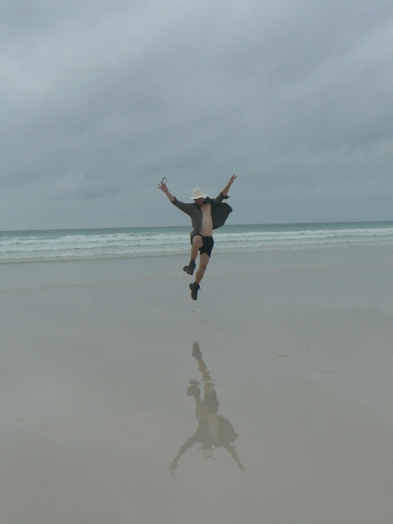Reflections on the beach in Tortuga Bay

Besides the iguanas, the other very interesting thing on that stretch of beach are the very clear reflections on the wet sand. Taking funny pictures here compensates for the lack of swimming possibility (the currents are too dangerous).
Further away in a small bay it is possible to swim, or rather just to cool down in the water, because it is way too shallow for a real swim. But on the shore a few blue-footed boobies, magnificent frigatebirds and a few Darwin finches can be observed.

An other attraction is just 10 minute walk away from town: the headquarter of the Charles Darwin research station which does all the scientific work on the Islands. Their info booth is not very interesting, but here one can visit the breeding station of the giant tortoises and even walk into their enclosures. There are also many baby tortoises visible. The aim of this project is to maintain and to increase the population of the several different giant tortoise species which decreased due to human influence. On one Island (Pinta) for example the indigenous tortoise species has only one single survivor: a male called Lonesome George.
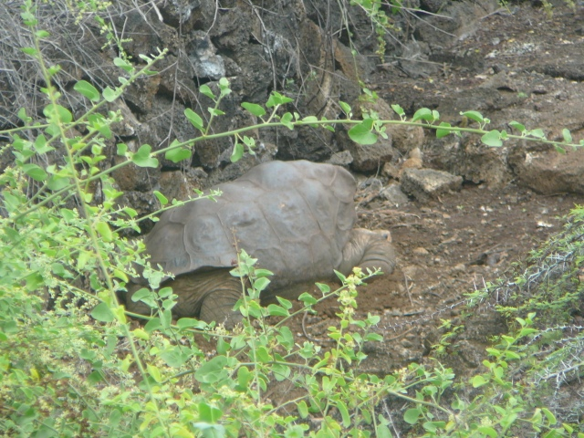Lonesome George
Because no other individual of the same species exists, the scientists decided to try to pair him with females of an other closely relates species, which lives on a neighboring island. However, so far they could not produce viable offspring. It is an other question whether such breeding program really makes sense, because the result would only be an artificial hybrid and whether further severe inbreeding is really healthy??? The research station has a breeding program for land iguanas as well, but one can only see 3 or 4 of these animals in different enclosures. They give a strange impression with their yellow colors.
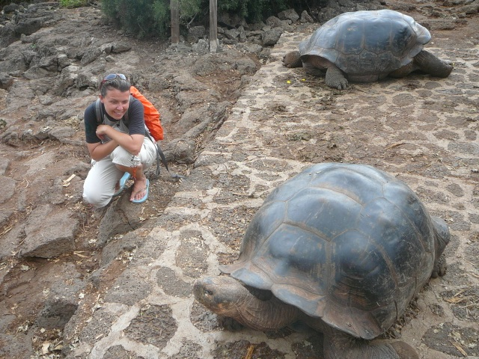Watching peaceful giants in the Charles Darwin station
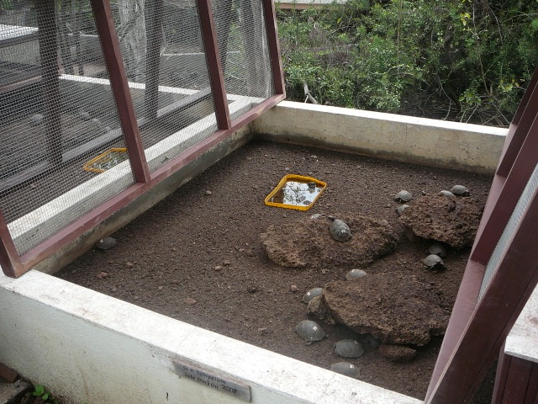Tortoise nursery

In the town itself there is not much to do. It is very touristy, full of souvenir shops, travel agencies and restaurants. One may hang out at the port to watch wildlife and in the evening to watch humanlife, as this is the time point when the town gets a bit more active. At the port there is free wireless as well and during the day there are sometimes volleyball games at the entrance to the port. Close to town there are a few short lava tunnels as well, but tourists do not go there often, because during their visits to the highlands in their tour package they are shown much bigger and longer ones. These are basically volcanic caves, which were created after an eruption, when the hot lava kept on flowing under the already cooled down surface.
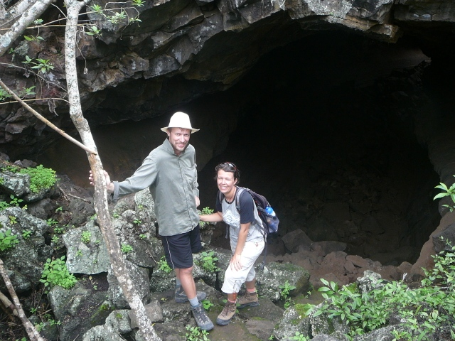At a lava tunel

On our last free afternoon we wanted to visit a volcanic gorge that is filled with both salt and fresh water. Interestingly the different waters do not mix here, but the saltwater that is filtered through the rocks from the sea remains on the bottom and the freshwater (originating from creeks and rain) stays on the top. To get there we took a boat to the other side of the bay in the port of Puerto Ayora and walked for half an hour through a dry landscape with cacti and bushes. We passed by an area where the locals are producing salt from the seawater by making it evaporate in a shallow pond. The gorge was quite spectacular with the highlight being the local guys jumping into the water from the top of the rocks.
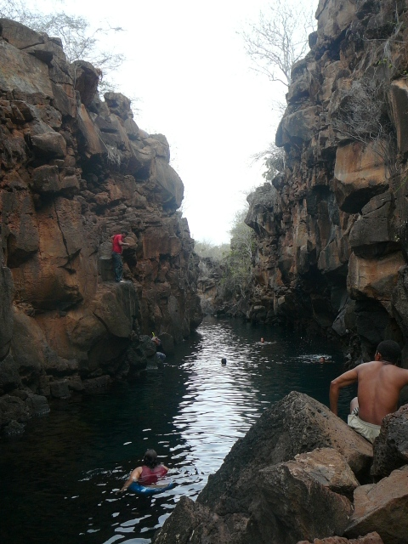Volcanic gorge

On our forth day we started our organized tour with the boat Flamingo. It is probably one of the smallest tourist boats and can only take 8 people. As the whole boat itself, the rooms were also very claustrophobic, with a bunk bed for 2 people and a small bathroom. Other boats have up to a few hundred tourists. The boat traffic is very strictly regulated. It is only possible to visit the Islands with licensed boats which all get their route determined by the National Park. They set the rules when the tourists may get to the shore and who may accompany them (only the tour guide usually, the rest of the crew may only enter land at very few areas). As there are only a few sites where tourists may get to shore, sometimes the boats literally line up at these areas and wait until they may enter the island. Between each landing there must be at least a 20 minutes time difference and it is also regulated how close the different groups may approach each other. On the Islands there are prepared trails one has to follow and it is not allowed to touch or disturb the animals. If a company breaks these rules, it means that their lose their license. Furthermore, it may have consequences for the whole tourist industry. We were told that for example in the Turtle Cove a guide once captured a turtle to show it to the tourists and the authorities found out about it. Because of this incidence they banned snorkeling at this site, even though it must be an amazing place since the turtles come here to mate and sharks and rays use the area as a kindergarten for the offspring.
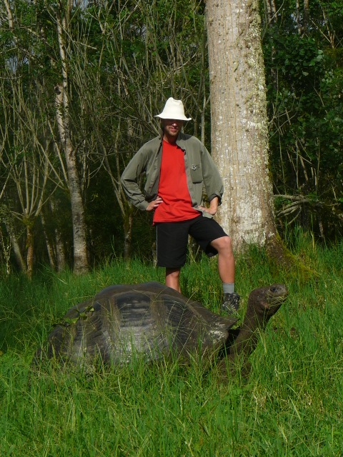Giant tortoise on a farm in the Highlands of Santa Cruz
Our tour covered a relatively short sailing around the Rabida, Bartolome, Santiago and Santa Cruz Islands. We started with a bus trip to the Highlands of Santa Cruz, which is basically the center area. It is the main farming area on Galapagos, where one sees many cows grazing. The main attraction here is the giant tortoises which are grazing along the cows. The farmers have to build their fences in a way that the tortoises can cross underneath them, so their movements would not be limited. We visited such a private farm and could observe many tortoises. It was really fascinating to walk around and spot such a giant creature munching on grass in almost every bush. Surprisingly they were very shy, unlike the other wild animals we have encountered on the island and pulled back their heads into their shells quickly when we approached them and gave a loud hissing sound.
On the same farm there was a large lava tunnel which is basically a volcanic cave and we could walk through it. We could also try how claustrophobic the tortoises might feel in their shells by crawling into the remains of a large tortoise.
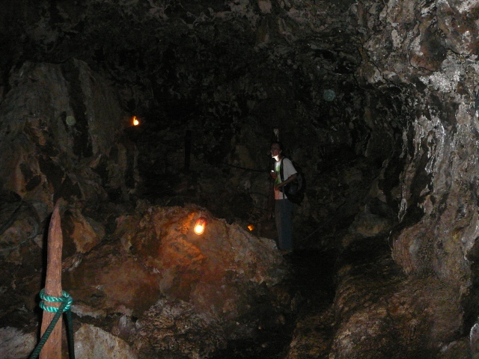Lava Tunel
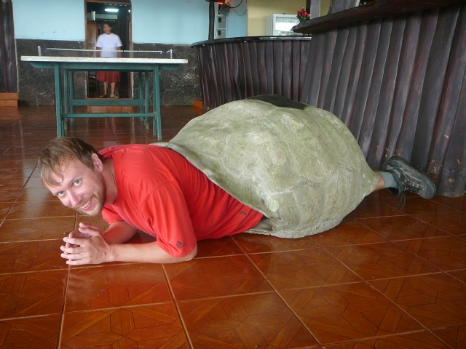Kaarel kilpkonn
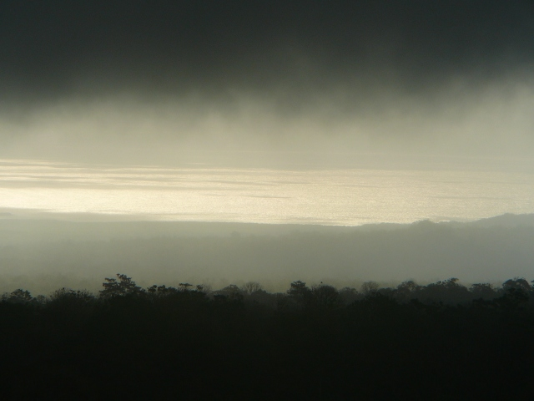Foggy view to the sea
After the visit we drove back to Puerto Ayora, got back on the boat and sailed during the night to Rabida Island. It is a very small island, famous for its red sand that has its color from its iron content. Mostly sea lions inhabit the island. They used to occupy only the sandy beaches and flamingos used to wade in a small salty lake close to the beach. However, since the authorities cut a path into the bushes which separate the lake and the beach from each other, the sea lions found a new playground and invaded the lake. The sea lions used these waters as a toilet which stunk to the flamingos (the amount of the algae and crabs the flamingos feed on in the lake decreased), so they abandoned the lake. Here we walked around among the sea lions who did not show interest in us whatsoever and did not move at all when we approached them. The babies however were very curious and approached us so much that we had to move out of their way. They were sooo cute and one would have wanted just to hug them and play with them. But of course this cannot be done, not only because of the rules of the authorities, but also because they would be abandoned by the mother if she can smell the human touch (so were we told). On the shore we found many sea stars that were probably taken out of the sea by the sea lions who like to play with them. Otherwise the island itself was not that interesting, the landscape was similar to the one on the coastal areas of Santa Cruz: many cacti, leafless trees, dry land. There are no large breeding colonies of birds here, either. The water on the other hand was full of colorful fish and it was fun to snorkel.
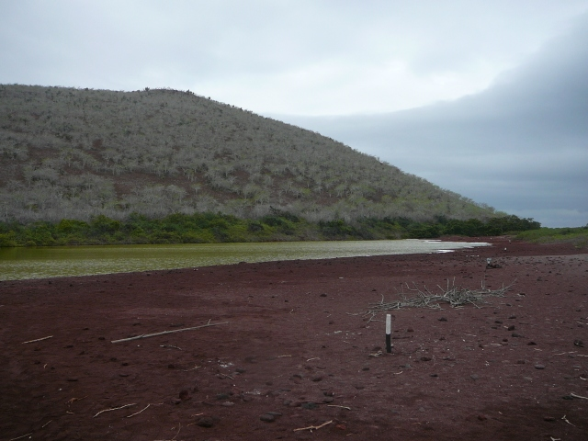Red sand beach on Rabida
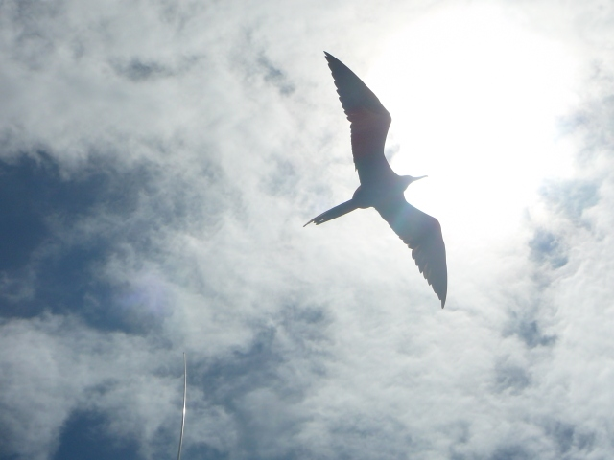Magnificent frigate bird

Our next stop was in Puerto Egas, on the western coast of Santiago Island, that was just a few hours away by boat. Here one may walk along the coast and snorkel on the beach. For people who did not go to Tortuga Bay, this is the first encounter with black lava rocks and marine iguanas and the colorful crabs. We saw a few fishing birds and sea lions as well. Because of the presence of the latter, snorkeling was a bit stressful, because there was a huge dominant male on the beach. An encounter with him in the water may end up quite nasty and it would not be him who would get hurt.

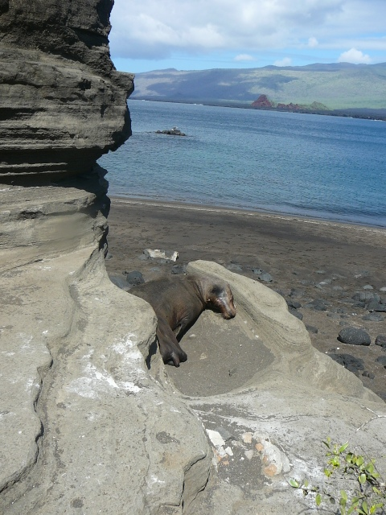Sea lion at Puerto Egas
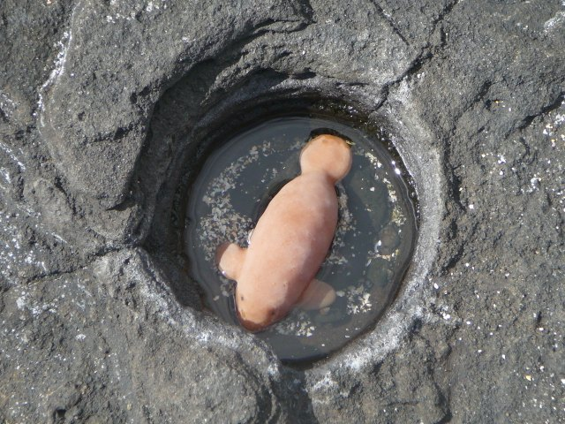Galapagos manatee or introduced species?
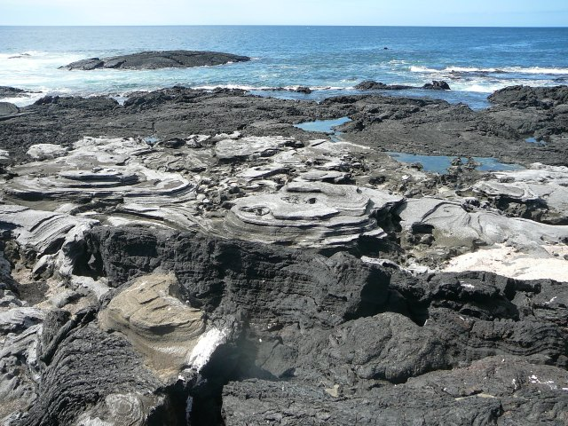Black lava at Puerto Egas

On the third day we reached Bartolome Island, located at the eastern side of Santiago Island. This is the place where most of the postcard pictures are taken of its two bays and the pinnacle rock. The island is really small and the tourists may walk on prepared boardwalks only. It consist of a cone of an extinct volcano and many secondary craters, through which gas and lava erupted many many years ago. Hardly anything grows here other than a few lava cacti, but the rocks have many colors, ranging from red to yellow.
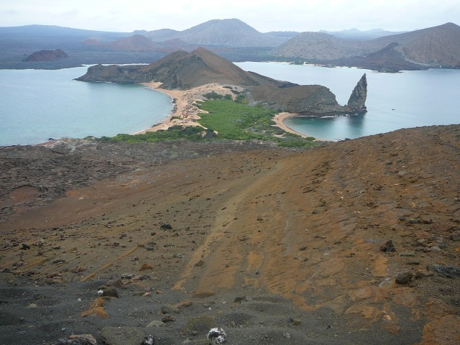Bartolome with the pinnacle rock
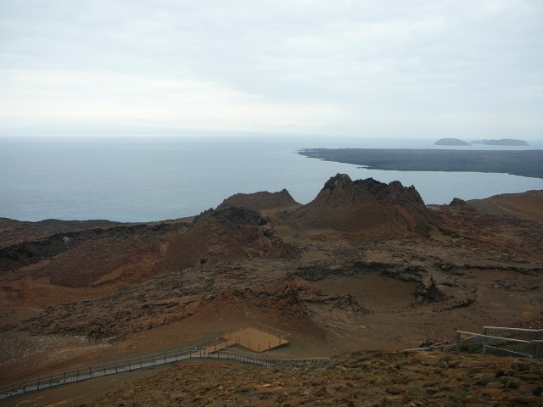Secondary cone on Bartolome
The highlight again was the snorkeling. We took a small boat to the opposite side of the island where the big boat was anchored and snorkeled back all the way. It took us 1.5 hours and we saw lots of animals!! Sometimes Galapagos penguins darted by, sometimes white-tipped reef sharks circled around us (at one point we counted 14 of them!!), at other times sea lions were swimming with us, blowing bubbles around us... We even saw a huge ray!! It was really amazing!!! However our next snorkeling in Sullivan Bay just across from Bartolome on Santiago Island was just as amazing. Besides these animals, we spotted several sea turtles and could follow them for quite a long time, observing their graceful flight through the waters... They come to this Bay to lay their eggs and we saw their traces on the beach in the sand, so probably there were quite a few nests there.
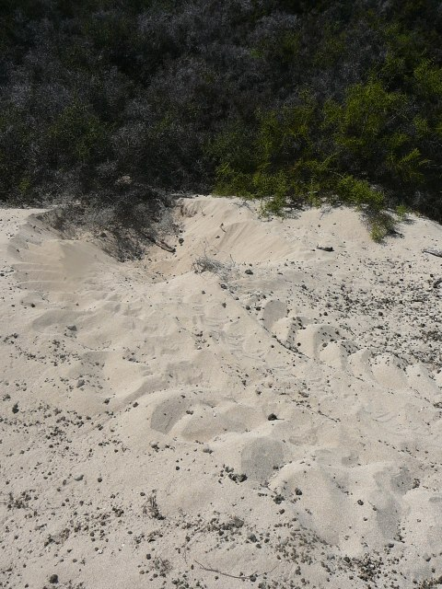Turtle nest, Sullivan Bay
The sandy area was quite small though, because after a recent eruption a lot of black lava covered up the coast. It left very weird formations behind and it was quite fun to walk on it and look for interesting shapes. This lava field was created after an eruption 125 years ago, so Darwin, who was exactly in this Bay some 180 years ago, saw a completely different landscape.
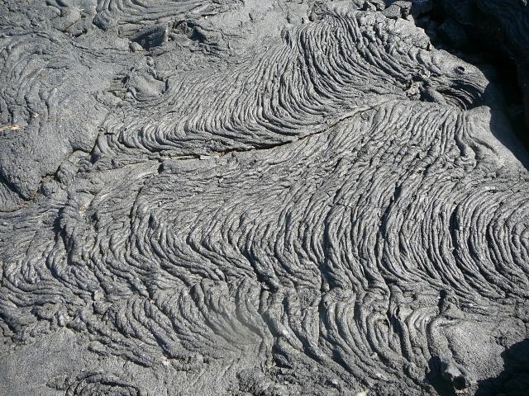Lava formation in Sullivan Bay
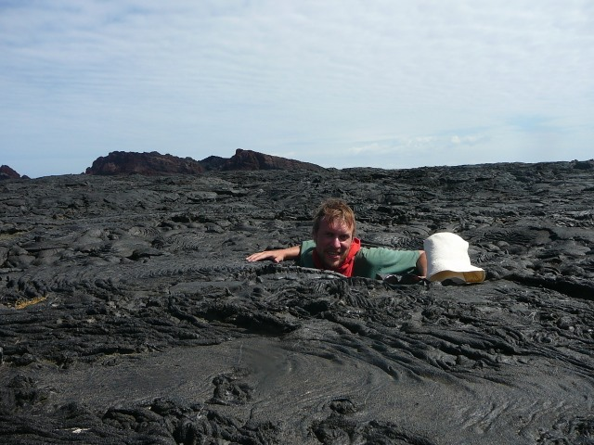Swallowed by the lava, Sullivan Bay

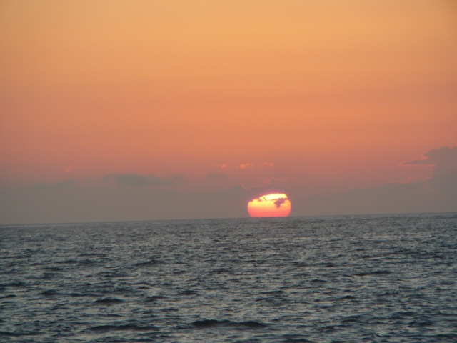Sunset on the sea
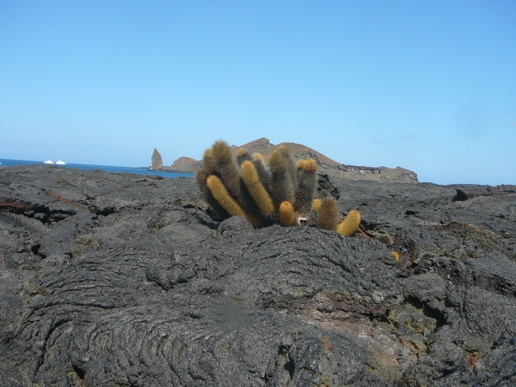Illustration 1: Lava Cactus in Sullivan Bay with Bartolome in the background
On our last day we visited the Black Turtle Cove, on the northern part of Santa Cruz Island, close to the airport. It is covered with mangrove that provides an ideal spot for sea turtles to mate and for shark and ray babies to grow up. So what we saw was mating sea turtles and shark and ray babies swimming around. This was a very memorable ending of our tour. A few hours later we were sitting on the plane back to Guayaquil...
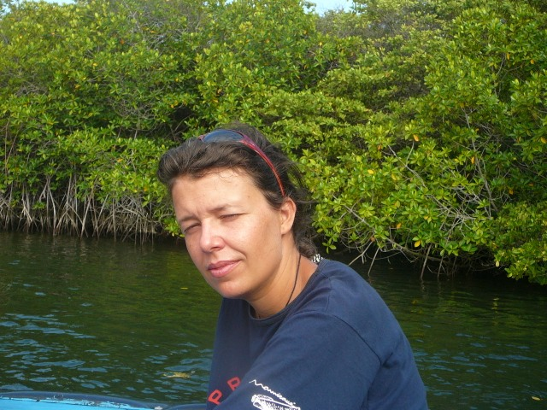Mangrove in Black Turtle Cove
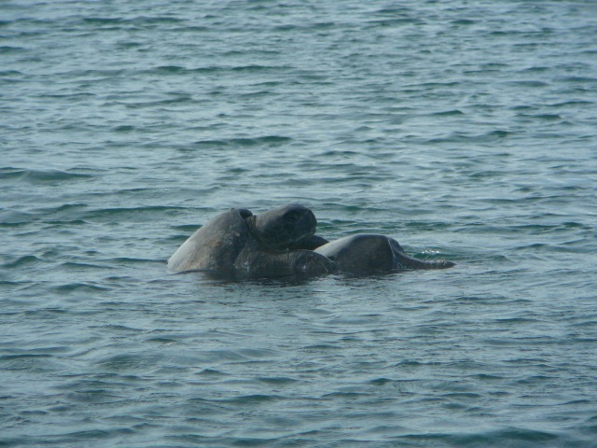Mating black turtles in Black Turtle Cove
To sum up, we had a great time on the Galapagos Islands. We encountered the unique wildlife, had a lot of surprises and amazing experiences, particularly during snorkeling. We chose a boat trip that covered a relatively small area and was, most of all about snorkeling. I think it was a great choice in January, because most of the large bird colonies that I would have wanted to see are deserted in this season e.g. that of the albatrosses and are located on the further Islands.

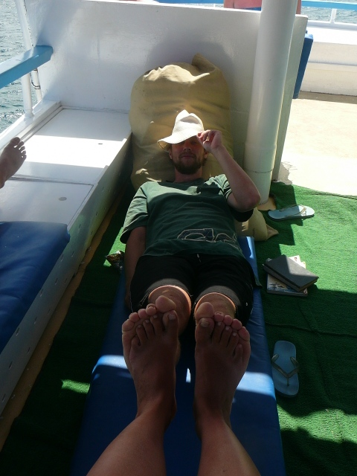Relaxing on the boat

