**Monitoring**

* Virtual Machine
  1. **CPU**:

CPU consumption of VM, ordered by various process running.

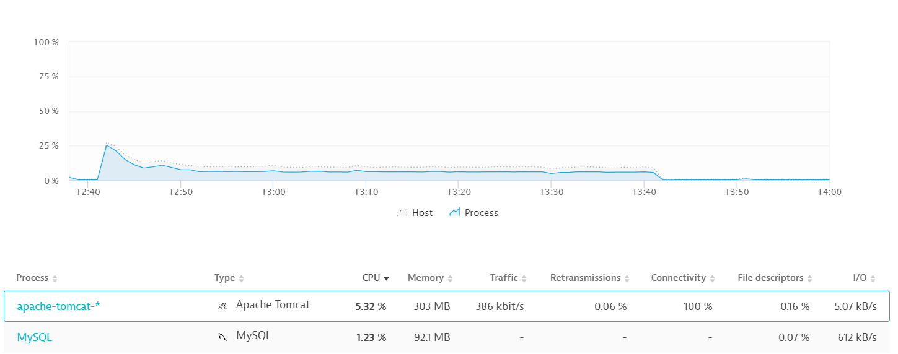

* 1. **Memory**:
     + 1. Memory usage of VM, based on processes.
       2. Total Memory
       3. Used Memory

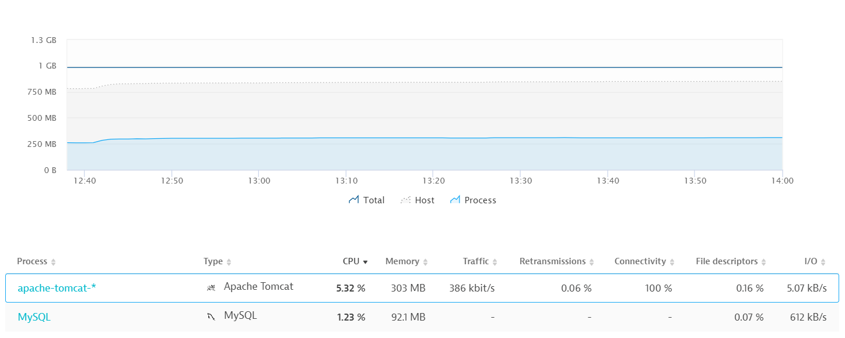

* 1. NW Traffic:

To determine how much traffic handled by VM

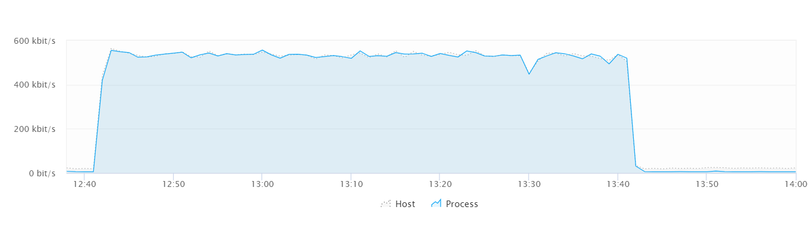

* 1. IO

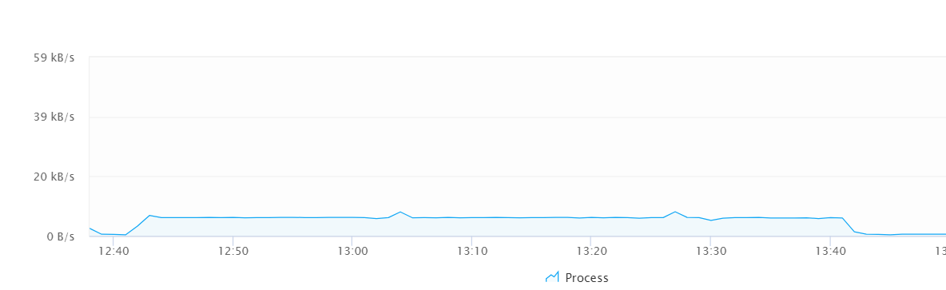

* Apache Tomcat process
  1. JVM
     + 1. Heap Usage
       2. Garbage collections

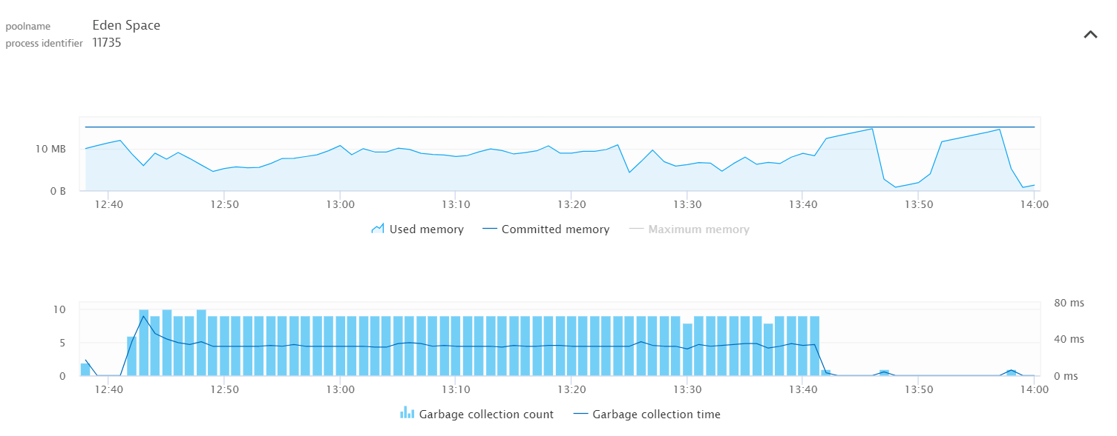

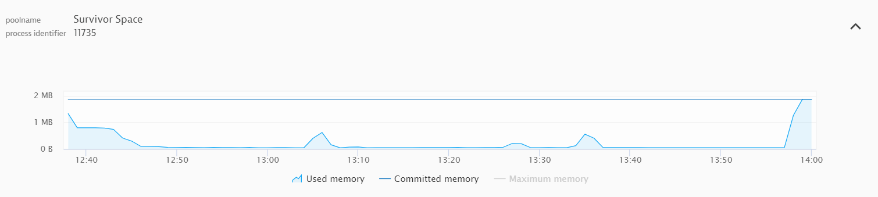

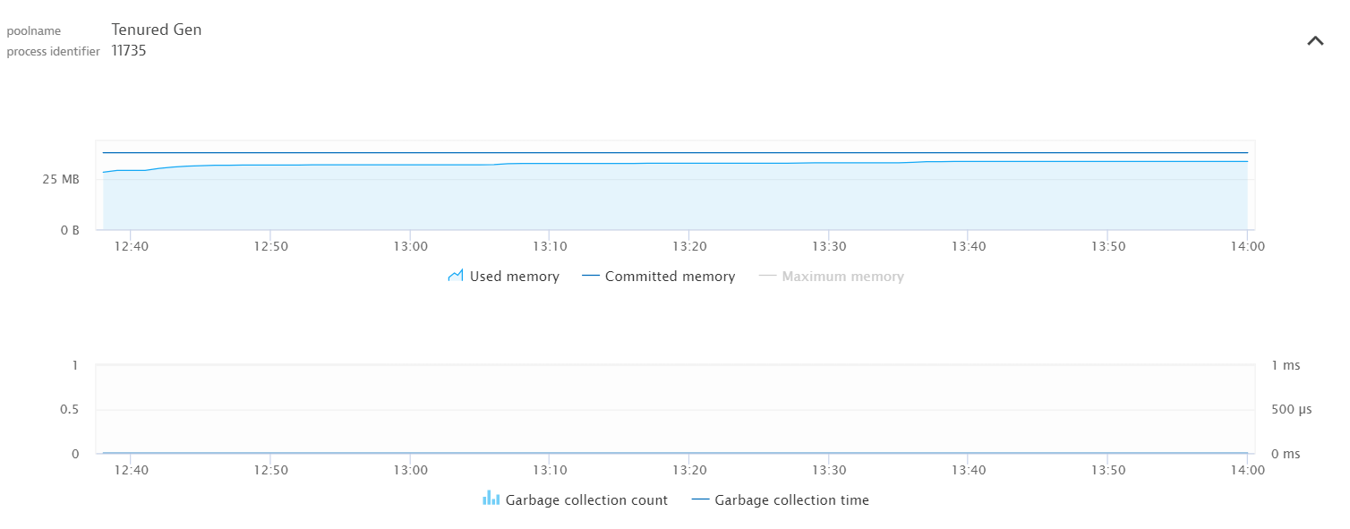

* 1. Memory:
     + 1. Memory consumption by process

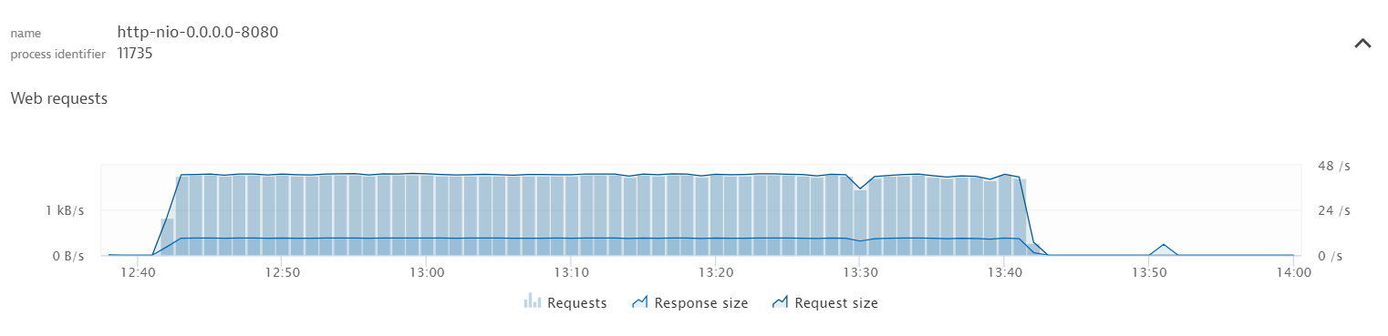

* 1. Threads:
     + 1. Number of Busy
       2. Idle threads

This explains what were status of threads during load, To verify do we have any limits on number of threads?

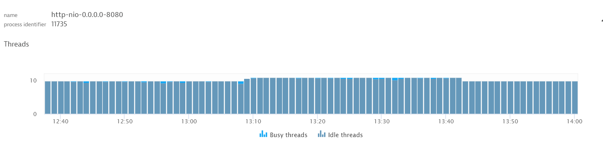

* MySQL process
  1. Number & Type of SQLs executed during Load .

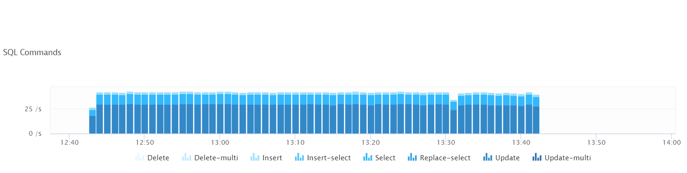

* 1. DB IOS:

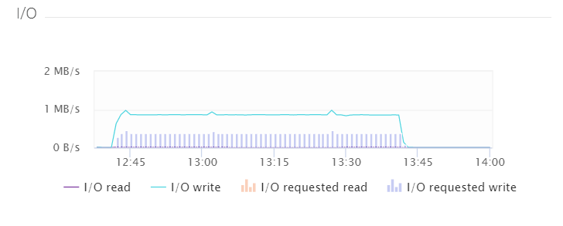

* 1. Page Faults:

More number bad for performance

