**Summery**

**Requirement:**

* Generate load perform all account activities actions at 10/secs per API using Jmeter,
* excluding account creations. For account creation, the target throughput is 2/sec.

**Work Load Model:**

* Run duration: 60 min
* Ramp up time: 1 user/5 sec
* Users/Threads: 12

|  |  |  |  |
| --- | --- | --- | --- |
| **API** | **TPS** | **USER** | **Think Time** |
| Create Account | 2 | 2 | 600 ms |
| Set Initial Balance | 10 | 10 | 100 ms |
| Deposit | 10 | 100 ms |
| Withdrawal | 10 | 100 ms |
| Get Balance | 10 | 100 ms |

**Test Environment:**

1. **Host:** ec2-3-139-67-65.us-east-2.compute.amazonaws.com
2. **Config.:**
   1. OS: Linux
   2. CPU: 1, 1 core
   3. RAM: 1 GB

**Application Details:**

<http://ec2-3-139-67-65.us-east-2.compute.amazonaws.com:8080/AccountREST-0.0.1-SNAPSHOT/myBank>

APIs

1. POST /addAccounts
2. POST /setInitialBalance
3. POST /deposit
4. POST /Withdrawal
5. GET /getBalance

**Tools:**

1. App development- Intelij, eclipse
2. Perf test tool - Jmeter
3. APM- Dynatrace/Cloud Watch

**Load Test Details:**

Test Duration:01/03/2020 12:42:00– 01/03/2020 13:42:00

1. Transactions per sec

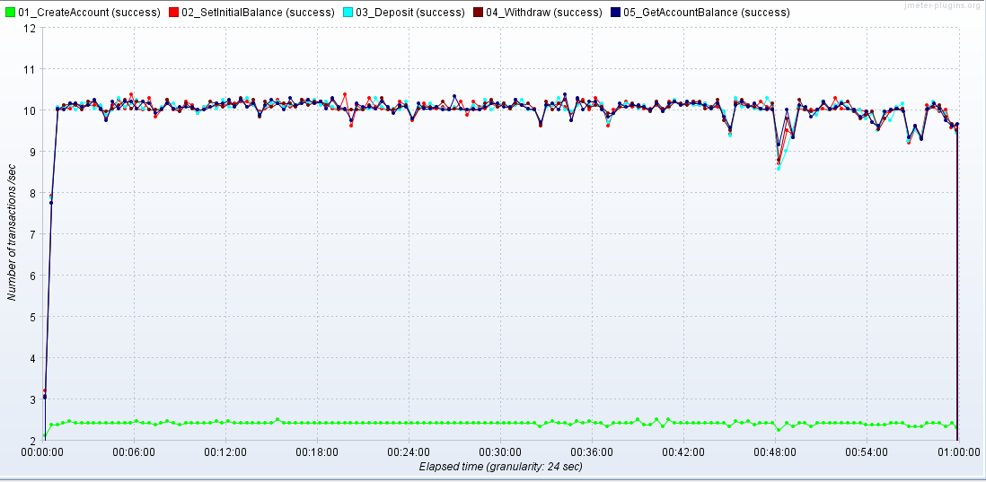

1. **Response Time:**

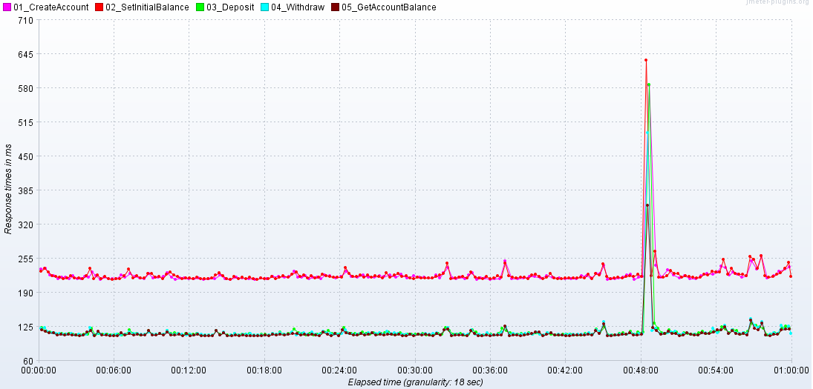

**Response Time Table:**

|  |  |  |  |  |
| --- | --- | --- | --- | --- |
| **Transaction** | **# of Transaction** | **Response Time**  **99% (seconds)** | **Throughput** | **Error %** |
| 01_CreateAccount | 8654 | 0.315 | 2.4/Sec | 0.00% |
| 02_SetInitialBalance | 35844 | 0.319 | 10.0/Sec | 0.00% |
| 03_Deposit | 35840 | 0.173 | 10.0/Sec | 0.00% |
| 04_Withdraw | 35839 | 0.174 | 10.0/Sec | 0.00% |
| 05_GetAccountBalance | 35836 | 0.17 | 10.0/Sec | 0.00% |

**Executive Summary:**

* + - Application able to handle required throughput
    - Overall Stable test with no significant issue in response time and TPS
    - Low infrastructure resource utilization
    - Response time with 0.5 seconds.
    - Spike in response time at 00:48:00 minutes is because of DNS query time increase at AWS instance level.

**Resources:**

1. Application GitHub repo.
   1. <https://github.com/tripaak/AccountREST/tree/master>
2. Jmeter test plan, monitoring details, Report
   1. <https://github.com/tripaak/Jmeter_Test_Plan_BANKACCOUNTAPI>/tree/master
   2. Refer folders for JTL file, HTML report , monitoring details, Summery report .