**List[Int]**

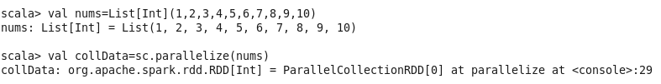

**Problem Statement#1**

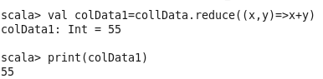

**Problem Statement#2**



**Problem Statement#3**

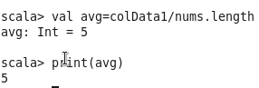

**Problem Statement#4**

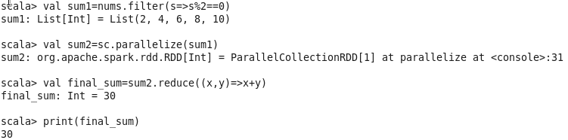

**Problem Statement#5**

