**Problem Statement#1**





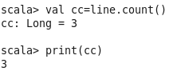

**Problem Statement#2**

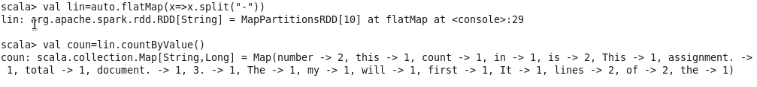

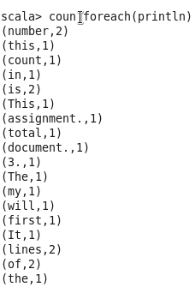

**Problem Statement#3**

