**Reading the data**



**Problem Statement#1.1**

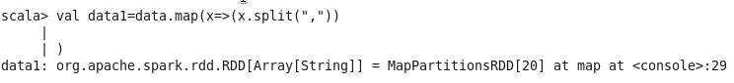



**Problem Statement#1.2**



**Problem Statement#1.3**



**Problem Statement#1.4**







**Problem Statement#1.5**







**Problem Statement#2.1**





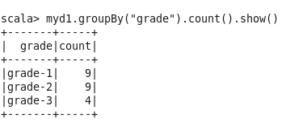

**Problem Statement#2.2**

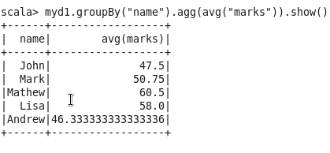

**Problem Statement#2.3**

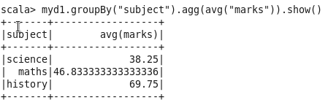

**Problem Statement#2.4**

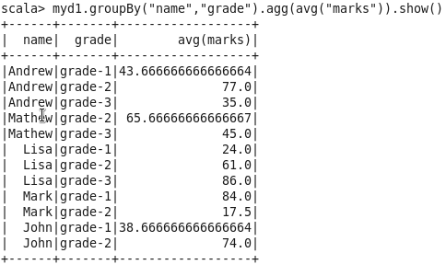

**Problem Statement#2.5**







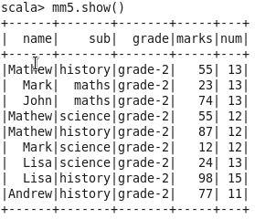

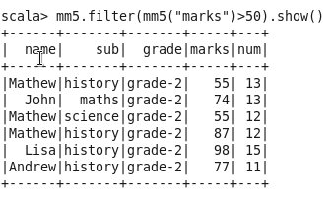

**Problem Statement#3.1**

