**Concat**

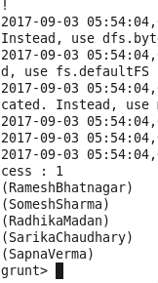

**Tokenize**

**C:\Users\Krishna\Desktop\tokenize.png**

**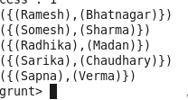**

**SUM**

**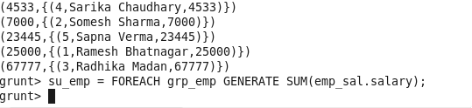**

**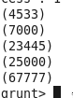**

**MIN**

**C:\Users\Krishna\Desktop\mi_syn.png**

**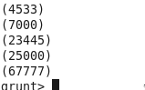**

**MAX**

**C:\Users\Krishna\Desktop\ma_syn.png**

**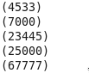**

**LIMIT**

**C:\Users\Krishna\Desktop\limit_syn.png**

**C:\Users\Krishna\Desktop\limit_op.png**

**STORE**

**C:\Users\Krishna\Desktop\store_syn.png**

**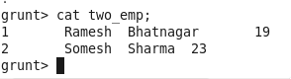**

**DISTINCT**

**C:\Users\Krishna\Desktop\distinct_syn.png**

**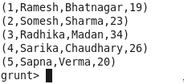**

**FLATTEN**

**C:\Users\Krishna\Desktop\flatten_syn.png**

**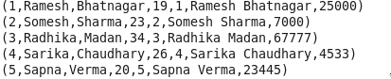**

**IsEmpty**

**