**Olympix_data.csv loaded into HDFS**

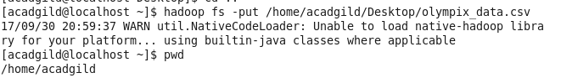

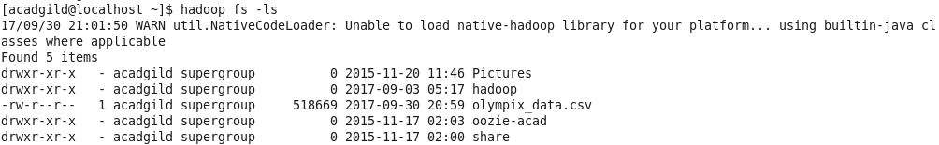

**Table Created**

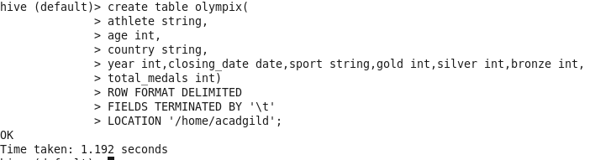

**Data loaded**

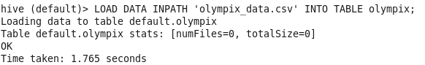

**Selecting the table data**



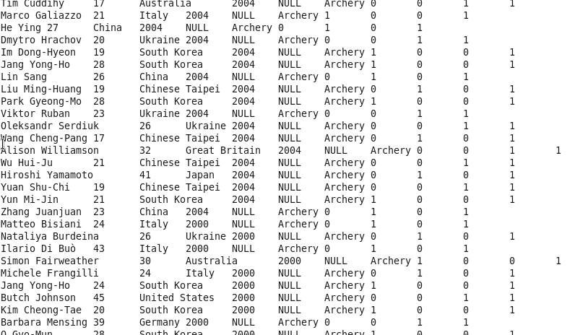

**Problem Statement#1**

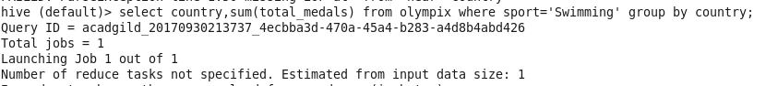

**Output**

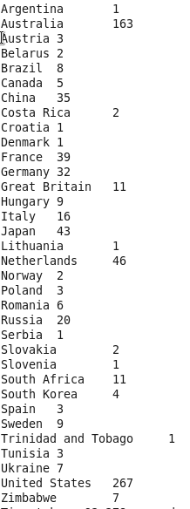

**Problem Statement#2**



**Output**

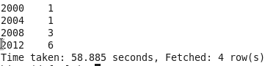

**Problem Statement#3**



**Output**

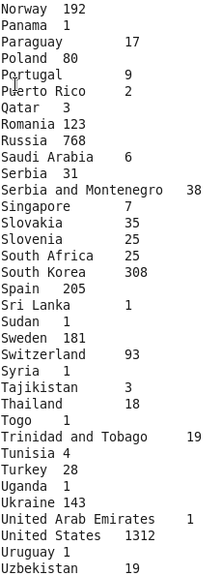

**ProblemStatement#4**



**Output**

