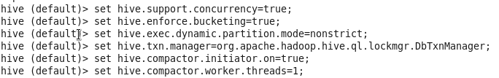

Table creation-



Insert-



O/P-

