**Problem Statement#1**

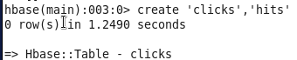

**Problem Statement#2**

