**UDF program**

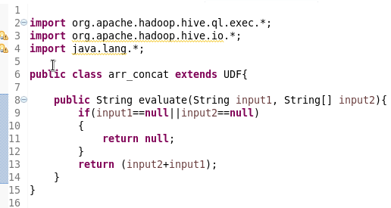

**Added jar to Hive**

