**First statement**

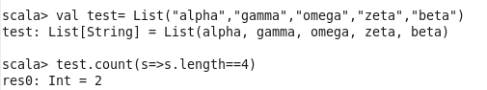

**Second Statement**



**Third Statement**





**Fourth Statement**

