**Screenshot 1**

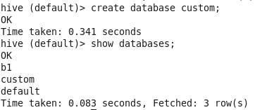

**Screenshot 2**

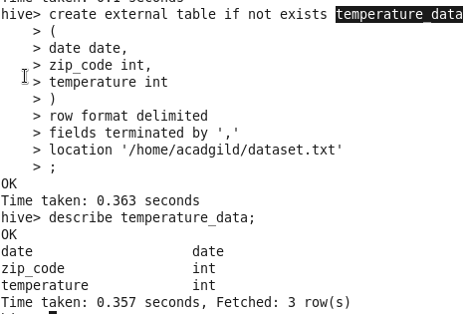

**Screenshot 3**

