**Problem Statement#1**

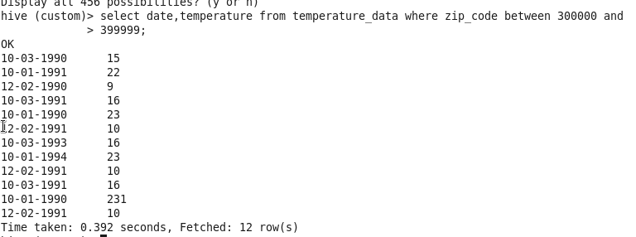

**Problem Statement#2**

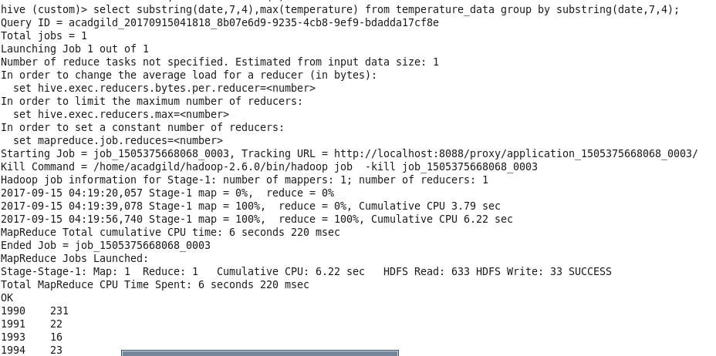

**Problem Statement#3**



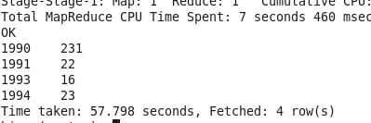

**Problem Statement#4**



**Problem Statement#5**

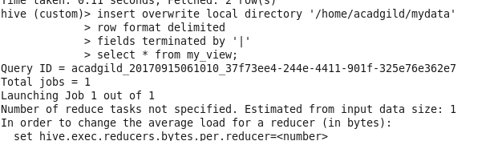

**O/P**

