**Hive Architecture**

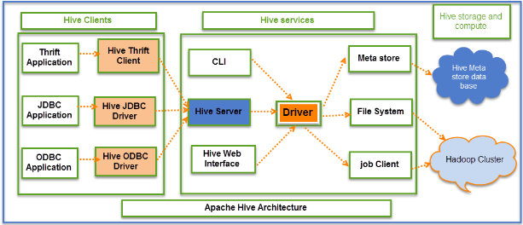

Hive Consists of Mainly 3 core parts

1. **Hive Clients**
2. **Hive Services**
3. **Hive Storage and Computing**

**Hive Clients:**

Hive provides different drivers for communication with a different type of applications. For Thrift based applications, it will provide Thrift client for communication.

For[Java](https://www.guru99.com/java-tutorial.html)related applications, it provides JDBC Drivers. Other than any type of applications provided ODBC drivers. These Clients and drivers in turn again communicate with Hive server in the Hive services.

**Hive Services:**

Client interactions with Hive can be performed through Hive Services. If the client wants to perform any query related operations in Hive, it has to communicate through Hive Services.

CLI is the command line interface acts as Hive service for DDL (Data definition Language) operations. All drivers communicate with Hive server and to the main driver in Hive services as shown in above architecture diagram.

Driver present in the Hive services represents the main driver, and it communicates all type of JDBC, ODBC, and other client specific applications. Driver will process those requests from different applications to meta store and field systems for further processing.

**Hive Components**

**Hive Storage and Computing:**

Hive services such as Meta store, File system, and Job Client in turn communicates with Hive storage and performs the following actions

* Metadata information of tables created in Hive is stored in Hive "Meta storage database".
* Query results and data loaded in the tables are going to be stored in Hadoop cluster on HDFS.

The data flow in Hive behaves in the following pattern;

1. Executing Query from the UI( User Interface)
2. The driver is interacting with Compiler for getting the plan. (Here plan refers to query execution) process and its related metadata information gathering
3. The compiler creates the plan for a job to be executed. Compiler communicating with Meta store for getting metadata request
4. Meta store sends metadata information back to compiler
5. Compiler communicating with Driver with the proposed plan to execute the query
6. Driver Sending execution plans to Execution engine
7. Execution Engine (EE) acts as a bridge between Hive and Hadoop to process the query. For DFS operations.

* EE should first contacts Name Node and then to Data nodes to get the values stored in tables.
* EE is going to fetch desired records from Data Nodes. The actual data of tables resides in data node only. While from Name Node it only fetches the metadata information for the query.
* It collects actual data from data nodes related to mentioned query
* Execution Engine (EE) communicates bi-directionally with Meta store present in Hive to perform DDL (Data Definition Language) operations. Here DDL operations like CREATE, DROP and ALTERING tables and databases are done. Meta store will store information about database name, table names and column names only. It will fetch data related to query mentioned.
* Execution Engine (EE) in turn communicates with Hadoop daemons such as Name node, Data nodes, and job tracker to execute the query on top of Hadoop file system

1. Fetching results from driver
2. Sending results to Execution engine. Once the results fetched from data nodes to the EE, it will send results back to driver and to UI ( front end)

**Different modes of Hive**

Hive can operate in two modes depending on the size of data nodes in Hadoop.

These modes are,

* **Local mode**
* **Map reduce mode**

**When to use Local mode:**

* If the Hadoop installed under pseudo mode with having one data node we use Hive in this mode
* If the data size is smaller in term of limited to single local machine, we can use this mode
* Processing will be very fast on smaller data sets present in the local machine

**When to use Map reduce mode:**

* If Hadoop is having multiple data nodes and data is distributed across different node we use Hive in this mode
* It will perform on large amount of data sets and query going to execute in parallel way
* Processing of large data sets with better performance can be achieved through this mode

In Hive, we can set this property to mention which mode Hive can work? By default, it works on Map Reduce mode and for local mode you can have the following setting.

Hive to work in local mode set

**SET mapred.job.tracker=local;**

From the Hive version 0.7 it supports a mode to run map reduce jobs in local mode automatically.