**Supplementary Table 1-** <https://drive.google.com/file/d/1UUUWcBcDanASRNIw7Ef_M4kLhy4UvOl6/view?usp=sharing>

**Supplementary Table 2**

<https://drive.google.com/file/d/1cj5_8KpOh4YMIEnE31WAmCKW6slbFLPt/view?usp=sharing>

**Supplementary Table 3- Analysis report**

<https://docs.google.com/spreadsheets/d/12zSr4akKzy0xt4_NWLq2n0oAs-P-OHXi/edit?usp=sharing&ouid=109218774252976453307&rtpof=true&sd=true>

**Supplementary Table 4 –**

**(A) GSE226773**

<https://docs.google.com/spreadsheets/d/1iQRp7Ch3jT3wccPrOsrQ8UiDg0SG1q_T/edit?usp=sharing&ouid=109218774252976453307&rtpof=true&sd=true>

**(B)**

[**https://drive.google.com/file/d/1of1mYkNDZGFaIQ5GEB-4ynkVCNhyzH2i/view?usp=sharing**](https://drive.google.com/file/d/1of1mYkNDZGFaIQ5GEB-4ynkVCNhyzH2i/view?usp=sharing)

**Github link-**

[**https://github.com/tripathivarsha/TCGA-LUSC_DEGs**](https://github.com/tripathivarsha/TCGA-LUSC_DEGs)

**Supplementary Table 5- List of top 10 drugs screened against CYP2B6 obtained from the Dgidb database.**

|  |  |  |  |
| --- | --- | --- | --- |
| PubChem Id | Drug Name | Docking Score | Interaction Score (Dgidb) |
| 3000469 | Artemotil | -7.2 kcal/mol | 0.20 |
| 5584 | Trimipramine | -7.5kcal/mol | 0.02 |
| 2995 | Desipramine | -7.5kcal/mol | 0.02 |
| 2554 | Carbamazepine | -8kcal/mol | 0.03 |
| 2733526 | Tamoxifen | -8.3kcal/mol | 0.02 |
| 5280961 | Genistein | -8.5kcal/mol | 0.02 |
| 6918456 | Prasugrel | -8.5kcal/mol | 0.13 |
| 10113978 | Pazopanib | -9.6kcal/mol | 0.11 |
| 216239 | Sorafenib | -9.9kcal/mol | 0.01 |
| 644241 | Nilotinib | -12.7kcal/mol | 0.40 |

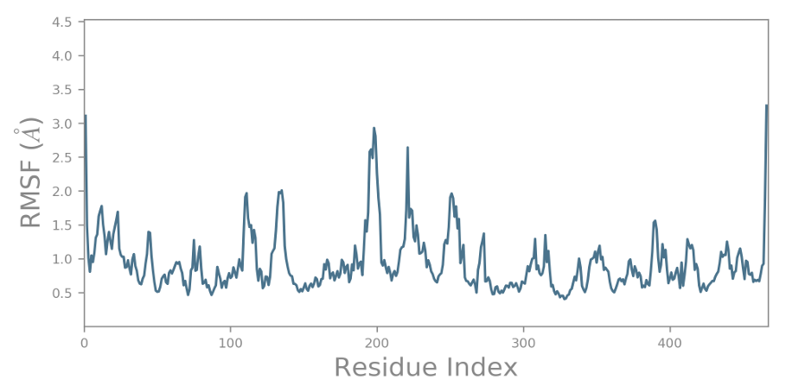

**(a)**

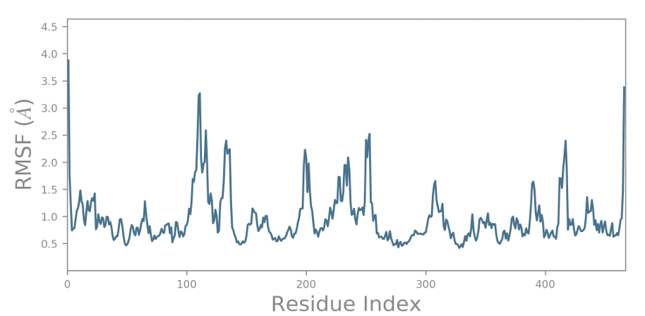

**(b)**

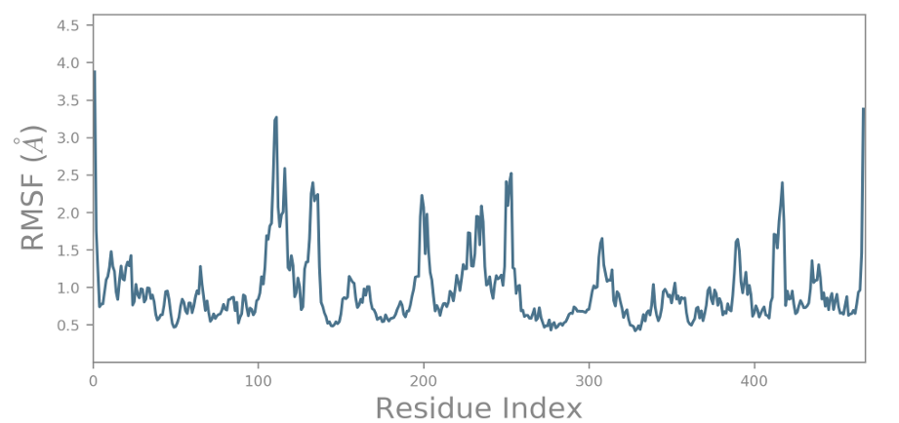

**(C)**

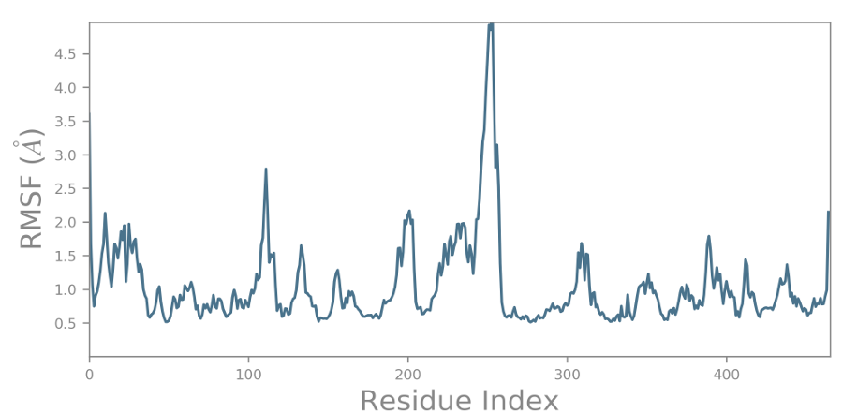

**(d)**

**Supp. Fig.1** RMSF plot generated for the CYP2B6 protein docked with the selected compounds. (a) Nilotinib (b) Pazopanib (c) Sorafenib (d) 4-(4-CHLOROPHENYL) IMIDAZOLE (control)

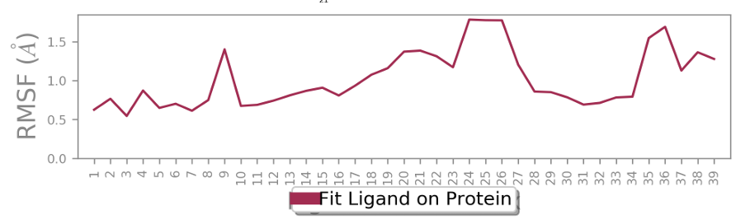

**(a)**

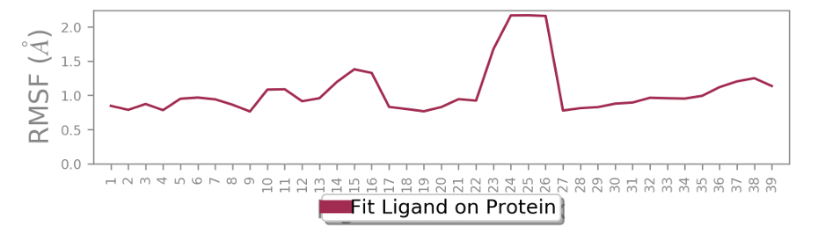

**(b)**

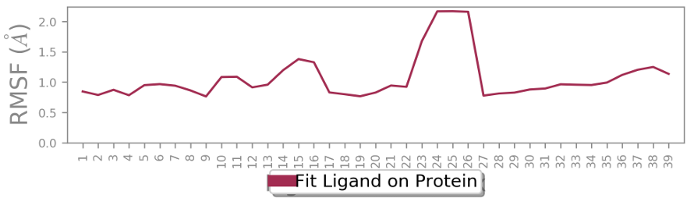

**(c)**

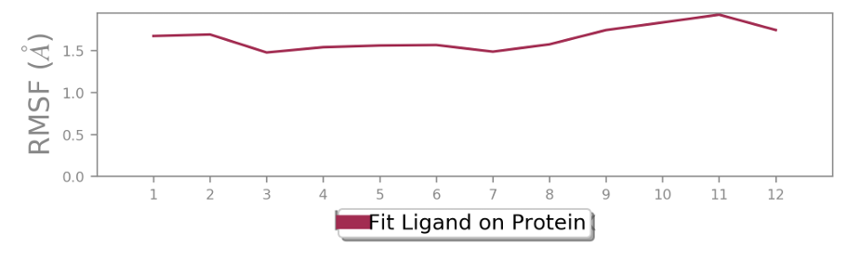

**(d)**

**Supp. Figure 2**: Ligand fit on Protein RMSF for CYP2B6 complexes. (a) Nilotinib (b), Pazopanib (c), Sorafenib (d), 4-(4-CHLOROPHENYL) IMIDAZOLE (Control)