Supplementary Table 1- https://drive.google.com/file/d/1UUUWcBcDanASRNIw7Ef_M4kLhy4UvOl6/view?usp=sharing
Supplementary Table 2
https://drive.google.com/file/d/1cj5_8KpOh4YMIEnE31WAmCKW6slbFLPt/view?usp=sharing
Supplementary Table 3- Analysis report
https://docs.google.com/spreadsheets/d/12zSr4akKzy0xt4_NWLq2n0oAs-P-OHXi/edit?usp=sharing&ouid=109218774252976453307&rtpof=true&sd=true
Supplementary Table 4 –
(A) GSE226773
https://docs.google.com/spreadsheets/d/1iQRp7Ch3jT3wccPrOsrQ8UiDg0SG1q_T/edit?usp=sharing&ouid=109218774252976453307&rtpof=true&sd=true
(B)
https://drive.google.com/file/d/1of1mYkNDZGFaIQ5GEB-4ynkVCNhyzH2i/view?usp=sharing

Github link-
https://github.com/tripathivarsha/TCGA-LUSC_DEGs

Supplementary Table 5- List of top 10 drugs screened against CYP2B6 obtained from the Dgidb database.
PubChem Id | Drug Name | Docking Score | Interaction Score (Dgidb)
3000469 | Artemotil | -7.2 kcal/mol | 0.20
5584 | Trimipramine | -7.5kcal/mol | 0.02
2995 | Desipramine | -7.5kcal/mol | 0.02
2554 | Carbamazepine | -8kcal/mol | 0.03
2733526 | Tamoxifen | -8.3kcal/mol | 0.02
5280961 | Genistein | -8.5kcal/mol | 0.02
6918456 | Prasugrel | -8.5kcal/mol | 0.13
10113978 | Pazopanib | -9.6kcal/mol | 0.11
216239 | Sorafenib | -9.9kcal/mol | 0.01
644241 | Nilotinib | -12.7kcal/mol | 0.40

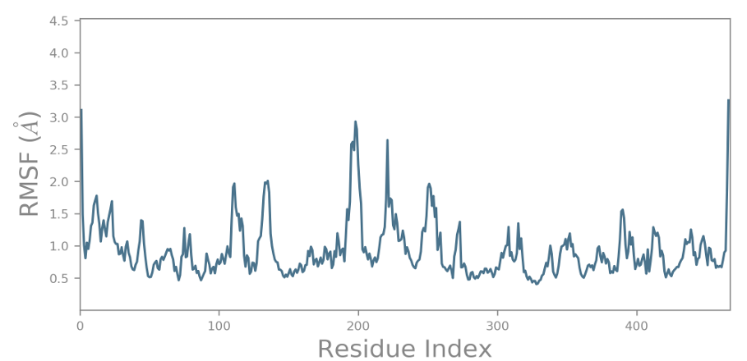

(a)

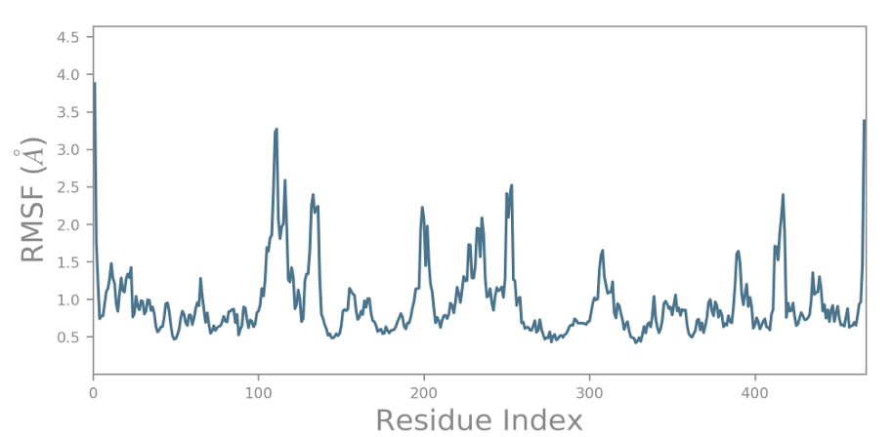

(b)

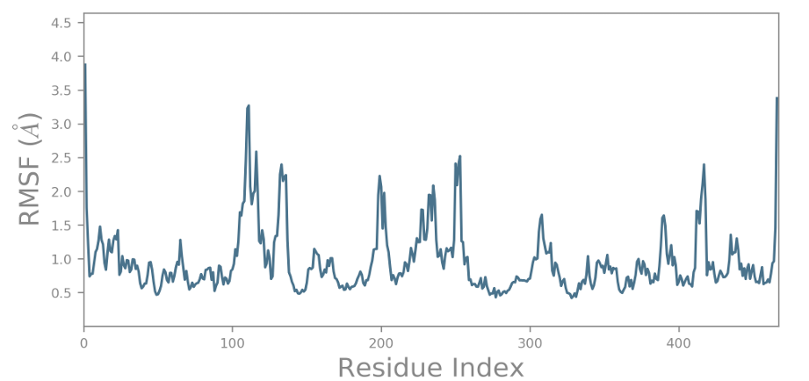

(C)

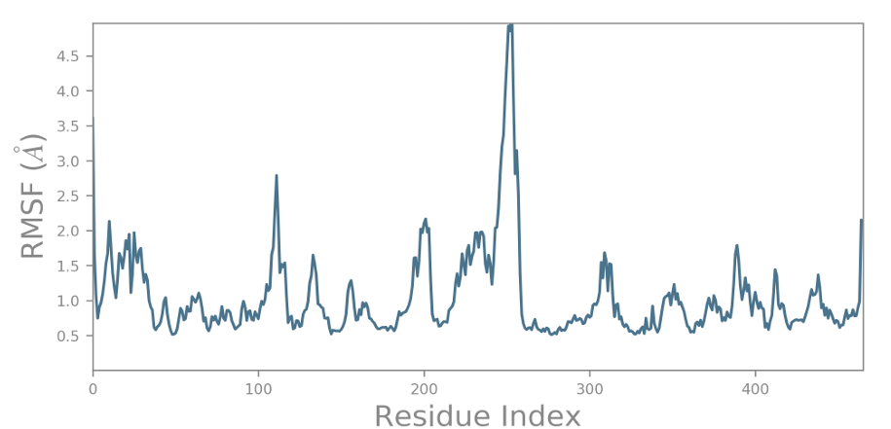

(d)

Supp. Fig.1 RMSF plot generated for the CYP2B6 protein docked with the selected compounds. (a) Nilotinib (b) Pazopanib (c) Sorafenib (d) 4-(4-CHLOROPHENYL) IMIDAZOLE (control)
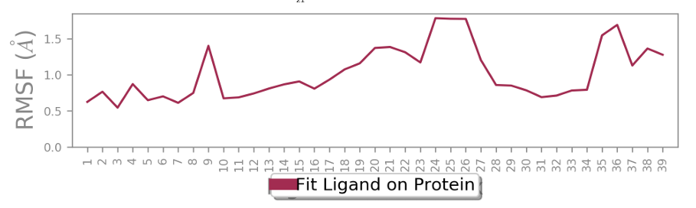
(a)

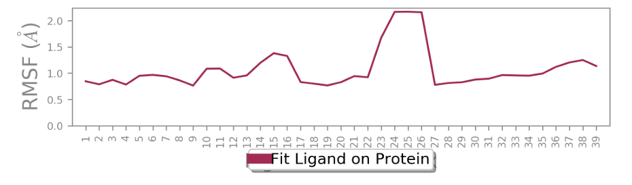
(b)

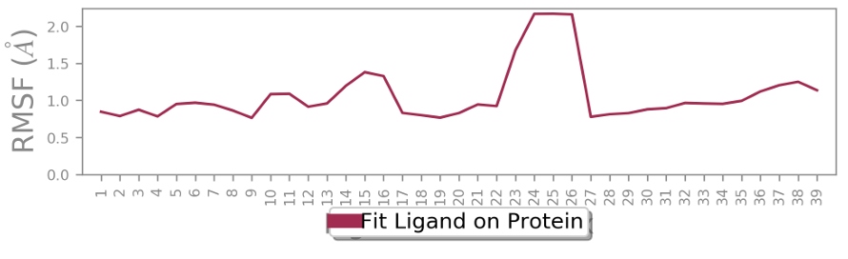

(c)

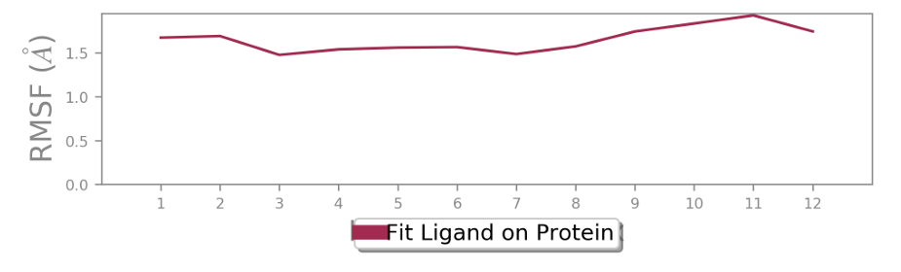
(d)

Supp. Figure 2: Ligand fit on Protein RMSF for CYP2B6 complexes. (a) Nilotinib (b), Pazopanib (c), Sorafenib (d), 4-(4-CHLOROPHENYL) IMIDAZOLE (Control)

