11 Rings of Power
- This map is all about the Rings of Power. Each faction has one, one is lost, one is missing, one is on The Great Dragons Lair

- Victory is achieved by one faction or a group of factions politically ALLIED attaining 6 Rings of Power.
- 8 player Free For All, FFA, with 1 fixed Capital & 5 random high value territories
- If 5 Rings of Power are attained, AI factions will get impending winners, those that are currently;
- HOSTILE will declare WAR and those are NEUTRAL will declare HOSTILE.
- When a faction has no land territories it is Vanquished, and all it’s units will be removed the map

- Stacking limit is enforced to help the AI give a better game.
- Most units stack up to 5s per Territory /Sea Zone, except Skirmisher, Bow, Spear stack up to 10s.
- AI friendly-ish, no Objectives, no Technology phases (There is a politics phase)

- Sea Zones have ownership flags and are worth 1-3pu/turn. All land territories can be blockaded if adjacent to a Sea Zone. There are no convoy centers/route/zones. Most ships can Blockade an enemy Territory for 1pu and Submarines Blockade for 2pu.
- The above sea units can only Blockade up to the value of the PUs of adjacent enemy land territories

Resources
- PU buys most units
- Fame buys Heroes, Leaders and Magicians, to earn Fame you must kill things, but only when you attack, not defend.
- Construct is made from owning Forest and Mountains and is needed for Town, City, Castle, Galley & Cogs building and repair
- Mana is generated by Magicians and a few places of Mana power on the map, like The Great Dragons bones, it is used to summon Beast
- Diplomacy is generated by a Leaders & The Dark Crystal & the Grail of Glory

- Politics has 5 relationships
WAR 🡪 NEUTRAL 🡪 FRIENDLY 🡪 ALLIED (note HOSTILE is skipped when suing for peace, goes from WAR to NEUTRAL)
WAR 🡨 HOSTILE 🡨 NEUTRAL 🡨 FRIENDLY 🡨 ALLIED

There are 8 factions, split into 2 loose alliances
- Darkside Orc, Goblin, Demon & Undead, start Neutral with each other and are, searching for The Dark Crystal & 11 rings
- Lightside Men, Dwarf, HighElf & WoodElf, start Neutral with each other and are, searching for The Grail of Glory & 11 rings
- The two loose alliances start HOSTILE to each other


Castles have 3 hits and auto repair at the being of the owners turn
They have Walls that Suppress, -1 Atk/Def up to 10 enemy units
Well supplied, all units can move +1, so 2-3 territories



Veteran & Cavalry
They are Armored, and Suppress -1 Atk/Def 1 enemy unit


Wild Things inhabit, yes wild regions, and can ambush your units.


There is a Mighty Dragon that can go on the rampage and pillage

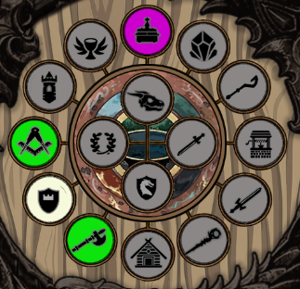
There are lots of Fate items to collect on land and sea, the best 16 are shown in a dial format, top right of the map.
Dragon Bones
Dragon Shield
Vorpal-Blade
Magicians Tower
Treasure Island


If you are really lucky you might find one of these Fate items

Darkside Monster or Dark Crystal



Lightside Archangel or Grail of Glory

