Assignment 9 Apportionment

Before class Monday 11/10: read this document and make note of any questions you might have.

Monday 11/10 and Wednesday 11/12: will be studio classes devoted to this assignment.

Friday 11/14: present your assignments

Friday 11/21: final version due in class.

Your goal is to develop an apportionment algorithm, that is, an algorithm that, given
- a list of states
- the population sizes of each state, and
- the “house” size, in number of seats,
apportions to each state an integral number of seats. The number of seats must add up to the house size and each state must get greater than or equal to zero seats. We are modeling here not specifically the United States, but the general problem. (And so we will ignore two specific restrictions that apply in the United States as to apportioning the House of Representative: the 30,000 rule and >= 1 rule.)

The big catch/challenge is that the goal is to have your apportionment algorithm be “fair.” But what does it mean to be fair? That is a tricky issue, and for example, the US Constitution does not clearly address it, but rather simply says that the apportionment must be “by the numbers.”

Of course, you are not the first people to be tackling this challenge. Many of the greatest figures in American history themselves were, like you, algorithms designers for solutions to this challenge. Among the most famous people who designed algorithms for this challenge were Jefferson, Adams, Webster, and Hamilton. (Yes, that is right: You are competing with two US presidents, a US secretary of state and the first US secretary of the treasury!)

Those famous people didn’t call their algorithms “algorithms.” (Even now, a common phrasing is, e.g., “Hamilton’s Method.”) But, really, they were specifying algorithms! And the first “referee” who had to decide whether a given algorithm should be adopted to apportion the US House was President George Washington. In fact, the very first presidential veto was cast on exactly this issue, by Washington!

Here is a formal definition of the apportionment problem.

Inputs:
 the number of states
Positive integers 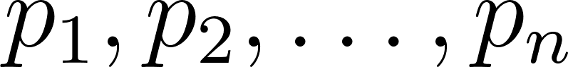, where  is the population of the th state.
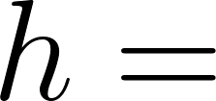 the number of seats in the House.
Outputs:
Integers 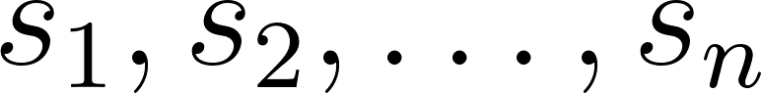, where 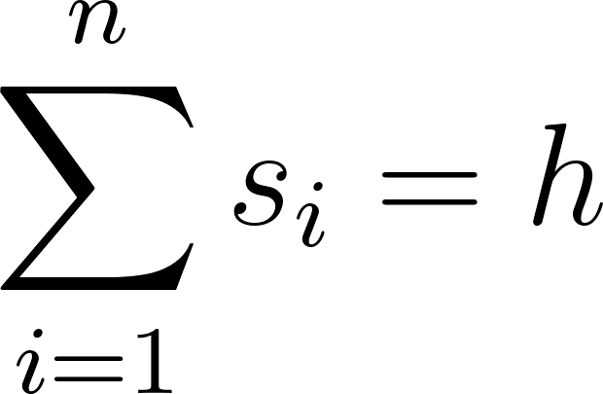.

Note that there are many solutions to this. It seems reasonable that some are “fairer” than others. For instance, if there were two states with population sizes of 50,000 and 300, respective and a House with 100 seats, giving 3 seats to the first state and 97 to the second hardly seems fair.

You must provide an algorithm as well as mathematically sound guarantees for its fairness. One concept you may use (but don’t have to) is that of a state’s quota: 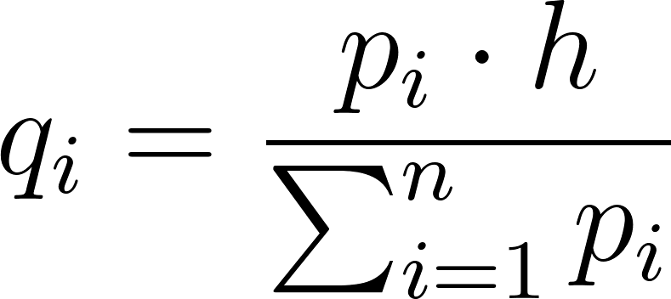, which represents the “ideal” allocation, if fractions were allowed. For instance, you might be able to should that your algorithm guarantees, for all , that 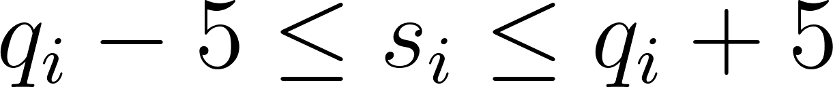.

Q1. Write your algorithm in pseudocode.

Q2. Provide an illustration or two that shows how your algorithm works.

Q3. What fairness guarantees does your algorithm provide and why?

