Tamam Shud case

Considered to be one of Australia's most profound mysteries, the [Tamam Shud Case](http://blogs.smithsonianmag.com/history/2011/08/the-body-on-somerton-beach/) revolves around an unidentified man found dead in December 1948 on Somerton beach in Adelaide, Australia. Aside from the fact that the man could never be identified, the mystery deepened after a tiny piece of paper with the words "Tamam Shud" was found in a hidden pocket sewn within the dead man's trousers. (It is also referred to as "Taman Shud.")

The phrase translates as "ended" or "finished" and is a phrase used on the last page of a collection of poems called “The Rubaiyat” of Omar Khayyam. Adding to the mystery, a copy of Khayyam's collection was later found that contained a scribbled code in it believed to have been left by the dead man himself.

Due to the content of the Khayyam poem, many have come to believe that the message may represent a suicide note of sorts, but it remains uncracked, as does the case.

Bermuda Triangle

[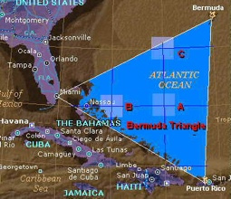](http://i1.wp.com/listverse.com/wp-content/uploads/2007/07/bermudatriangle-1.jpg)

The Bermuda triangle is an area of water in the North Atlantic Ocean in which a large number of planes and boats have gone missing in mysterious circumstances. Over the years many explanations have been put forward for the disappearances, including bad weather, alien abductions, time warps, and suspension of the laws of physics.  
have  
Although substantial documentation exists to show that many of the reports been exaggerated, there is still no explanation for the unusually large number of disappearances in the area