**Loans 4 U Amendments**

1. 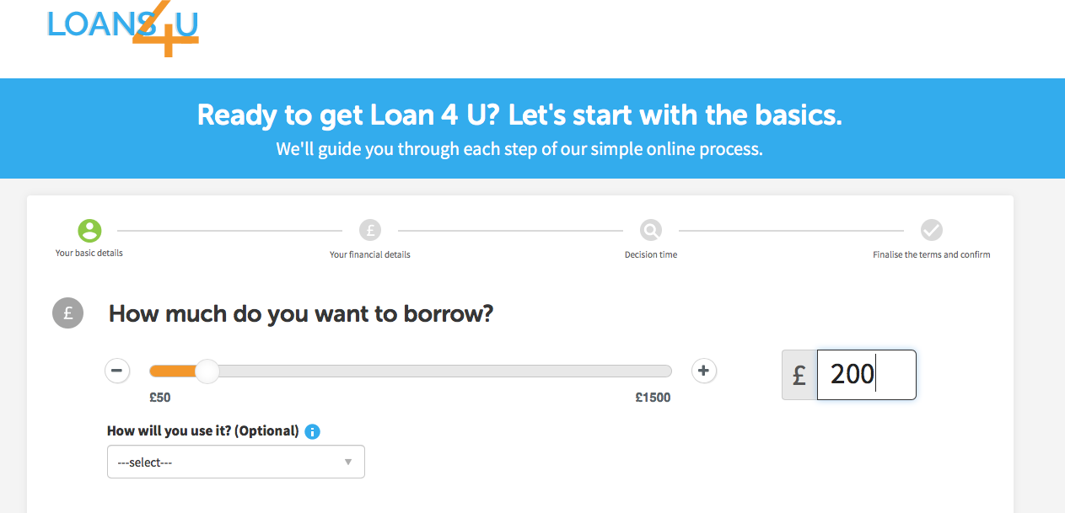The Loan Amount on the first page needs to be the same as the Loan Amount on the apply page (see screenshots)
2. 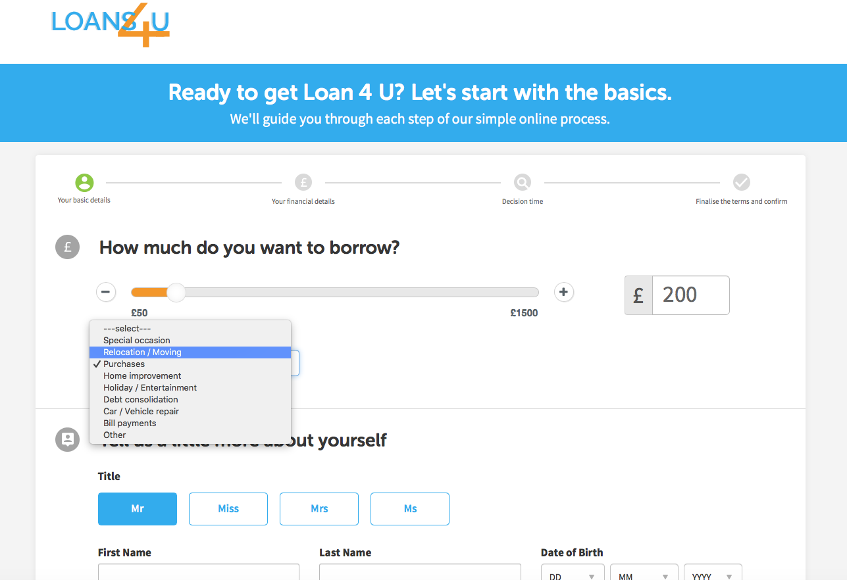Can we make sure all the fields have the same info as [www.paydaymate.co.uk](http://www.paydaymate.co.uk) (see examples below)
3. We need to make sure the fields are in the correct format so they can post into Lead Capsule CRM (see below)

* Time At Address

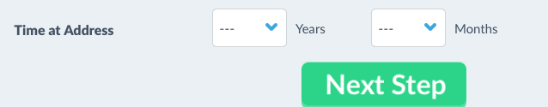

* 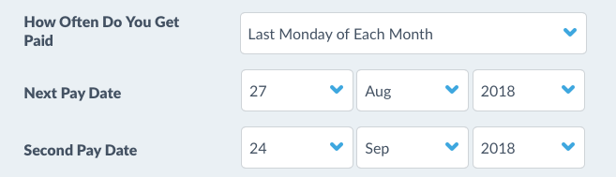How often do you get paid needs to be the same as [www.paydaymate.co.uk](http://www.paydaymate.co.uk)

1. Validation – there needs to be validation on the fields…if a field has not been completed then there needs need error message and highlight which fields need completing  
     
   Also there needs to be phone and email validation. (valid phone number is 11 digits and valid email must have @)
2. You have missed the bank verification page when I click this button it goes straight to the form post   
     
   